Self-Regulation/SEL
4th Grade

Purpose: To teach self-regulation (SEL), help students identify where they feel emotions in their bodies, and how to handle settle their glitter.
*This lesson can be broken up into multiple lessons or used for a group focusing on managing emotions.

Materials:
Bottle of soda (20 oz.)
Bottle of water
Brain Poster: https://docs.google.com/presentation/d/1kMORCbVZK8_0095eilZHtJnklmhNxPyjpJMM2z55uwY/copy
Physical Feeling Warning Signs handout for each student (below)
Feeling Thermometer for the counselor (make ahead of time out of wrapping paper tube)
Paper towel tube for each student (or 1 per class)
Piece of red construction paper for each student (or 1 per class)
Glitter jar
Calm down cards for each student (below)

Additional resources:
Brain Song: https://docs.google.com/presentation/d/1xhXc5aoUpg_LWz-SZ3-xppr5x7fC_vhOlBwlWthQ_iY/copy
Feelings Poster https://resources.finalsite.net/files/v1617985556/mesquiteisdorg/m7j9nawjtrmcymo6atb6/ResourceFeelingsPoster-Eng-Span.pptx
OR Feelings Picture Wall https://www.teacherspayteachers.com/Product/Emotions-and-Feelings-Vocabulary-Word-Wall-Cards-plus-Write-and-Wipe-Version-3657974
Stop Think Settle Your Glitter: https://resources.finalsite.net/files/v1617993729/mesquiteisdorg/yrzlkxrqqmcdqiqefybr/Resource-Stop-Think-SettleYourGlitter.docx
Brain Song: https://docs.google.com/presentation/d/1xhXc5aoUpg_LWz-SZ3-xppr5x7fC_vhOlBwlWthQ_iY/copy
Extension activities and parent handouts available for download from: https://www.mesquiteisd.org/resources-services/counseling-services/guidanceprogram/counseling-program/social-emotional-learning
Slides with Visuals: https://docs.google.com/presentation/d/1RA-hVhUPY0vcAvLw4oQqNgv0kNjZkEH_uHcpHBTHsfw/copy
Settle Your Glitter Video: https://youtu.be/fsjRZUIoGBQ
Flipping your lid video: https://www.youtube.com/watch?v=2xeDcPBD5Fk

Time:
Approximately 30-45 minutes

Focus:
Show students the bottle of soda. Shake it up. Stand near a student and pretend to open it. Process the reaction; “What happens if I were to open it?” Now shake up the water and open it. “How is the water different?” -One explodes under pressure and one doesn’t (can also tie in “thinking clearly” versus flipped lid).
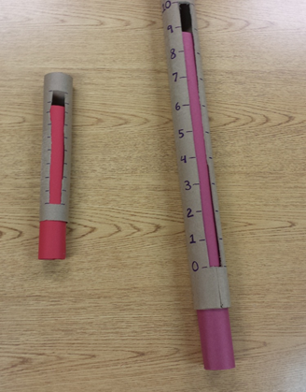
Lesson:
Tell students that this lesson is over controlling our emotions, including anger. It’s a myth that anger can’t be controlled. It’s okay to be angry; it’s what you do with it. It’s not okay to hurt yourself or others.

Tell students that their brain is responsible for everything about them: thinking, feeling, doing, hearing, seeing, touching, smelling, tasting. Review the brain hand signal (see pic below): thinking brain (prefrontal cortex) where we make decisions, feeling brain (amygdala) where our fight/flight/freeze response and emotions are. You can use the Brain Poster and give the teacher a copy. Describe what happens when we “flip our lid”. Show students the hand signal at different levels (partially open, mostly open, all the way open).

Explain that you can feel emotions physically, in our bodies.

Pass out the Physical Feelings Warning Signs page. Go over each warning sign and have students circle or highlight the characteristics that apply to themselves. Talk about how each of these warning signs are clues to what’s going on with us and can signal that you are close to flipping your lid. We can use these clues to help ourselves before we explode like the soda bottle.

Show students the large anger thermometer. (Teacher model is made out of a wrapping paper tube, the student model is made of a paper towel tube). Ask them what a thermometer does? (Tells temperature.) This thermometer gages levels of feelings. Come up with a 1-10 list of levels of anger, sadness, and fear using the table below.
Guide students through making the anger thermometers. Have students cut a window out of the paper towel tube. Have them label it 1-10. Give each student a piece of red construction paper to roll up and put in the tube. **If you don’t have enough tubes to make one per kid, make one for the class.

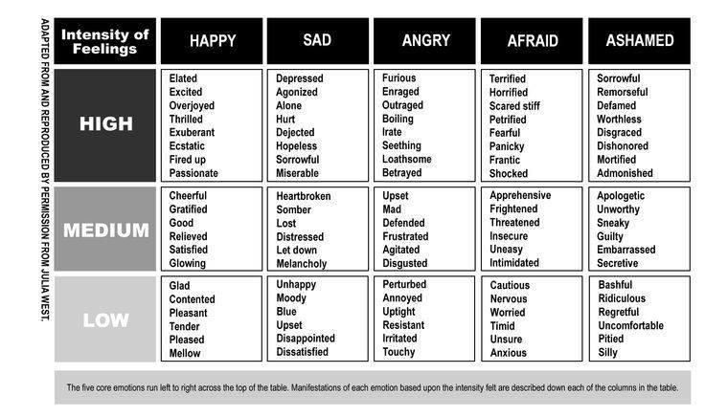

Show students a glitter jar with different size glitter. Shake it up and ask them what they see. This is what the brain is like when we are sad, mad, scared. It’s hard to see through all the glitter, and like the shaken coke bottle, it’s hard for us to think and make good choices. Point out the different size glitter. Those are like the different sizes of our emotions. Notice some glitter settles faster than others. We have to work harder to calm ourselves down with big emotions.

Have students discuss in partners ways to help themselves (manage emotions, problem solve, and cope) in unfavorable circumstances. With the class, create a T-chart with the “Emotions” on one side and “Coping Skills” on the other.
Pass out calm down cards to students. (Can have them pre-filled, or have students fill in ways to help themselves.)

Closure:
Show the #OneYou video. Emphasize that there is only one of them, so they need to take care of their brain and bodies.

Extension:
Send home parent brain infographic.
Students can create an action plan using a thinking map of what to do when they feel angry.
OR Show students the Feelings Poster or the Feelings Picture Wall that you are going to leave for them in the classroom. Explain to them that this is something their teacher is going to use to continue to talk about some of the feelings we talk about today. The teacher may want to hang it up and refer to it daily as a poster or you can cut it apart and have the teacher add one feeling at a time as they discuss until they are all up. The teacher can reinforce belly breathing and the glitter jar as they discuss each feeling with the class.
OR Review and give the teacher a copy of the “Stop Think Settle Your Glitter” paper to hang in their room.

Ways I can Calm Down  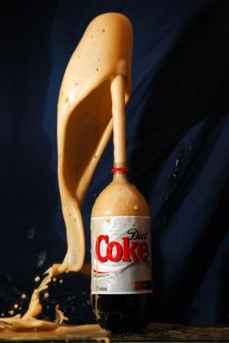  1: Notice your warning signs.  2: Stop. Think.  3: Pick a strategy.  - Stress ball  - Journal  - Count  - Deep Breaths  Repeat as needed! | Ways I can Calm Down  1: Notice your warning signs.  2: Stop. Think.  3: Pick a strategy.  - Deep breaths  - Count  - Draw about it  - Write about it  - Quiet time  - Talk to someone  Repeat as needed!
Ways I can Calm Down  1: Notice your warning signs.  2: Stop. Think.  3: Pick a strategy.  - Deep breaths  - Count  - Draw about it  - Write about it  - Quiet time  - Talk to someone  Repeat as needed! | Ways I can Calm Down  1: Notice your warning signs.  2: Stop. Think.  3: Pick a strategy.  - Deep breaths  - Count  - Draw about it  - Write about it  - Quiet time  - Talk to someone  Repeat as needed!!
Ways I can Calm Down  1: Notice your warning signs.  2: Stop. Think.  3: Pick a strategy.  - Deep breaths  - Count  - Draw about it  - Write about it  - Quiet time  - Talk to someone  Repeat as needed! | Ways I can Calm Down  1: Notice your warning signs.  2: Stop. Think.  3: Pick a strategy.  - Deep breaths  - Count  - Draw about it  - Write about it  - Quiet time  - Talk to someone  Repeat as needed!
Ways I can Calm Down  1: Notice your warning signs.  2: Stop. Think.  3: Pick a strategy.  - Deep breaths  - Count  - Draw about it  - Write about it  - Quiet time  - Talk to someone  Repeat as needed! | Ways I can Calm Down  1: Notice your warning signs.  2: Stop. Think.  3: Pick a strategy.  - Deep breaths  - Count  - Draw about it  - Write about it  - Quiet time  - Talk to someone  Repeat as needed!

Physical Feeling Warning Signs

Feelings are physical. Sometimes emotions can affect what you say or do before you even recognize how you’re feeling. You may become so used to the feeling of anger that you don’t notice it, sort of like how you can hear the sound of an air condition, or the humming of a refrigerator, but block it from your mind.

Even if you are not aware of your feelings, they influence how you behave. The first step to managing emotions is learning to recognize your personal warning signs that will tip you off about how you’re feeling.

How do you react when you feel angry? Some of these warning signs might start when you are only a little irritated, and others might start when you are very angry.

Circle or color in the warning signs that apply to you.

Mind goes blank | Insult the other person | Face turns red | Body or hands shake | Start sweating
Throw things | Heavy or fast breathing | Stare at the other person aggressively | Scowl or make an angry face | Scream, yell, raise voice
Clench fists | Tighten jaw | Feel sick to the stomach | Punch walls | Tear things up
Feel hot | Become argumentative | Crying | Pace around the room | Get quiet and shut down
Headaches | Can’t stop thinking about the problem | Eat a lot of food or snacks | Don’t want to eat anything | Procrastination
Adapted from TherapistAid.com © 2014

