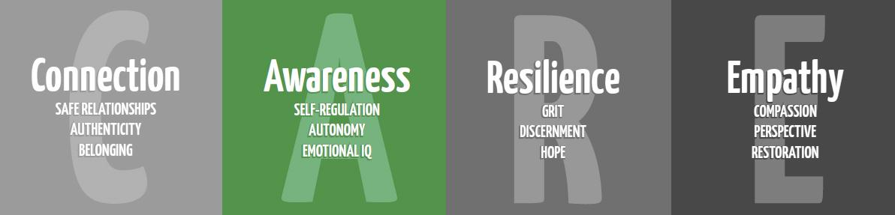
Self-Regulation/SEL

3rd Grade Part 2

Purpose: To educate students on things inside and outside of their control, and to teach self- regulation (SEL), managing emotions, problem solving, and coping skills in unfavorable circumstances.

Materials: This is part two of the SEL lessons; If you only have time for one, do this lesson and review “flip your lid” after the focus.
Glitter Jar
The Bad Seed by Jury John
Paper for t-chart
Fortune Teller/Cootie Catcher (below)- Pre-copied for each student
OR Regulation Heart (below)- Pre-copied for each student
Elementary #OneYou video https://www.youtube.com/watch?v=lPIMPLYrKqQ

Additional Resources:
Feelings Poster https://resources.finalsite.net/files/v1617985556/mesquiteisdorg/m7j9nawjtrmcymo6atb6/ResourceFeelingsPoster-Eng-Span.pptx
OR Feelings Picture Wall https://www.teacherspayteachers.com/Product/Emotions-and-Feelings-Vocabulary-Word-Wall-Cards-plus-Write-and-Wipe-Version-3657974
Stop Think Settle Your Glitter: https://resources.finalsite.net/files/v1617993729/mesquiteisdorg/yrzlkxrqqmcdqiqefybr/Resource-Stop-Think-SettleYourGlitter.docx
Brain Song: https://docs.google.com/presentation/d/1xhXc5aoUpg_LWz-SZ3-xppr5x7fC_vhOlBwlWthQ_iY/copy
Extension activities and parent handouts available for download from: https://www.mesquiteisd.org/resources-services/counseling-services/guidanceprogram/counseling-program/social-emotional-learning
Slides with Visuals: https://docs.google.com/presentation/d/1RA-hVhUPY0vcAvLw4oQqNgv0kNjZkEH_uHcpHBTHsfw/copy

Time:
Approximately 30 minutes

Focus:
Ask students how is their brain today? Remind students of the brain hand and “flipping your lid”. Review the parts of the brain (feeling, thinking brain). Show students a glitter jar with different size glitter. Shake it up and ask them what they see. This is what our brain is like when we are sad, mad, scared. It’s hard to see through all the glitter, and it’s hard for us to think and make good choices. Point out the different size glitter. Those are like the different sizes of our emotions. Notice some glitter settles faster than others. We have to work harder to calm ourselves down with big emotions.

Lesson:
Read “The Bad Seed” by Jury John. Discuss the life events that the character can and can’t control (you may remind students of the circle of control from Part 1 lesson). Contrast with how this story differs from the story of Alexander having a bad day or the characters in I Can Do Hard Things from the previous story that we read. Have students discuss in partners ways to help themselves (manage emotions, problem solve, and cope) in unfavorable circumstances. With the class, create a T-chart with the “Emotions” on one side and “Coping Skills” on the other. Discuss how each person and their personality is unique, so things that work for one person won’t work for everybody. We also might want different things for different emotions. Talk through some examples using yourself (Example: When I’m mad, I like to go for a walk or punch a pillow, and when I’m sad I like to talk to a friend or watch funny cat videos). Talk through with students about how they can settle their own glitter and apply it to the foldable they are going to create.

Students will make a self-control/self-regulation foldable “fortune teller/cootie catcher” using the blank template below. ***This template follows the colors for “Get to Green”. The example picture does not.***

Closure:
Show the “One You” Video. Emphasize that there is only one of them, so they need to take care of their brain and bodies.

Extension:
Show students the Feelings Poster or the Feelings Picture Wall that you are going to leave for them in the classroom. Explain to them that this is something their teacher is going to use to continue to talk about some of the feelings we talk about today. The teacher may want to hang it up and refer to it daily as a poster or you can cut it apart and have the teacher add one feeling at a time as they discuss until they are all up. The teacher can reinforce belly breathing and the glitter jar as they discuss each feeling with the class.
OR Review and give the teacher a copy of the “Stop Think Settle Your Glitter” paper to hang in their room.

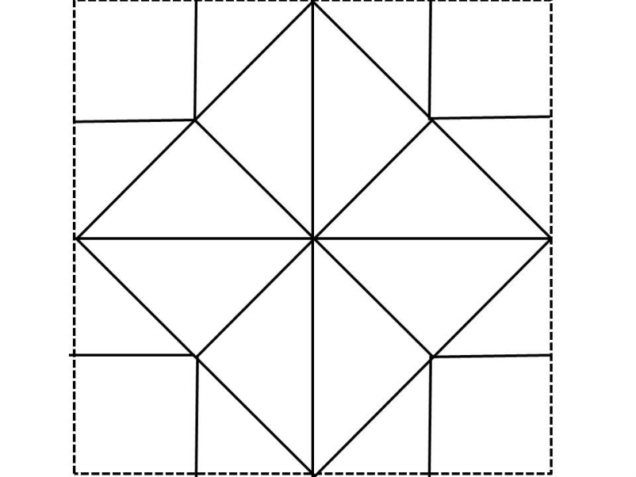

Yellow
Orange
Red
Blue
2
Feelings
3
Coping Skills
4
Feelings
1
Coping Skills
5
Coping Skills
6
Feelings
7
Coping Skills
8
Feelings

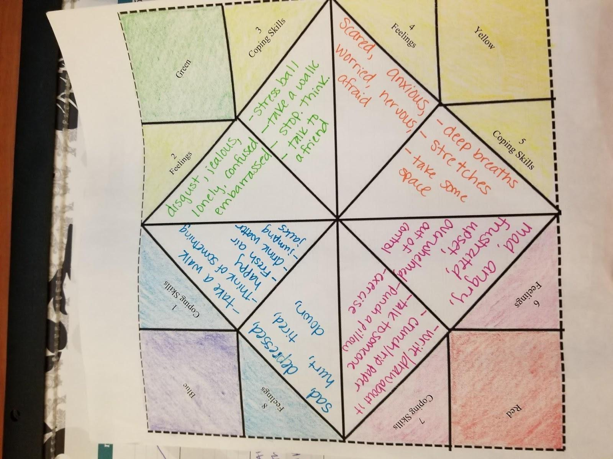

***The template follows the colors for Get to Green. This example picture does not. Change green to orange. Green is calm and represents where we want to be.

*Green has been changed to orange.

Alternative: fold along the dotted lines into a heart

