Self-Regulation/SEL

Flip Your Lid for 2nd

Purpose: To educate students on how their brain works and create a universal language among students and teachers for taking the emotional temperature.

Materials: This is part one of the SEL lessons; Settle Your Glitter comes second.
Bag of sugar/ some kind of model of the brain
Brain Poster: https://docs.google.com/presentation/d/1kMORCbVZK8_0095eilZHtJnklmhNxPyjpJMM2z55uwY/copy
Why Do We Lose Control of Our Emotions? Video https://www.youtube.com/watch?v=3bKuoH8CkFc
OR Your Fantastic Elastic Brain by JoAnn Deak (don’t read ALL the pages)
OR Even Superheroes Have Bad Days by Shelly Becker (TPT Extension activity: https://www.teacherspayteachers.com/Product/Superhero-Behavior-Classroom-Guidance-Lesson-Book-Companion-Activity-3724816?utm_source=CKBlog%20%7C%20Superheroes%20Bad%20Day&utm_campaign=Bad%20Day%20Lesson)
Optional: Flip Your Lid book https://www.teacherspayteachers.com/Product/Flipping-a-Lid-Brain-Activities-and-Lesson-4370860

Additional resources:
Brain Song: https://docs.google.com/presentation/d/1xhXc5aoUpg_LWz-SZ3-xppr5x7fC_vhOlBwlWthQ_iY/copy
Extension activities and parent handouts available for download from: https://www.mesquiteisd.org/resources-services/counseling-services/guidanceprogram/counseling-program/social-emotional-learning

Time:
Approximately 30 minutes

Focus:
Show students a bag of sugar or other model of the brain. Pass it around for them to feel how heavy it is. Tell them that their brain weighs 3lbs, about as much as the bag of sugar.

Lesson:
Tell students that their brain is responsible for everything about them: thinking, feeling, doing, hearing, seeing, touching, smelling, tasting. Tell students the brain can get stronger and faster like muscles. You can give your brain a workout, training your brain to grow and learn new things! The more you try, the more you make mistakes, and the more your brain grows!

Review the brain hand signal (see pic below): thinking brain (prefrontal cortex) where we make decisions, feeling brain (amygdala) where our fight/flight/freeze response and emotions are. You can use the Brain Poster and give the teacher a copy. Describe what happens when we “flip our lid”. Show students the hand signal at different levels (partially open, mostly open, all the way open).

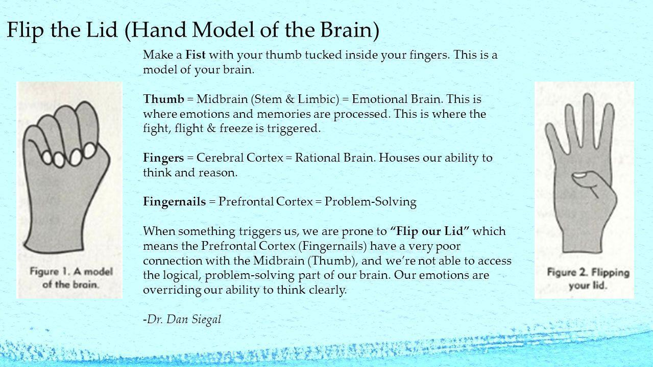

Show the video "Why Do We Lose Control of Our Emotions", read Fantastic Elastic Brain or Even Superheroes Have Bad Days. Model the brain hand signal as you watch/read.

Closure:
Have students share or write one thing they have flipped their lid over.
Have them practice taking their brain’s temperature by showing the hand signal.

Extension:
Sing the Brain Song.
Even Superheroes have bad days: Use activities from TPT linked at the top.
Send home parent brain infographic.

