Self-Regulation/SEL

Flip Your Lid for 1st

Purpose: To educate students on how their brain works and create a universal language among students and teachers for taking the emotional temperature.

Materials: This is part one of the SEL lessons; Settle Your Glitter comes second
Bag of sugar/ some kind of model of the brain
Dog finger puppet (Not for student viewing: video of a counselor modeling this starts at minute 4 https://drive.google.com/file/d/0Bx78wF2y-BzCTXc3VmtLbkZzb1E/view?usp=sharing )
Brain Poster: https://docs.google.com/presentation/d/1kMORCbVZK8_0095eilZHtJnklmhNxPyjpJMM2z55uwY/copy
In My Heart: A Book About Feelings by Jo Witek OR Puppy Mind by Andrew Jordan Nance https://www.youtube.com/watch?v=Xd7Cr265zgc (Puppy Mind Activity Extension: https://www.teacherspayteachers.com/Product/Puppy-Mind-Mindfulness-Activities-To-Help-With-Self-Control-And-Staying-Focused-3854402?st=42e1b738dc97d7c0b7008334a6cc11e1 )
Optional: Flip Your Lid book https://www.teacherspayteachers.com/Product/Flipping-a-Lid-Brain-Activities-and-Lesson-4370860

Additional resources:
Brain Song: https://docs.google.com/presentation/d/1xhXc5aoUpg_LWz-SZ3-xppr5x7fC_vhOlBwlWthQ_iY/copy
Extension activities and parent handouts available for download from: https://www.mesquiteisd.org/resources-services/counseling-services/guidanceprogram/counseling-program/social-emotional-learning

Time:
Approximately 20-30 minutes

Focus:
Show students a bag of sugar or other brain model. Pass it around for them to feel how heavy it is. Tell them that their brain weighs 3lbs, about as much as the bag of sugar.

Lesson:
Tell students that their brain is responsible for everything about them: thinking, feeling, doing, hearing, seeing, touching, smelling, tasting. Tell students the brain can get stronger and faster like muscles. You can work out your brain and train your brain to grow and learn new things! The more you try, the more you make mistakes, the more your brain grows!

Show students the brain poster and point out the areas.

Teach children the brain hand signal (see pic below): thinking brain aka the doghouse (prefrontal cortex) where we make decisions and our dog feels safe, feeling brain aka dog (amygdala) where our fight/flight/freeze response and emotions are. Describe what happens when we “flip our lid” and our dog comes out of our doghouse. Show students the hand signal at different levels (partially open, mostly open, all the way open).

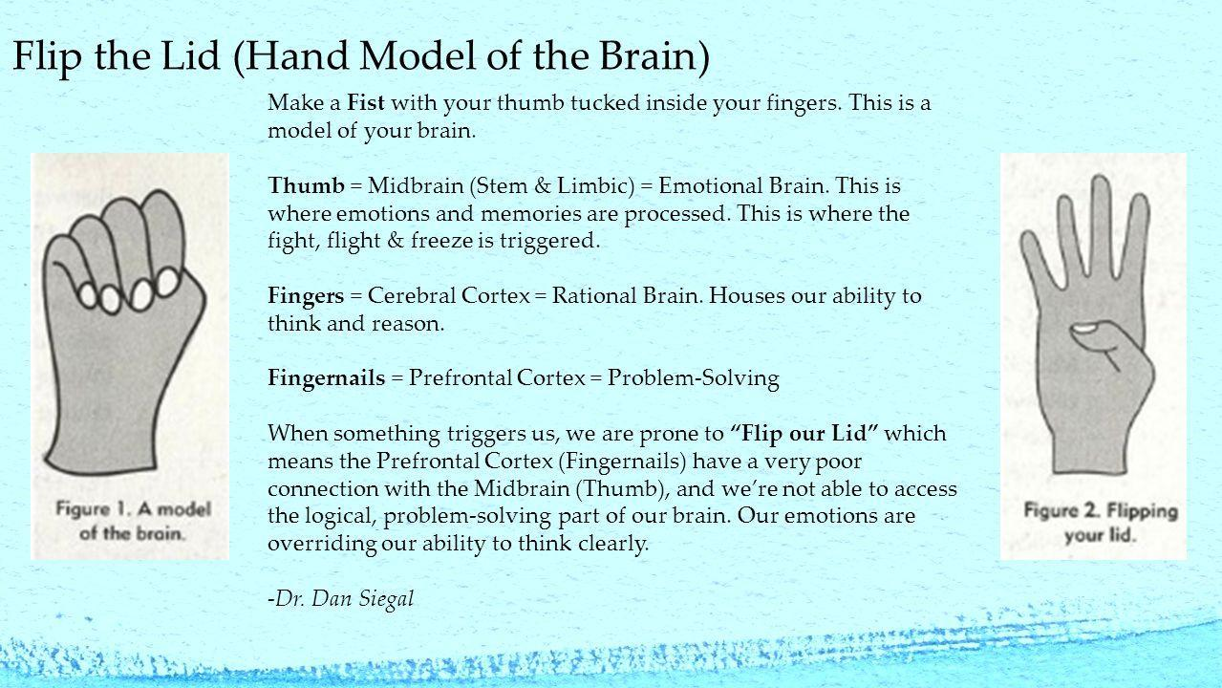

Tell students that their brain is responsible for everything about them: thinking, feeling, doing.
Read In My Heart: A Book About Feelings by Jo Witek OR Puppy Mind by Andrew Jordan Nance. During or after reading have students relate the hand brain model to the story.

Closure:
Have them practice taking their brain’s temperature by showing the hand signal.

Extension:
Teach the Brain Song.
Puppy Mind: Use activities from TPT linked at the top.
In My Heart: Give each student a heart template and let them choose a color or colors to describe what they are feeling that day.
Send home parent brain infographic.

