Self-Regulation/SEL

Flip Your Lid for Kinder

Purpose: To educate students on how their brain works and create a universal language among students and teachers for taking the emotional temperature.

Materials: This is part one of the SEL lessons; Settle Your Glitter comes second
Bag of sugar/ some kind of model of the brain
Dog finger puppet (Not for student viewing: video of a counselor modeling this starts at minute 4 https://drive.google.com/file/d/0Bx78wF2y-BzCTXc3VmtLbkZzb1E/view )
Brain Poster: https://docs.google.com/presentation/d/1kMORCbVZK8_0095eilZHtJnklmhNxPyjpJMM2z55uwY/copy
Shrek Video https://www.youtube.com/watch?v=6I5B0jyLBUg
Optional: Flip Your Lid book https://www.teacherspayteachers.com/Product/Flipping-a-Lid-Brain-Activities-and-Lesson-4370860
Optional: Cookie Monster Me Want It video https://youtu.be/9PnbKL3wuH4

Additional resources:
Brain Song: https://docs.google.com/presentation/d/1xhXc5aoUpg_LWz-SZ3-xppr5x7fC_vhOlBwlWthQ_iY/copy
Extension activities and parent handouts available for download from: https://www.mesquiteisd.org/resources-services/counseling-services/guidanceprogram/counseling-program/social-emotional-learning

Time:
Approximately 15 minutes

Focus:
Show students a bag of sugar or other model of the brain. Pass it around for them to feel how heavy it is. Tell them that their brain weighs 3lbs, about as much as the bag of sugar.

Lesson:
Tell students that their brain is responsible for everything about them: thinking, feeling, doing, hearing, seeing, touching, smelling, tasting. Tell students the brain can get stronger and faster like muscles. You can work out your brain and train your brain to grow and learn new things! The more you try, the more you make mistakes, the more your brain grows!

Show students the brain poster and point out the areas.

Teach children the brain hand signal (see pic below): thinking brain aka the doghouse (prefrontal cortex) where we make decisions and our dog feels safe, feeling brain aka dog (amygdala) where our fight/flight/freeze response and emotions are. Describe what happens when we “flip our lid” and our dog comes out of our doghouse. Show students the hand signal at different levels (partially open, mostly open, all the way open).
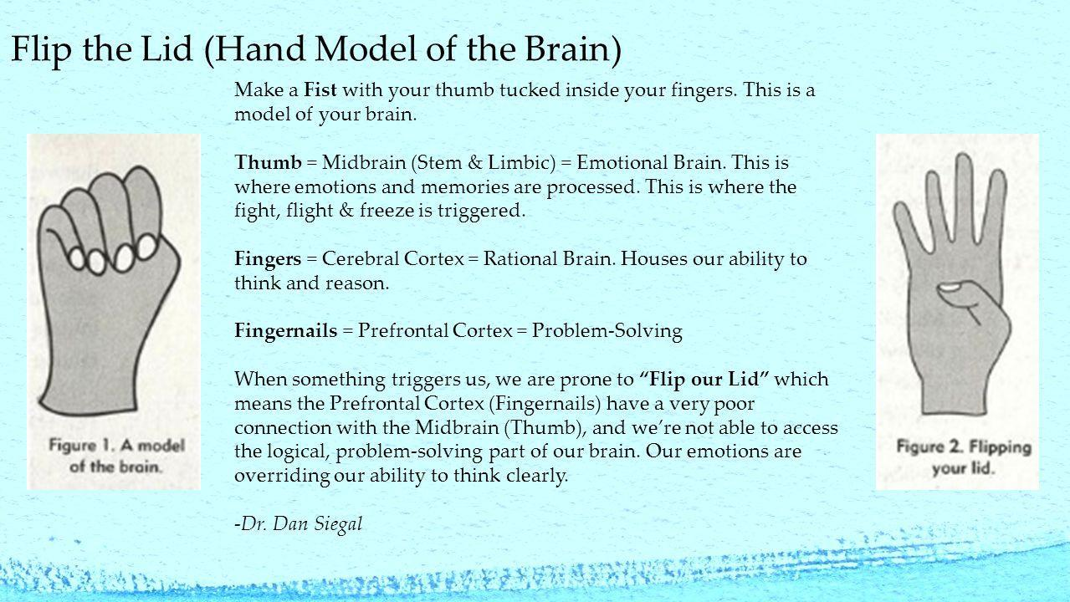

Talk about paying attention to the signs that our brains are about to flip our lid.

Before viewing the video, tell students that we are going to be watching Shrek at his kids’ birthday party. Ask them to watch Shrek as everything happens around him. Show the video.

After the video, ask, “What did you notice about Shrek? Did his body change? Did his voice change? What happened when Shrek got frustrated?”. Allow kids to answer each question and begin discussing our brains with the idea of “Flipping Your Lid”. Shrek flipped his lid because he became frustrated and angry. This is what happens to us when we get frustrated or angry. Sometimes we respond in a scary or harmful way.

Closure:
Have them practice taking their brain’s temperature by showing the hand signal. Say, “How’s your brain?!” and have kids show the signal. Repeat. OR close with the Cookie Monster Me Want It video.

Extension:
Teach the Brain Song.
Send home the parent infographic.

