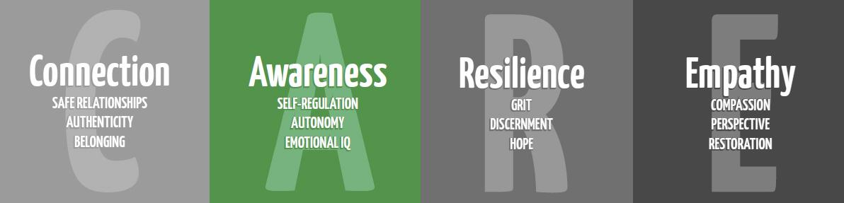

Self-Regulation

Flip Your Lid for Pre-K

Purpose: To educate students on things inside and outside of their control, and to teach self-regulation (SEL), managing emotions, problem solving, and coping skills in unfavorable circumstances.

Materials: This is part one of the SEL lessons; Settle Your Glitter comes second
Bag of sugar/ some kind of model of the brain
Dog finger puppet (Not for student viewing: video of a counselor modeling this starts at minute 4 https://drive.google.com/file/d/0Bx78wF2y-BzCTXc3VmtLbkZzb1E/view?usp=sharing)
Brain Poster: https://docs.google.com/presentation/d/1kMORCbVZK8_0095eilZHtJnklmhNxPyjpJMM2z55uwY/copy
Puppy Mind by Andrew Jordan Nance https://www.youtube.com/watch?v=Xd7Cr265zgc
OR Color Monster by Anna Llenas (The Color Monster Book Companion: https://www.teacherspayteachers.com/Product/The-Color-Monster-A-Book-Companion-2553231 )
Optional: Flip Your Lid book https://www.teacherspayteachers.com/Product/Flipping-a-Lid-Brain-Activities-and-Lesson-4370860
Optional: Cookie Monster Me Want It video https://youtu.be/9PnbKL3wuH4

Additional resources:
Brain Song: https://docs.google.com/presentation/d/1xhXc5aoUpg_LWz-SZ3-xppr5x7fC_vhOlBwlWthQ_iY/copy
Extension activities and parent handouts available for download from: https://www.mesquiteisd.org/resources-services/counseling-services/guidanceprogram/counseling-program/social-emotional-learning

Time:
15 minutes

Focus:
Show students a bag of sugar or other model of the brain. Pass it around for them to feel how heavy it is. Tell them that their brain weighs 3lbs, about as much as the bag of sugar.

Lesson:
Tell students that their brain is responsible for everything about them, even feelings! “What are feelings? Can you tell me some feelings that you know?” See what feelings they share out or give them a few examples.
Use the hand model of the brain (See below) and explain using the dog finger puppet. You can use a visual model from the Flip Your Lid book from Teachers Pay Teachers resource linked above or the brain poster linked above. The hand model will allow kids to have a common language and portable example of flipping a lid.

**For Pre-K 4 teach the flip your lid. For Pre-K 3 skip this part.** Teach children the brain hand signal (see pic below): thinking brain aka the doghouse (prefrontal cortex) where we make decisions and our dog feels safe, feeling brain aka dog (amygdala) where our fight/flight/freeze response and emotions are. Describe what happens when we “flip our lid” and our dog comes out of our doghouse. Show students the hand signal at different levels (partially open, mostly open, all the way open).

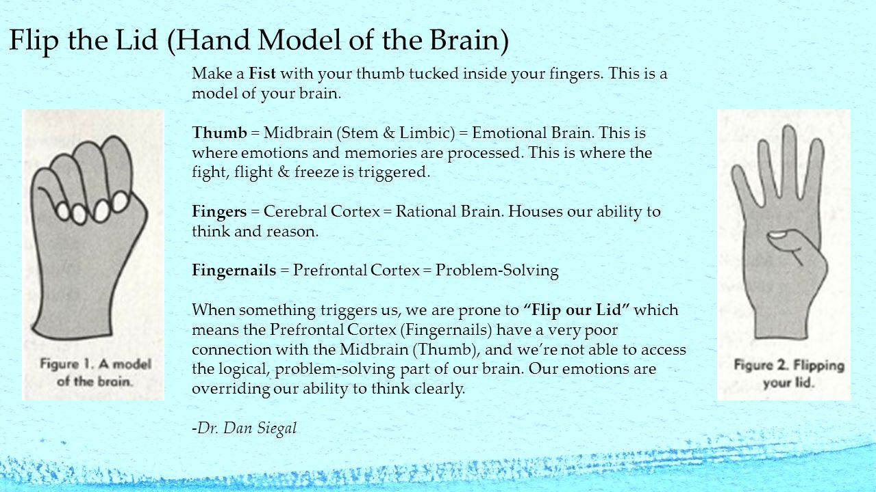

Read/watch the video for Puppy Mind or The Color Monster.

Closure:
Ask to show a calm brain (hand model) and a flipped lid (hand model). Have them practice showing the hand model.

Extension:
Teach the Brain Song (link above). Or use TPT book companion for Color Monster. Or show Cookie Monster Me Want It video.
Send home parent infographic.

