Utah’s English Language Arts Essential Standards – Secondary

The purpose of these essential standards is to provide educators with a prioritized list of standards to focus on during COVID-19. While all standards have value, COVID-19 may limit instructional hours. The essential standards identify the main standard with the understanding that all substandards (see example below) will be included and taught during instructional time. These essential standards are critical for future literacy development. While these are the essential standards, if there is more instructional time, the recommendation is to extend the instructional focus to all standards.
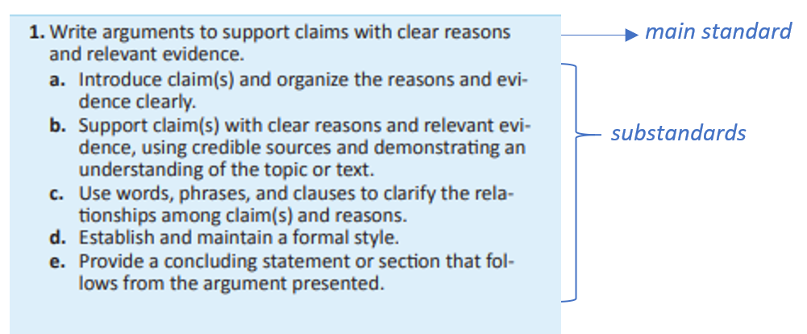

6th | 7th | 8th | 9th & 10th | 11th & 12th
READING LITERATURE AND READING INFORMATIONAL TEXT
RL.6.1 & RI.6.1  Cite textual evidence to support analysis of what the text says explicitly as well as inferences drawn from the text | RL.7.1 & RI.7.1  Cite several pieces of textual evidence to support analysis of what the text says explicitly as well as inferences drawn from the text; provide an objective summary of the text. | RL.8.1 & RI.8.1  Cite the textual evidence that most strongly supports an analysis of what the text says explicitly as well as inferences drawn from the text. | RL & RI.9/10.1  Cite strong and thorough textual evidence to support analysis of what the text says explicitly as well as inferences drawn from the text. | RL & RI.11/12.1  Cite strong and thorough textual evidence to support analysis of what the text says explicitly as well as inferences drawn from the text, including determining where the text leaves matters uncertain.
RL & RI.6.2  Determine a theme or central idea of a text and how it is conveyed through particular details; provide a summary of the text distinct from personal opinions or judgments | RL.7.2  Determine a theme or central idea of a text and analyze its development over the course of the text; provide an objective summary of the text. | RL.8.2  Determine a theme or central idea of a text and analyze its development over the course of the text, including its relationship to the characters, setting, and plot; provide an objective summary of the text. | RL.9/10.2 Determine a central idea of a text and analyze its development over the course of the text, including how it emerges and is shaped and refined by specific details; provide an objective summary of the text. | RL.11/12.2  Determine two or more central ideas of a text and analyze their development over the course of the text, including how they interact and build on one another to provide a complex analysis; provide an objective summary of the text.
RL & RI.6.10  By the end of the year, read and comprehend literature and informational texts in the grades 6–8 text complexity band proficiently, with scaffolding as needed at the high end of the range. | RL &.RI 7.10  By the end of the year, read and comprehend literature and informational texts in the grades 6–8 text complexity band proficiently, with scaffolding as needed at the high end of the range. | RL & RI.8.10  By the end of the year, read and comprehend literature and informational texts in the grades 6–8 text complexity band proficiently, with scaffolding as needed at the high end of the range. | RL & RI.9/10.10  By the end of the year, read and comprehend literature and informational texts in the grades 9-10 text complexity band proficiently, with scaffolding as needed at the high end of the range. | RL & RI.11/12.10  By the end of the year, read and comprehend literature and informational texts in the grades 11-12 text complexity band proficiently, with scaffolding as needed at the high end of the range.
WRITING
W.6.1  Write arguments to support claims with clear reasons and relevant evidence. | W.7.1  Write arguments to support claims with clear reasons and relevant evidence. | W.8.1  Write arguments to support claims with clear reasons and relevant evidence. | W.9/10.1  Write arguments to support claims in an analysis of substantive topics or texts, using valid reasoning and relevant and sufficient evidence. | W.11/12.1  Write arguments to support claims in an analysis of substantive topics or texts, using valid reasoning and relevant and sufficient evidence.
W.6.2  Write informative/explanatory texts to examine a topic and convey ideas, concepts, and information through the selection, organization, and analysis of relevant content. | W.7.2  Write informative/explanatory texts to examine a topic and convey ideas, concepts, and information through the selection, organization, and analysis of relevant content. | W.8.2  Write informative/explanatory texts to examine a topic and convey ideas, concepts, and information through the selection, organization, and analysis of relevant content. | W.9/10.2  Write informative/explanatory texts to examine and convey complex ideas, concepts, and information clearly and accurately through the effective selection, organization, and analysis of content. | W.11/12.2  Write informative/explanatory texts to examine and convey complex ideas, concepts, and information clearly and accurately through the effective selection, organization, and analysis of content.
W.6.9  Draw evidence from literary or informational texts to support analysis, reflection, and research. | W.7.9  Draw evidence from literary or informational texts to support analysis, reflection, and research. | W.8.9  Draw evidence from literary or informational texts to support analysis, reflection, and research. | W.9/10.9  Draw evidence from literary or informational texts to support analysis, reflection, and research. | W.11/12.9  Draw evidence from literary or informational texts to support analysis, reflection, and research
W.6.10  Write routinely over extended time frames (time for research, reflection, and revision) and shorter time frames (a single sitting or a day or two) for a range of discipline-specific tasks, purposes, and audiences. | W.7.10  Write routinely over extended time frames (time for research, reflection, and revision) and shorter time frames (a single sitting or a day or two) for a range of discipline-specific tasks, purposes, and audiences. | W.8.10  Write routinely over extended time frames (time for research, reflection, and revision) and shorter time frames (a single sitting or a day or two) for a range of discipline-specific tasks, purposes, and audiences. | W.9/10.10  Write routinely over extended time frames (time for research, reflection, and revision) and shorter time frames (a single sitting or a day or two) for a range of discipline-specific tasks, purposes, and audiences. | W.11/12.10  Write routinely over extended time frames (time for research, reflection, and revision) and shorter time frames (a single sitting or a day or two) for a range of discipline-specific tasks, purposes, and audiences.
SPEAKING AND LISTENING
SL.6.1  Engage effectively in a range of collaborative discussions (one-on-one, in groups, and teacher-led) with diverse partners on grade 6 topics, texts, and issues, building on others’ ideas and expressing their own clearly | SL.7.1  Engage effectively in a range of collaborative discussions (one-on-one, in groups, and teacher-led) with diverse partners on grade 7 topics, texts, and issues, building on others' ideas and expressing their own clearly. | SL.8.1  Engage effectively in a range of collaborative discussions (one-on-one, in groups, and teacher-led) with diverse partners on grade 8 topics, texts, and issues, building on others' ideas and expressing their own clearly. | SL.9/10.1  Initiate and participate effectively in a range of collaborative discussions (one-on-one, in groups, and teacher-led) with diverse partners on grades 9–10 topics, texts, and issues, building on others’ ideas and expressing their own clearly and persuasively. | SL.11/12.1  Initiate and participate effectively in a range of collaborative discussions (one-on-one, in groups, and teacher-led) with diverse partners on grades 11–12 topics, texts, and issues, building on others’ ideas and expressing their own clearly and persuasively.
LANGUAGE
L.6.1  Demonstrate command of the conventions of standard English grammar and usage when writing or speaking. | L.7.1  Demonstrate command of the conventions of standard English grammar and usage when writing or speaking. | L.8.1  Demonstrate command of the conventions of standard English grammar and usage when writing or speaking. | L.9/10.1  Demonstrate command of the conventions of standard English grammar and usage when writing or speaking. | L.11/12.1  Demonstrate command of the conventions of standard English grammar and usage when writing or speaking
L.6.6  Acquire and use accurately grade-appropriate general academic and domain-specific words and phrases; gather vocabulary knowledge when considering a word or phrase important to comprehension or expression. | L.7.6  Acquire and use accurately grade-appropriate general academic and domain-specific words and phrases; gather vocabulary knowledge when considering a word or phrase important to comprehension or expression | L.8.6  Acquire and use accurately grade-appropriate general academic and domain-specific words and phrases; gather vocabulary knowledge when considering a word or phrase important to comprehension or expression | L.9/10.6  Acquire and use accurately general academic and domain-specific words and phrases, sufficient for reading, writing, speaking, and listening at the college and career readiness level; demonstrate independence in gathering vocabulary knowledge when considering a word or phrase important to comprehension or expression. | L.11/12.6  Acquire and use accurately general academic and domain-specific words and phrases, sufficient for reading, writing, speaking, and listening at the college and career readiness level; demonstrate independence in gathering vocabulary knowledge when considering a word or phrase important to comprehension or expression.

