How to Change Smoke Alarm Batteries

https://www.homedepot.com/c/ah/how-to-change-smoke-alarm-batteries/9ba683603be9fa5395fab90146fd9422

- TIME REQUIRED: Under 2 hours
- DIFFICULTY: Beginner

Knowing how to change a smoke alarm battery is essential to maintaining a safe home. If your smoke alarm starts “chirping” or giving off short “beeps,” it usually needs a new battery change. The first step in learning how to change a smoke detector battery is determining which type of alarm you have. Battery smoke detectors run solely on batteries. Hardwired smoke detectors run on electricity, but they also have a backup battery for power outages. When you hear a hard-wired smoke detector beeping, it means you need to replace its battery. This Home Depot guide gives instructions on how to change a smoke detector battery and how to turn off a smoke alarm.

1
Remove Cover
Most smoke detectors twist open, but some models have a plastic lock you open with a screwdriver, while others need to be popped open using your fingers. See your user’s manual for specific instructions on how your model works.
Tip: Before working on a hard-wired smoke detector, turn off the main power at your circuit breaker to avoid electrical shock.

2
Replace Battery
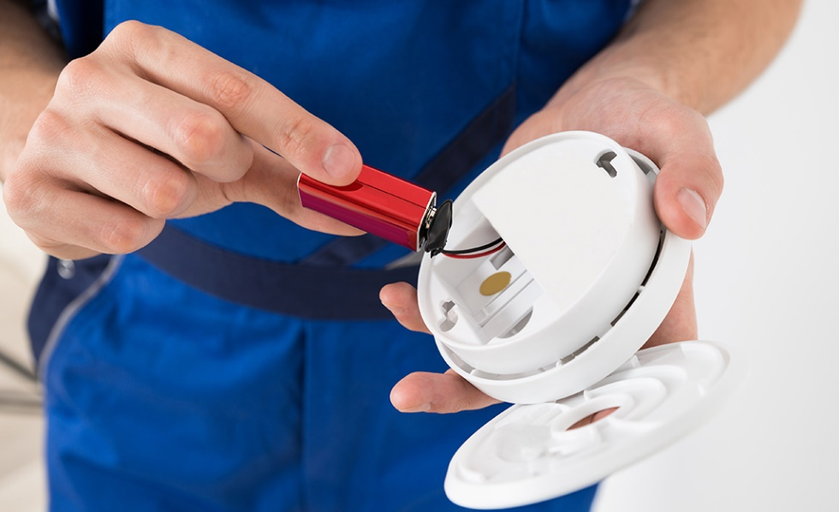
Once you remove the cover of the detector, it's easy to see how to change a smoke alarm battery. Simply remove the old battery and install the new one. Make sure the negative and positive connections match the labels in the smoke detector.

Tip: Many smoke and carbon monoxide detectors use a 9v battery but some use lithium batteries that can last for ten years.

3
Test Smoke Alarm
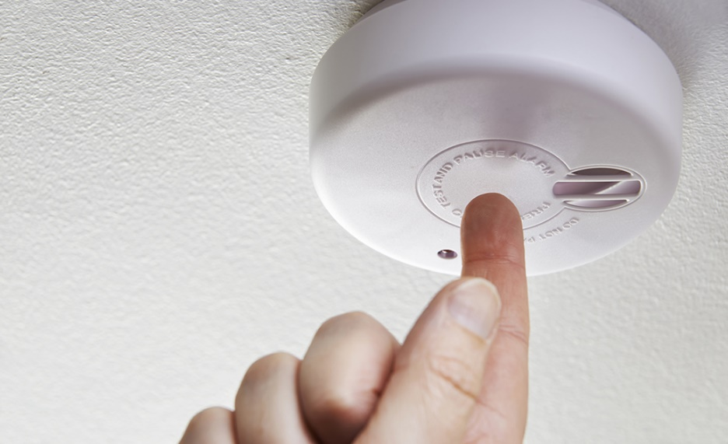
Before you finish re-installing the smoke detector, make sure its new battery or batteries work. Locate the test button and press it for a few seconds to engage the test.
- If your test alarm doesn’t sound, check battery connections and try different batteries.
- If your smoke alarm fails the test with new batteries, then you need to replace your smoke detector.

Tip: Be safe. Do not re-install your smoke alarm unless you are sure it is working properly.

4
Smoke Alarm Tips
- Fire safety experts recommend you replace your smoke alarm battery two times a year. A good rule of thumb is to change it when the clocks change in the fall and spring. Or, set a calendar reminder for when to change your smoke alarm batteries.
- Replace the backup battery in a hard-wire unit yearly whether it beeps or not.
- Mark the date you changed your battery on the inside of the smoke alarm.
- Buy a new smoke detector or smoke alarm every 10 years. After 10 years, smoke alarms expire. You can calculate the expiration date by looking on the back of the device to see the manufacture date.
- Check your smoke detectors, CO alarms and fire extinguishers at least once a year to ensure they are up-to-date.
- It's recommended you place smoke detectors inside each bedroom, right outside sleeping areas, on every level of your home, in the living room and near stairwells.
Following these steps will make your home more secure in case of a fire. Keeping your smoke alarm up-to-date, as well as making sure the batteries work, will ensure your home remains safe.

