**Secondary Guidance Lesson**

*Holiday Blues*

**Objective:** To help students recognize, avoid and/or cope with the holiday blues.

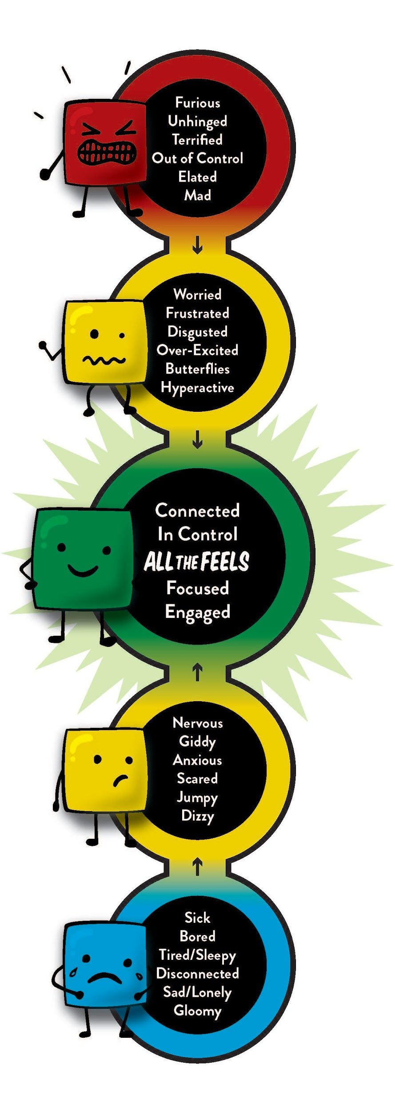

**Video**: <https://youtu.be/lawjtCcC_og>

**Activity:**

**Group Discussion Questions:**

What is your favorite part of the holidays?

Describe what it means to feel blue?

How do you know if you are feeling blue?

What are things you can do to go from blue to green?

Mindfulness and breathing

Exercise

Talking to someone

Who are some people you can talk to?

**Follow-up/Closing:**

Write a note to yourself with reminders of what your favorite parts of the holidays are and ways that you will cope with the holiday blues if you experience them. Include a list of things that you are grateful for and refer back to this list if you start feeling blue during the school break. Also, include your list of people you can call, text or reach out to if you need to talk to someone.