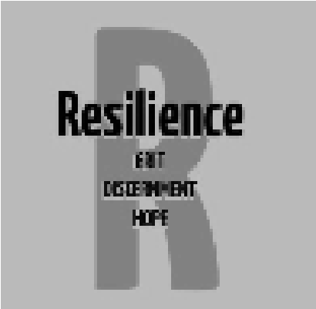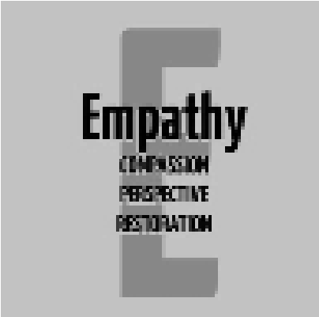
Secondary Guidance Lesson
Adult/Student Interaction

Objective: To identify with situations that involve student and adult interactions. To introduce alternative approaches to assist in a positive outcome.

Video:​ https://youtu.be/rUDBsCw4SRw

Activity:
- First, think of an interaction that you have experienced or observed, involving a student and an adult, that you felt could have been handled differently.

- Next, come up with alternative ways that the situation could have gone differently.​

- Finally, discuss what outcomes you would like to see in those situations.

Follow-up/Closing:

When a teacher, administrator, custodian, security guard, counselor, or substitute gives you a directive, simply comply immediately. If you feel that you have an extenuating circumstance, (perhaps a family emergency and need to keep your phone close) ask to speak to the adult privately.

Mutual respect between students and adults is the key. There are times when emotions can be overwhelming

