# 

# Step 1: Log in to system.

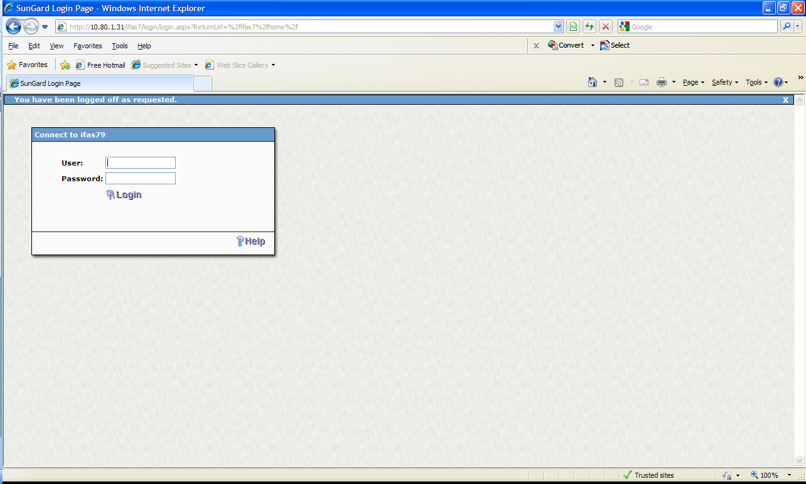

**Enter: User ID & Password**

***Note: You will be directed to the Home Tab. See below.***

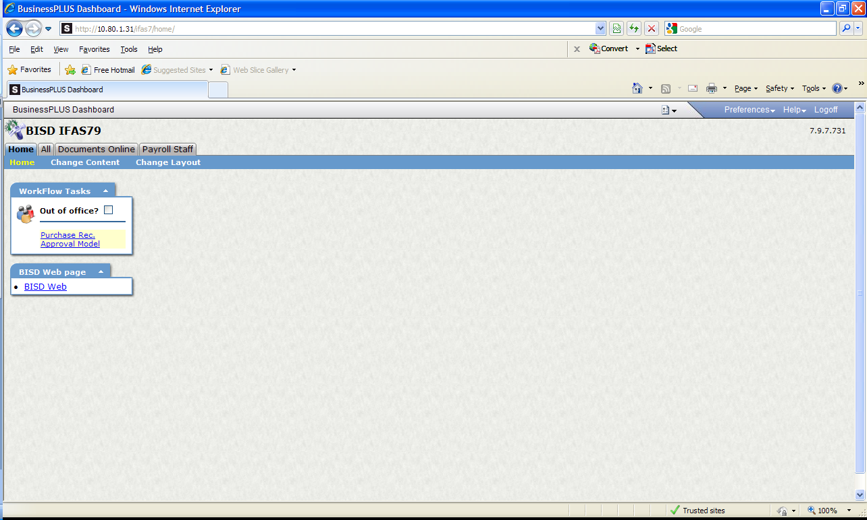

**Select: All Tab**

***Selections under “All” tab will be visible. See next screen.***

# Step 2: Access SunGard Task List Screen

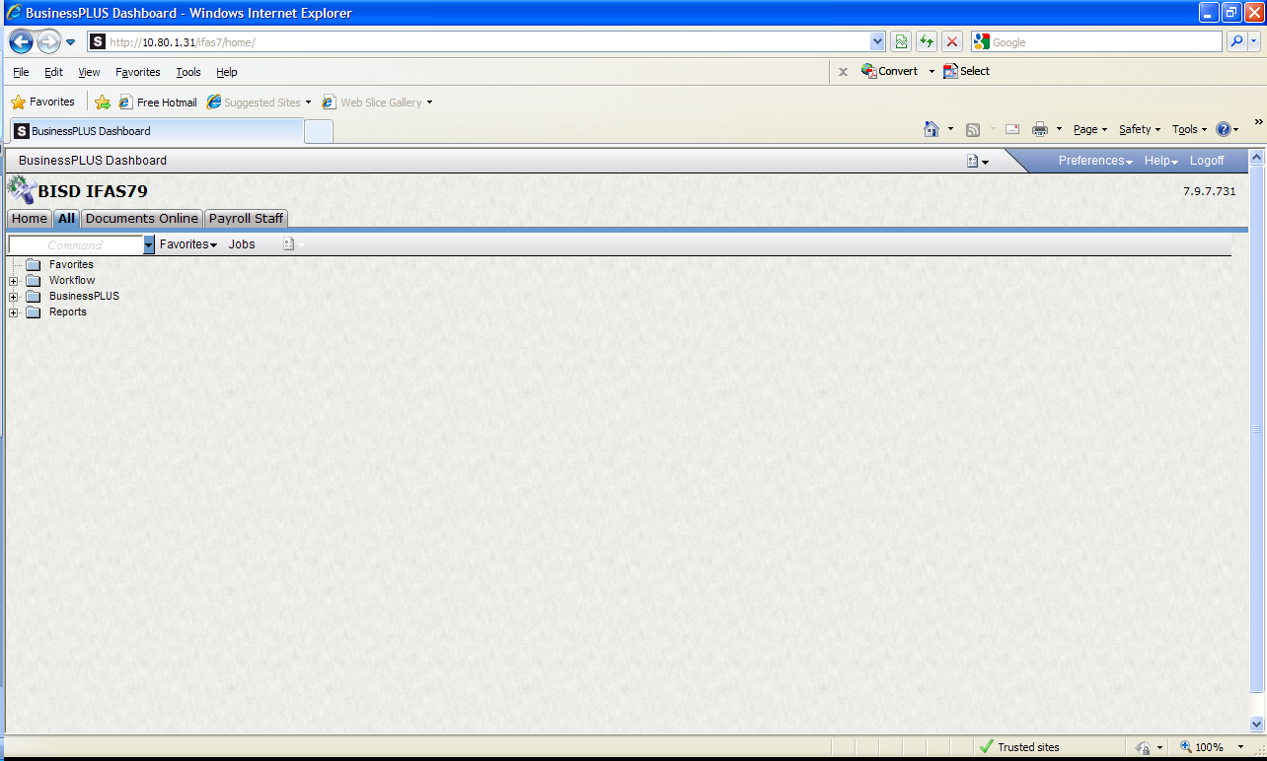

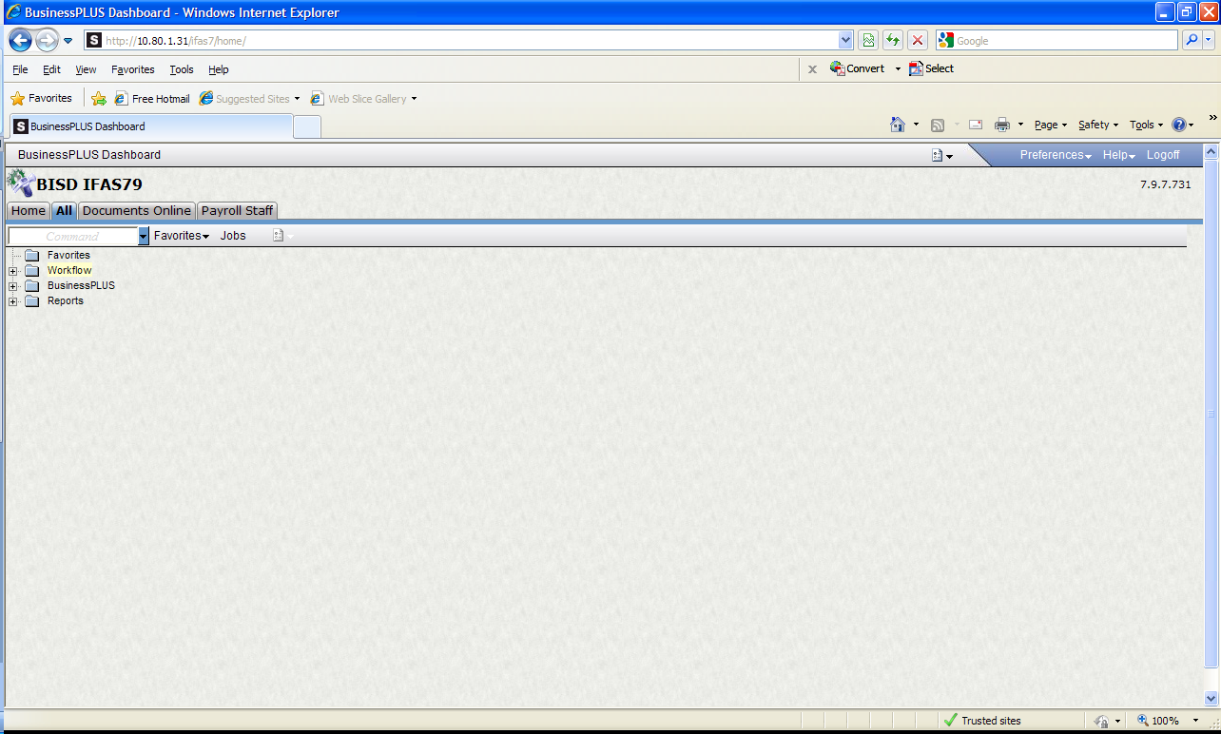

**Click: “+” Workflow Folder**

***Note: Tree Selection will expand.***

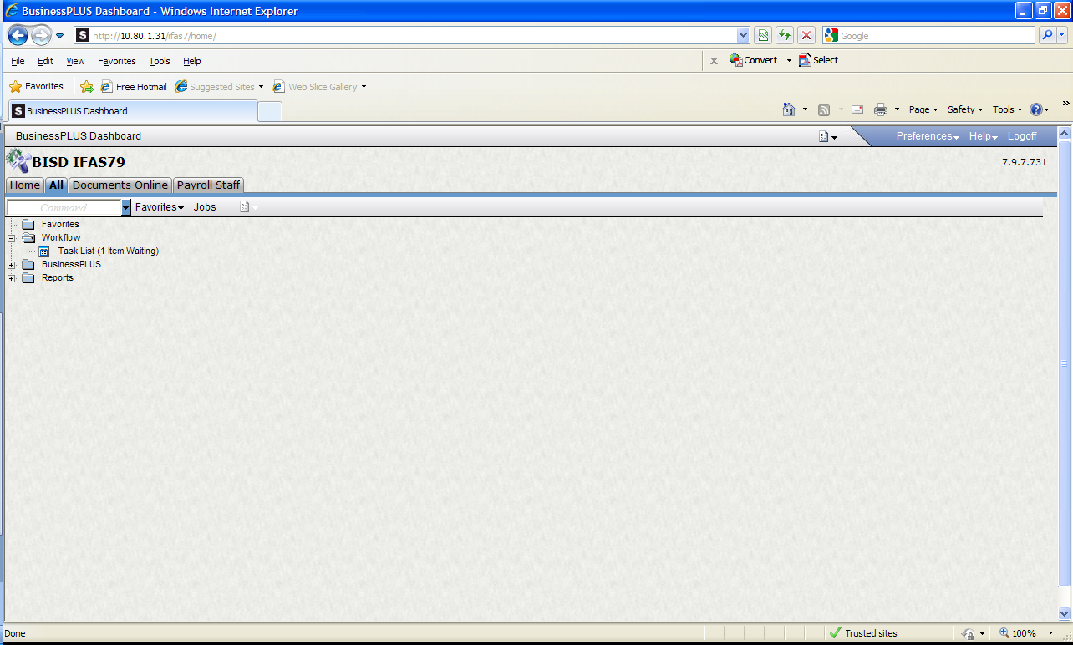

**Click: Task List Note: In parenthesis you will find # of items pending approval (Ex: 1 Item Waiting)**

***SunGard Task List Screen will populate.***

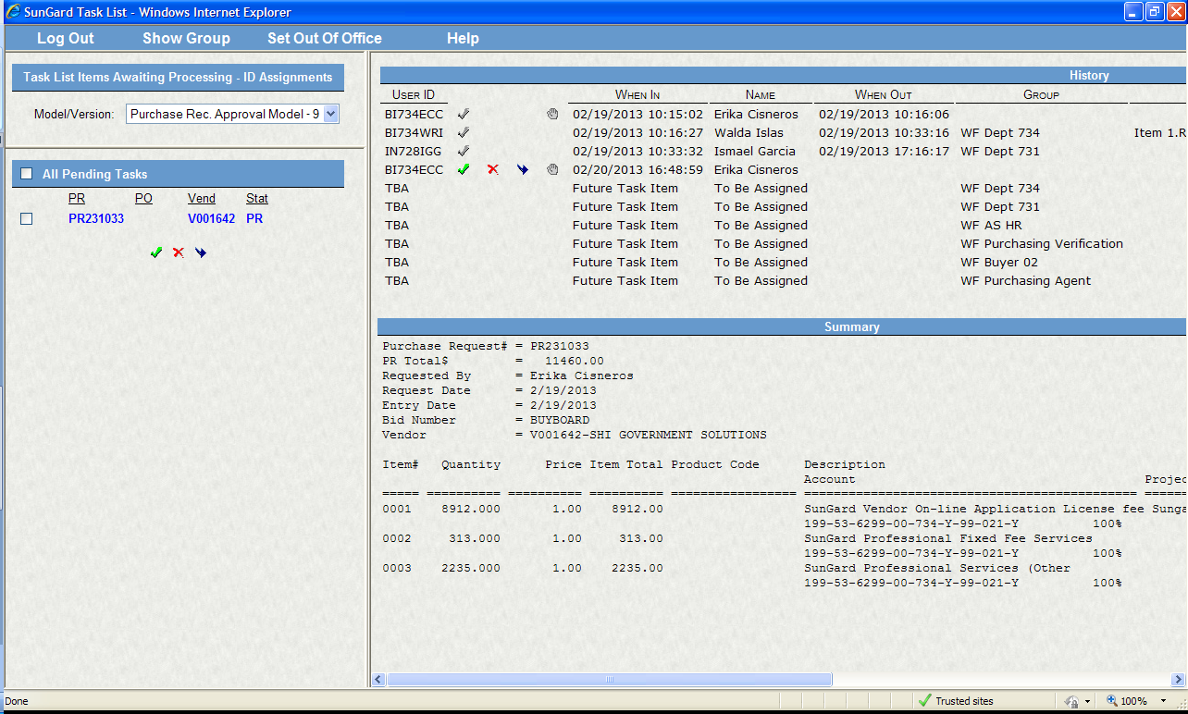

**A list of Pending PRs will be viewable here.**

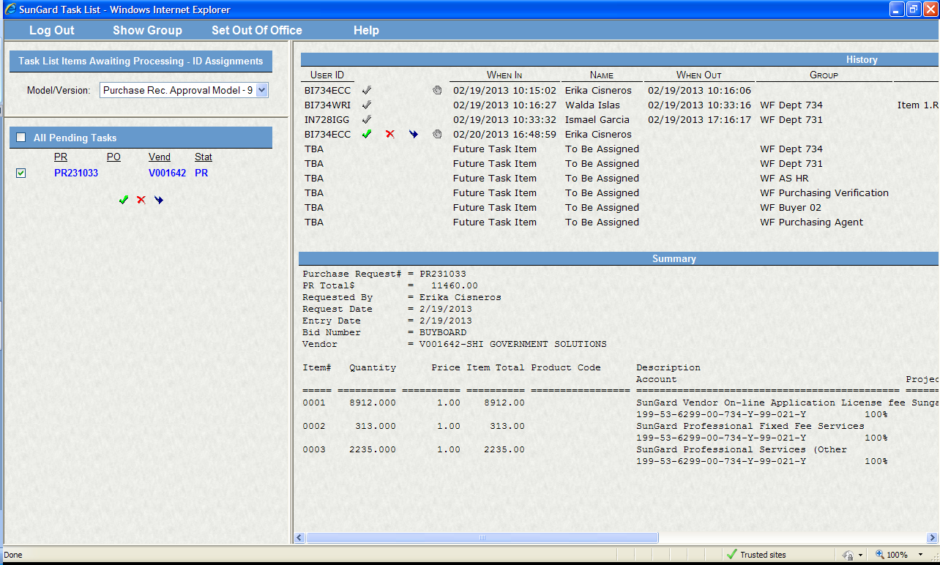

**If multiple PRs; click to input check mark to view details of the PR**



**Details of Workflow status**



**A summary w/details of the Purchase Requisition**

***Note: Verify the information prior to approving.***



**There are two options to approve PR; click either one of the green check marks.**

# Step 3: Approve Purchase Requisition

**1st Option below.**



**Click green check mark to approve.**

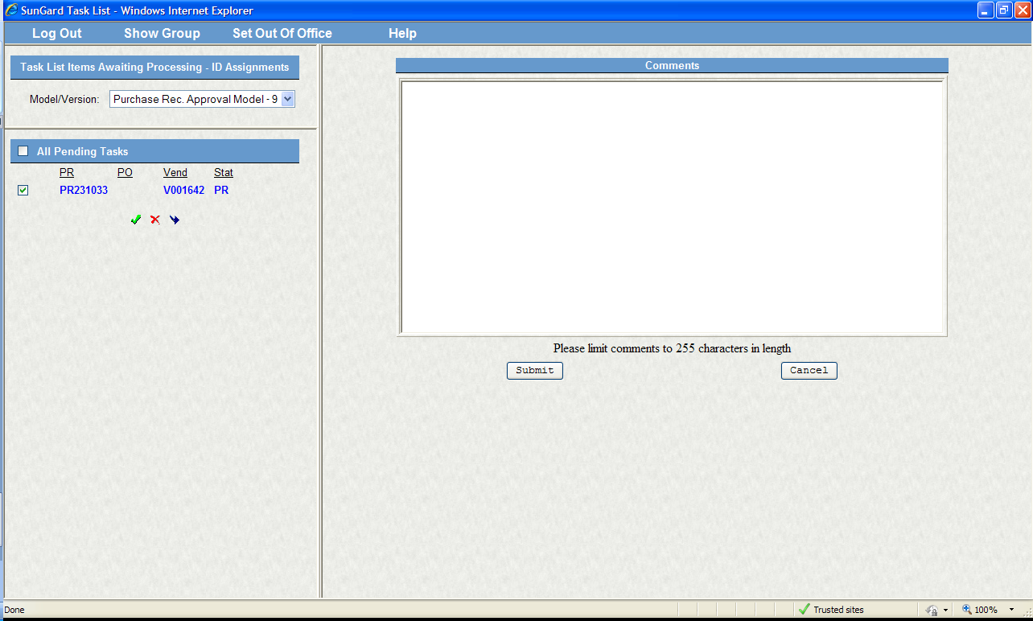

**Comments Screen will open. Space is available for any comments to the approvers.**

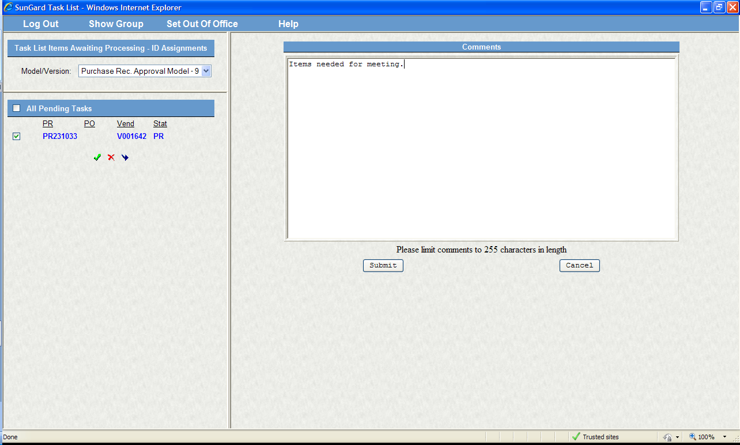

**NOTE: DO NOT** USE SPECIAL CHARACTERS! SUCH AS: #, &, $, @, *,% etc…PR WILL NOT GO THRU!

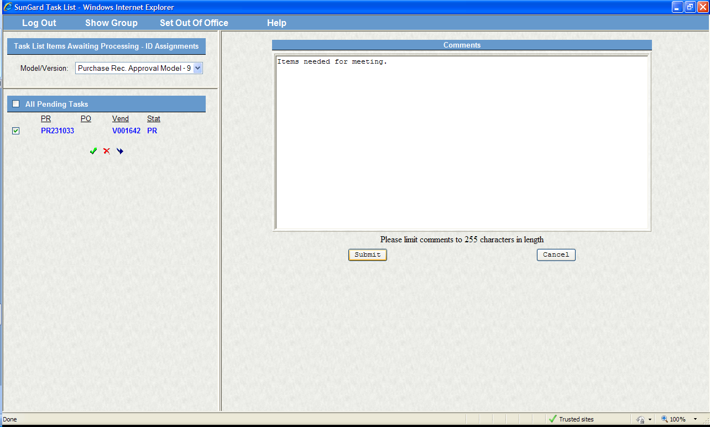

**Click: Submit**

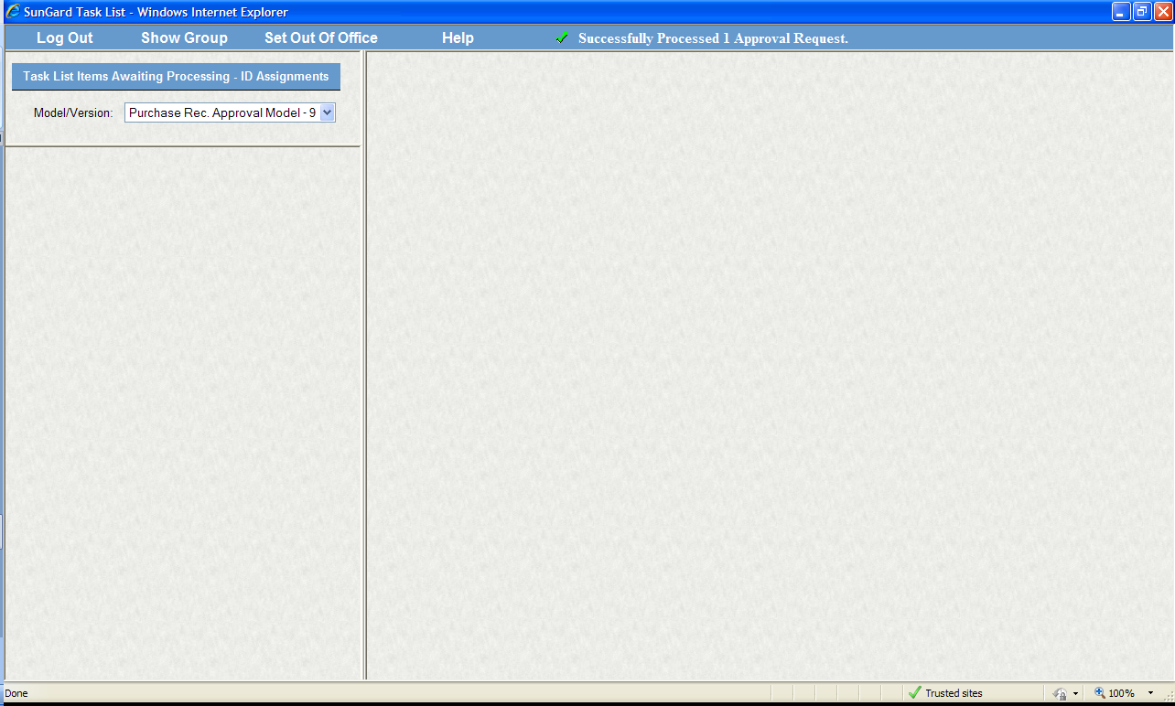

**The following message will appear as confirmation that you have successfully approved PR.**

**2nd Option below.**

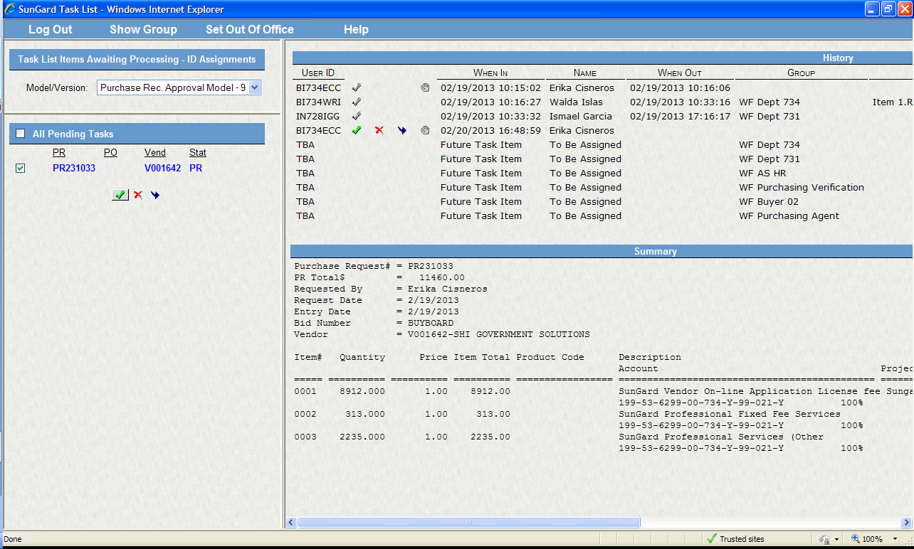

**Click green check mark to approve.**

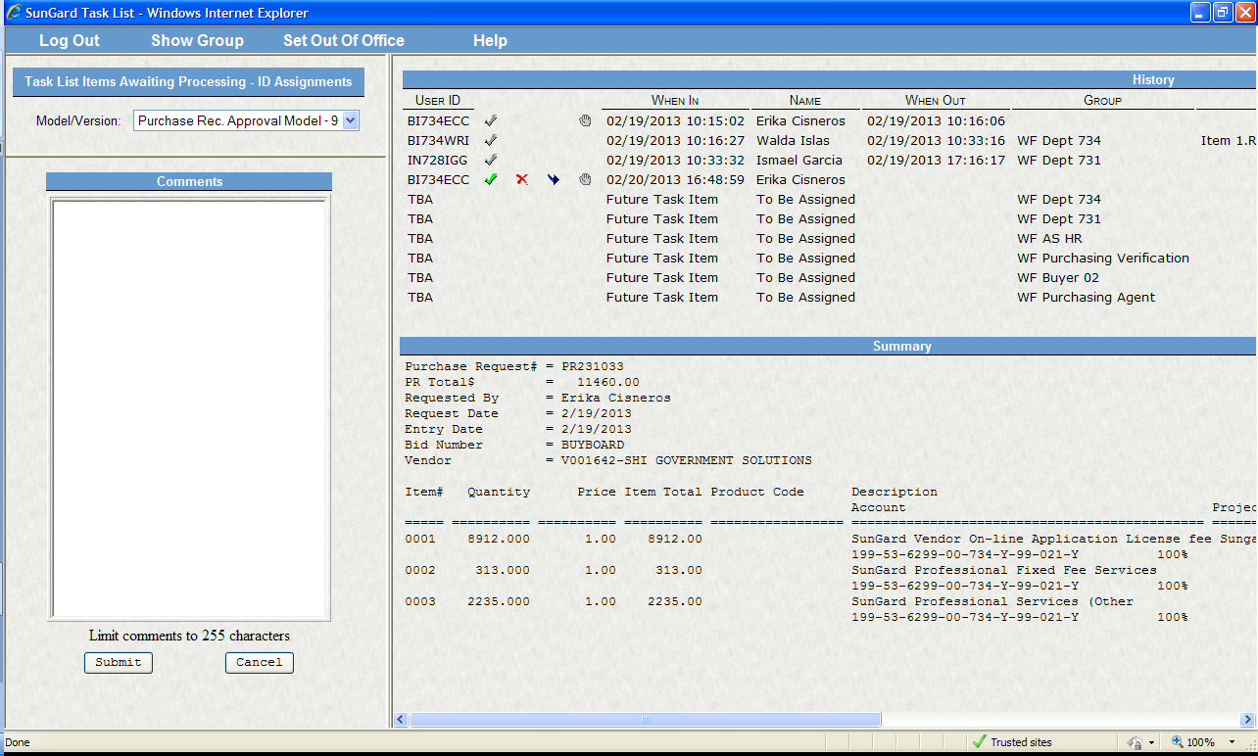

**Comments Screen will open. Space is available for any comments to the approvers.**

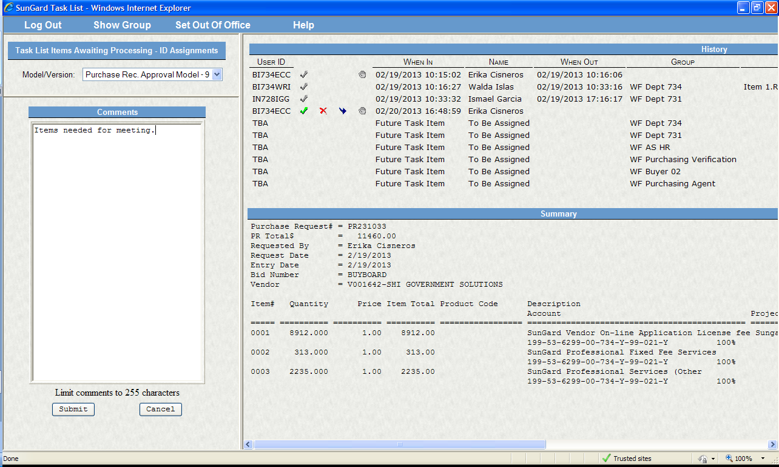

**NOTE: DO NOT** USE SPECIAL CHARACTERS! SUCH AS: #, &, $, @, *,% etc…PR WILL NOT GO THRU!

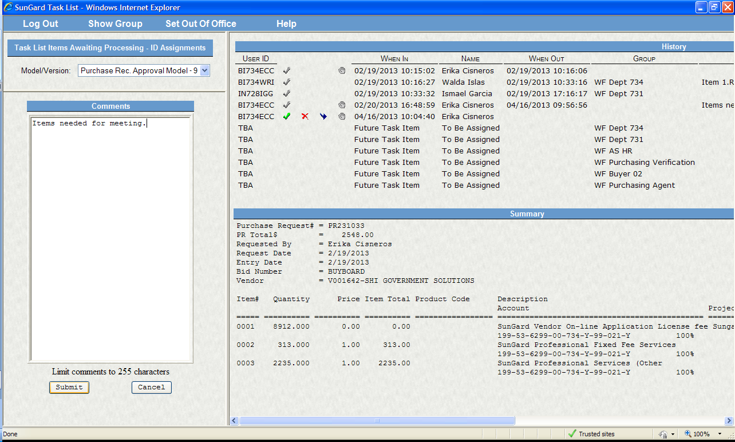

**Click: Submit**

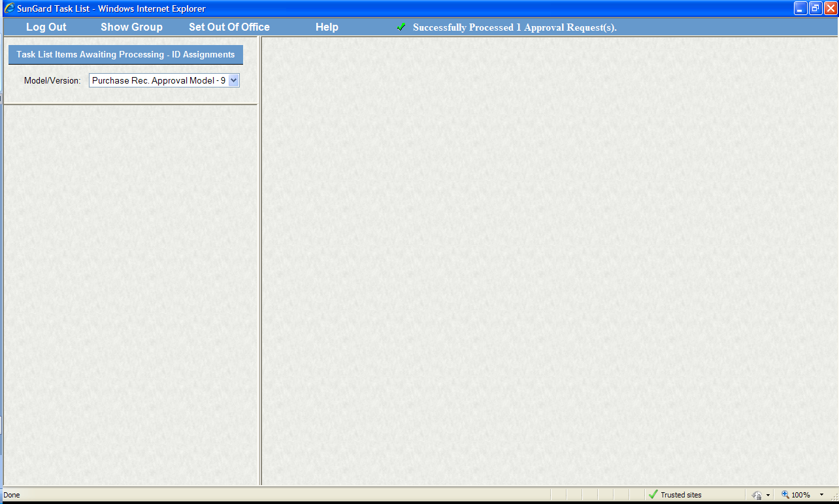

**The following message will appear as confirmation that you have successfully approved PR.**

***The PR will now move forward through Workflow to the next approver.***