**2015**

# cid:image002.jpg@01CD69AA.59537190

Vendor PunchOut Guide

[](http://tibh.org/) [](https://www.hgacbuy.com/) [](http://www.tcpn.org/)**[http://www.bisd.us/Purchasing/Region%20One.JPG](http://www.esc1.net/esc1/site/default.asp)** [](http://www.buyboard.com/) [](http://www2.dir.state.tx.us/ict/contracts/Pages/ProductsServices.aspx)[](http://www.uscommunities.org/)[](http://www.tips-usa.com/index.cfm)  **[http://www.bisd.us/purchasing/images/UST_trans.gif](http://ustechusa.com/bisd/)** [Walmart. Save Money. Live Better.](http://www.walmart.com/)[Office Depot Business Solutions Division](https://bsd.officedepot.com/index.do)****

Business Software Help Desk



Table of Contents

Step 1: Log in to system. 3

Step 2: Access SunGard PunchOut Screen 4

Step 3: Input Account # 5

Step 4: Input Security Code (Campus/Department Location #) 6

Step 5: Input Ship ID 7

Step 6: Input Address Code 7

Step 7: Start Shopping 8

Step 8: Modifying account #. 11

Step 9: Input Bid # and Contract #. 12

Step 10: Approve PR 13

# 

# Step 1: Log in to system.

***\* Note: Log in as normal if not automatically logged in, then input your credentials.***

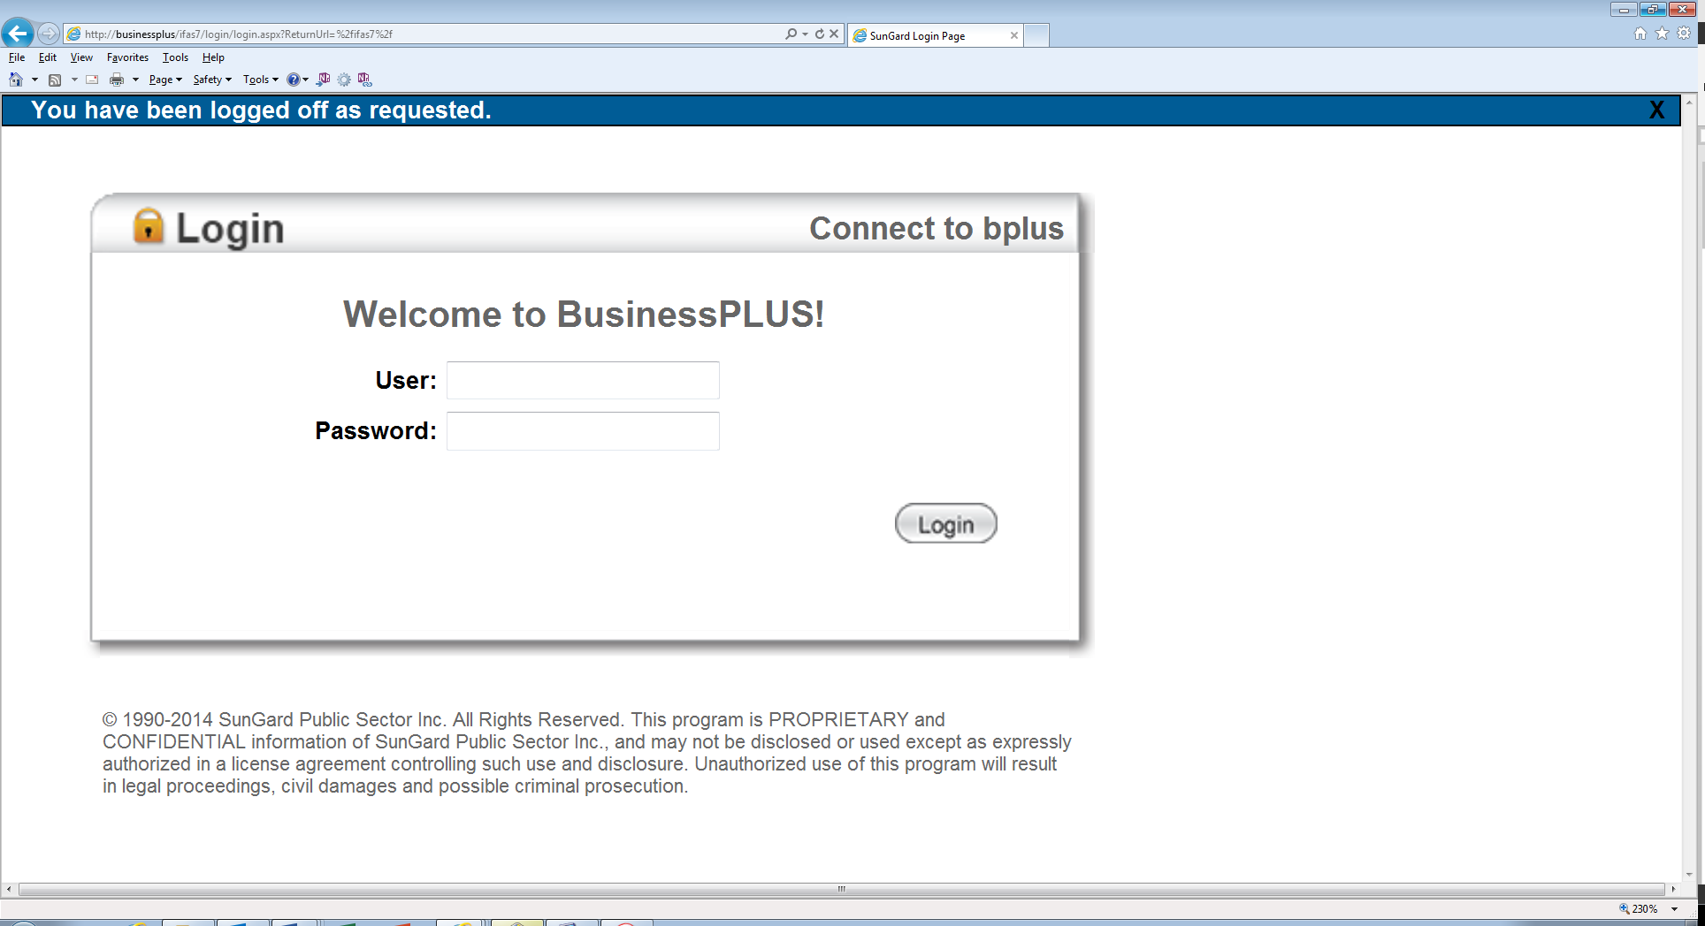

jdoe

**Password you currently use to log in to your computer. Click: Login**

**User ID is your email address without the @bisd.us (Ex:** [**jdoe@bisd.us**](mailto:jdoe@bisd.us) **)**

***Note: You will be directed to the Home Tab. See below.***

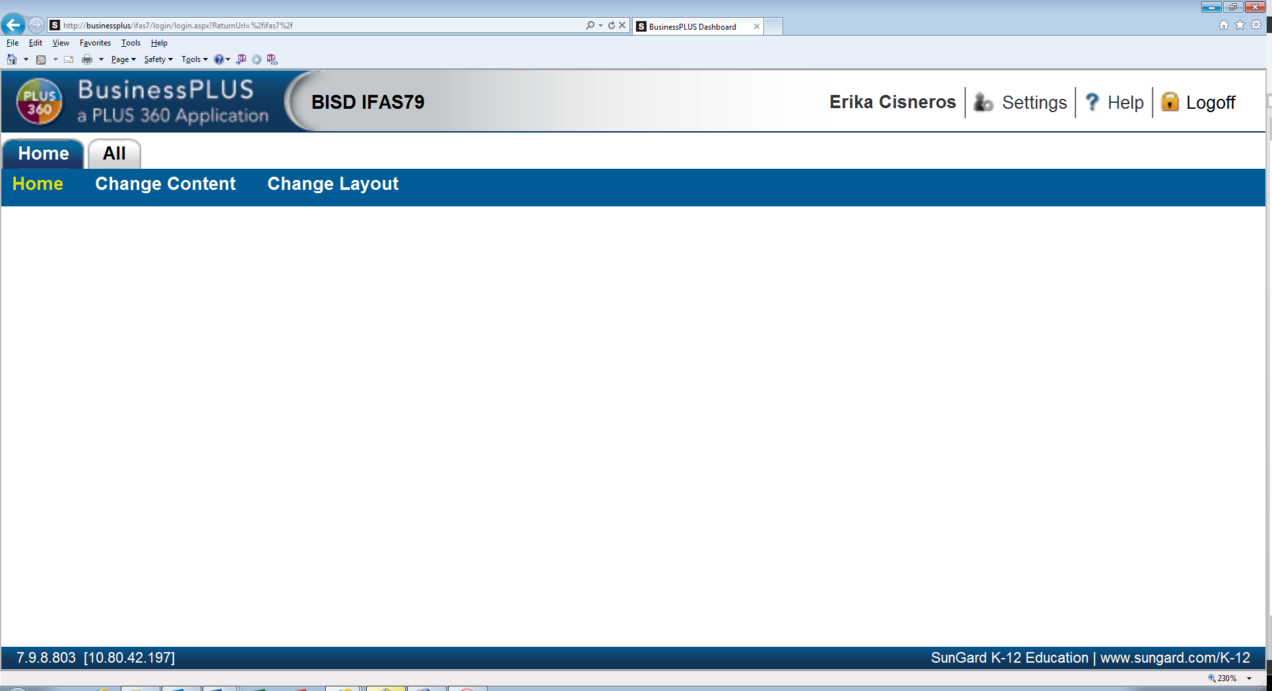

User Name

**Select: All Tab**

***Selections under “All” tab will be visible. See next screen.***

# Step 2: Access SunGard PunchOut Screen

**(Using mask “POUPPP”)**

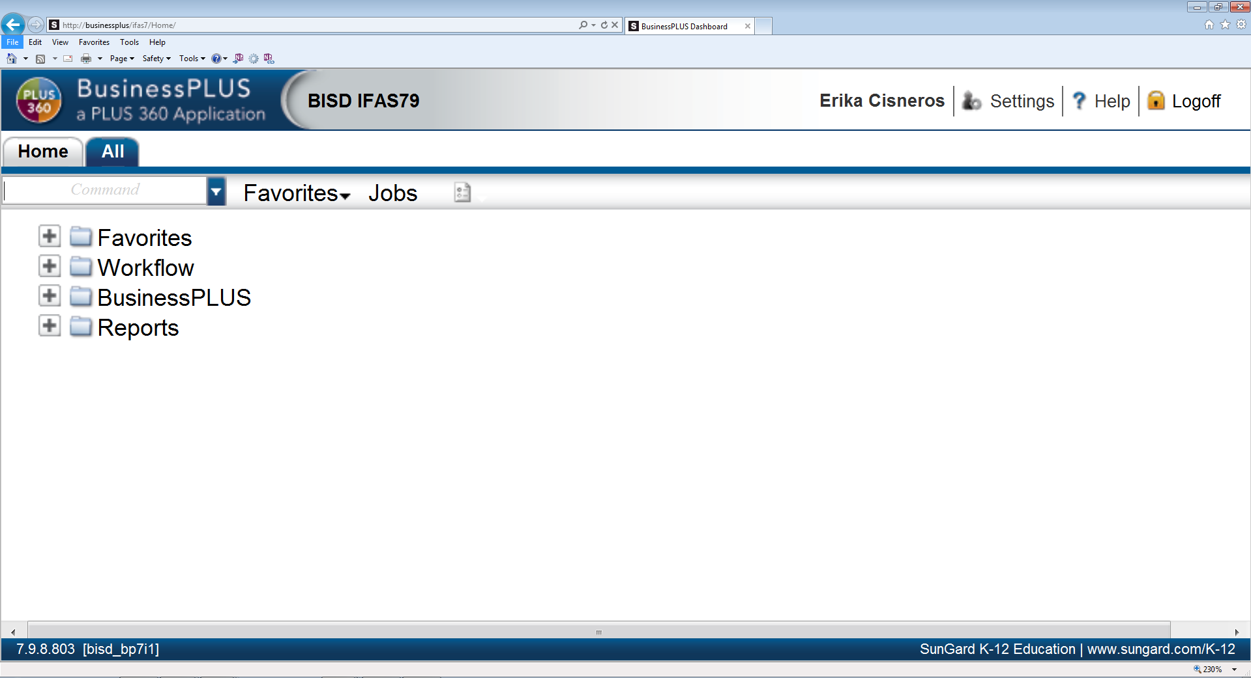

**Input: Command Mask “POUPPP”**

User Name

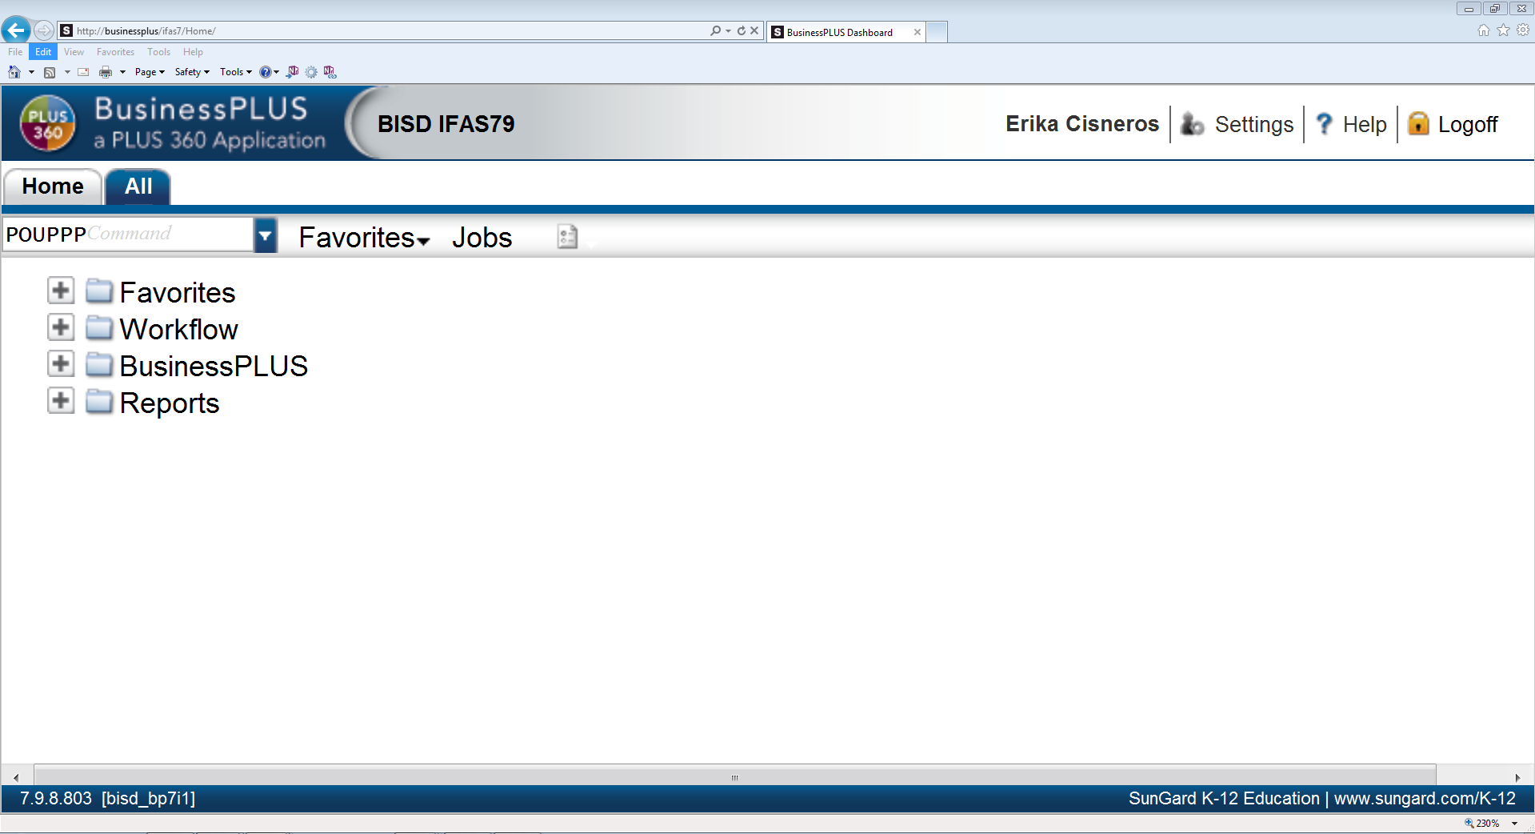

**Hit: Enter**

**Hit: Enter**

User Name

***You will be directed to SunGard PunchOut Screen.***

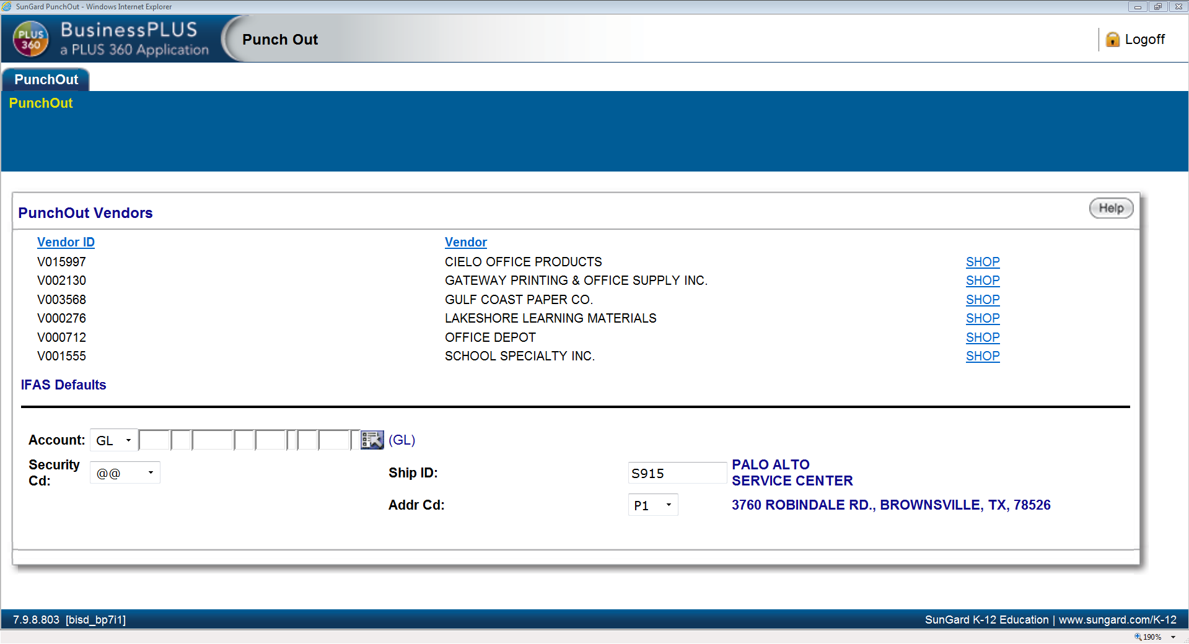

**List of Vendors will display here.**

# Step 3: Input Account #



**Input: Account # (Only one account is allowed; you may change account # if multiple accounts are needed in Step 8.)**

# Step 4: Input Security Code (Campus/Department Location #)

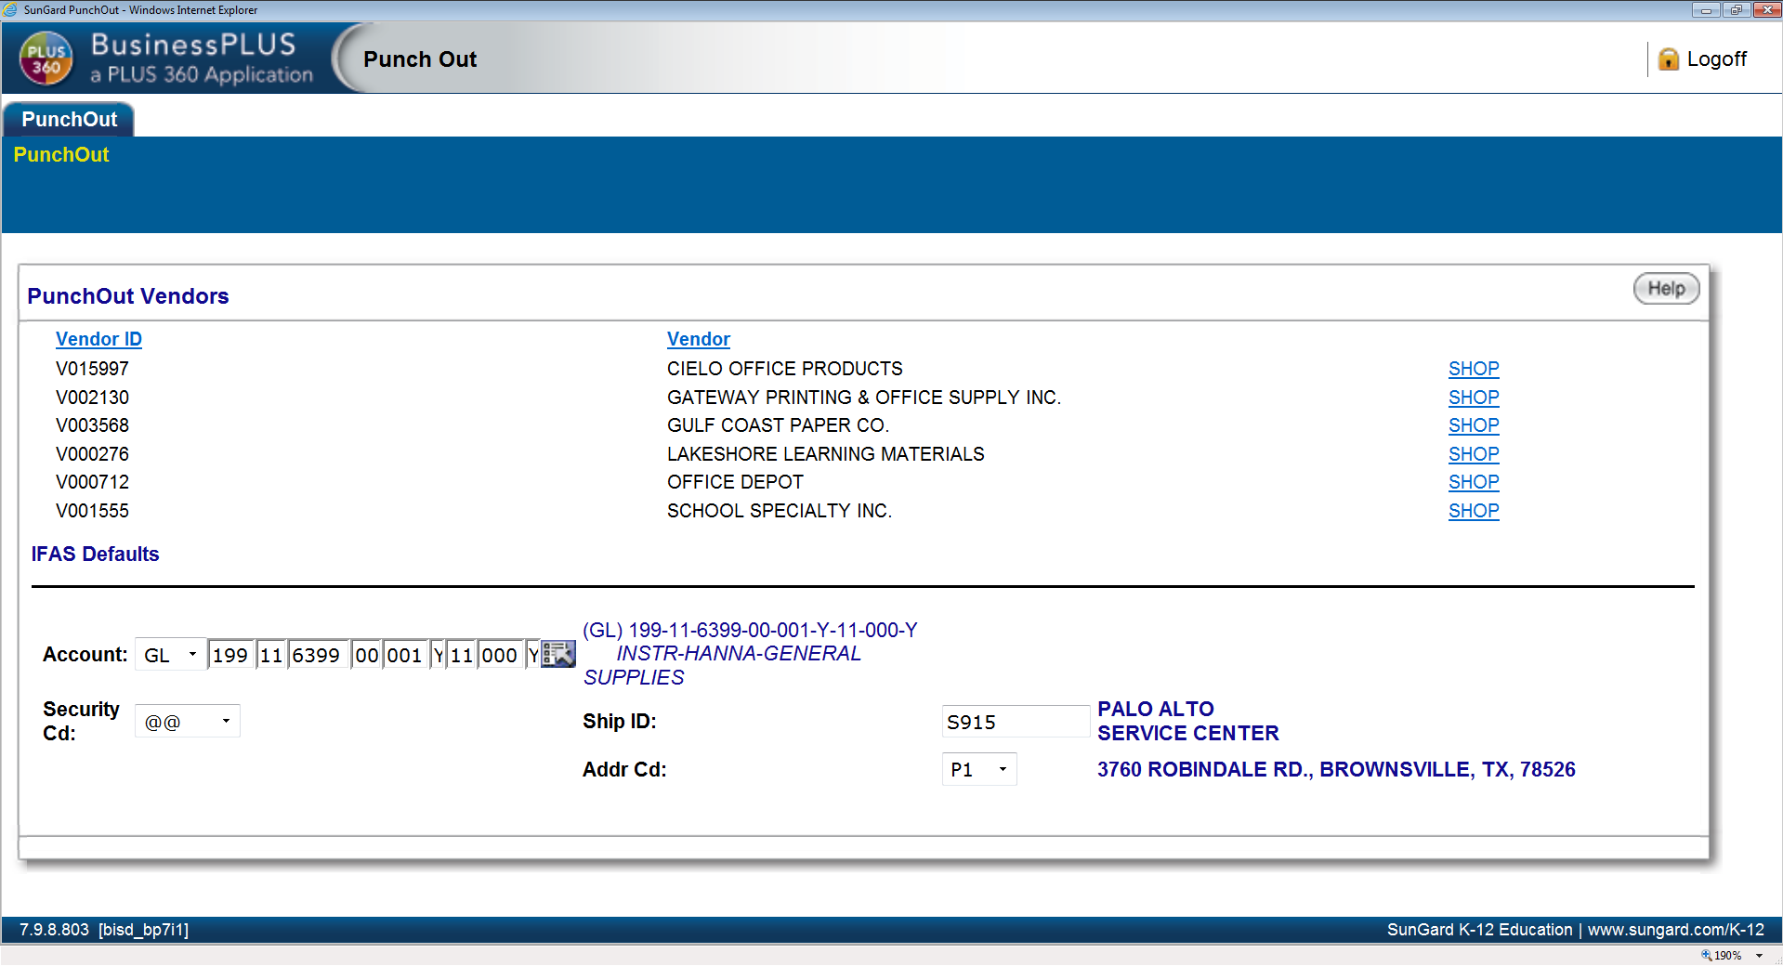

**Click: Drop Down Arrow**

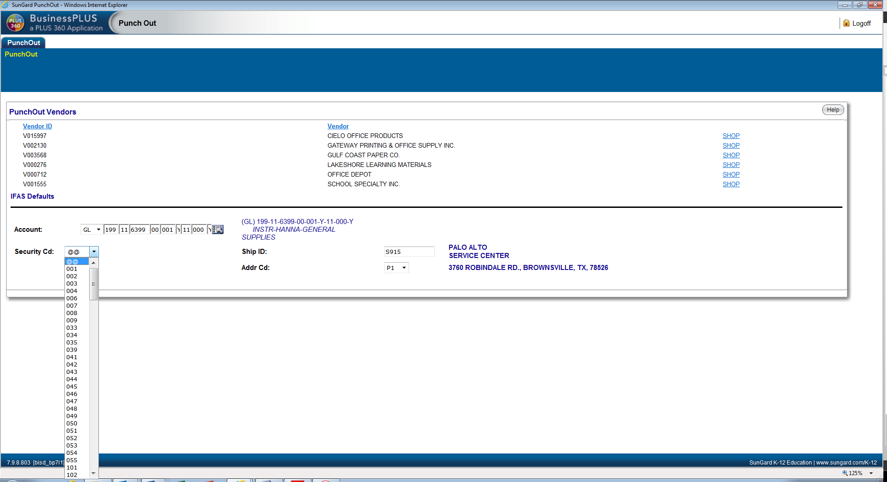

**Select: Location (ex: 001 Hanna High School)**

# Step 5: Input Ship ID

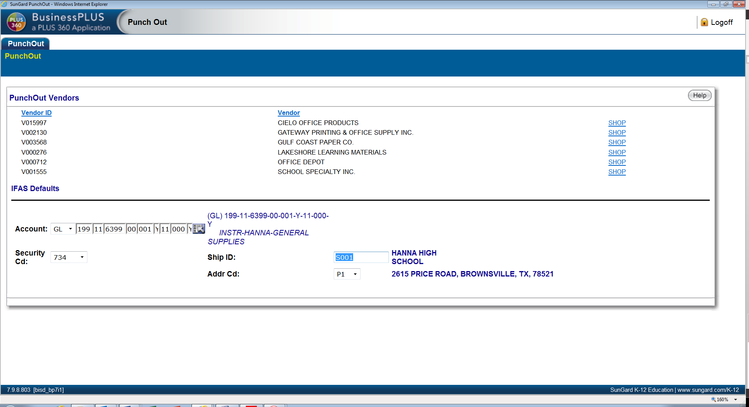

**Input: Ship ID =Location of where items need to be delivered. (Ex. Hanna HS) Code needs to be an “S” followed by 3 digit location #: S001**

**\*\*Note: Only Schools should change the Ship ID for Office Depot and Gulf Coast orders. All Departments should default to S915 (Warehouse) 3760 ROBINDALE RD., BROWNSVILLE, TX, 78526**

Step 6: Input Address Code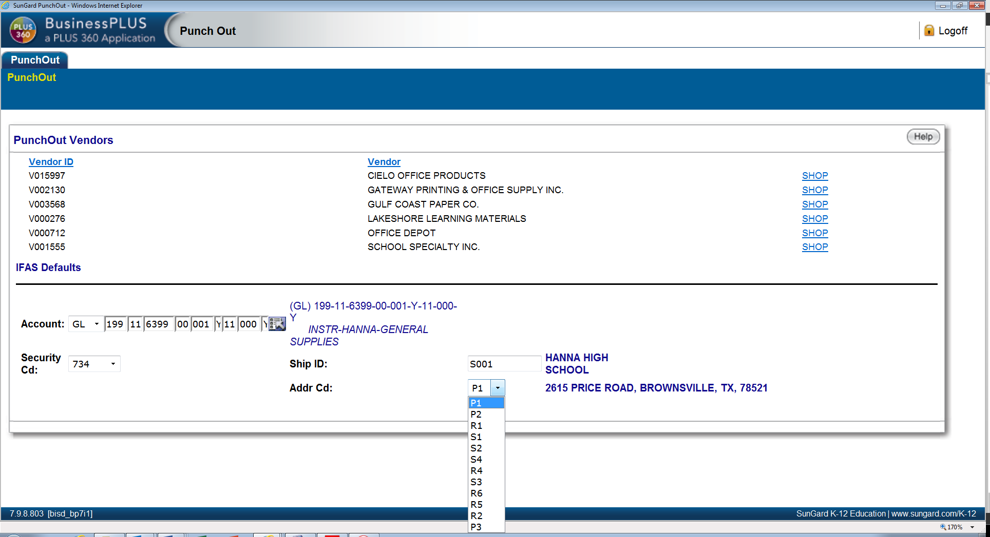

**Click: Drop down; input Addr Cd (ship to address)**

# Step 7: Start Shopping

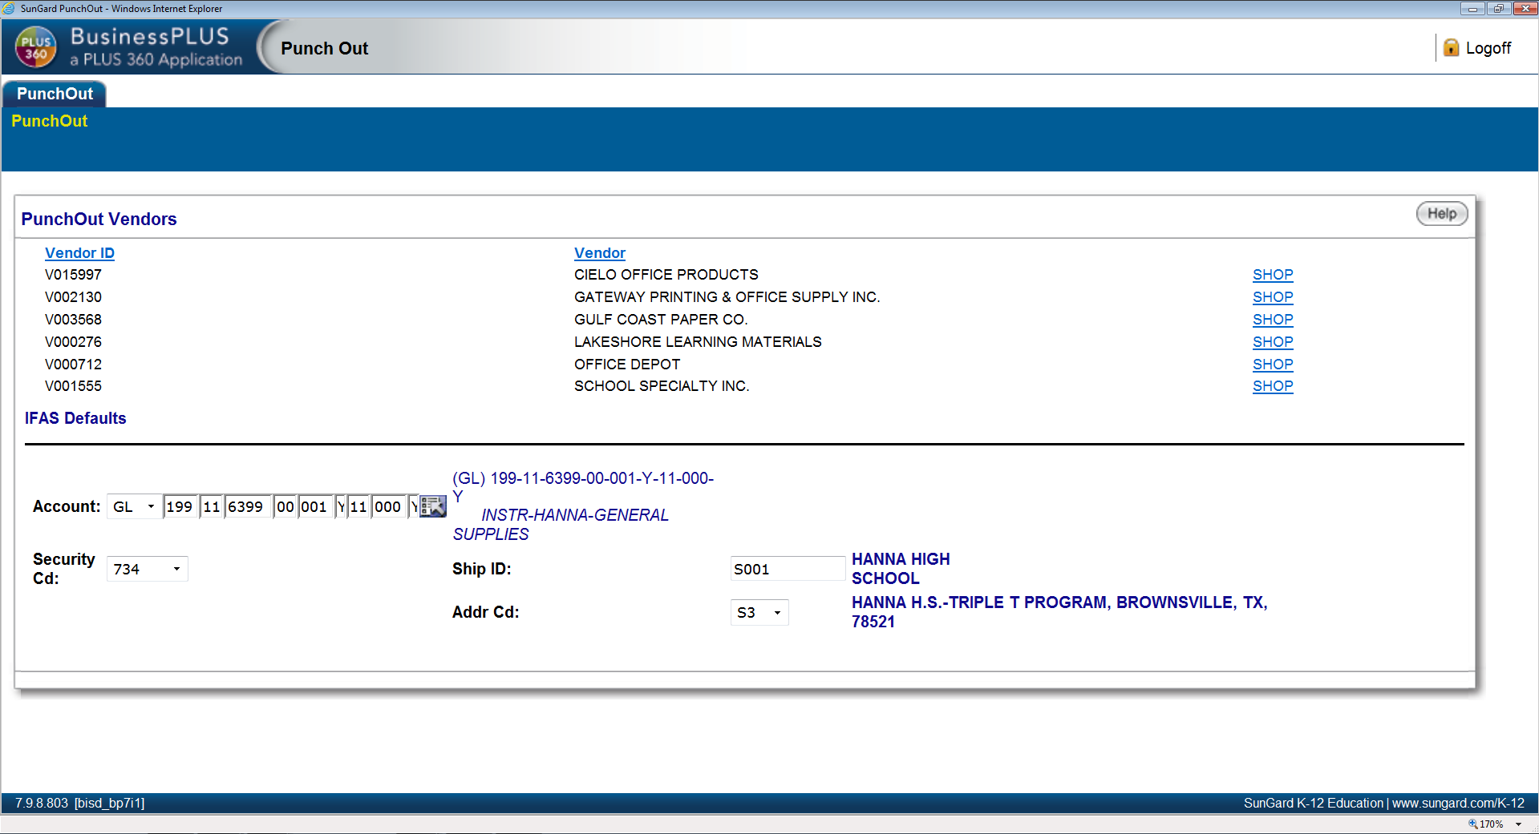 ***You will be redirected to Vendor’s Website.***

**Note: Address change when selecting S3**

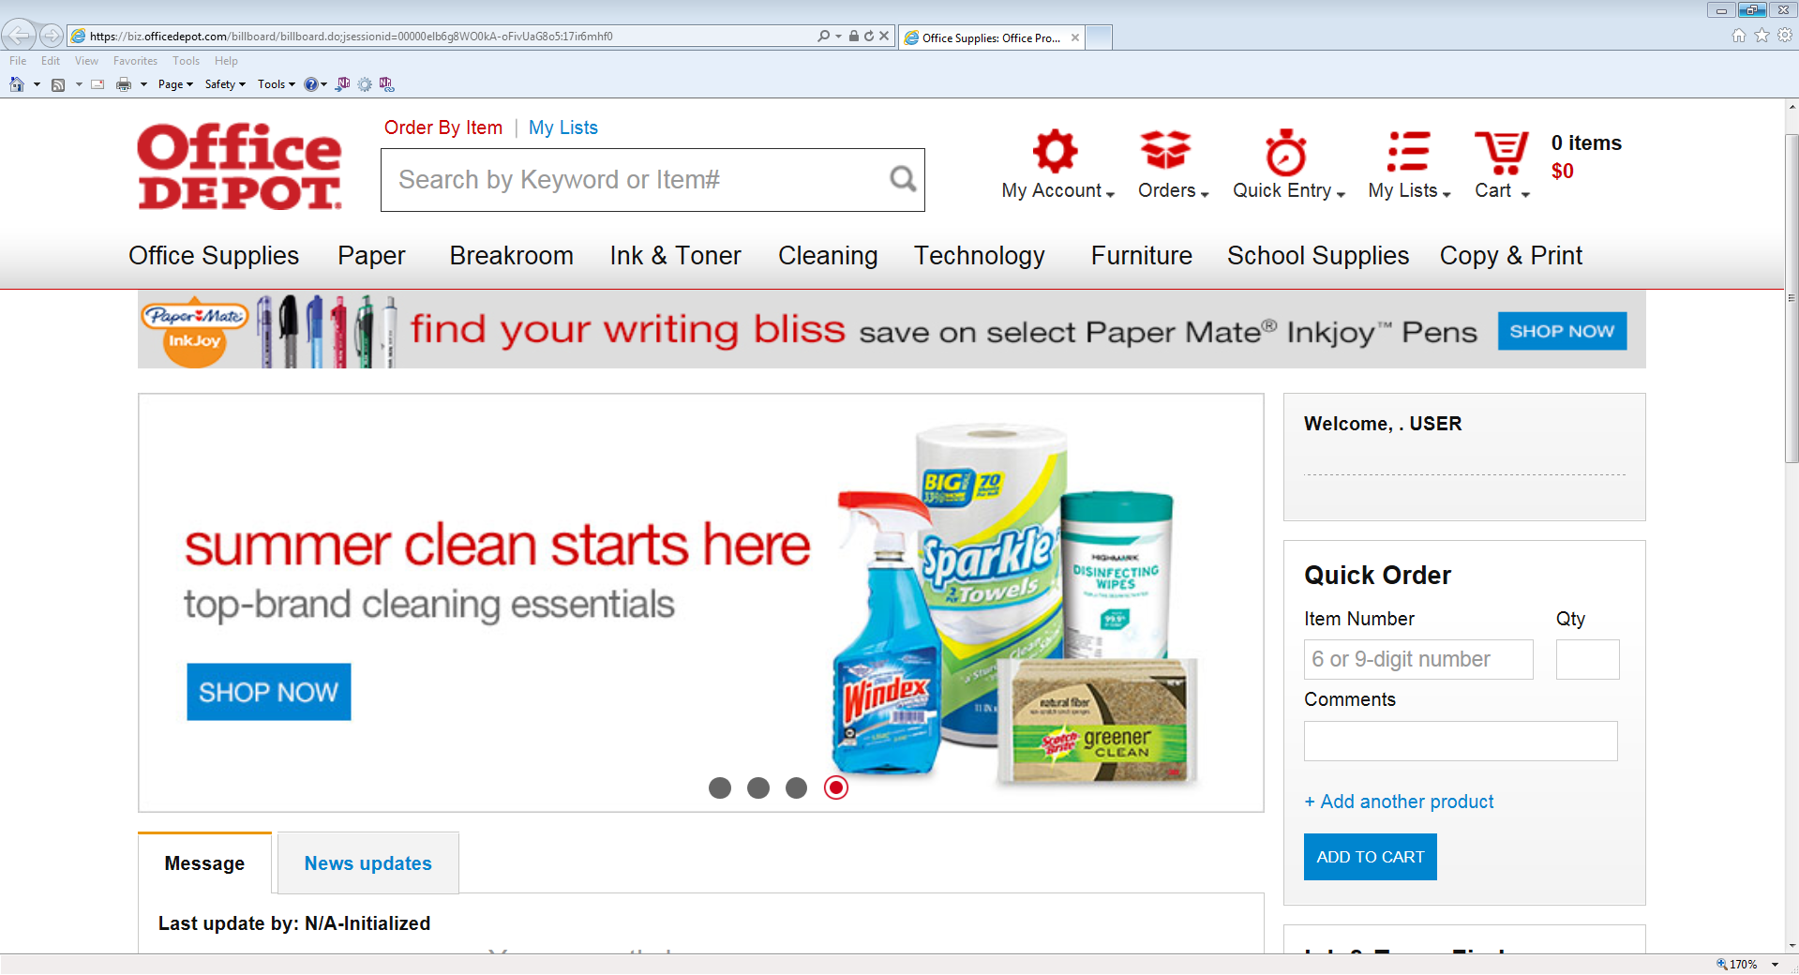

**VENDOR NAME**

***Select items you wish to purchase; see sample below.***

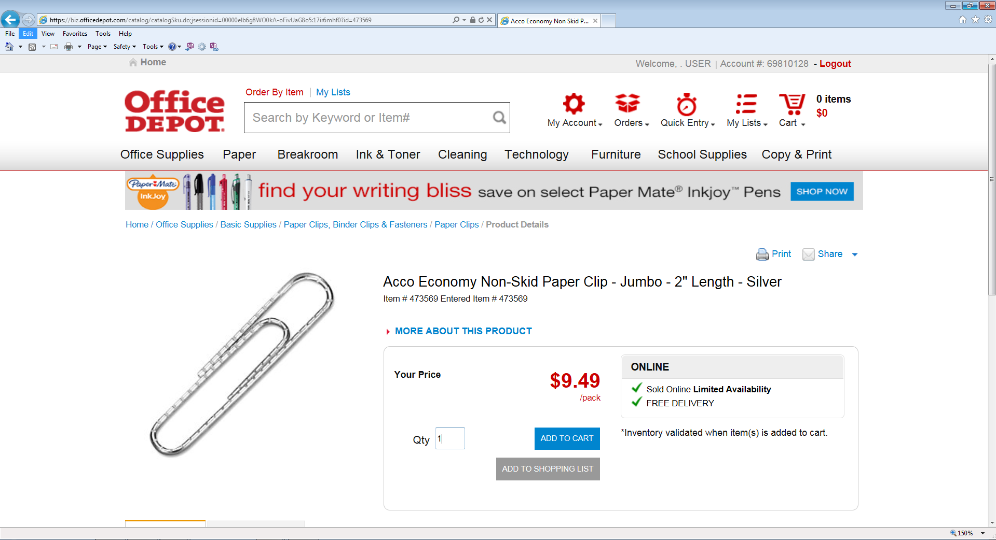

**VENDOR NAME**

**Input: Quantity Click: Add to Cart**

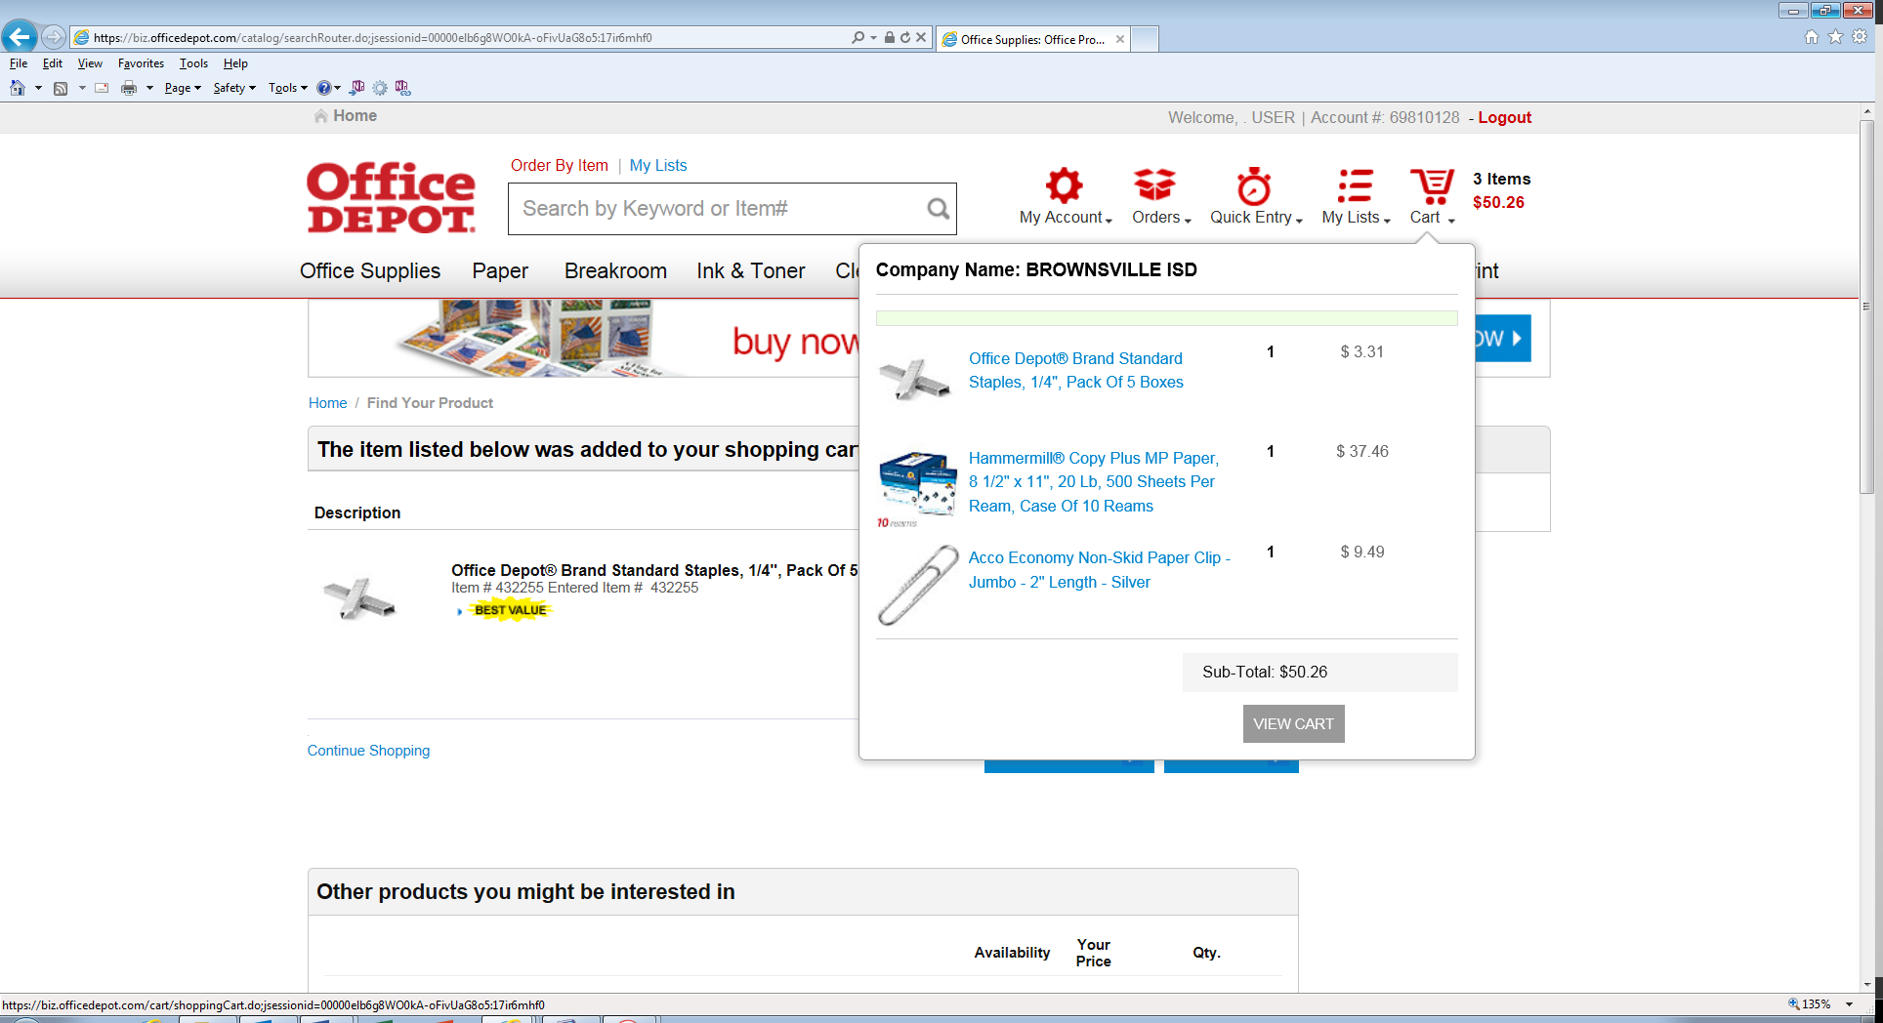 ***You will be directed to your shopping list/cart; review all items prior to checkout.***

**VENDOR NAME**

**Click: Cart to view your list of items.**

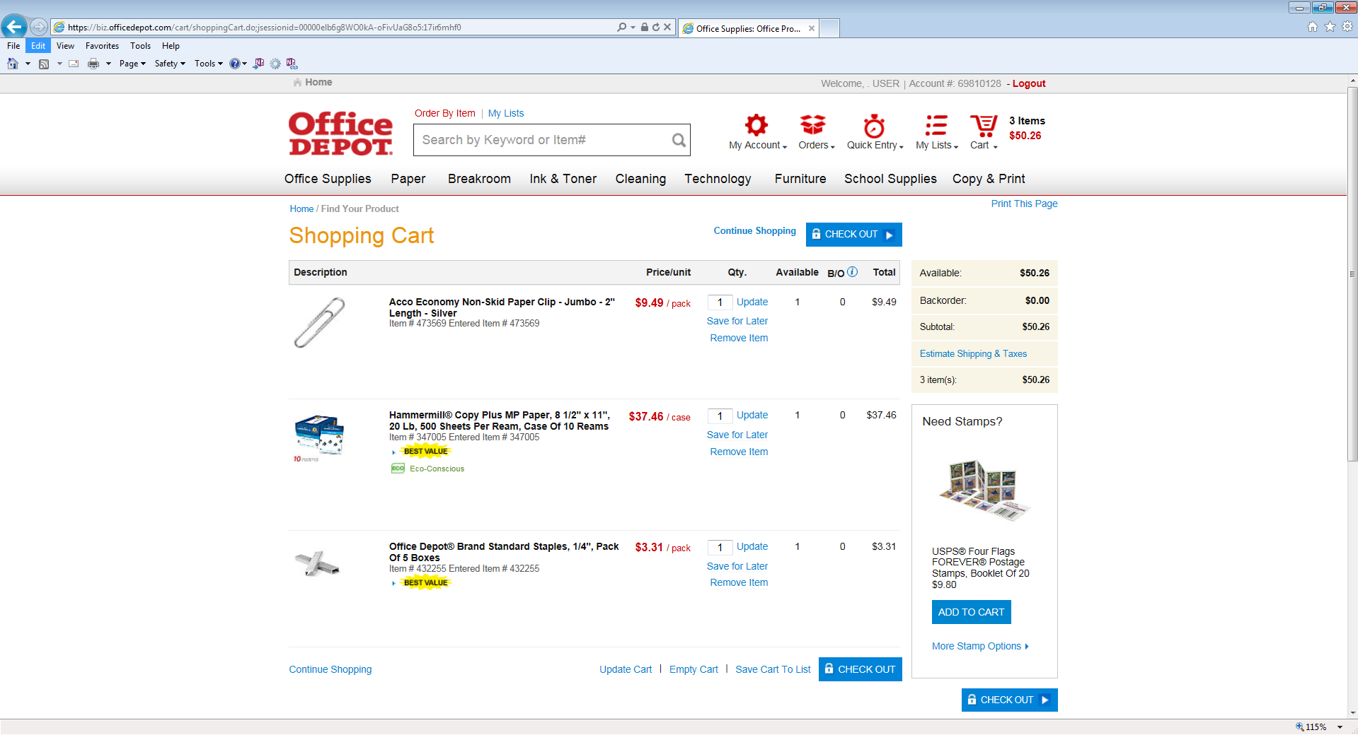

**Click:** **once you are done selecting/reviewing the items.**

**VENDOR NAME**

***\*\*Note: Be sure to review all items! You will NOT be able to make any changes after this point.***

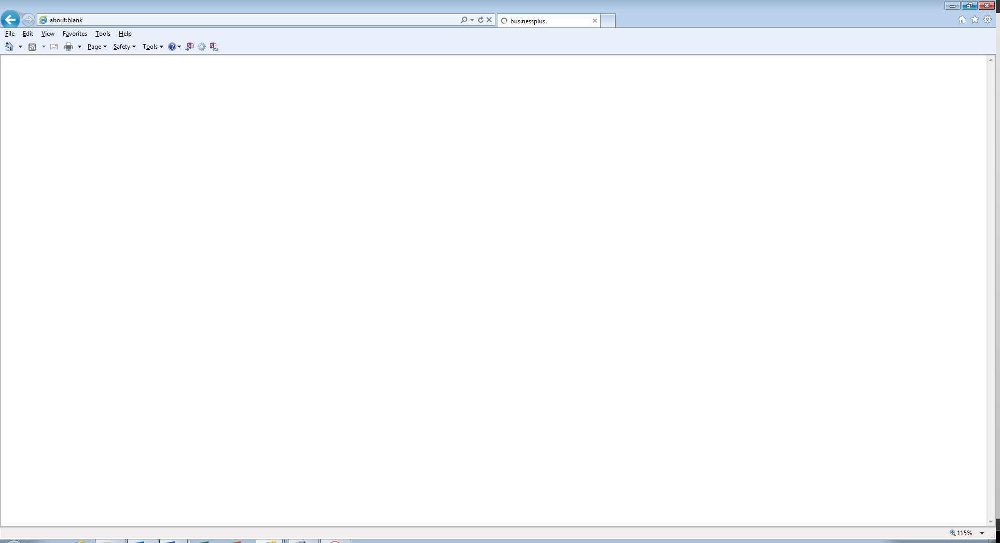

**A blank page will display for a few seconds; order is being processed and a Purchase Requisition is being created!**

***Once process is complete all information will automatically populate; see example below.***

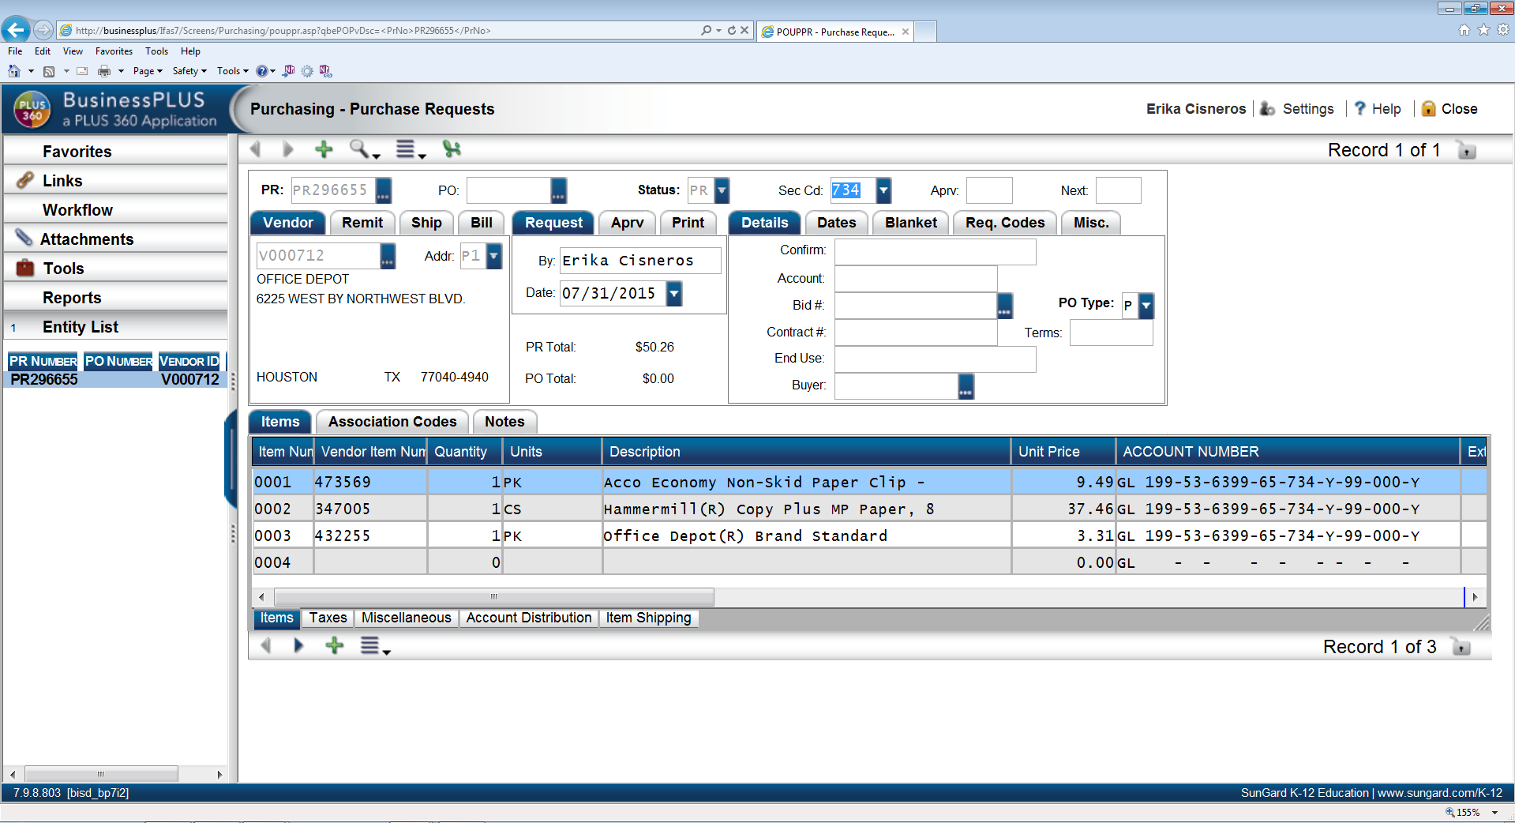

**Note: PR # has generated and items you selected from website have been transferred to PR Screen.**

User Name

Vendor Name

# Step 8: Modifying account #.



User Name

User Name

Vendor Name

**Note: Account # defaulted to account used in Step 3. You may change it now if needed. Do Not make any other changes; such as, items, quantities, or unit price. Changes will not reflect in Vendor’s order.**

# Step 9: Input Bid # and Contract #.



User Name

User Name

Vendor Name

**Input: Bid # and Contract # if Required. Hit: Enter**

***\*\*Note: For a list of Bid and Contract #’s contact Purchasing Dpt.***

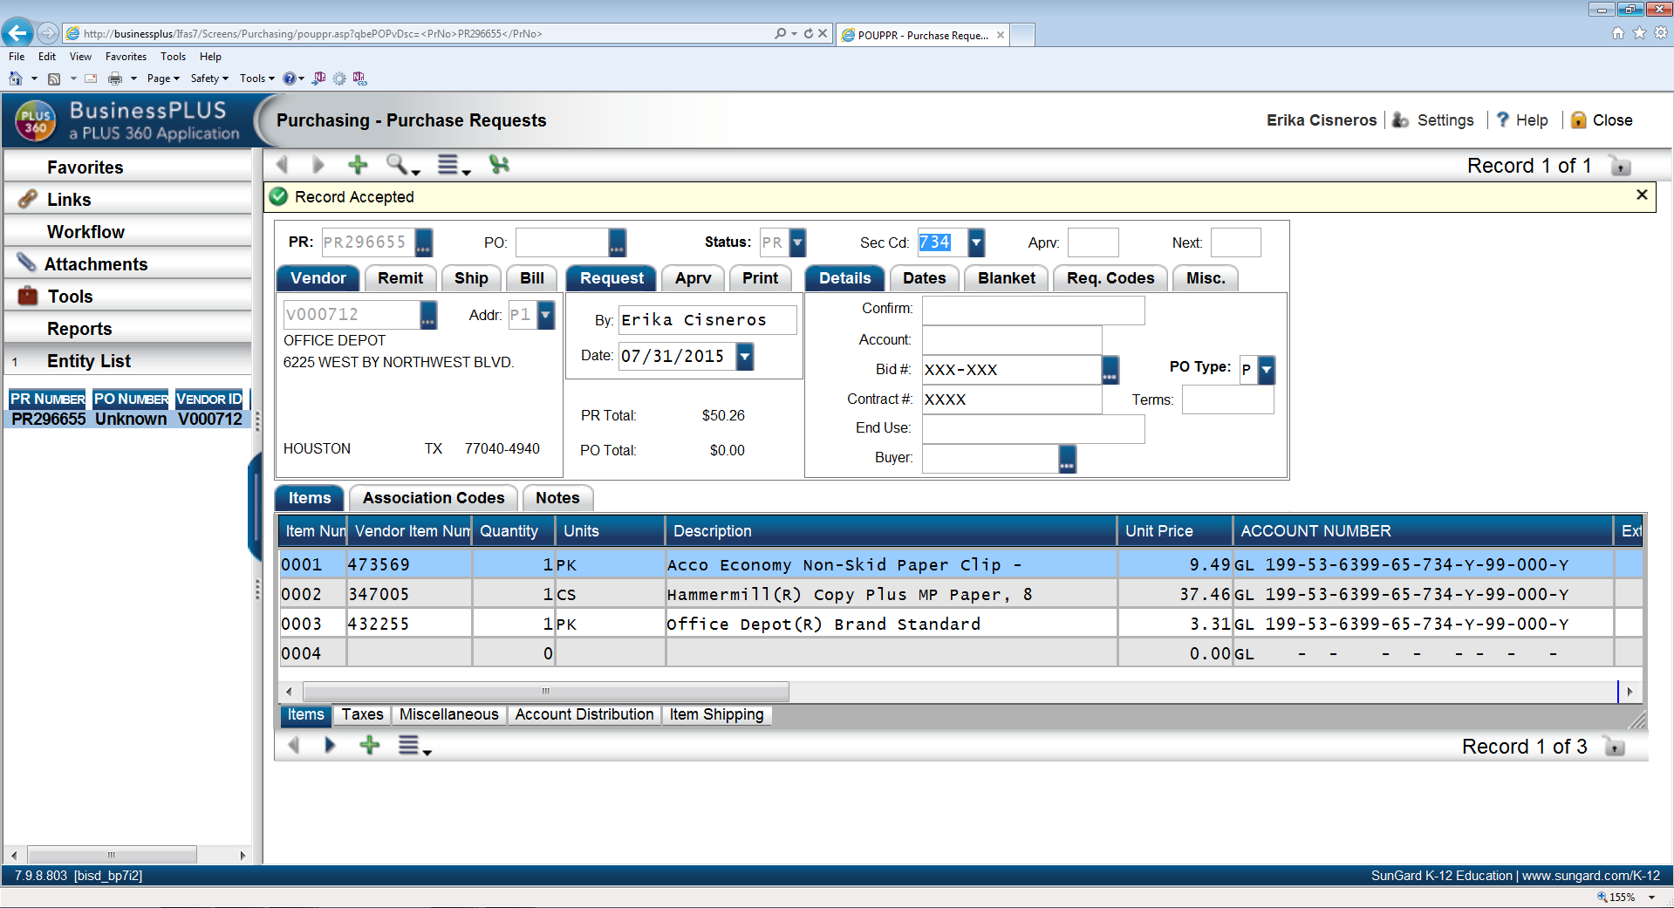 ***You are now ready to approve Purchase Requisition.***

User Name

User Name

Vendor Name

**“Record Accepted” will display.**

# Step 10: Approve PR

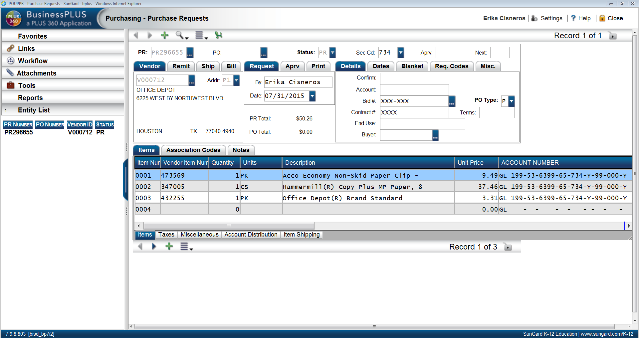

User Name

User Name

Vendor Name

**Click: Workflow**

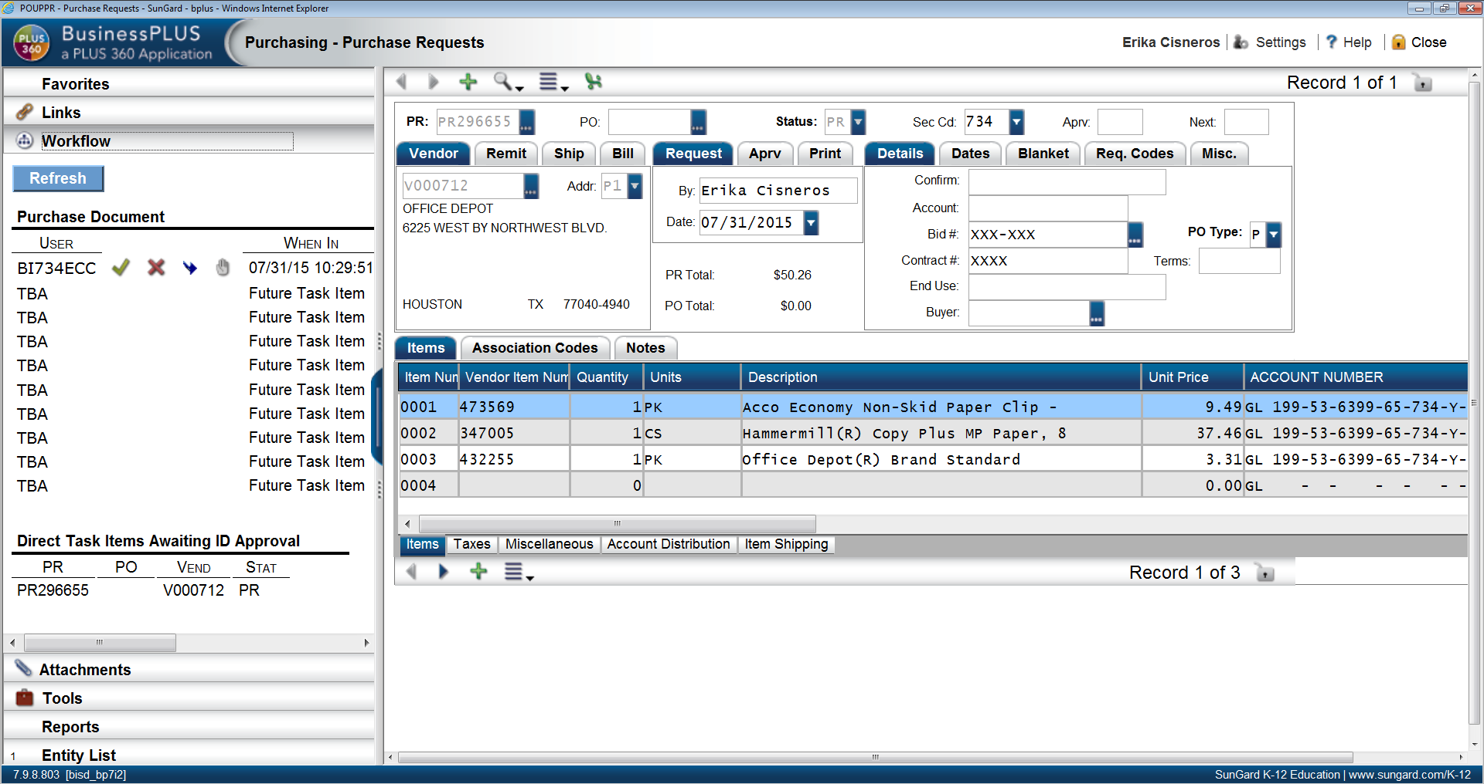

User Name

User Name

Vendor Name

**Note: You may now proceed with approval process as normal.**

***PR is now complete and will move through the Workflow for approvals. Once workflow process is complete a PO# will generate.***

***NOTES:***