**2015**





Business Software Help Desk

Adding Attachment Capabilities

***STEP 1:*** *Access Purchase Requests Screen (POUPPR)*

***\*\*Note:*** *Feature is available to other screens such as: Fixed Assets (FAUPAS), Warehouse Orders (SIOEUB). Once you’ve added to either screen; capability is activated for all screens.*

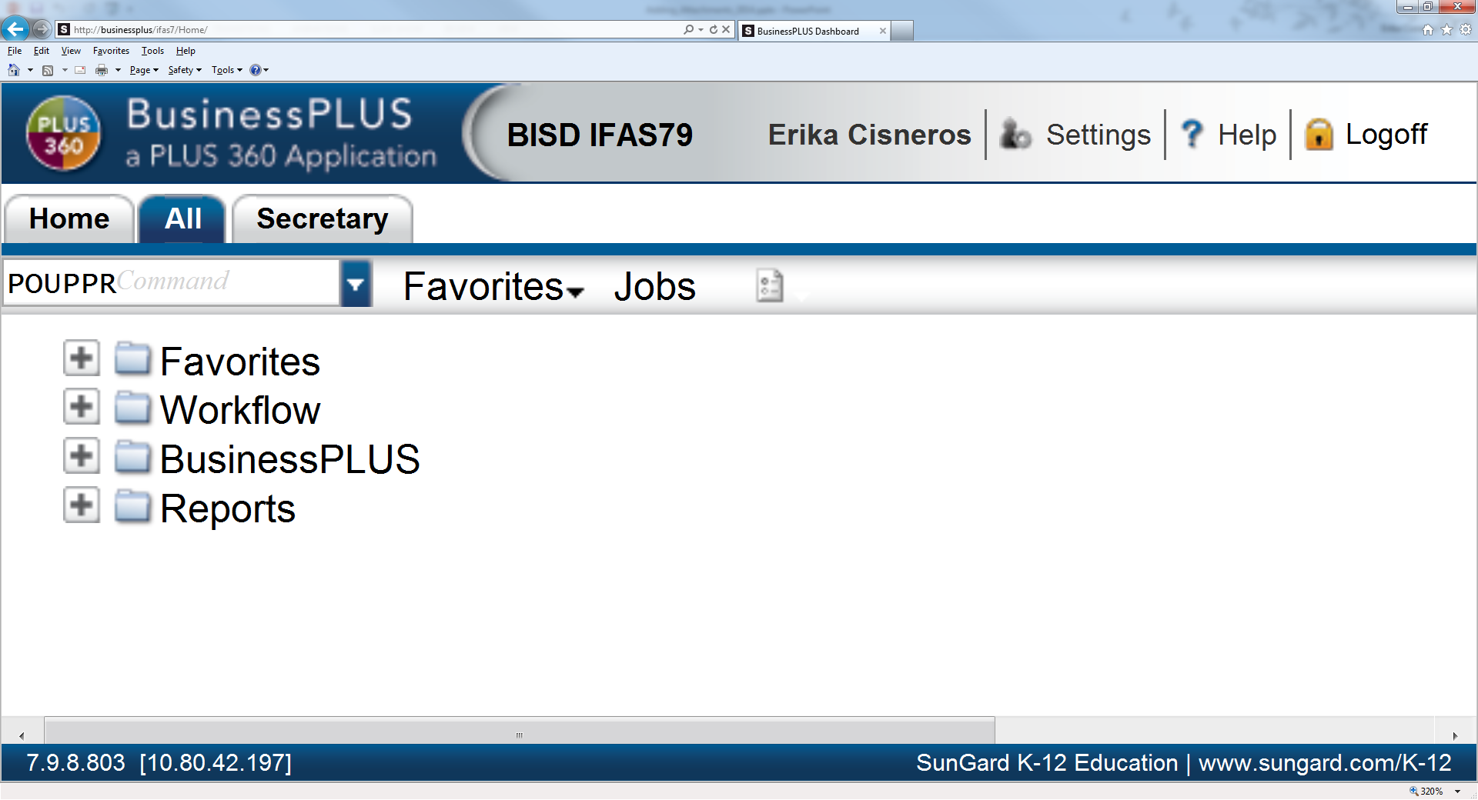*POUPPR-Purchase Request Screen below…*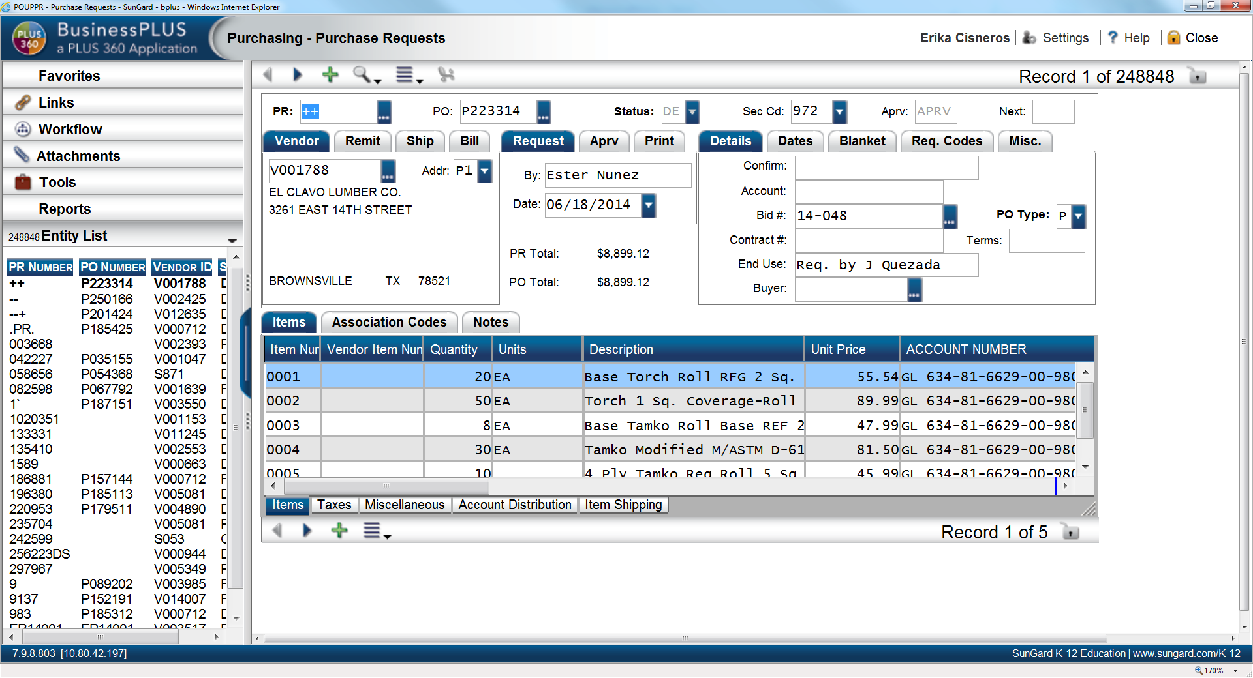

**Click: Settings.**

User Name

**User Name**

**Access: Using mask or Menu Tree.**

*The following screen will populate…*

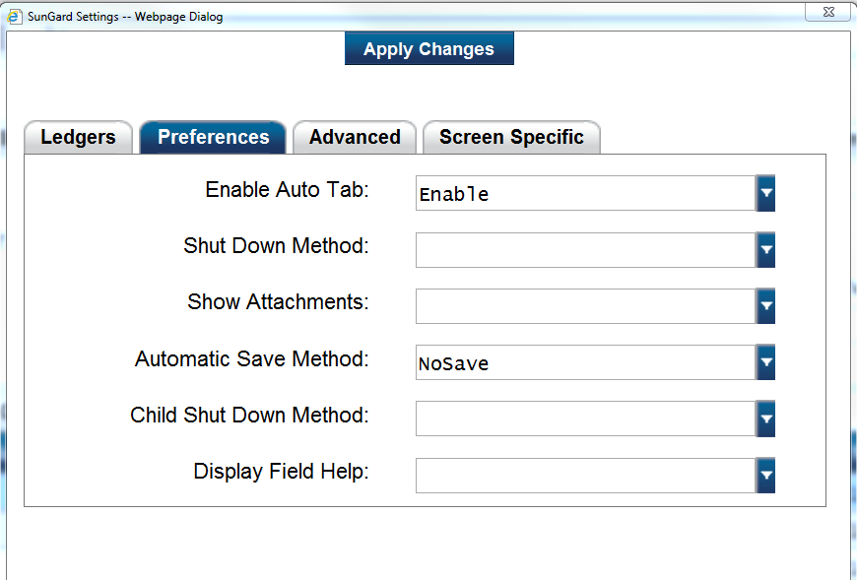

**Click: Preferences Tab**



**Click: Drop Down Arrow**

**For Show Attachments**

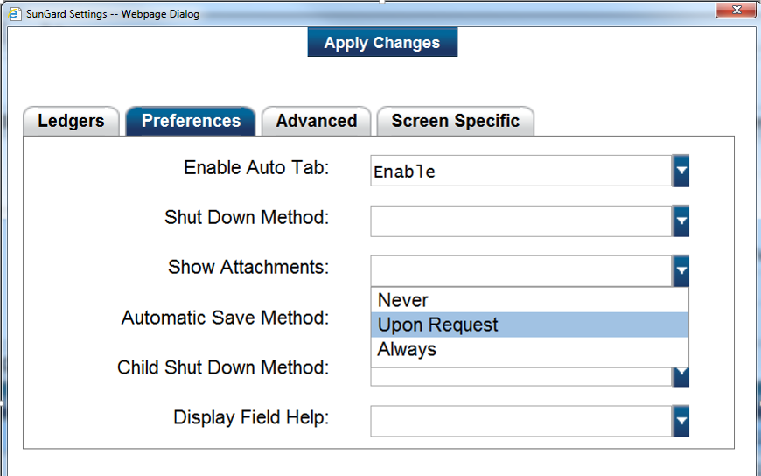

**Select: Upon Request**

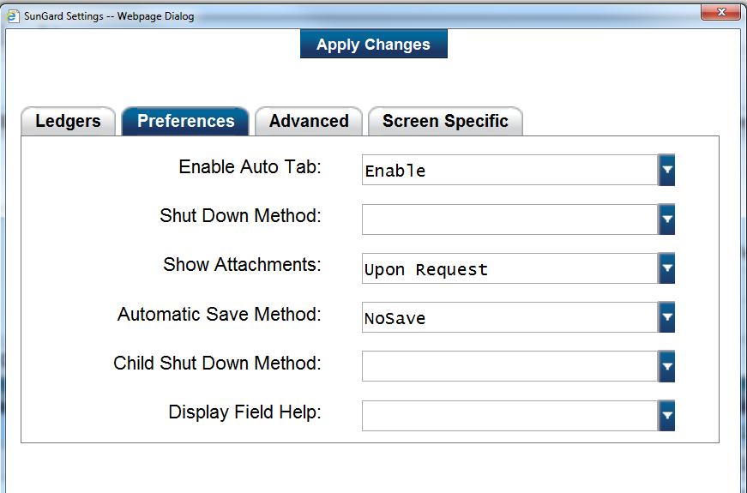***\*\*Note:*** *Be sure you click “Apply Changes”! Screen will disappear…*

**Click: Apply Changes**

***STEP 2:*** *Log out and Log back in.*

*Re-access P/R Screen (POUPPR)*

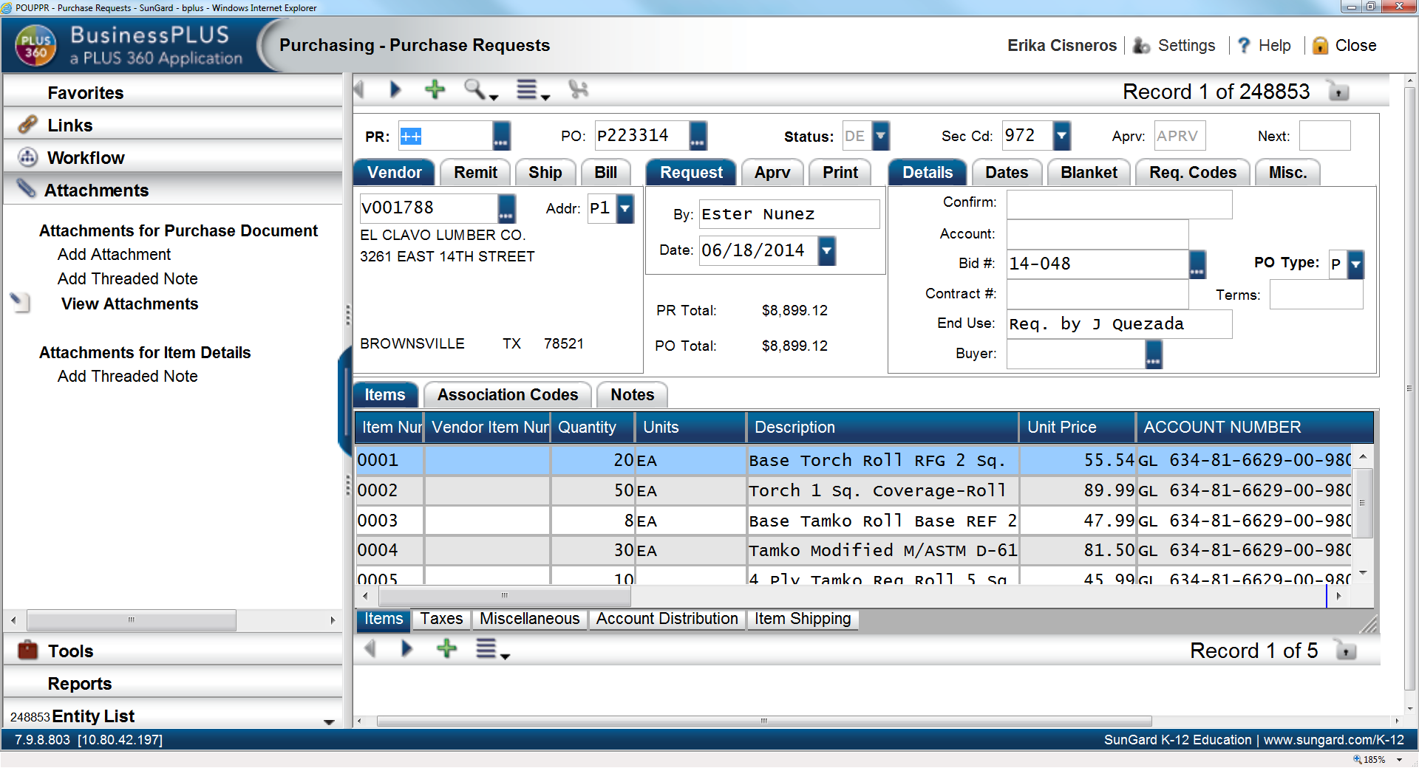

User Name

**Click: Attachments Notice: Add Attachment & View Attachment is now available.**

***STEP 3:*** *Add Attachment.*

***\*\*Note: For this step, document should be saved in your files prior to proceeding. You will need to create your PR as normal or Find/Search the PR that needs the attachment.***

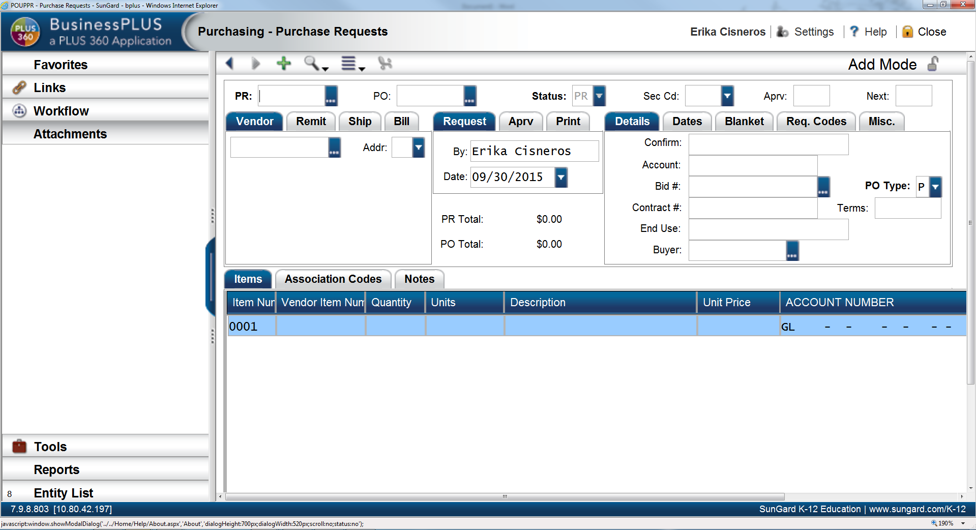

User Name

User Name

**Fill Out: All required fields.**

***You may now add your attachment.***

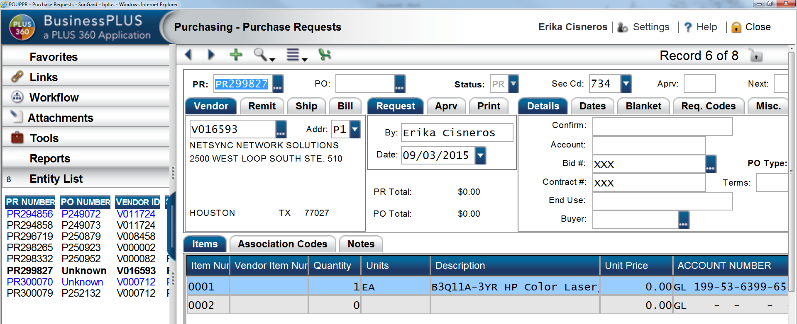

User Name

User Name

**Click: Attachments**

**Click: Attachments**

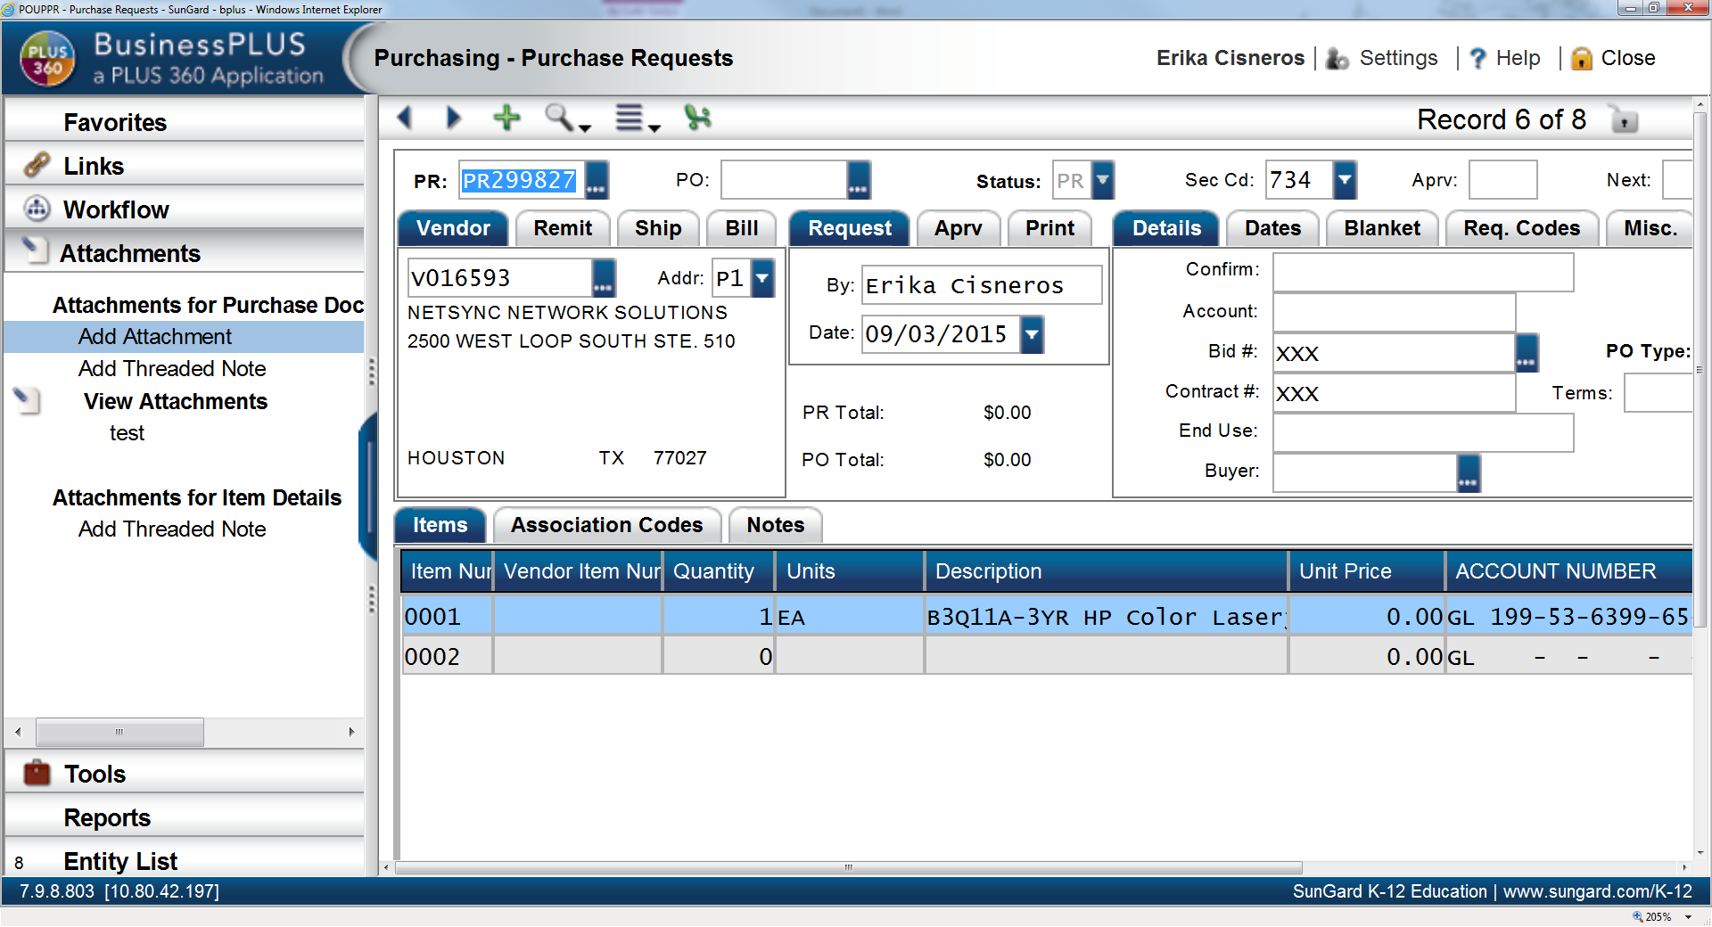

User Name

User Name

**Click: Add Attachment**

***Attachment Dialog Box will populate.*** 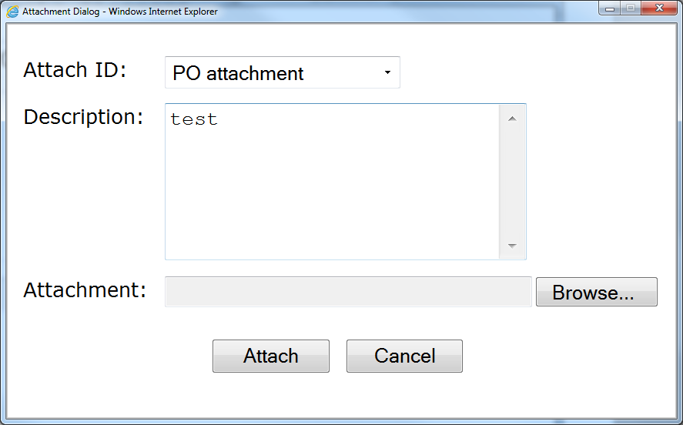

**Type: A description/title of File Click: Browse**

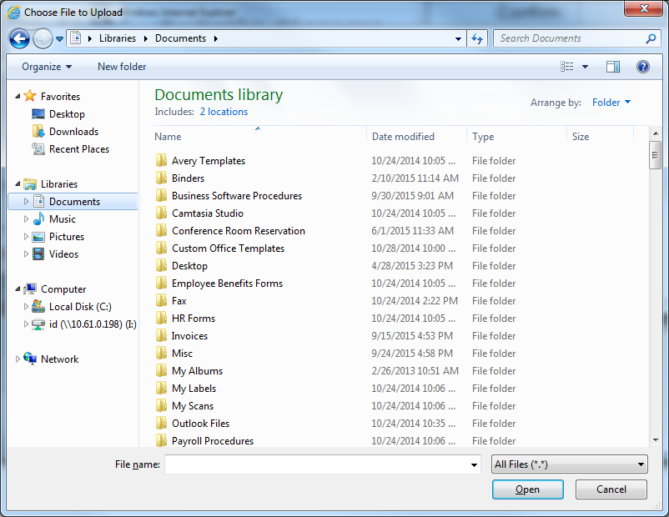

**Browse: For the file to be attached.**

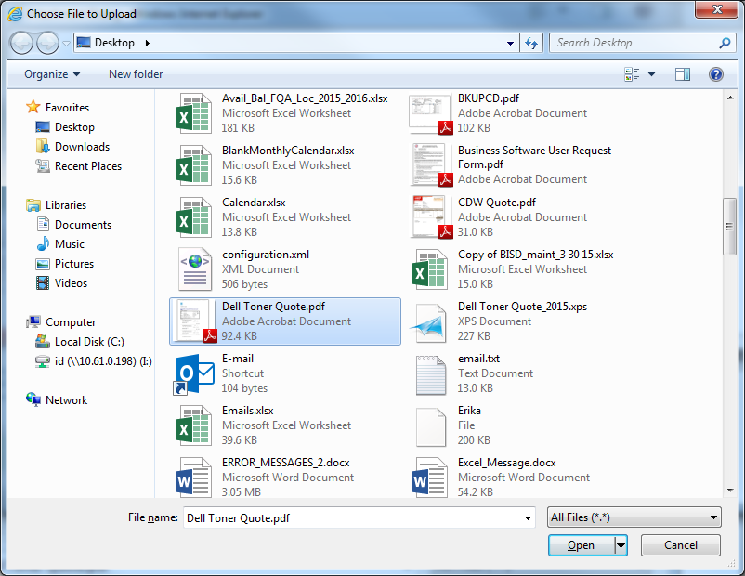

**Locate: File Click: Open**

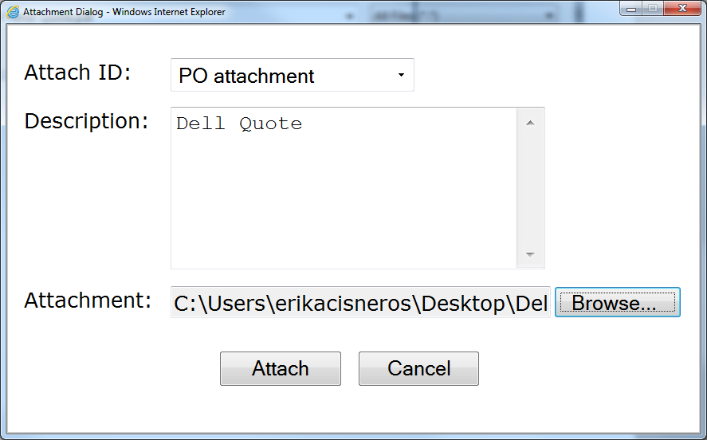

**Click: Attach**

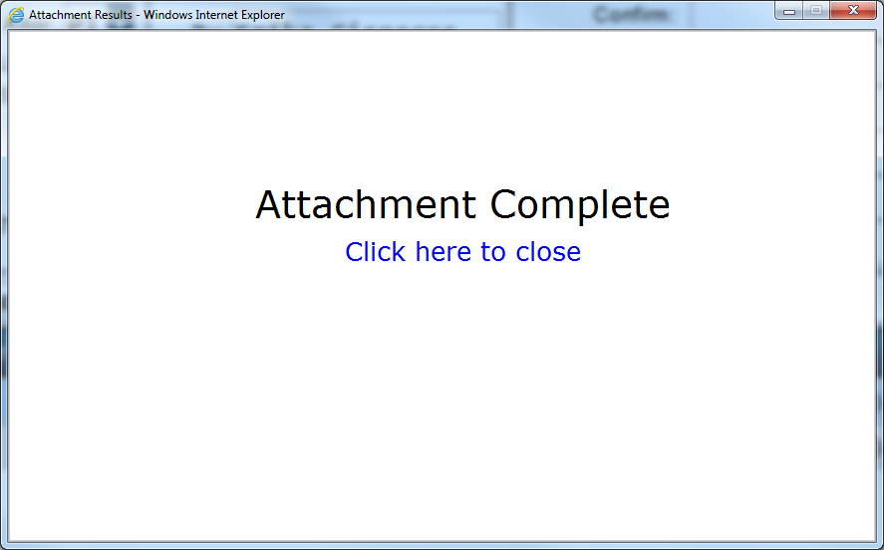

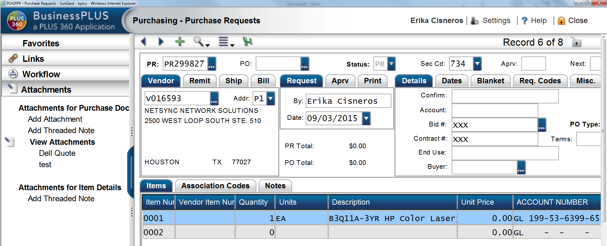

User Name

**Notice: Attachment has been added. Click: on title to view document.**

***See example of document that was attached.***

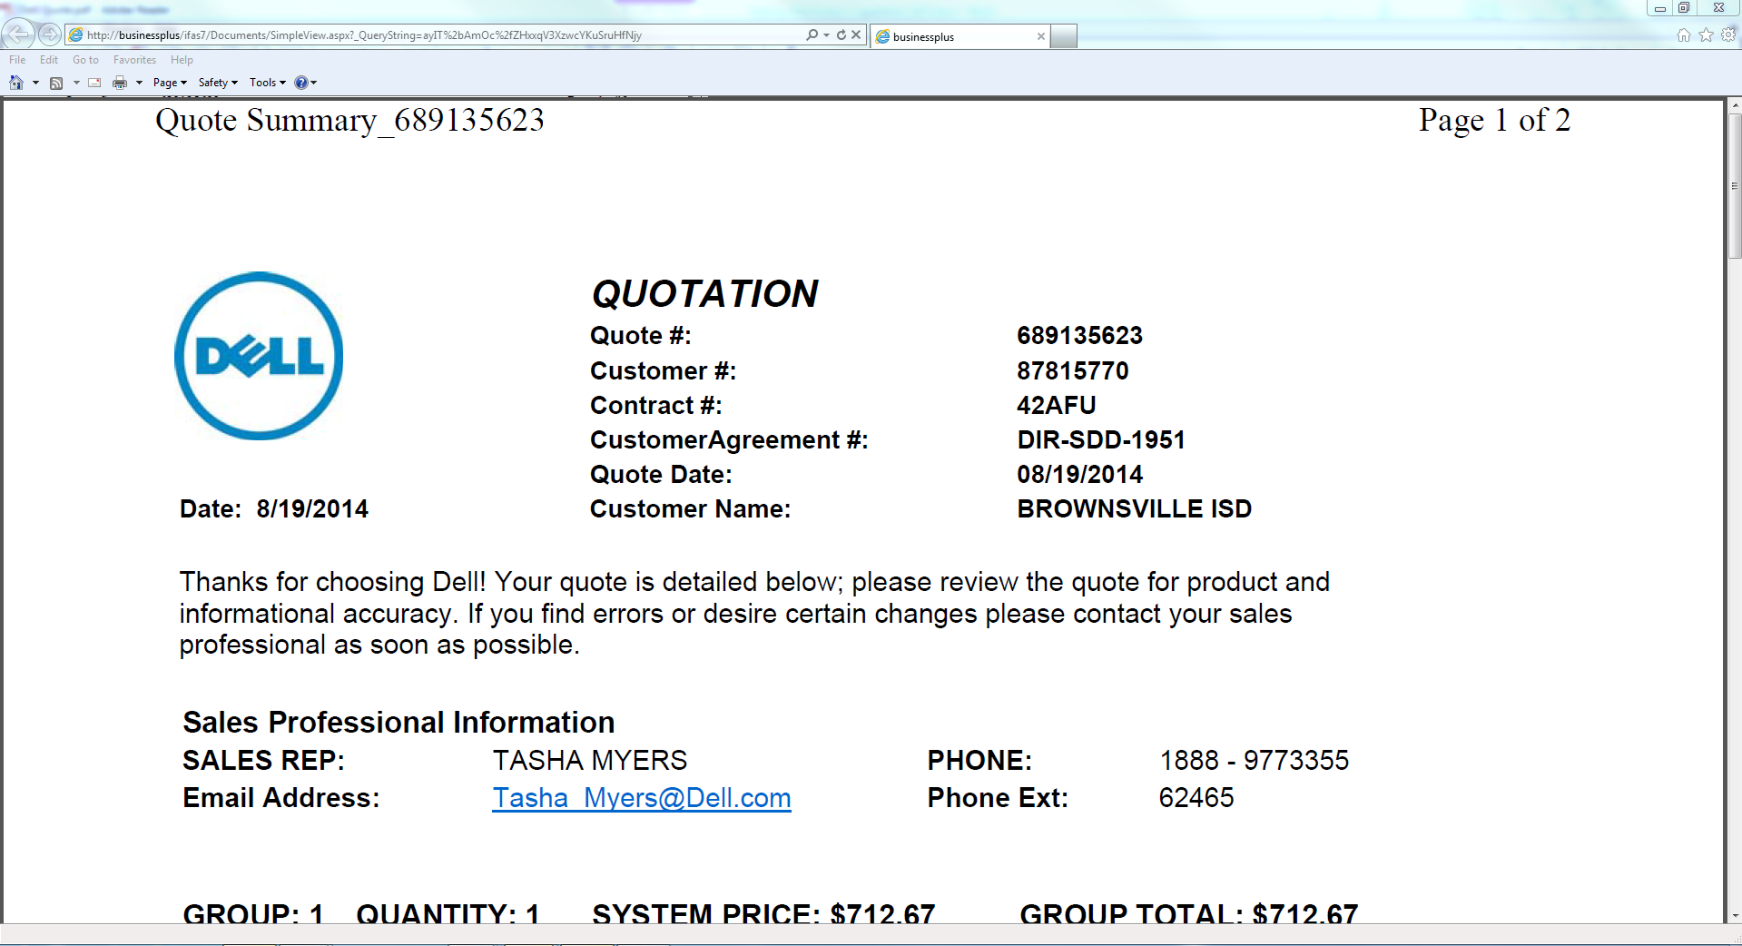

***\*\*Note: Multiple attachments can be added; next is an example of a PR with two attachments***

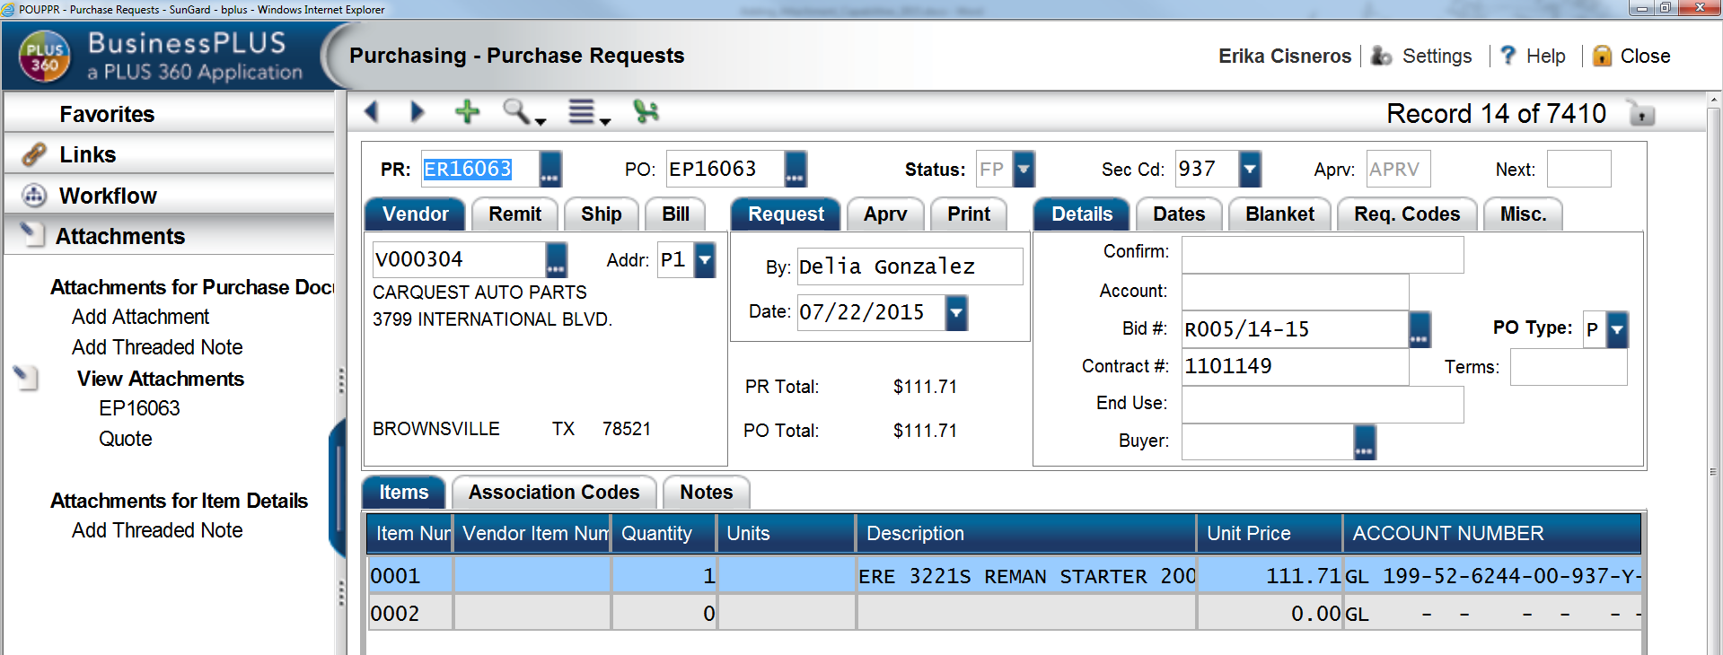

User Name

User Name

***If you have any questions you may contact Business Software Help Desk @ 956-698-1254.***