

How to Trigger a Purchase Req.

**2016**

Business Software Help Desk 

# Step 1: Access Purchase Requisition

\**Example below demonstrates a PR that is frozen due to a rejection.*

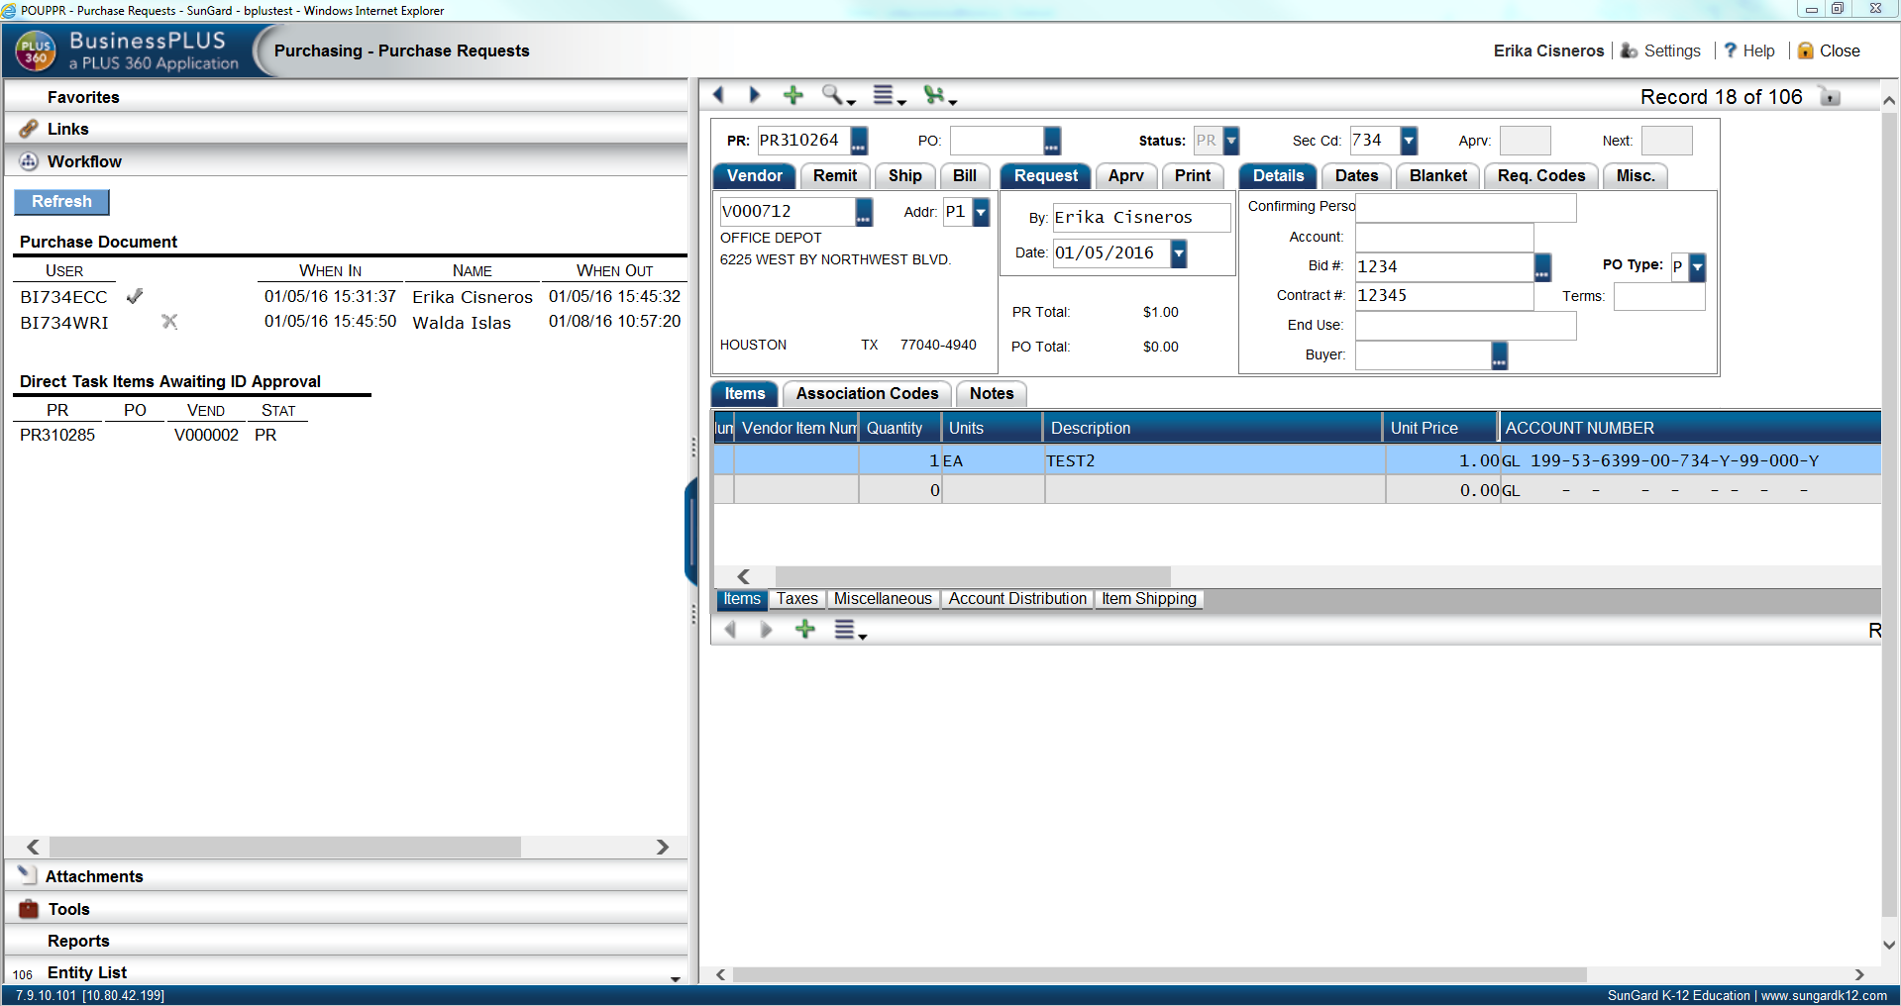

Name

First Appvr

User Name

User Name

User Name

Step 2: Type an * in the Confirming Person Field

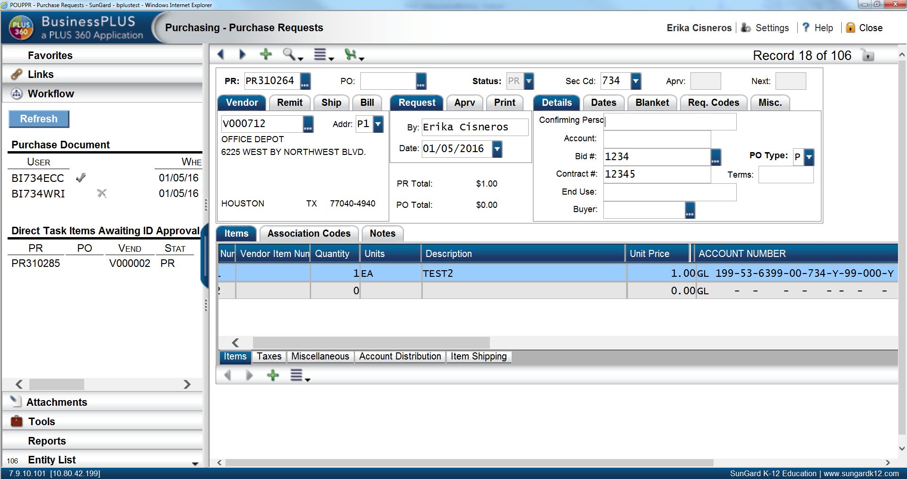

User Name

User Name

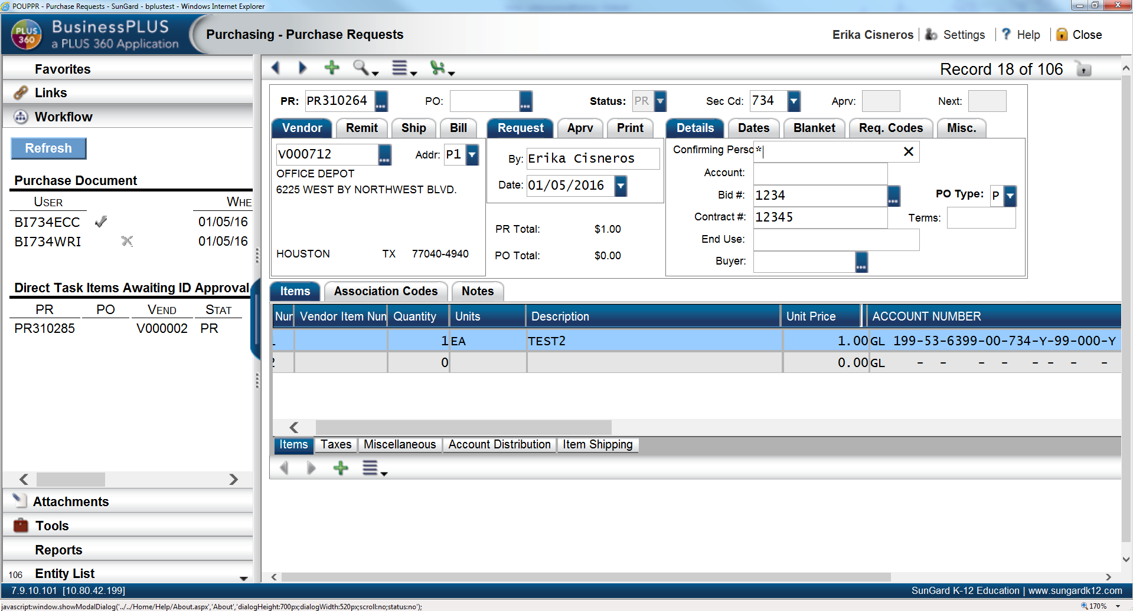

User Name

User Name

**Type: * Hit: Enter Key**

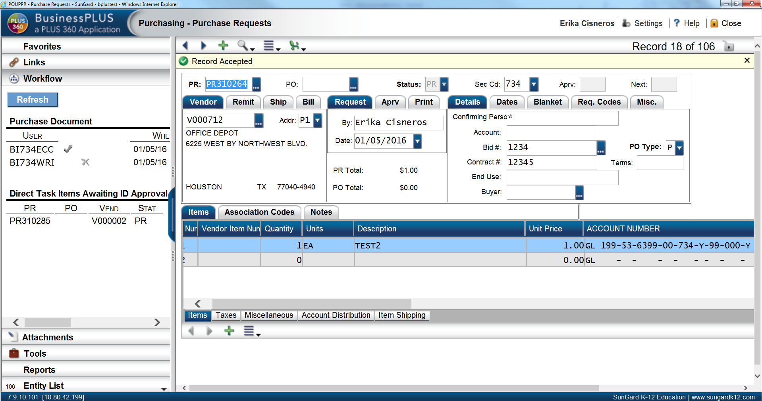

User Name

**Record Accepted message will populate.**



Step 3: Refresh the Screen

\**Note: You must refresh the screen by closing and re-opening the PR Screen or by “Reselecting”. Example below demonstrates the “Reselect” Feature.*

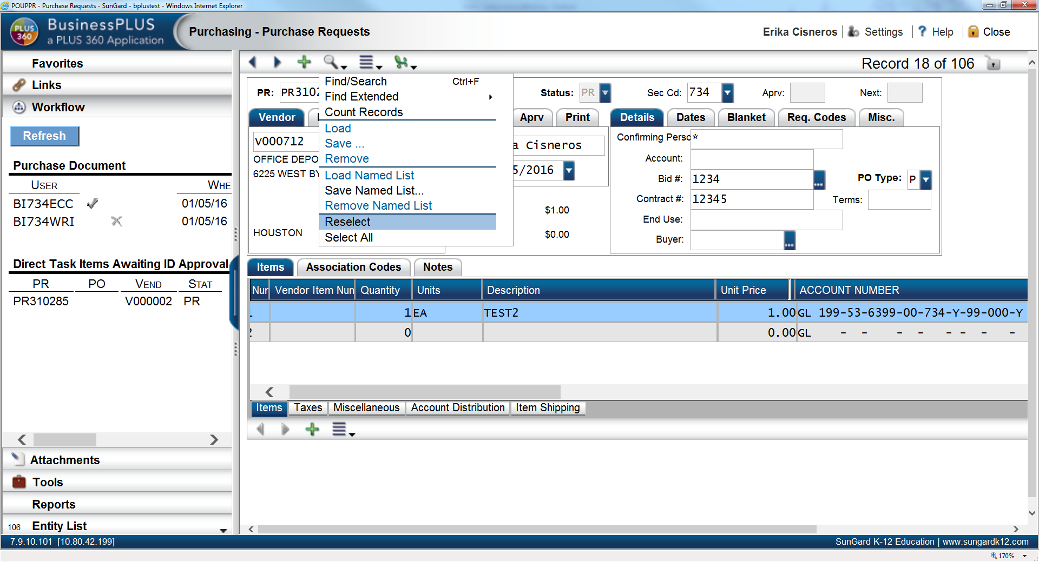

Name

User Name

**Click: Magnifying Glass Click: Reselect**

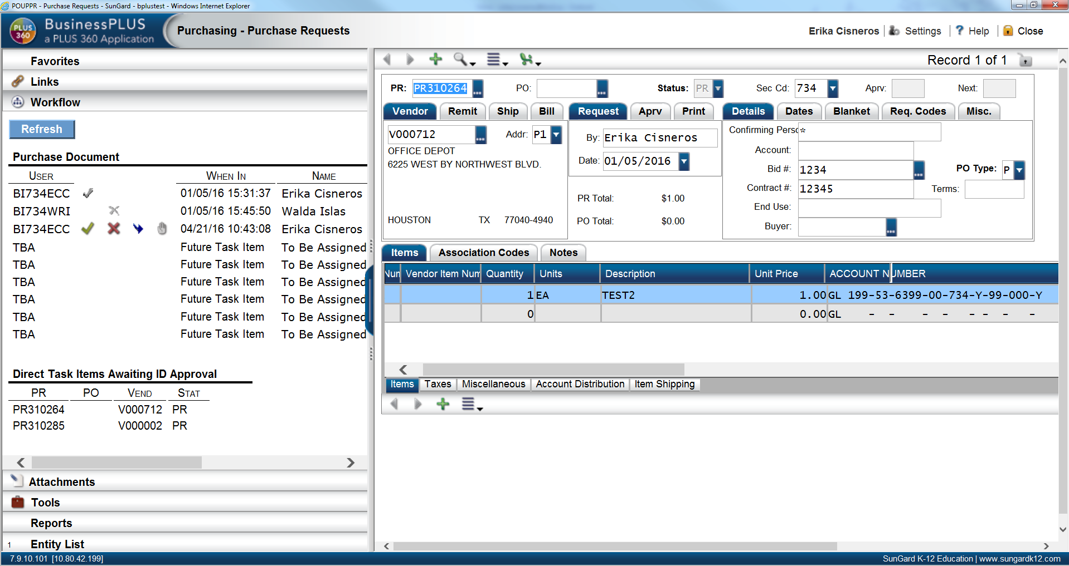

Name

User Name

User Name

First Appvr

User Name

User Name

**Workflow has restarted back with originator.**

***Proceed with re-approving the Purchase Requisition accordingly. PR will then travel through Workflow as normal.***