User’s Quick Navigation Guide
Login to access the BusinessPLUS Dashboard.
Each user will have a Personal Dashboard that can be customized. Links to the Task List, Job Monitor, Weblink and Reports Components are available with 6 layouts to choose from. The user can also rename their Personal Dashboard.
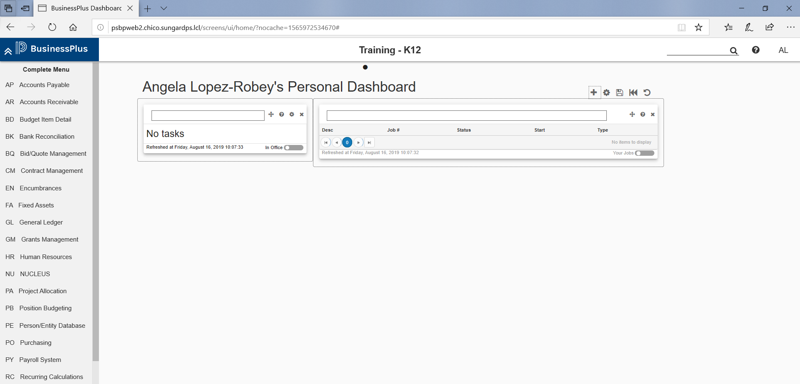
LogOut is done by clicking your initials in the upper right corner and clicking Sign Out
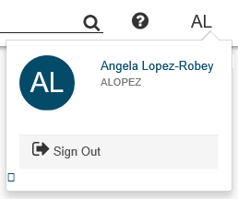
Screens can be accessed from the Search field. Press enter twice after entering full mask.
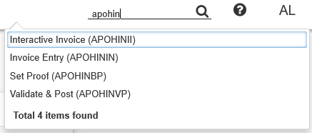
Another option to access a screen is using the Complete Menu in the left panel of the screen by clicking the links for the masks.
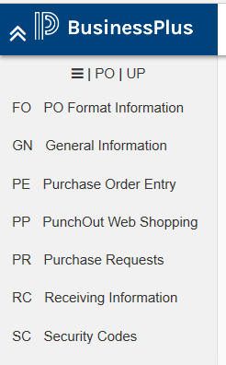

Screens open in Search mode.
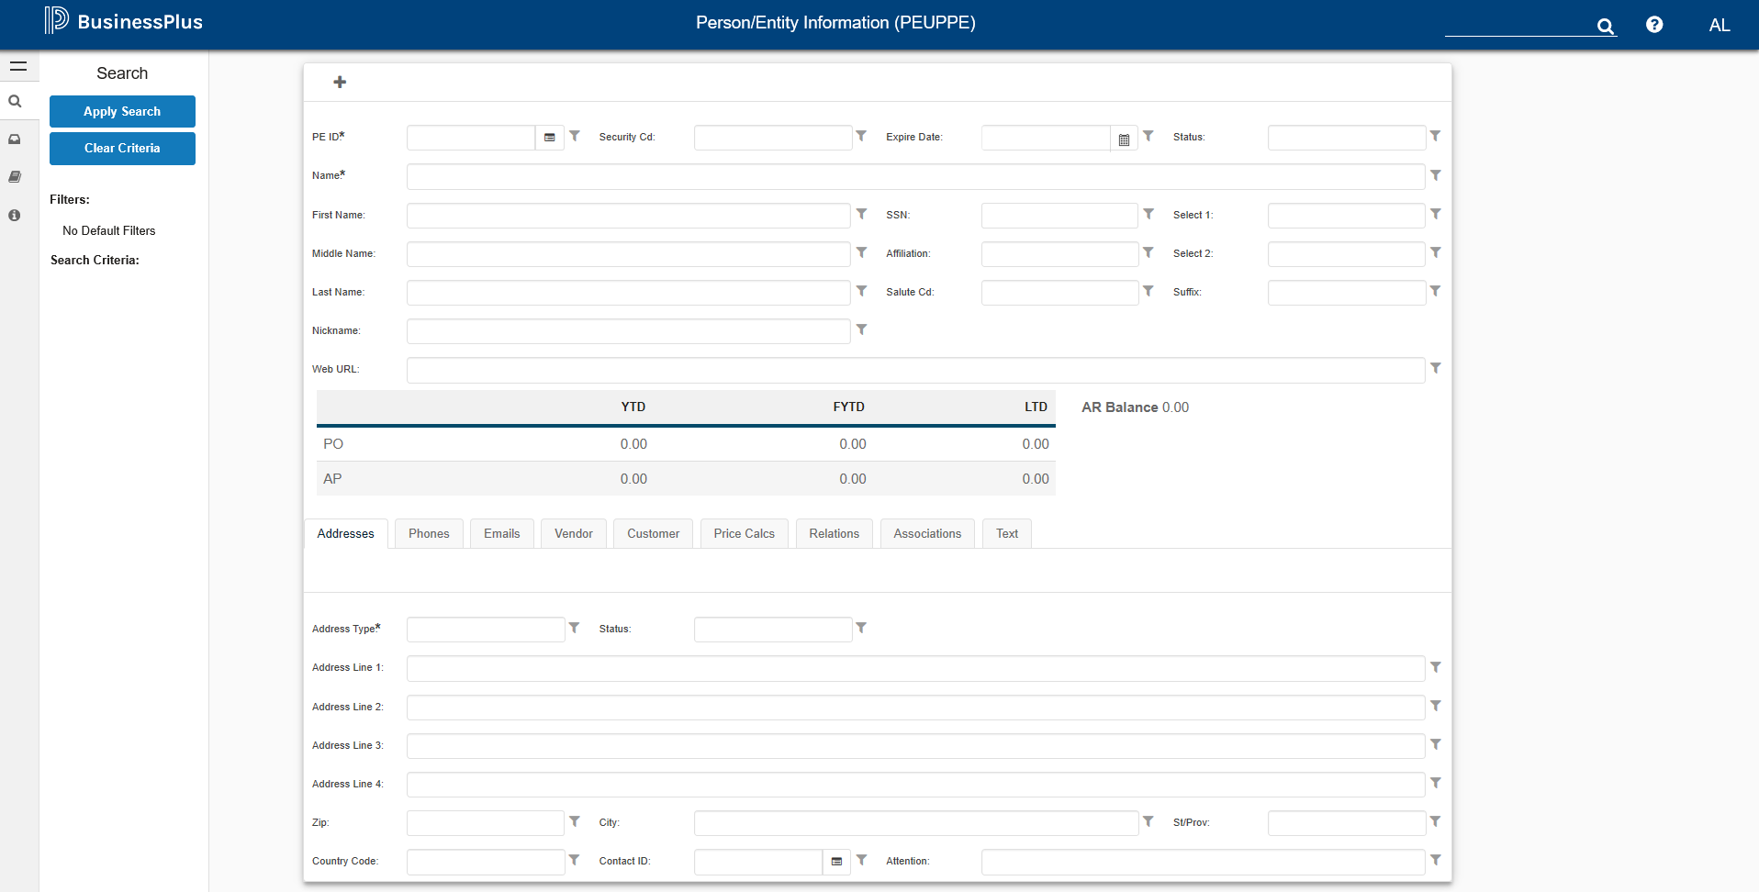

Click the plus sign to change to Add mode for data entry.
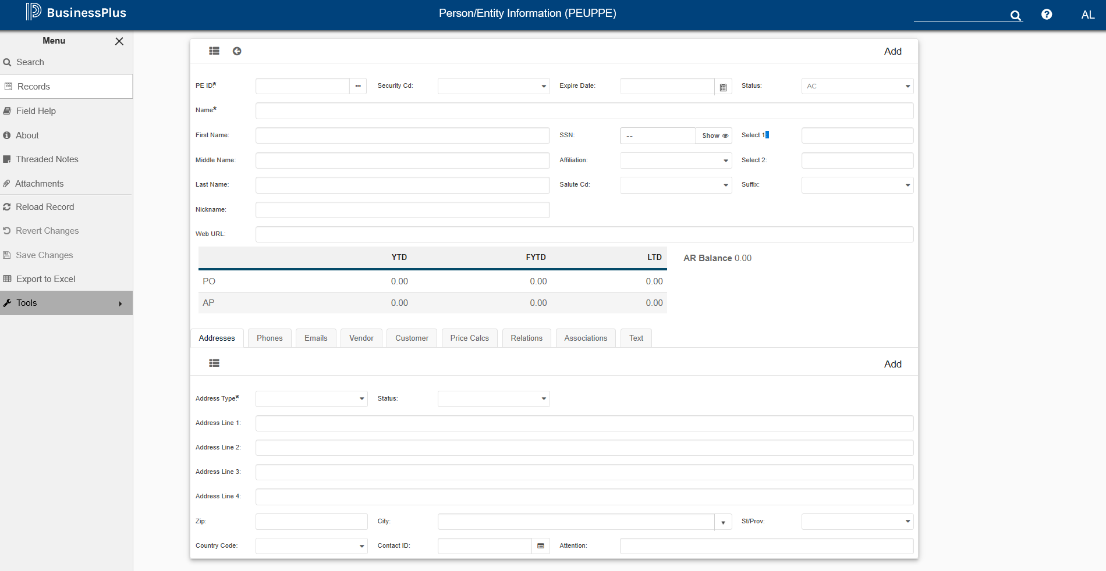
Page Menu Options:
SYMBOL | NAME | DESCRIPTION
 | Expand/Minimize | Expand or minimize the page menu.
 | Search | Enable Search mode. Entered selection criteria appear under “Search Criteria” listing the page or tab name. Click the X to remove.
 | Advanced Search | Save entered selection criteria. Must be in Search Mode to display this option.
 | Records | Display selected record(s) in Grid or Single Record view.
 | Field Help | Display field related DB information in lower right corner of the page.
 | About | Displays release, user, server, connection and Web browser information.
 | Threaded Notes | Displays saved threaded notes. Selecting a saved note or the “Add New Thread” button opens the Update Generic Text (SYUTTXUP) page. User must have appropriate security.  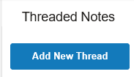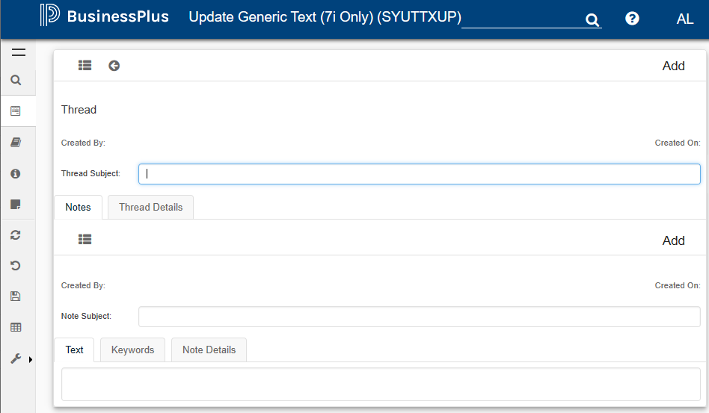
 | Screen Links | Displays links to related screens, if available.
 | Attachments | Displays DO attachments, if any. Select “Add New Attachment” to attach new item.  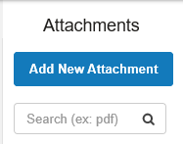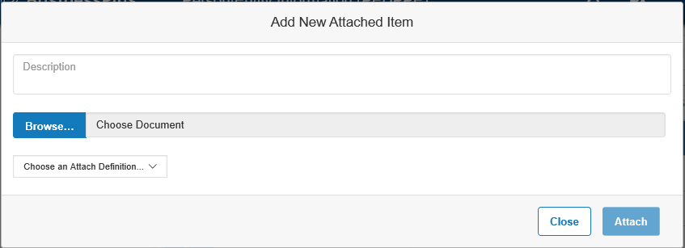
 | ReLoad Record | Reload the current record.
 | Revert Changes | Reverts all changes since the record was last saved. Greyed out if no changed made.
 | Save Changes | Save Changes. Greyed out if no changes made.
 | Export to Excel | Opens the Export to Excel window from which users can select what data to export to excel.
 | Tools | Screen-specific tools appear in bold.  Ledger Settings – Change ledger preferences.  View Last Changes – Displays most recent set of changes  Data Dictionary – Displays DB information for all page fields.

Grid Mode: Search records are returned in this mode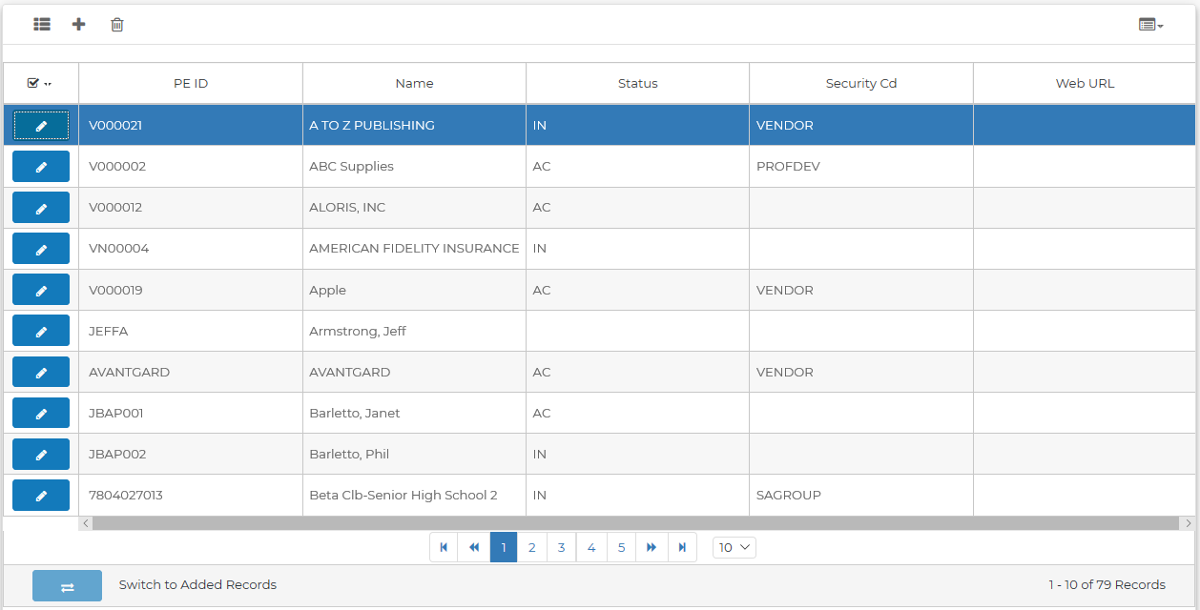
Edit Mode:
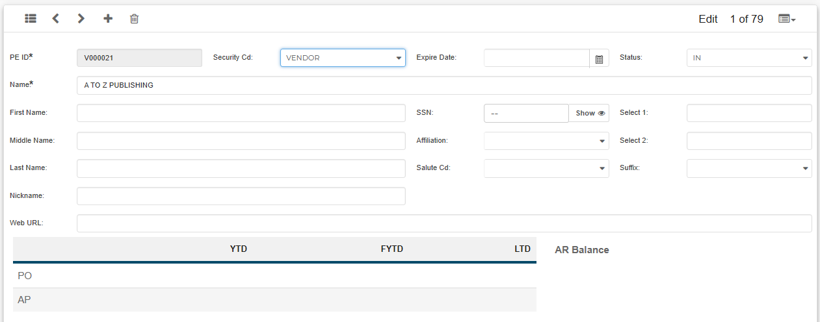

Single and Grid modes Record Controls:
SYMBOL | DESCRIPTION
 | Toggle between Grid and Edit view.
 | Go to previous record
 | Go to next record.
 | Add a new record.
 | Back to Grid from Add mode
 | Delete current record.
 | Copy current record
 | Paste record.
Select page Sort option.
Record Info displays Record Data and Log History.
Copy/Paste current record commands.
 | Switch to Added Records
 | Select columns to display in Grid mode.
 | Edit the selected record in Edit mode.
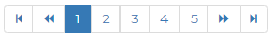 | Use the arrows or page numbers forward or back.
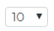 | Select the number of rows to display the Search results window.
 | Which subset of records out of the total number of records is currently displayed.

