GMS Elementary Distance Learning Log-In Information
*Teachers will be in touch via Remind and/or email. Please keep this document in a safe place for referral.
To access the learning platform (Schoology or Google Classroom), curriculum, and learning websites, follow the steps below:
Step | Directions | Icon
1 | Go to wsd3.org | NA
2 | Scroll down the page. Click on the Clever & Student Links tab
3 | Click on Clever (written in blue font)
4 | Log in using student Google account (email and password). Your child’s log-in information should be shared with you via his/her teacher. | NA

Here your student can access everything they need.
Step | Directions | Icon
1 | Scroll down and click on Schoology/Google Classroom | 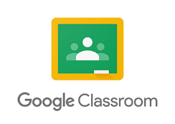
2 | Click on __________________________
3 | Click on _______________________ to locate conferences.

Computer log-in information is located _________________________________.
Specials classes are located _______________________________________.

