Day | Morning physical activity - http://jumpstartjonny.co.uk/ | 0945-1000 | Free time | 1010-1030 | Free time | 1100-11.20 | 11.20-1140 | LUNCH BREAK | 1-1.30pm | 1.30pm 2.30pm | Physical Activity
M |  | Phonics: Log on to Purple Mash and find Phonics Phase 3. Can you complete the sounds game and add the sounds to the words. Remember to say your sounds and read the word.  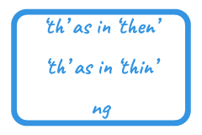 |  | Maths - Logon to Purple Mash  https://www.purplemash.com/#tab/pm-home/maths/numbers/number_addition_subtraction.  Maths adding up to 20  Can you solve the addition to 20 number sentences? Use objects around your home to help you. Can you count 20 dolls or 20 cars?  https://login.mymaths.co.uk/login |  | English – Logon to Purple Mash  https://www.purplemash.com/#tab/pm-home/literacy/purplemashcams  Can you put yourself into the role of an astronaut? You’re your thoughts and character in the speech bubble. Can you describe what you would see? How you would feel and what you would like to explore.  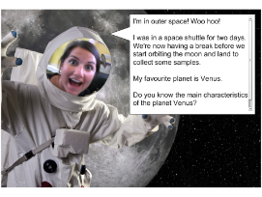 | STORYTIME – reading or listening to a story  https://www.booktrust.org.uk/books-and-reading/have-some-fun/storybooks-and-games/. This website has interactive books to read online as well as videos of stories being read aloud. |  | Reading via Bug Club or your allocated reading book(s).  https://www.activelearnprimary.co.uk/login?c=0 | Physical Activity–  This week we’re going to pretend you’re a bouncing alien. Can you bounce on the spot then bounce around? Can you make your bounces higher so they are like jumps? Now try jumping over small things like cuddly toys or cushions. How far can you bounce? Remember to bend your knees and your ankles. You could lay out a bouncing obstacle course.  Remember:  You could challenge yourself even further by counting the number of bounces you make. Can you beat your score each time?
T |  | Phonics: Log on to Purple Mash and find Phonics Phase 3. Can you complete the sounds game and add the sounds to the words. Remember to say your sounds and read the word. |  | Maths – Logon to Purple Mash  https://www.purplemash.com/#app/pup/maths_activities_Y1_addition_upto_10_10  Maths addition up to 20  Can you solve the addition to 20 number sentences? Use objects around your home to help you. Can you count 20 dolls or 20 cars?  https://login.mymaths.co.uk/login |  | English – Logon to Purple Mash  https://www.purplemash.com/#tab/pm-home/literacy  Can you create a story for your astronaut on 2Create a story. Once your story is completed can you draw a picture to match your story.  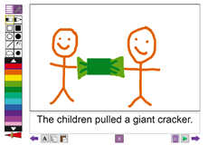 |  |  | Reading via Bug Club or your allocated reading book(s).  https://www.activelearnprimary.co.uk/login?c=0 | History – Can you imagine you are Neil Armstrong? Watch the footage of the first landing on the moon.  Write a postcard to your friends and family describing what you can see on the moon and how you feel to be the very first person to land on the moon.  https://www.nasa.gov/mission_pages/apollo/apollo11.html  Remember:  Say each sentence out loud before you write it.  Hear the sounds and say each word as you write it.  Use capital letters and full stops.  Re-read your work through afterwards to check that it makes sense.
W |  | Phonics:  Log on to Purple Mash and find Phonics Phase 3. Can you complete the sounds game and add the sounds to the words. Remember to say your sounds and read the word.  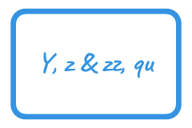 |  | Maths:  Logon on to Purple Mash  https://www.purplemash.com/#tab/pm-home/maths/numbers/number_addition_subtraction/printable_resources_maths_number_bonds  Can you print out or write your numbers on post it notes 1-10 and play the number bonds game?  Can you write all your numbers to 10 in words?  Then challenge yourself to either print out or write your numbers up to 20 on post it notes. Can you play the number bonds up to 20 game?  Can you write all your numbers in words up to 20?  https://login.mymaths.co.uk/login |  | English – Logon to Purple Mash  https://www.purplemash.com/#tab/pm-home/literacy/2publish  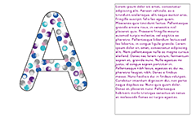  Choose the capital letter for your name and write as many facts as you can about yourself. |  |  | Reading via Bug Club or your allocated reading book(s).  https://www.activelearnprimary.co.uk/login?c=0 | Art – Logon to Purple Mash  https://www.purplemash.com/#tab/pm-home/art  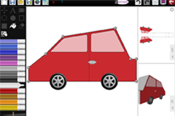  Can you design your own moon buggy for an adventure on the moon.  Remember:  You could try thinking about the materials you might need to make the moon buggy. Can you label the different materials and equipment you may need to make it.  Can you make your moon buggy?  Please email or tweet your finished sculptures to us.
Th |  | Phonics: Log on to Purple Mash and find Phonics Phase 3. Can you complete the sounds game and add the sounds to the words. Remember to say your sounds and read the word.  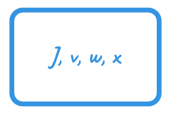 |  | Maths: Logon to Purple Mash  https://www.purplemash.com/#tab/pm-home/maths/numbers/number_addition_subtraction  Can you complete the addition and subtraction number sentences to 20?  https://login.mymaths.co.uk/login |  | English – Logon to Purple Mash  https://www.purplemash.com/#tab/pm-home/literacy/2publish  Can you create a dinner menu for Beegu ready for when she returns back to Earth? Can you write an invitation for Beegu to join you for dinner? Would you like Beegu to eat your favourite dinner or desert?  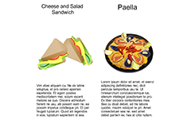 |  |  | Reading via Bug Club or your allocated reading book(s).  https://www.activelearnprimary.co.uk/login?c=0 | RE –  This term we have been learning about some of the Parables that Jesus told which are found in the Bible and how they can link to our Academy values:  Care, Respect, Independence, Success Perseverance  This week we’d like you to design a poster of our core values and describe which values are most important to you and why?  Remember –  Please add labels to your poster.
F |  | Phonics:  Log on to Purple Mash and find Phonics Phase 3. Can you complete the sounds game and add the sounds to the words. Remember to say your sounds and read the word. |  | Maths - Logon to Purple Mash  https://www.purplemash.com/#app/maths/maths_activities_y1_addsub_quiz4  Can you challenge yourself to complete the worded problems?  Remember to count out the different objects you have in your home to help you.  https://login.mymaths.co.uk/login |  | English – Logon to Purple Mash  https://www.purplemash.com/#tab/pm-home/literacy/2publish  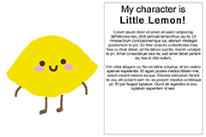  Can you draw a picture of Beegu and then describe her. Remember to include what she looks like, how she is feeling and what happens to her here on Earth. |  |  | Reading via Bug Club or your allocated reading book(s).  https://www.activelearnprimary.co.uk/login?c=0 | Share success

