Day | Morning physical activity - http://jumpstartjonny.co.uk/ | 0945-1000 | Free time | 1010-1030  Reception ‘We can solve it!’ Week - 1 | Free time | 1100-11.20 | 11.20-1140 | LUNCH BREAK | 1-2 | Physical Activity
M |  | Phonics: Log in to purple mash and find mini mash. Click on the picture of the lady with the book.  Look at the phase 2 phonics games focusing on s,a,t,p,I, n  https://www.purplemash.com/#tab/mm_literacy/phonics_cloze_mm  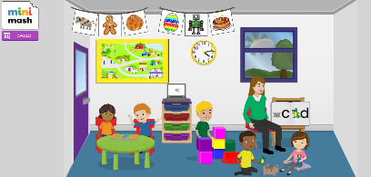  Can you put the correct sound at the start of the word? Don’t forget to say the word to help you hear the sound. |  | Maths: Log on to purple mash, mini mash and find maths city:  https://www.purplemash.com/#app/games/mc1_minimash  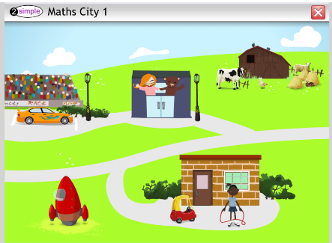  Find the car racing game. Match the numbers on the cars to the numbers on the race track. Which number is the biggest? Which number is the smallest? |  | Literacy/speaking  This week we are going to be Helping Mother Goose, and she is looking after the character Humpty Dumpty. Do you know who he is? Can you tell someone the rhyme?  Can you get your grown up to tell you the rhyme and pause – can you finish the sentence?  Remember:  To speak clearly when saying the rhyme.  Try and say it in different ways – maybe try singing. | STORYTIME – reading or listening to a story  https://www.booktrust.org.uk/books-and-reading/have-some-fun/storybooks-and-games/. This website has interactive books to read online as well as videos of stories being read aloud. |  | Art / Computing  Have a look on purple mash and see if you can use 2paint to create your own picture of Humpty Dumpty.  Remember  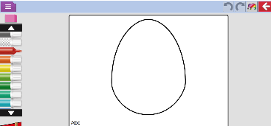  Think about what shapes and colours you will need.
T |  | Reading  Log into bug club and read a story with your grown up.  Remember:  To talk about what happened in the story and what you think might happen next to develop understanding and speaking and listening skills. |  | Maths – Log on to purple mash and find the 2 count app, choose the dice option  https://www.purplemash.com/#app/tools/2count  Roll the dice (you could make your own if you don’t have one) 10 times. Have a go at counting how many times you roll each number  Remember:  Count the spots carefully  When you have finished count how many times you rolled each number. Which number did you roll the most? Which number did you roll the least? |  | Literacy/speaking  Thinking about the Humpty Dumpty rhyme. Can you get your grown up to mix up the different parts of the rhyme and then have a go at putting the it back in the right order. Can you draw pictures to match each section?  Remember:  Think carefully about the rhyme and what happens in it.  Use a good pencil grip and think about what shapes and colours you might need. |  |  | Computing:  Have a look on mini mash and explore the different sections.  There are lots of different learning opportunities that the children can explore.  Remember  To only use the computer / iPad with a grown up.
W |  | Phonics: Log in to purple mash and find mini mash. Click on the picture of the lady with the book. Look at the phase 2 phonics games focusing on m and n this time  https://www.purplemash.com/#tab/mm_literacy/phonics_cloze_mm  Can you put the correct sound at the start of the word? Don’t forget to say the word to help you hear the sound.  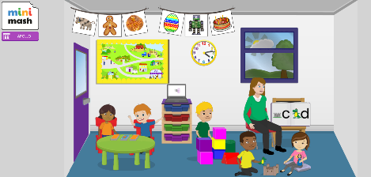 |  | Maths – repeating patterns  This week we are going to be having a look at how to make a repeating pattern. Can you find 2 different objects from around your house or outside and make a repeating pattern?  Remember  You need to use the same things to make sure that it is a repeating pattern.  Think about how many different ways you could make your pattern  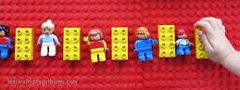  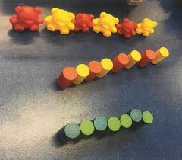  Think about size, colour and shape of your objects. |  | Literacy/speaking  Using purple mash, can you have a go at making a speech bubble for Humpty Dumpty? What might he be saying?  Remember:  Think about what you want to write.  Think about what sounds you can hear and have a go at recording them.  https://www.purplemash.com/#app/mashcam/humpty_dumpty_cam  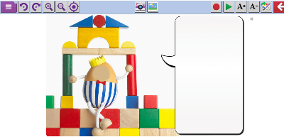 |  |  | Music: Log on to purple mash, mini mash and go outside to find the music section  https://www.purplemash.com/#tab/mm_music  Experiment with the different instruments. What sounds do you like the best? Can you talk about why you like them?
Th |  | Reading  Log into bug club and read a story with your grown up.  Remember:  To talk about what happened in the story and what you think might happen next to develop understanding and speaking and listening skills. |  | Maths – repeating pattern  Ask someone to start off a repeating pattern for you – have a go at continuing the pattern that they have started  Remember:  Look carefully at the objects that they have used.  Think about the shape, size and colour of the objects  Think about how many different objects they have used in their pattern.  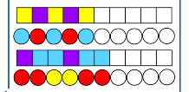 |  | Literacy –  Oh no! Humpty keeps falling off the wall and breaking. Can you make a plan to stop him from breaking when he falls off the wall?  Remember –  Think about your idea and draw your picture.  Can you have a go at labelling it, think about what sounds you can hear. |  |  | Art –  Humpty Investigation.  Can you have a look around your house and find things that are hard and things that are soft. Talk about what you think would be the best thing for Humpty to land on.  If your grown up says yes, boil some eggs and have a go at dropping them on the different objects. Which one worked best?  Remember –  To make it a fair test, always drop it from the same height.
F |  | Phonics: log on to Purple mash and find the letter pairs game.  Choose one of the sounds that we have learnt so far – m,a,s,t,I,n,o,p  https://www.purplemash.com/#tab/mm_literacy/phonics_cloze_mm  Can you name all of the different objects? Match the pairs together that start with the same sound. |  | Maths – repeating pattern  Have a look around your house or outside. Can you find anything that has a repeating pattern. Talk to someone about the pattern that you can see. If you were carrying on the pattern what would you need next?  Remember:  Look carefully it might be a small pattern  What colours or shapes can you see that have been used in the repeating pattern? |  | Literacy –  Now you have some good ideas about how to help Humpty Dumpty, can you write him a letter to tell him what he should do?  Remember –  To address the letter to Humpty Dumpty and start from the top of the page. |  |  | TIME TO SHINE – Please share your creations and activities via your year group Twitter page.  Please remember that you can follow us at :  https://twitter.com/PHInfants  You can also follow our Reception Twitter page @PHIReception
If you need a re minder of log in information for any of the sites mentioned below please do not hesitate to email – office@phiacademy.org.uk
Instructions on how to get to mini mash:
- Log into Purple Mash
- Click on Mini Mash
- It should take your straight to Mini Mash, but if another screen comes up press ‘Enter Mini Mash’.

