IBERIAN MUN GENERAL ASSEMBLY

Officer Report 2020

*The question of protecting mental health during isolation and times of crisis.*

During the past decades, mental health, an issue commonly overlooked in the past, has become prominent in everyday and political debates. According to the WHO, this term refers to “a state of well-being in which an individual realizes his or her own abilities, can cope with the normal stresses of life, can work productively and is able to make a contribution to his or her community” (WHO). The urgency to discuss the issue at hand springs from the fact that about 25% of the global population is predicted to face a mental health condition. The most common being depression (which is estimated to become the top global burden of disease in 2030), intellectual disabilities, schizophrenia and disorders such as anxiety, mood, psychotic, eating, addiction, personality, obsessive-control post-traumatic (WHO).

In addition to the eminent medical implications, mental health, when poorly managed, can have broad consequences in the social, economic, and political sectors. Regarding its social impacts, there is an increased level of sexual and physical abuse towards the person suffering from the disorder, as well as verbal discrimination, and psychological manipulation. These issues tend to be more prominent in nations that uphold conservative views and stigmatize mental health by not addressing it often nor properly. The debate at hand should focus on preventing such forms of violence not only at home, but also in public settings such as hospitals and prisons. These repercussions have recently augmented as a response to the coronavirus pandemic, including a 20% increase in alcoholic addiction between the ages of 15 and 49, a 33% increase in anxiety symptoms (UN News), a rise in dementia among the elder population due to isolation and limited physical activity, and some countries faced up to a 600% increase in domestic violence (The Department of Global Communications). Thus, it is imperative that measures to facilitate the denouncing of these behaviors are proposed and implemented, especially during periods of isolation, in order to attenuate the mental deterioration of the victims. Keep in mind that social misbehaviors can be the consequence but also the cause of mental health issues.

From an economic standpoint, the cost of mental health is between 3% and 4% of the Gross National Product, GNP, (*Investing in Mental Health)*. Yet, this number does not even consider the estimated 12 billion working days that are lost annually due to a lack of productivity from workers with poor mental health, and that by 2030, will cost the global economy about $16 trillion (The Carter Center). Two common terms used when discussing the relationship between mental health and workplace performance are absenteeism, which refers to missed workdays, and presenteeism, which is the reduced productivity while present in the workplace (Kuhl). The increased tendency towards mental health conditions among the youth is also predicted to decrease the quality of performance at school, which can result in increased unemployment and reduced earning potential. Hence, the short-term consequences will be amplified in the future if no immediate action is taken. On the other hand, the economy itself can also act as a determinant of mental health issues, especially during national and international economic crises, so both sides need to be addressed in the debate.

The worsening of mental health isn’t just a reality during the Covid-19 pandemic nor does it only occur due to medical crises; there are numerous examples sparked from political conflicts. A current political crisis that has raised concerns on the issue of mental health is that of Hong Kong, which has been marked by the acts of suicide committed by protestors during public demonstrations. According to Hong Kong University, the unrest and political instability have led to a 1.1% increase of suicidal thoughts among the region’s population (Kuo). Another existing crisis that has brought light to the issue of mental health is the Black Lives Matter Movement, since it has emphasized authority’s and the police’s poor handling of individuals with mental conditions (Ankel). Mental health is also commonly debated in elections worldwide, whether it is to make promises for better care or question a candidate’s fitness. Nowadays, it is also more frequent to hear complaints suggesting an association between increased mental health struggles with poor governance, as has been made clear by the anti-lockdown protests around the world (Yussuf). Independently of their motives, one thing is clear: isolation has negative consequences on mental health and this debate needs to procure ways to promote cognitive abilities in times of isolation.

Some successful measures that have been taken to protect civilians’ mental health from social, economic and political pressures during crises include the WHO’s QualityRights tool kit. This kit was implemented as a result of the pandemic and can be adhered to by Member States as a means of accessing practical information to ensure the quality of human rights standards in facilities of mental health and social care. It calls upon the protection of the mental health of not only patients affected by the virus, but also of the medical staff (WHO). An advantage of this tool kit is that it is applicable to low-, middle- and high-income nations, as well as to NGOs. The WHO has also published campaign handouts for suicide prevention targeting the victims, possible helpers and even the media writing about such sensitive topics. Hence, all delegates are highly encouraged to strategize the sharing of this campaign in their own state, among other suicide prevention techniques that are easily accessible under lockdown guidelines and that respect privacy. Delegates should also read the “The WHO Special Initiative for Mental Health (2019-2023)”, which aims to establish universal health coverage for mental health, as it has already done in 110 countries through the Mental Health Gap Action Programme, mhGAP. Both are excellent examples of how to plan a feasible and successful project (WHO). Likewise, research “The Lancet Commission on Global Mental Health and Sustainable Development” which focuses on reducing prevention, treatment and care gaps, as well as the stages post-disorder and recovery. The United Nations also have taken action that is a good starting point for delegates researching this agenda issue, such as the Convention on the Rights of Persons with Disabilities.

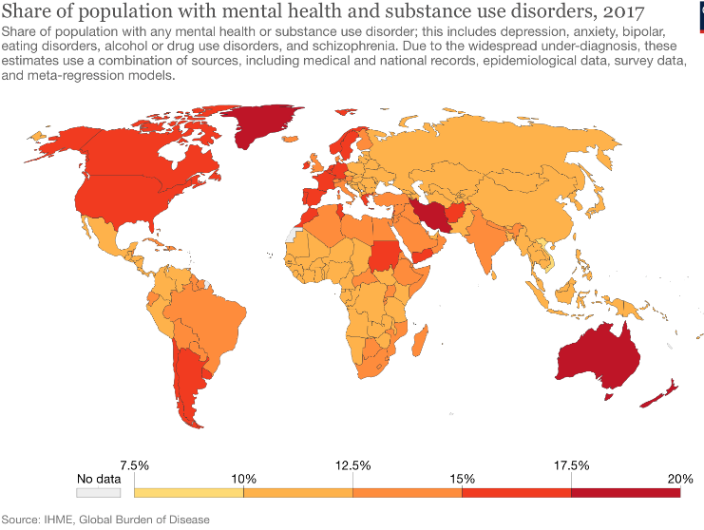

Figure I: Colored graph displaying global health quantified. (Source: Our World in Data)

Upon drawing lessons and conclusions from the publications mentioned above, delegates are encouraged to revert to technology in order to protect mental health during crisis. During the Covid-19 pandemic, several startups were created with the intent of personalizing immediate treatment and to attempt to diagnose mental health disorders at early stages. For example, Canada started “WellTrack”, which is focused on students and tracks changes in their levels of stress, anxiety and mood swings (*StartusInsights)*. Additionally, it also includes techniques to relax. Similarly, the US developed “Welltory” that uses LED technology to measure heart rate and personalizes fitness gadgets. To combat the economic downfall of mental health, the UK implemented “Unmind”, which allows managers to track their workers’ mental health through techniques like those already mentioned, with the particular interest that it is free for workers in the health sector (StartusInsights). Finally, to combat isolation, there are apps such as Flowly that utilize Virtual Reality to restore calmness (*StartusInsights)*. Bear in mind that these programs don't only rely on technological expertise, but also psychiatric, so delegates should reflect upon and, if deemed needed, reallocate funding to increase the numbers of psychiatrists and psychologists available.

As shown by Figure I, North America, Europe and Oceania are the regions with the highest number of mental health conditions. Considering that many MEDCs belong to these regions, it is a sign that even these countries require global guidance and cooperation. From another perspective, Figure 1 can also be an indication that LEDCs don’t have the necessary means to detect such conditions, which is why they are never reported. Since this issue can affect all people alike, all delegates will play an equally important role in ensuring that the clauses and policies that are proposed and installed directly target the improvement of mental health facilities and support, reduce stigma, eliminate discrimination and pressure towards those suffering from these conditions, and prepare the global population to take proper care of its mental health in the case of another pandemic or crisis (independently of its nature). Emphasis should be placed on handling the consequences of isolation. The ultimate goal is to create a safe environment where there is acceptance and a drive to help and seek out help.

Works Cited

Ankel, Sophia. "From Spit Hoods to Ketamine Injections: The Controversial Police Tactics Highlighted by the Black Lives Matter Movement." *Business Insider*, 6 Nov. 2020, www.businessinsider.com/black-lives-matter-6-disputed-police-tactics-highlighted-by-protests-2020-9#3-injecting-ketamine-to-sedate-suspects-3.

The Carter Center. "Mental Illness Will Cost the World $16 USD Trillion by 2030." *Psychiatric Times*, vol. 35, no. 11, 16 Nov. 2018, www.psychiatrictimes.com/view/mental-illness-will-cost-world-16-usd-trillion-2030.

The Department of Global Communications. "UN Supporting 'Trapped' Domestic Violence Victims during COVID-19 Pandemic." *United Nations Covid-19 Response*, 12 June 2020, www.un.org/en/coronavirus/un-supporting-%E2%80%98trapped%E2%80%99-domestic-violence-victims-during-covid-19-pandemic.

"5 Top Mental Health Technologies For The Coronavirus Pandemic." *StartusInsights*, www.startus-insights.com/innovators-guide/5-top-mental-health-technologies-the-coronavirus-pandemic/.

*Investing in Mental Health*. Geneva, World Health Organization, 2003, www.who.int/mental_health/media/investing_mnh.pdf.

Kuhl, Emily A. "Quantifying the Cost of Depression." *American Psychiatric Association Foundation*, www.workplacementalhealth.org/Mental-Health-Topics/Depression/Quantifying-the-Cost-of-Depression.

Kuo, Lily. "'Society Is Suffering': Hong Kong Protests Spark Mental Health Crisis." *The Guardian*, 22 Oct. 2019, www.theguardian.com/society/2019/oct/22/society-is-suffering-hong-kong-protests-spark-mental-health-crisis.

"UN Leads Call to Protect Most Vulnerable from Mental Health Crisis during and after COVID-19." *UN News*, 14 May 2020, news.un.org/en/story/2020/05/1063882.

WHO. *The WHO Special Initiative for Mental Health (2019-2023)*. 2019, apps.who.int/iris/bitstream/handle/10665/310981/WHO-MSD-19.1-eng.pdf?sequence=1&isAllowed=y.

Yussuf, Ahmed. "'Most of Us Come from Countries with Corruption's': What's Driving Some of the Anti-Lockdown Protests in Melbourne." *SBS*, 4 Nov. 2020, www.sbs.com.au/news/the-feed/most-of-us-come-from-countries-with-corruption-what-s-driving-some-of-the-anti-lockdown-protests-in-melbourne.