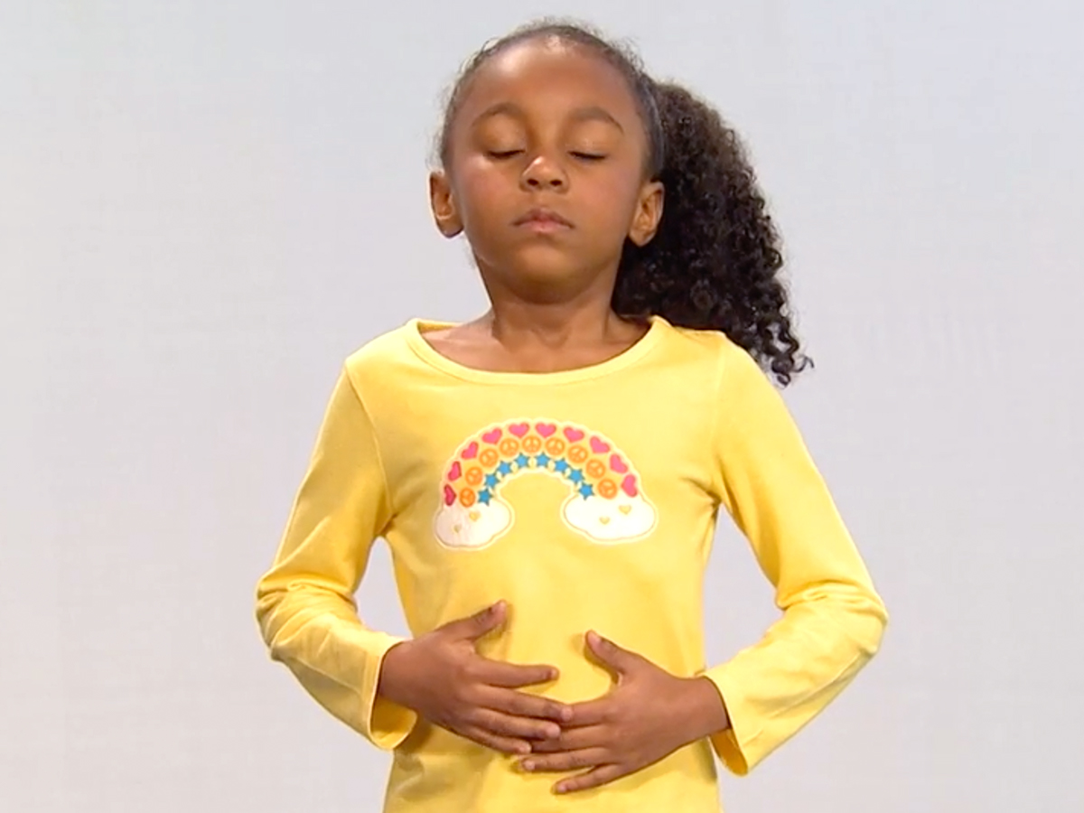

Belly Breathing

Place both hands on your stomach

Breath in slowly counting to 6

and out slowly for 6