Interim Principal: Tom Jordan

Sept 2020

Dear Parent/Carer,

Bug Club is an online reading platform, whereby children can access books to support their reading development and interact with wider reading activities linked to the allocated texts. As you are aware, under current government guidelines, reading books cannot be sent home and as an academy (with support of the University of Brighton Academies Trust) we are very conscious of providing wider opportunities to support the children’s reading development during this academic year.

You are able to access Bug Club by following this attached link: https://www.activelearnprimary.co.uk/login?c=0

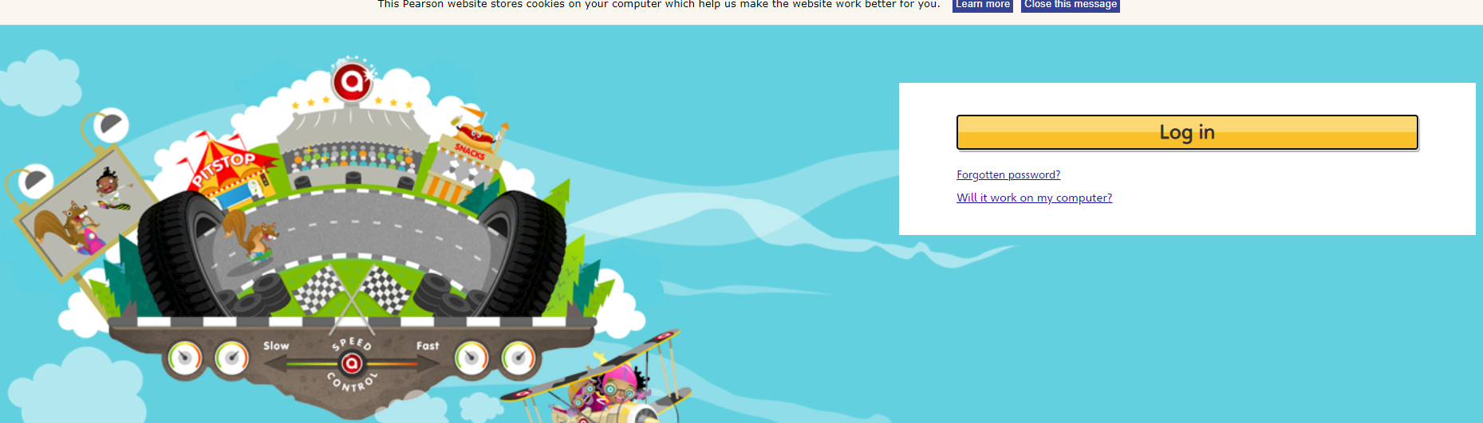

Once you have pressed the link, please press the ‘Log in’ button. You will then need to add your child’s sign-in details:
Username: the first 4 letters of your child’s first name followed by the first 4 letters of their surname eg Jonathan Smith – jonasmit. The names used for your child will be those you gave us as preferred first name and surname.

Password: This will have been emailed to you from the academy, if you need any help with your password please do not hesitate to email office@phiacademy.org.uk
School code: 6a97

An attached video clip will further support you in accessing your child’s account: https://www.youtube.com/watch?v=paOEVzjgwnk&safe=active

Once you have gained access, you and your child will be able to open an allocated reading book. Initially, these have been automatically generated and academy teaching staff will support in allocating more books to further support your child’s reading development

Once you or your child have opened an allocated book, children will be able to read books, listen to them being read and answer comprehension questions about the text if there is an image of a bug on a page. Every ‘bug question’ answered enables children to collect coins (points) which can then be used in their portal for other games and activities.
Further information and guidance in accessing Bug Club can be found through the attached video clip: https://www.youtube.com/watch?v=R_91DamY8Gk&safe=active

A typical page looks like this:
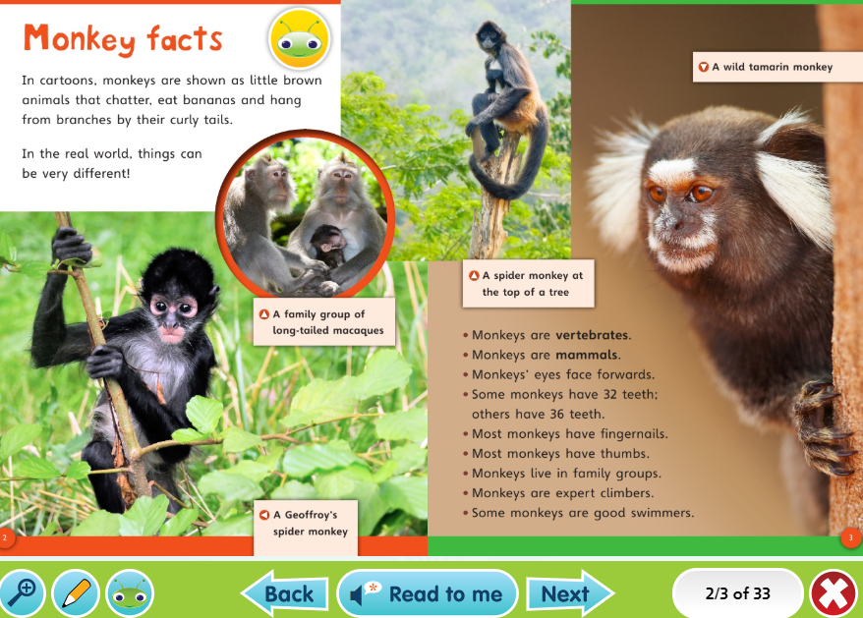

We hope every child enjoys the opportunity to access their allocated books throughout this period to further support their reading skills.

If you require any further assistance, please do not hesitate in contacting the academy office: office@phiacademy.org.uk

Please take care and stay safe. We are thinking of you all.

Yours sincerely,
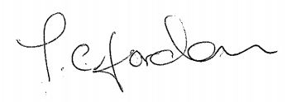

Tom Jordan
Interim Principal

