Hybrid Schedule (begins on October 5, 2020)

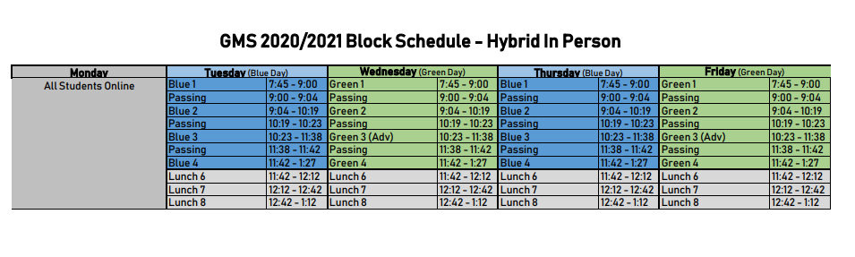

Morning Entrance/Afternoon Exit Doors
