Major Clarity Transcript Request Instructions

- Log into Clever and choose Log in with Google.

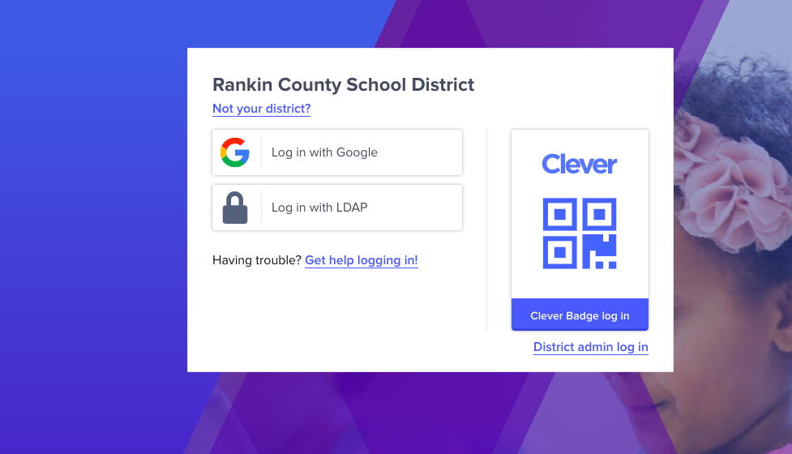

- Click on the Major Clarity icon.
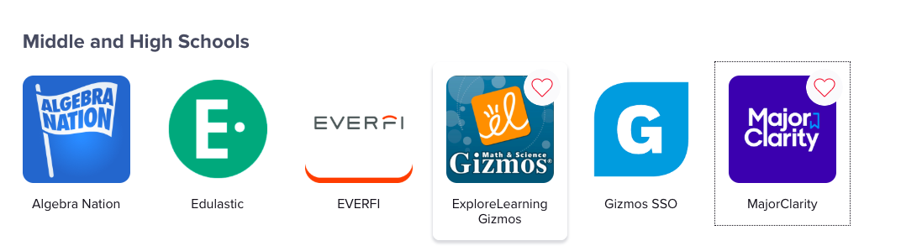

- Click on continue with Google.

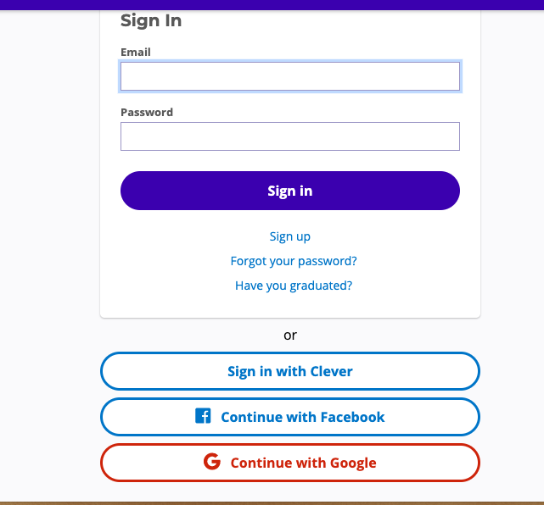

- Use your school email address to login.

- On the left side of the screen, click Application Center.

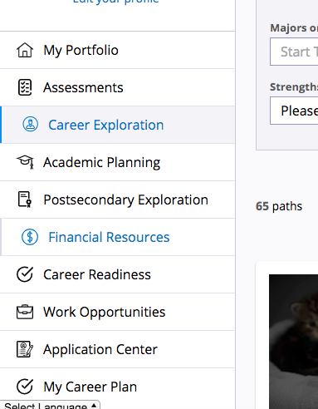

- Then choose request transcript and enter the name of the school where you are requesting your transcript to be sent.

*If you cannot login through Clever, you can go straight to the Major Clarity website at platform.majorclarity.com. Follow the instructions from there.

