Accessing Schoology Conferences

To get to Schoology Conferences, first you want to log into Schoology. You can go to wsd3.schoology.com, or schoology.wsd3.org or you can follow these directions: Student Access to Schoology.

Schoology Conferences does NOT work with Microsoft Edge. Please make sure you are accessing Schoology Conferences through Chrome or Firefox.

Once in Schoology, click on Courses.

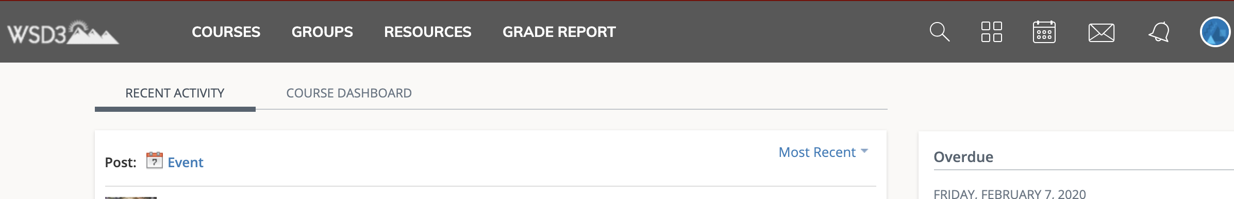

If you don’t see the course you are looking for, click on My Courses.

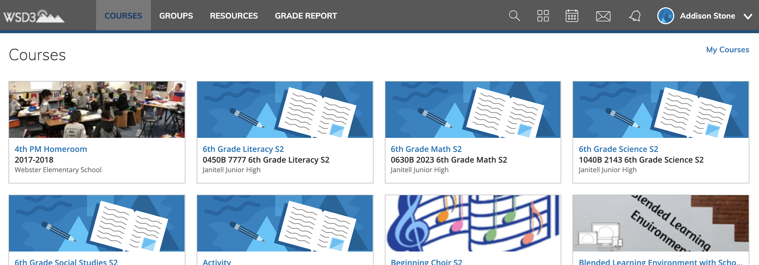

Find the course that you are looking for and go into that course. On the left-hand side of the screen, you should see “Conferences”. Click on that. (This is an example from a course, that might not look exactly like your course, but the links on the side should be the same.)

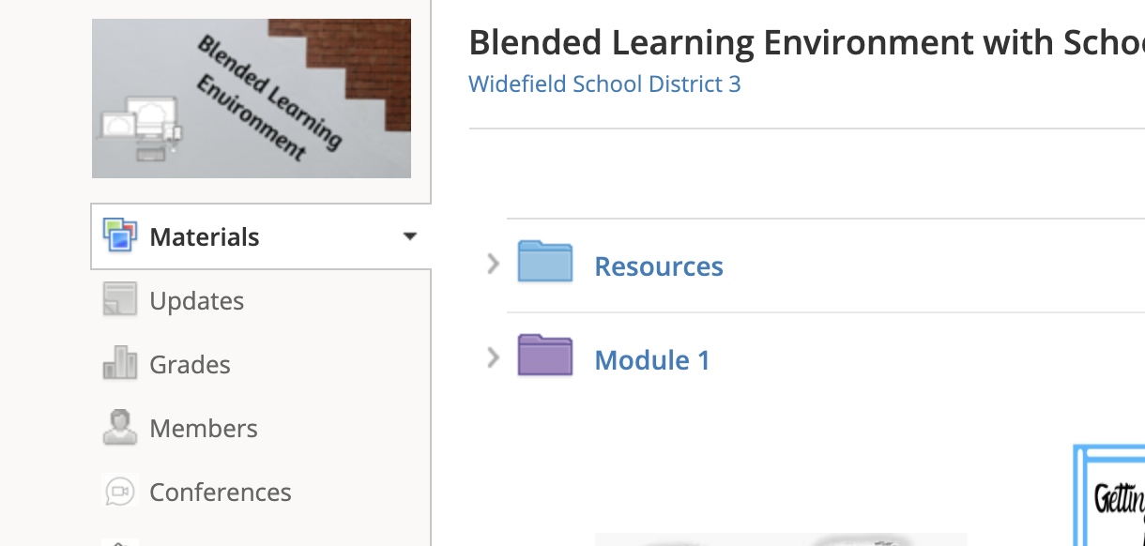

After you click on Conferences, you will come to a screen like this. If there is not a conference scheduled, it will be blank like the first picture below.

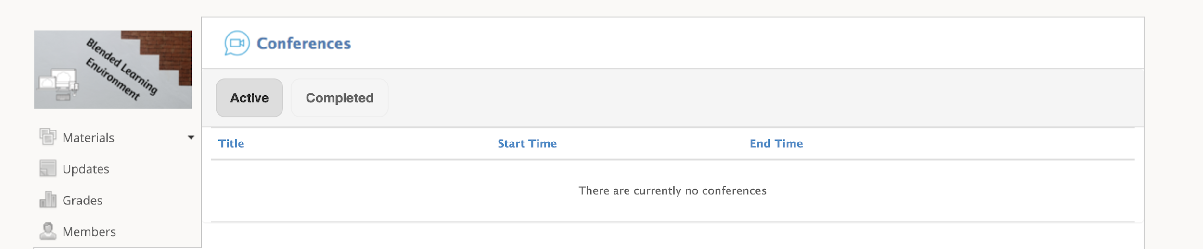

If there is a scheduled conference, but the teacher has not started the conference, you will see the conference listed, but it will not have a link to join.

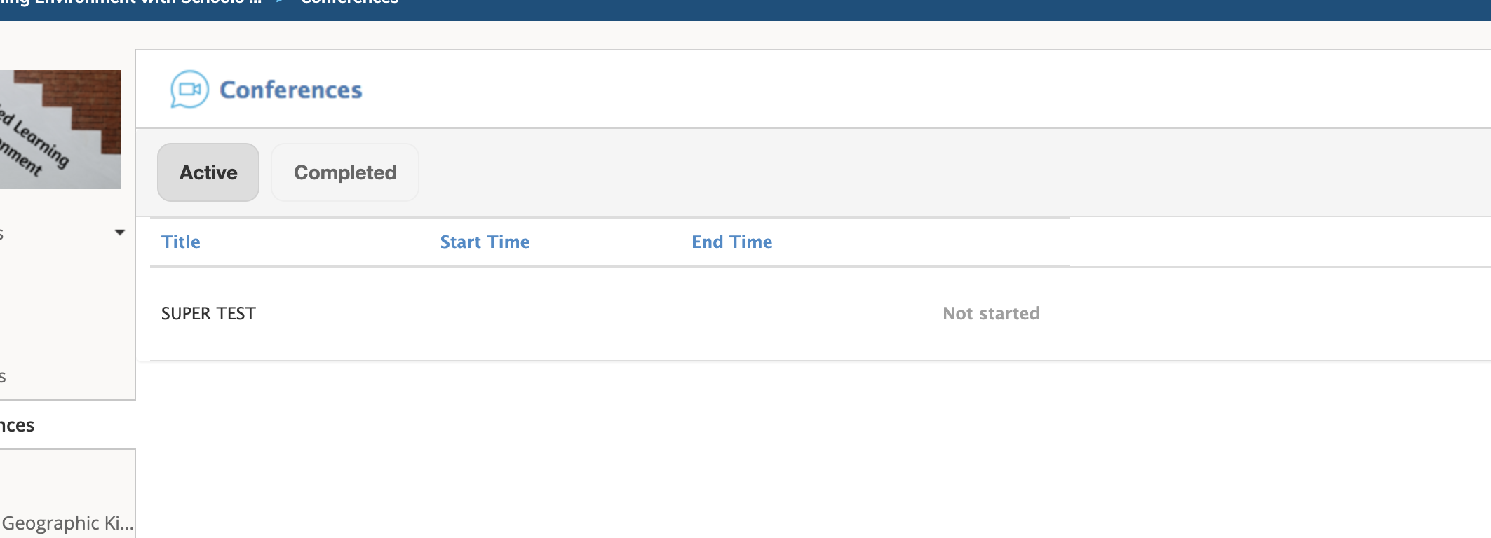

When your teacher has started the conference, it will then become a link to join. Click on the link and it will then enter you into the conference.

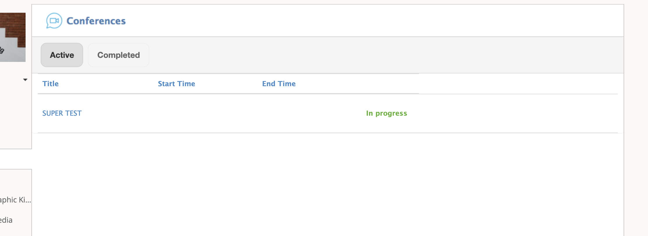

Click this link

