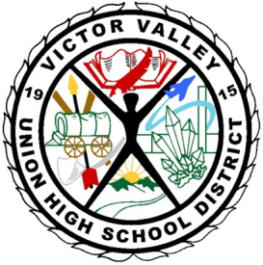

VICTOR VALLEY UNION HIGH SCHOOL DISTRICT
Silverado High School
14048 Cobalt Road
Victorville, CA 92392

Meeting is “Open to the Public” /Public Comment (3 min. per/person)
Date and Time: Wednesday, October 9, 2013 3:00 pm
Location: The Library
Agenda Posting Date: October 5, 2013

School Site Council Agenda
- Call to Order
- Introduction of Members
- Additions/Deletions of Agenda Items
- Reading and Approval of Previous Meeting Minutes
- Read and approve minutes from September 23, 2013 meeting.
- Reports of Officers/Standing and Special Committees/Student
- Discussion Items
- Discussion/Joint Development: School Plan 2013-14*
- Roles and Responsibilities of SSC
- District Parent Involvement Policy*
- District Parent Complaint Policy and Procedure
- Title 1 School - “What does this mean?”
- API/AYP/CAHSEE/CELDT School Data

- Information Items
- Action/Consent Items
- Ratification of SPSA as a working draft to revisit each meeting
- Unfinished Business and General Orders
- Elections Chairperson, Vice-Chairperson, Secretary, Parliamentarian
- New Business
- Public Comment (3 minutes)
- Adjournment – Meeting was adjourned at ________________________________

Next Meeting: _____________________
Parents that need special accommodations other than written translation and/or oral interpretation in Spanish, please contact the office 3 days prior to the date of the meeting.

