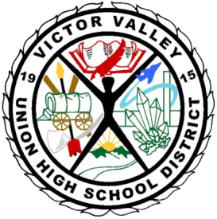

VICTOR VALLEY UNION HIGH SCHOOL DISTRICT
Silverado High School
14048 Cobalt Road
Victorville, CA 92392

Meeting is “Open to the Public” /Public Comment (3 min. per/person)
Date and Time: Wednesday, May 7, 2014, 3:00 pm
Location: Room 3104
Agenda Posting Date: May 2, 2014

School Site Council Agenda
- Call to Order
- Reading and Approval of Previous Meeting Minutes
- Reports of Officers/Standing and Special Committees/Student
- Information Items
Constituency Election/Results
SPSA Evaluation 2013-2014
- Action/Consent Items
Meeting dates for 2014-2015

- New Business
Preliminary 2014-2015 SPSA Expenditure Requests
SSC Member ideas toward the new 2014-2015 SPSA

- Public Comment (3 minutes)
- Adjournment – Meeting was adjourned at ________________________________

Next Meeting: __TBD___________________

Parents that need special accommodations other than written translation and/or oral interpretation in Spanish, please contact the office 3 days prior to the date of the meeting.

