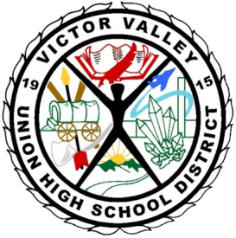

VICTOR VALLEY UNION HIGH SCHOOL DISTRICT
Silverado High School
14048 Cobalt Road
Victorville, CA 92392

Meeting is “Open to the Public” /Public Comment (3 min. per/person)
Date and Time: Wednesday, January 15, 2014, 3:00 pm
Location: The Library
Agenda Posting Date:

School Site Council Agenda
- Call to Order
- Reading and Approval of Previous Meeting Minutes
- Reports of Officers/Standing and Special Committees/Student
- Discussion Items
Expenditure Update

- Information Items
School Plan Update-
Transportation
Explicit Direct Instruction Training January 30, 2014
Hawk Mini Grants

VI. Action/Consent Items
DAC Election
- Unfinished Business and General Orders

- New Business

- Public Comment (3 minutes)

- Adjournment – Meeting was adjourned at ________________________________
Next Meeting: February 12, 2014
Parents that need special accommodations other than written translation and/or oral interpretation in Spanish, please contact the office 3 days prior to the date of the meeting.

