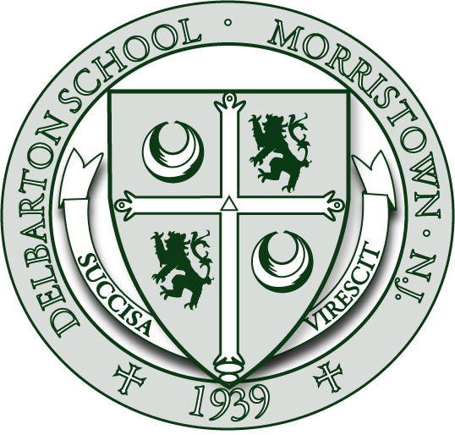
FINANCIAL AID INFORMATION
FOR THE 2021-22 ENROLLMENT YEAR

TADS APPLICATION DUE DATE:
DECEMBER 11, 2020

2020 FEDERAL INCOME TAX DUE DATE:
FEBRUARY 22, 2021

All financial aid applications are processed by TADS an independent Financial Aid Service. The application needs to be completed by December 11, 2020 and your 2020 Federal Income Tax Form 1040 should be submitted to TADS by February 22, 2021. Financial aid awards are announced with the acceptance letters.

Delbarton is grateful for the opportunity to educate talented young men, and we are aware of how important the decision is to send a boy to an independent school. This is why we see our parents as our partners in the work of educating students and why Delbarton feels like such a belonging community. We welcome every aspiring student and curious family to apply.

We also know that the financial commitment to an independent school can be beyond the reach of families with qualified students. Consequently, Delbarton has developed over the years the resources to aid many families to bridge the gap between their means and the School’s expenses. Delbarton seeks a broad diversity in its student body and is committed to making its educational opportunities available to exceptional young men regardless of race, color, creed or financial status.

The financial aid budget for the 2019-20 academic year is approximately $3.5 million. All awards take the form of outright grants and are issued according to the family’s demonstrated financial need as determined by TADS, a private financial aid service. Independently of admission considerations, financial aid decisions are made by the Financial Aid Committee and kept strictly confidential.

