End-of-Year AP Calculus Projects

Congratulations! You’ve conquered the AP Calculus Exam! For the next three weeks, you will be responsible for completing one of the projects below.

Possible Project 1 – Calculus Recipe Project

Find a recipe with at least 10 numerical values in the recipe (ingredients amount, cooking temperature, baking time, serving size, etc.). You must re-write all numerical values in the recipe using calculus problems that represent the correct amounts in the recipe.

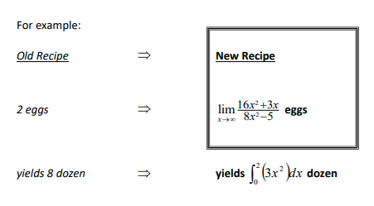

Recipe must include each of the following types of
problems once:

- Limit evaluation

- Definite Integral

- Average Value

- Slope of a Tangent Line

- Absolute Maximum/Minimum Value

ADDITIONAL CRITERIA:

- You must include a copy of the original recipe, separate from your typed calculus version of the recipe.

- You must also hand in an answer sheet that shows FULL SOLUTIONS for every value. Your work does not need to be typed, but it must be neat and organized.

Possible Project 2 – Mathematics Interest Project

“Research” a topic that interests you that pertains to any mathematical concept. (It does not necessarily have to be a high-level math concept…sometimes the simplest connections are the most interesting!).

- Write a synopsis of your interest topic to be submitted.

Possible Interest Project Topics

Fractals Origami

Tessellations (and MC Optical illusions

Escher) Card tricks

Mobius strip Fibonacci Sequence/The

The geometry of Tetris Golden Ratio (math in

Rubik’s Cube nature)

Logic Problems (Lewis Cryptography and codes

Carroll) Board games

Sudoku Voting methods

Card counting Graph theory

Casino games

Alternative numbering systems/the history of numbers and numbering systems

Abacus/slide rule (calculating before the calculator)

The history of Calculus (Newton and Liebniz)

