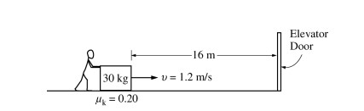
Beginning at time t = 0, a student exerts a horizontal force on a box of mass 30 kg, causing it to move at 1.2 m/s toward an elevator door located 16 m away, as shown above. The coefficient of kinetic friction u_{k} between the box and the floor is 0.20.

(a) On the dot below that represents the box, draw and label the forces (not components) that act on the box as it moves at constant speed.

b) Calculate the magnitude of the horizontal force the student must exert on the box in order to keep it moving at 1.2 m/s. If you need to draw anything other than what you have shown in part (a) to assist in your solution, use the space below. Do NOT add anything to the figure in part (a).

At t = 4.0 s, the elevator door opens and remains open for 5.0 s. The student immediately exerts a larger constant force on the box and the front of the box reaches the elevator door just as it starts to close.
(c) Calculate the magnitude of the new force that the student exerts.

(d) On the axes below, sketch graphs of the acceleration a, velocity v, and position x of the box versus time t between t = 0 and the time the front of the box reaches the elevator.
