Energy Skate Park Lab

Go to http://phet.colorado.edu/ and type in the search bar: skate. Select Energy Skate Park: Basics and then Run in HTML5.
Click on the Intro tab/screen. Use the “U” shaped track and select the speed box so the speedometer shows up.
- When does the skater have the most kinetic energy?

- When does the skater have the most potential energy?

Now select the bar graph.
- Explain how the bar graphs visually keep track of energy. Draw an example.

- Once the skater is placed on the track (and when it moves up and down) does the total energy bar change heights? Explain why that is.

READ: Energy is not created or destroyed; it is simply transferred from one storage place to another. This is the law of conservation of energy. It is not the same thing as “conserving energy”, which implies that we need to limit our energy usage and use our resources wisely. The conservation of energy is one of the most important ideas in science.

Now click on the friction tab/screen.
- Investigate how friction affects the energy of the skater/ramp system. Experiment with all three track shapes.
  - How does increasing the friction affect the charts/graphs?

  - Where/when does most of the energy get transferred to thermal in the simulation? Why do you think they choose to make it that way?

  - What are two other names/categories we could use for thermal?

- What are some advantages to representing the energy with bar graphs?

- Predict (draw) what the energy bar graphs will look like at A, B, C and D. Assume no friction.

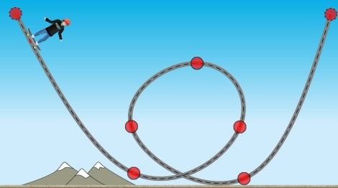
B
D
C
A

Now click on the playground tab/screen.
- Move the friction slider to “none”. Did you predict correctly? Explain.

Now add in a small amount of friction and make a second prediction. Try it. Was it correct?

- What did you learn about energy from this simulation? Explain.

