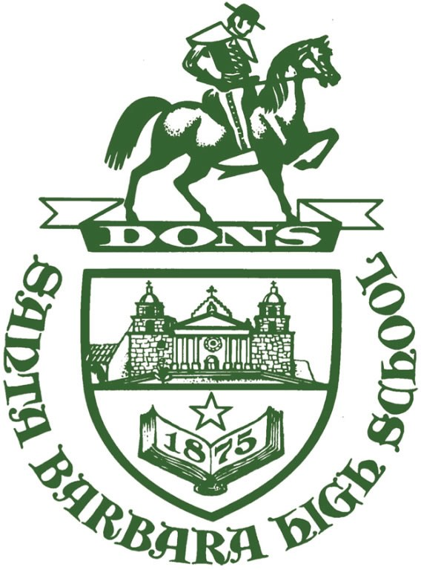
SANTA BARBARA SENIOR HIGH SCHOOL
PROGRESS REPORT
700 E. Anapamu St.
Santa Barbara, CA. 93103
Santa Barbara Unified School District
June 2020
Accrediting Commission for Schools
Western Association of Schools and Colleges

CONTENTS
I: Student/Community Profile Data 3-15
II: Significant Changes and Developments 16
III: Ongoing School Improvement 17
IV: Progress on Critical Areas for Follow-up/Schoolwide Action Plan 18-20
V: Schoolwide Action Plan Refinements 21

I: Student/Community Profile Data

Santa Barbara Senior High School (SBHS), home of the Dons, opened its doors in 1875 and is the third oldest public high school in California. SBHS is located 90 miles north of Los Angeles on California’s Central Coast, primarily serving the cities of Santa Barbara, Goleta, and Montecito. SBHS welcomes incoming freshmen from within our own school district and numerous local, private schools. We are proud to carry on our proud 145-year history today with a wide variety of high-quality academic, athletic, extra-curricular, and co-curricular programs that serve to meet our students’ diverse needs. Among those programs are AVID (elective offered in all grades), MultiMedia Art & Design (MAD) Academy, Visual Arts & Design (VADA) Academy, Computer Science Academy (CSA), Program for Effective Access to College (PEAC), and 18 Advanced Placement courses offered in the 2019-2020 school year, with plans to offer two more Advanced Placement courses next year. SBHS offers six CTE pathways (Two Arts/Media/Design, Construction Technology, Culinary Arts, Sports Medicine, and Computer Science) to help prepare our students for College & Career.
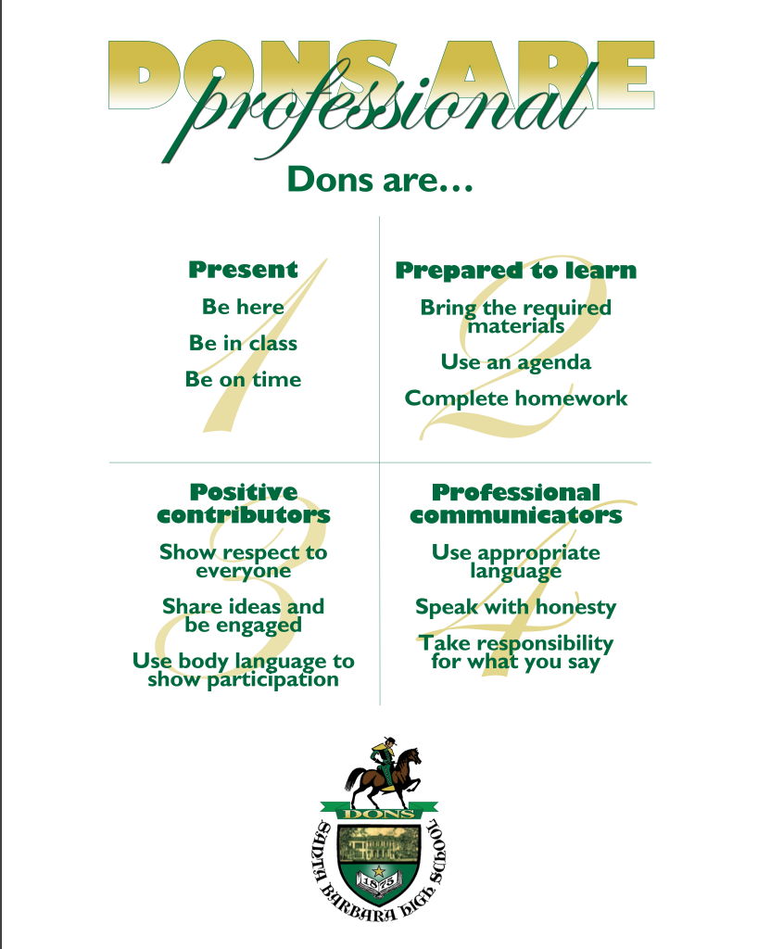
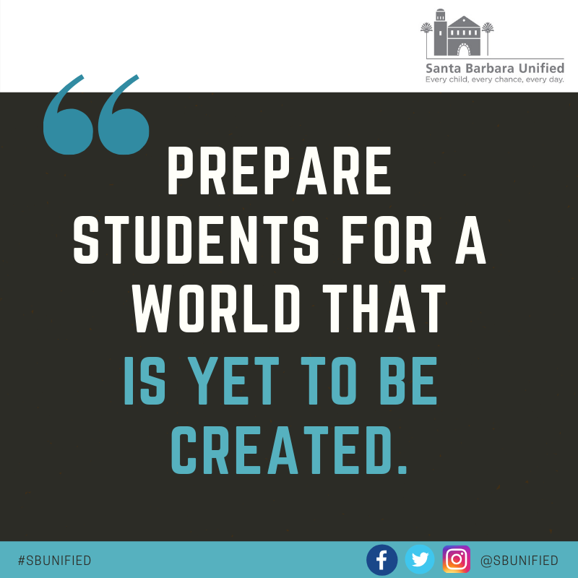
SBHS follows the district’s overarching mission of “Preparing students for a world yet to be created”. This new mission was adopted by the SBUSD Board of Education in April 2019 and serves as the center of the district’s and the school’s decision-making process. In addition to the district’s mission statement, SBHS adheres to our “Dons are Professional” vision statement whereby we expect our Dons to be “Present, Prepared to Learn, Positive Contributors, and Professional Communicators”. In the summer of 2019, the SBHS administration, in collaboration with the Site Leadership Team (SLT), developed the Instructional Focus of expecting all students in all classes to be able to make a claim and support that claim with appropriate evidence and reasoning. This instructional focus came from analysis of our CAASPP data, capitalizing on skills that students can demonstrate in any class, equip them for college and career expectations, and will help our students be more successful on both ELA and Math CAASPP assessments.
Similarly, SBHS partnered with the non-profit agency AHA! to build the staff’s social-emotional learning capacity. In the 2018-2019 school year, all 9th grade teachers received training in social-emotional learning. For the 2019-2020 school year, this was expanded to include all teachers and administrators. The goals this year were to introduce the staff to the tenets and benefits of addressing social-emotional aspects of learning and to deepen the connection between staff members. During the 2020-2021 school year, the focus will be to explicitly equip teachers with tools they can use in the classroom to help address our students’ varied social-emotional needs.

Total Student Enrollment:
SBHS’s enrollment has remained consistent over the last three years, with only a small projected drop in district-wide enrollment next year. Each year SBHS welcomes nearly 200 students who do not reside within our attendance boundary via the SBUSD’s intra-district transfer process.
2018-2019 2017-2018 2016-2017
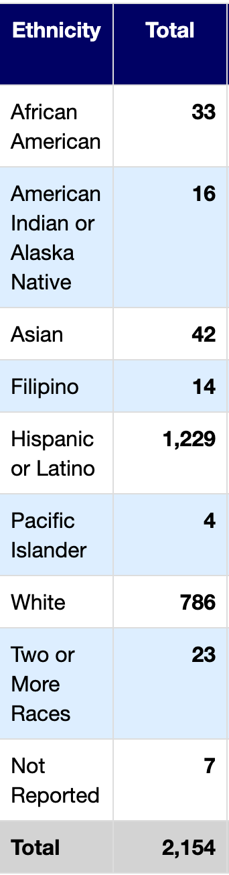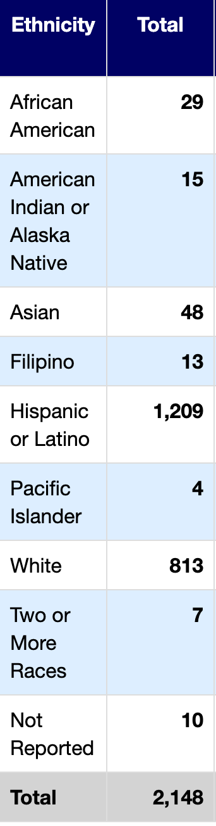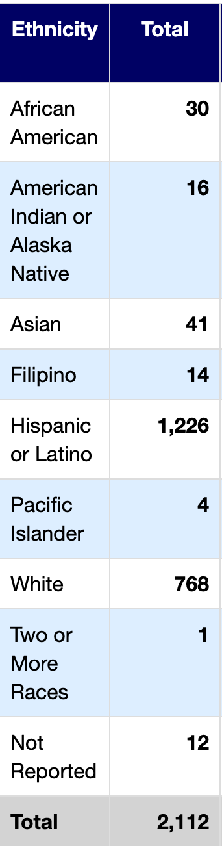

Enrollment by Student Group
2018-2019 2017-2018 2016-2017
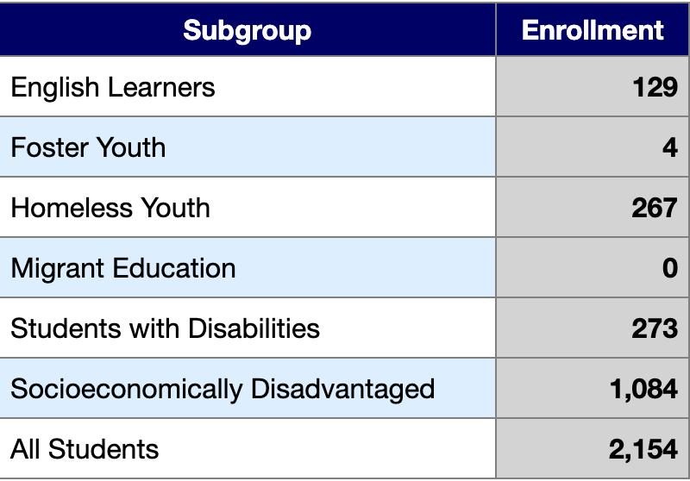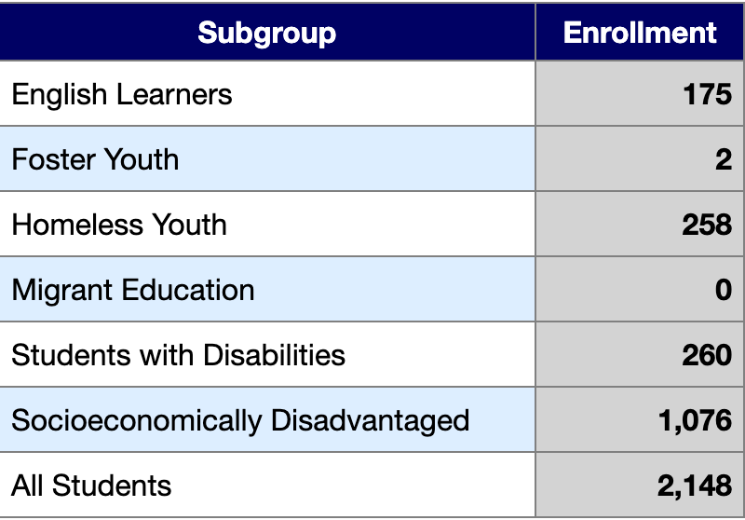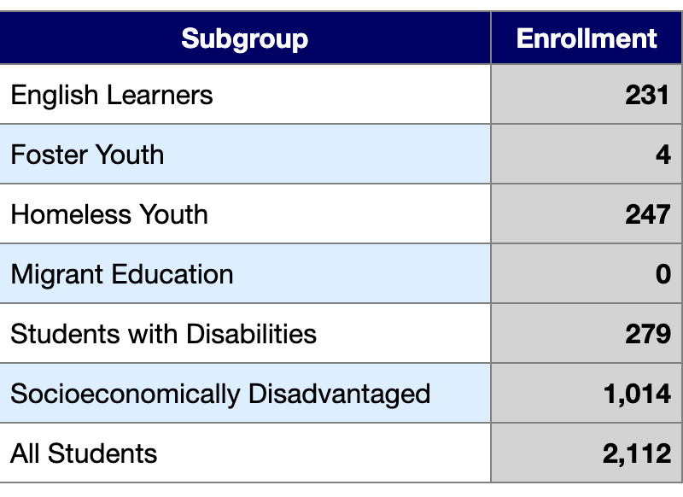

Conclusions Based on this Data:
- In terms of ethnicity, the student body at SBHS has remained relatively consistent over the past three years; the two largest subgroups being Hispanic/Latino and White. This is consistent with the overall demographics of the City of Santa Barbara.
- Of note, over the past three years, the number of English Learners (EL) has dropped significantly from 289 students in 2015-16 to 129 in 2018-19. This drop is due to two factors: 1) a revamp of our Reclassification process to increase opportunities for students to reclassify as Reclassified Fluent English Proficient (RFEP) and 2) an evaluation of long-term EL students with Individual Education Plans (IEPs) to ensure that those that cannot reclassify due to a learning disability are designated as such.

Teaching Staff Demographics

98 credentialed teachers on campus.

Gender: 54 females, 44 males.

Ethnicity: 79 identify as "No, not Hispanic or Latino" and 19 identify as "Yes, Hispanic or Latino" under the EEO definition.
White: 90
Asian: 4
American Indian/Alaskan: 3
Black: 1

Longevity:
6 teachers in year 1 @ SBHS
9 teachers in years 2-3 @ SBHS
33 teachers in years 4-10 @ SBHS
13 teachers in years 11-15 @ SBHS
37 teachers in years 16+ @ SBHS

CAASPP Results
While SBHS is proud of our school wide achievement on the CAASPP assessment, the school continues to explore ways to help all student groups improve. Our Special Education, Socioeconomically Disadvantaged, English Learner, and Hispanic students continue to perform lower than other student groups, and the school as a whole.

CAASPP ELA:
Students scoring Standard Exceeded (4) and Standard Met (3)
All Students:
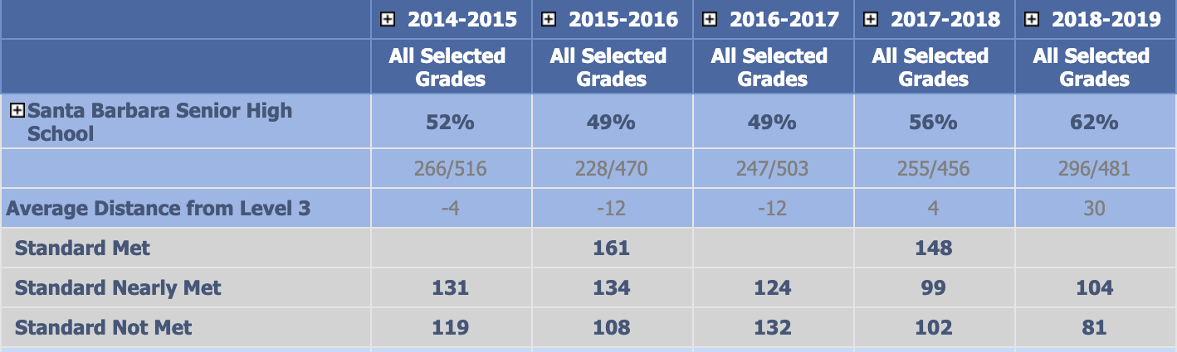
Hispanic:
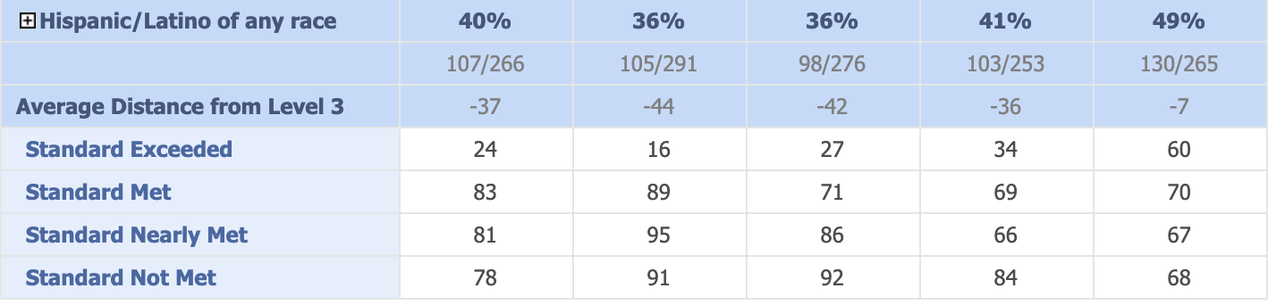
English Learners:
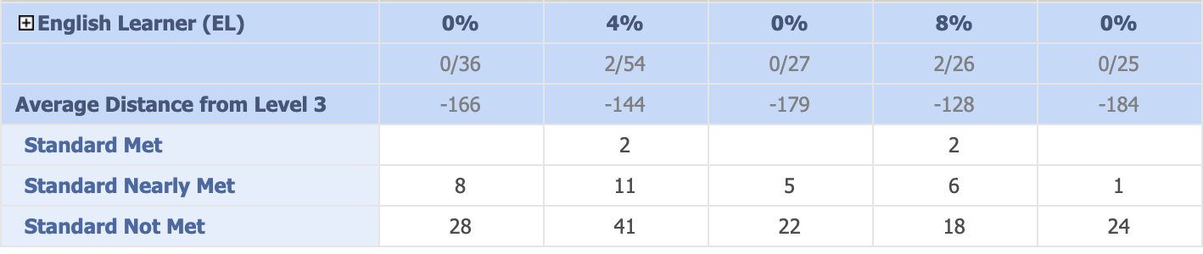

Socioeconomically Disadvantaged:
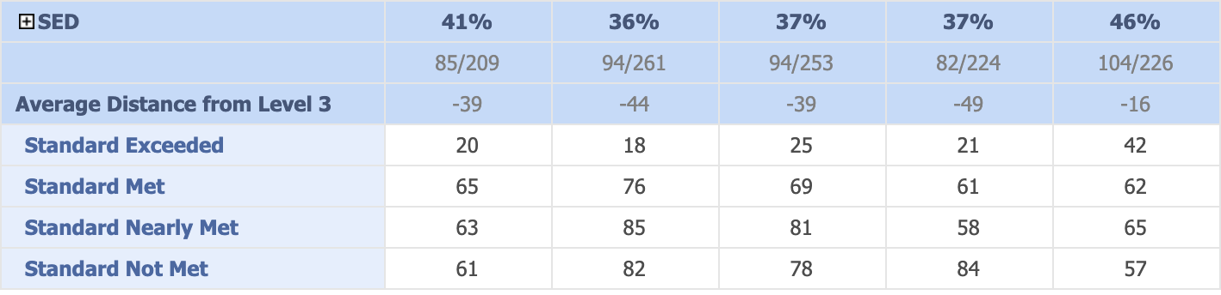

Special Education:
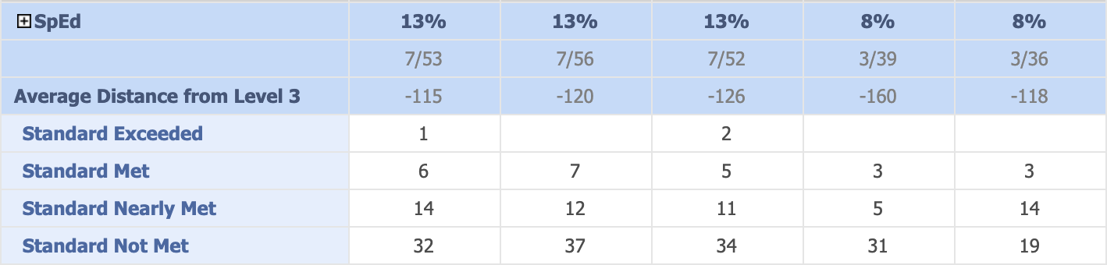
White:
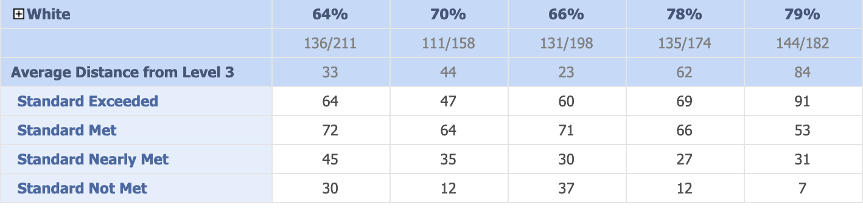

CAASPP MATH:
Students scoring Standard Exceeded (4) and Standard Met (3)

All Students:
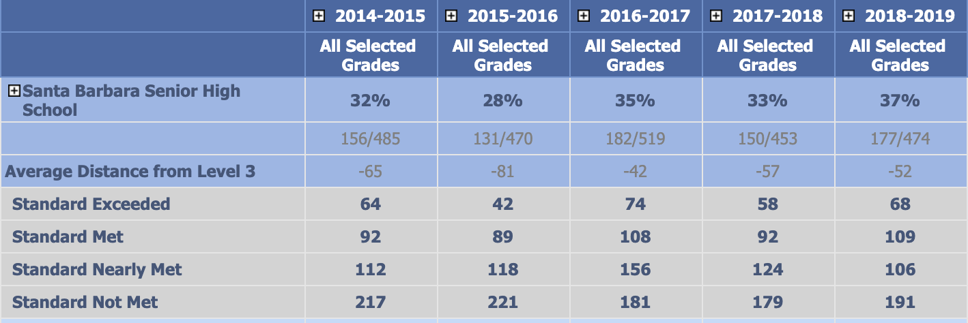
Hispanic:
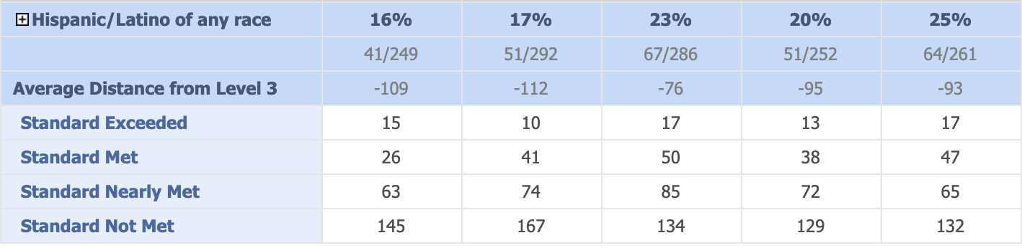
English Learner:
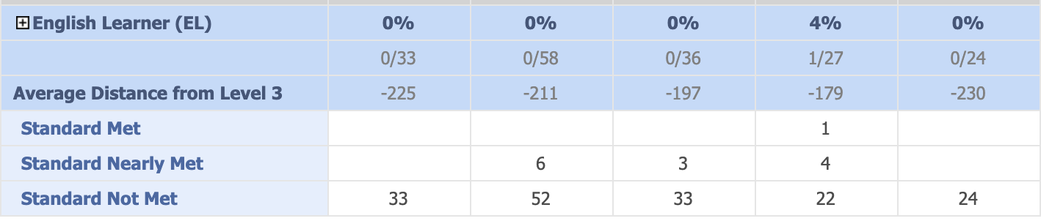
Socioeconomically Disadvantaged:
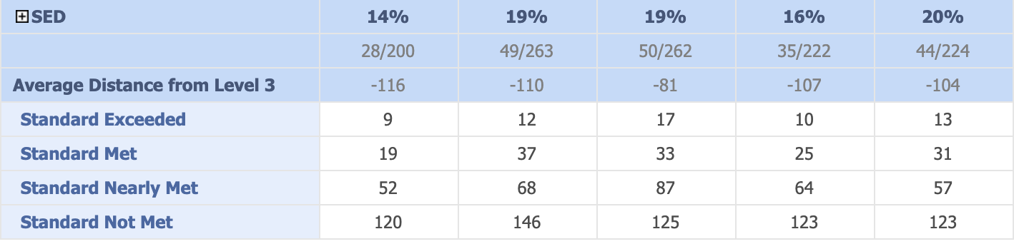

Special Education:
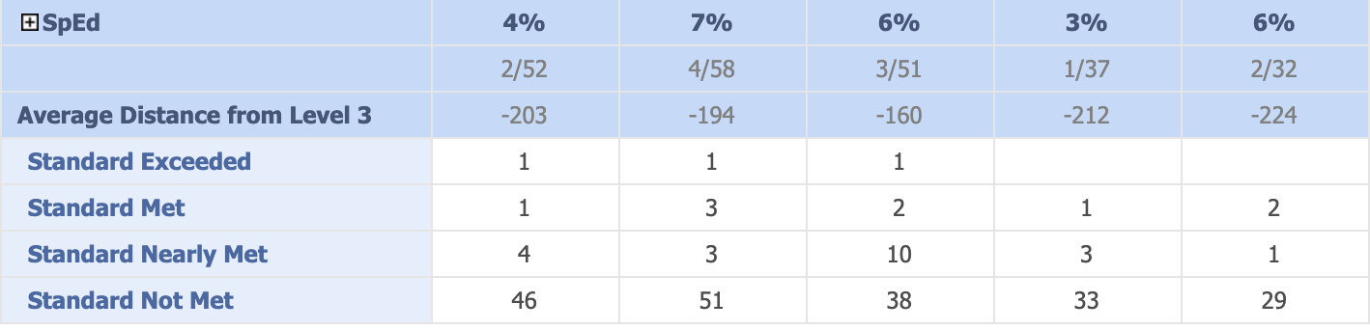
White:
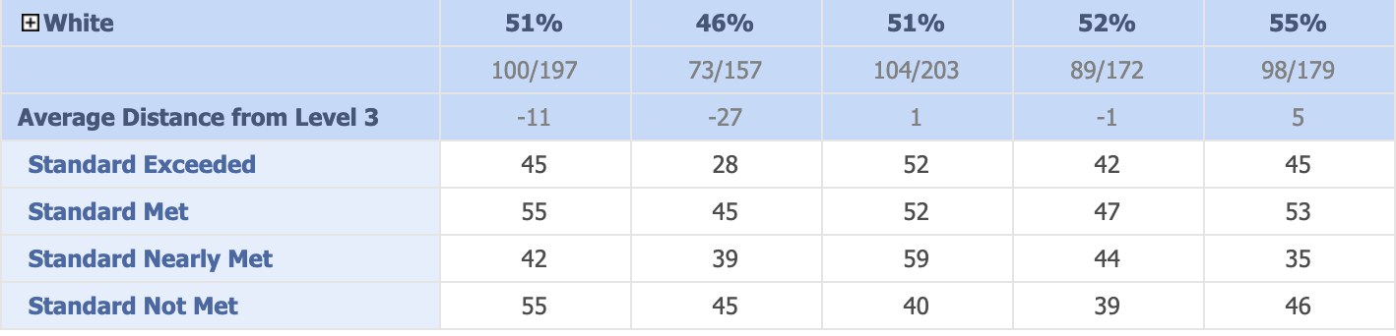

Conclusions Based on this Data:
- School-wide, SBHS has made slow but consistent progress in the number of students achieving or exceeding standards in ELA and Mathematics. Specific student groups showing consistent but moderate improvement are Hispanic, Socioeconomically Disadvantaged, and White.
- Two student groups who continue to achieve at rates lower than their peers are Special Education and English Learners. SBHS continues to explore multiple ways to better serve these specific student groups.

Advanced Placement Results
2019
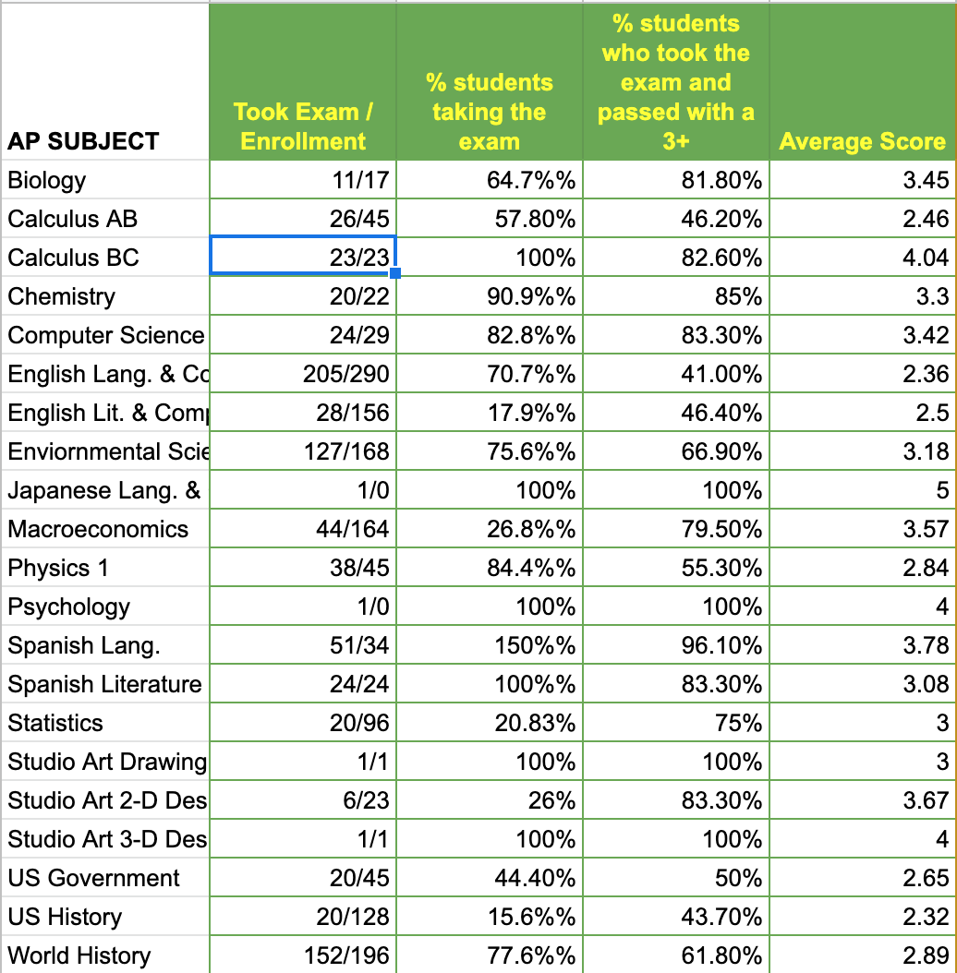

2018
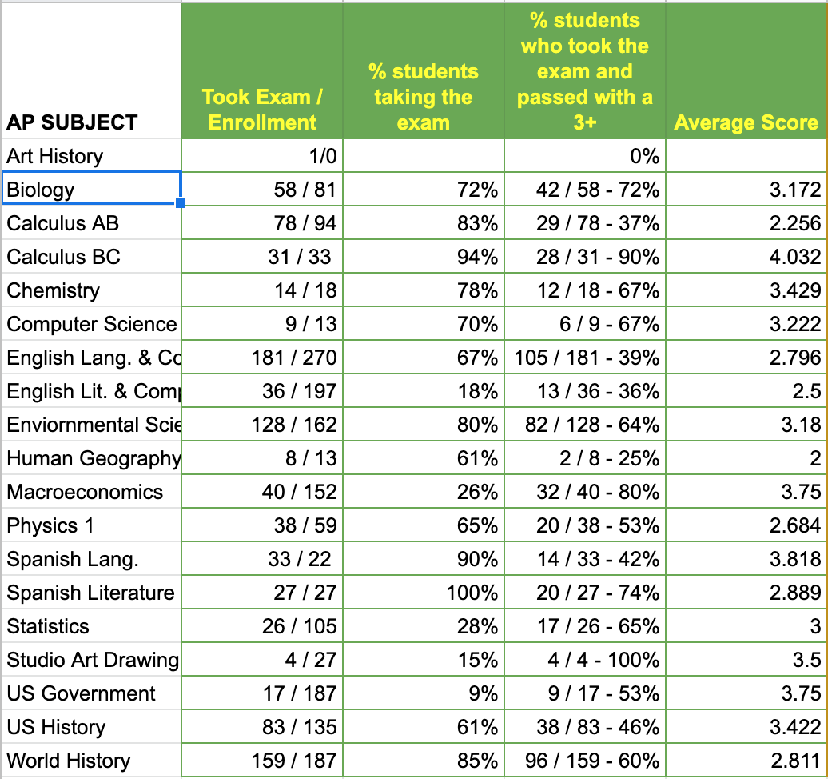

2017
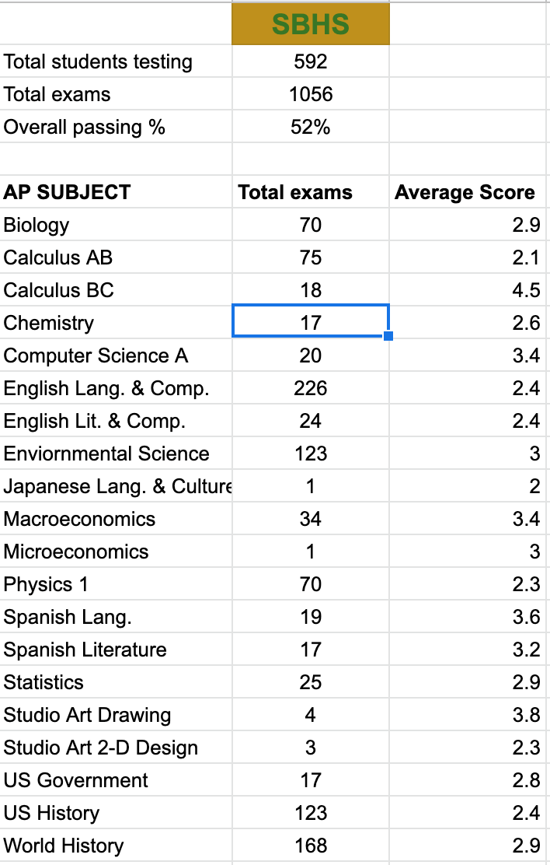

Conclusions Based on this Data:
- School-wide, SBHS continues to achieve higher than the state and national averages for most AP exams. Particular areas to celebrate are Calculus BC, Biology, Spanish Language, Studio Art, Macroeconomics, and Computer Science A.
- SBHS continues to explore ways to increase the AP exam participation rate for all exam areas.

Academy Enrollment Demographics 2019-2020
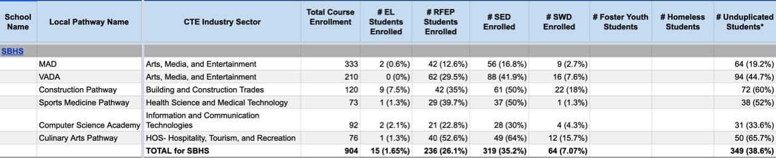

Conclusions Based on this Data:
- This is the first year that SBHS (and SBUSD as a whole) has tracked this data for academy enrollment.
- While the percentage of students within the groups of RFEP and Socioeconomically Disadvantaged more closely mirror SBHS’s schoolwide demographics, EL students (referred to as Emerging Multilingual Students in SBUSD) and students with disabilities participate in our academies at lower rates than the school as a whole. This is a self-identified need and one of the areas for follow up left by the spring 2019 WASC Visiting Committee.
- All teachers within our CTE pathways undertook aggressive outreach campaigns in the spring of 2020 in order to recruit students who more closely reflect the school’s demographics as a whole. We look forward to seeing if these efforts were successful, as the academies are completing the admissions processes as we write this report. We can report anecdotal evidence of this success as SBHS carries out its transition IEPs for incoming freshmen. We note that 50% of the transition IEPs held thus far are for students who have been admitted to the MAD and VADA academies.

Graduation Data 2018-2019
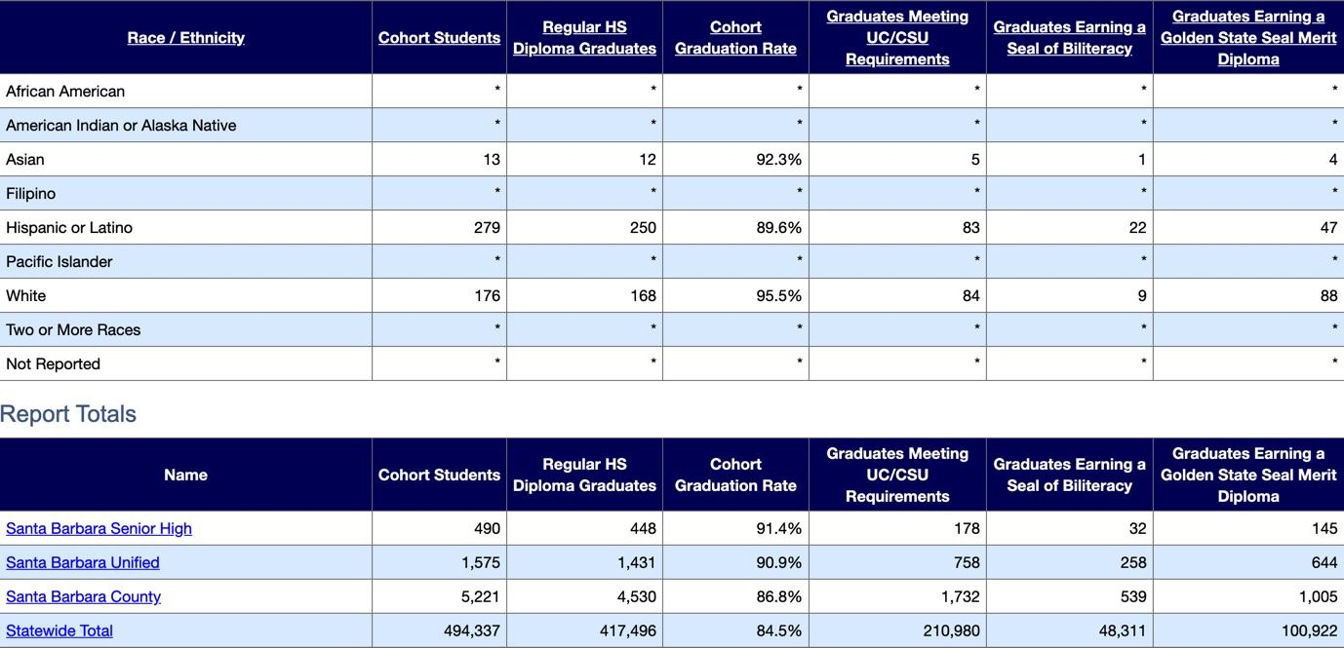
Conclusions Based on this Data:
- As a whole, SBHS’s 2018-2019 four-year cohort graduation rate exceeded the SBUSD, County-wide, and State-wide percentages. In 2017-2018, SBHS was slightly below the SBUSD average, but still well above the County-wide and State-wide percentages.
- While we are proud that SBHS Hispanic graduates earn the State Seal of Biliteracy at higher rates than the school as a whole, this student group has the lowest four-year cohort graduation rate.
- SBHS utilizes OdysseyWare online courses for credit recovery. Students have the opportunity to work on these courses throughout the school day in a “study hall” period or after school under the guidance of a credentialed teacher.
- The SBHS administration focused on an MTSS-model that emphasized effective first instruction as a Tier I support offered to all students. Dedicated professional development time at three staff meetings throughout the school year took place in the area of ensuring effective first instruction for all students in all classes as a Tier I guarantee.

College and Career Readiness 2017-2019
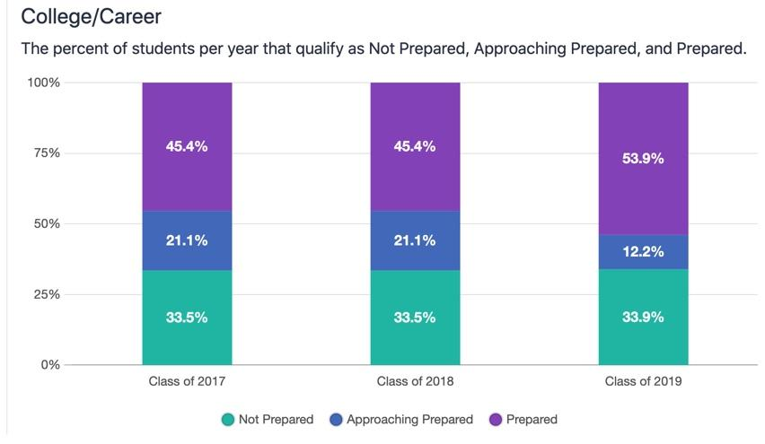

Conclusions Based on this Data:
- SBHS is proud that we improved our percentage of students Prepared for College and Career by 8% for the 2019 school year.
- This change can be attributed to a variety of deliberate efforts:
  - Increased awareness and professional development of the staff as a whole (specifically the administration and counseling department) regarding the seven factors that contribute to the College and Career Readiness indicator.
  - Creation of a district-level CTE Director whose main focus is to align our work with CTE requirements and to ensure that we accurately report those efforts.
  - Coordinated district-wide effort between the Educational Technology (ETS) Department and all curriculum assistant principals to ensure that all of our CTE pathway courses are properly identified and recorded in our student information system.
  - Similarly, all curriculum assistant principals worked together this year to ensure that all courses in the SBUSD course catalog are properly identified in the UCOP a-g portal.
  - ETS automatized the State Seal of Biliteracy, Golden State Seal of Merit, and UC/CSU a-g eligibility calculations in order to accurately record our students’ achievements.

UC/CSU a-g Eligibility Rates 2018-2019
Year | Graduates | Total a-g eligible | Percentage
2018 | 546 | 62 | 11.4%
2019 | 490 | 163 | 33.3%

Conclusions Based on this Data:
- The large variance in year-to-year a-g eligibility rates is due to a data reporting error that was discovered in the summer of 2018. Since that time, SBUSD’s Educational Technology Services has worked diligently to ensure that accurate data is reported to provide us with more reliable statistics regarding our graduates’ a-g completion and eligibility rates. SBHS looks forward to seeing this percentage continue to increase as we accurately report on our graduates’ achievements.

Post-secondary Enrollment 2012-2019
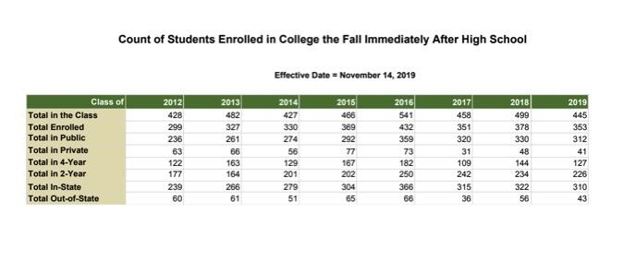
Conclusions Based on this Data:
- Even considering moderate year-to-year variance, SBHS is proud that its percentage of students enrolled in college immediately following graduation has seen an upward trend since 2012, increasing 10% in that eight-year span.
- Santa Barbara City College’s “Promise” program, offering free tuition to SBUSD graduates (initiated in 2017), has certainly helped with this effort.

Advanced Placement Participation 2019

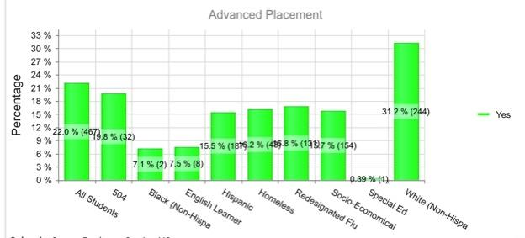

Conclusions Based on this Data:
- Demographic enrollment in Advanced Placement courses still does not mirror SBHS’s demographics as a whole. White students enroll in Advanced Placement courses at nearly double the rate of any other student group. The need to enroll a more diverse student group into AP courses is both a self-identified need and a recommendation left by the previous WASC Visiting Committee.
- As our programs of choice, including our CTE academies, aggressively recruit a more diverse population, we look forward to this number beginning to more closely mirror our overall student demographics. All of our CTE academies include AP courses in their course sequence. Anecdotally, a significantly higher number of incoming freshmen with IEPs for 2020-21 have been accepted into our academies. SBHS has processes in place to help these students persist in these programs of choice. This effort will yield a more diverse AP course demographic enrollment in subsequent years.
- The counseling department initiated an aggressive informational and recruitment campaign to enroll a more diverse student group into AP courses. These efforts included two informational nights for students and families, classroom presentations to each student in grades 9 - 11, and a greatly expanded High School Showcase presented during the school day to all incoming 9th graders.

II: Significant Changes and Developments

For the 2019-2020, two significant and relevant changes occurred on campus. First, three of the five administrators are new to their respective positions at SBHS. The Dean of Student Engagement, in his fifth year in the position overall, transferred to SBHS from another comprehensive high school in the SBUSD. In his short time on campus, he has worked hard to decrease truancy rates through proactive measures and ensuring accurate attendance reporting. Another Assistant Principal came to SBHS with five years experience as a curriculum and instruction specialist. He has worked hard to increase AP exam participation rates. And a third Assistant Principal is in her first year as an administrator. She is a SBHS graduate and worked as a science technology coach for the district prior to moving into administration. And, she has worked closely with the three Academies on their outreach and recruitment.

The second significant change, ongoing while the writing of this report is taking place, is the statewide closure of schools in response to the COVID-19 health crisis. This circumstance will lead to a dearth of achievement data related to CAASPP and CAST, since those statewide assessments were suspended by the CDE. Similarly, this school closure will impact the school’s push to increase AP exam participation rates, as students (we believe) may choose not to take their exams without a full year’s instruction to prepare. However, SBHS looks forward to the resumption of on campus schooling for the 2020-2021 school to continue our efforts to meet our students’ diverse needs.

III: Ongoing School Improvement

SBHS employed a variety of means to solicit input for this report with all stakeholders. Drafts of the report were shared throughout the year with the Site Leadership Team, a group comprised of administrators, department leads, and other personnel in leadership positions on campus. During the April staff meeting, hosted virtually during the school closure, a draft of this report was shared with the entire staff to solicit their input.
Throughout the school year, the principal and assistant principal overseeing academies met with the three academy directors to formulate plans to address the critical areas for follow up left by last year’s visiting committee. Increasing the amount and frequency of Spanish-language communication to families related to academy applications and further outreach efforts were the focus of these meetings.
On a monthly basis, the School Site Council met to discuss the WASC Action Plan, the Single Plan for Student Achievement (SPSA), and the funds allocated to support these plans. We also evaluated the implementation of the plans through the analysis of student achievement and engagement data. During the evaluation process, council members provided feedback and input as we worked to revise the WASC Action Plan and SPSA. Due to school closure, the development of the SPSA for 2020 has been postponed to fall.
The Principal sought input from families through “school climate meetings” held twice throughout the year. The third and fourth meetings were cancelled due to COVID-19 school closures. However, SBHS was aided in this effort by a district wide school climate survey sent out to all families in December.
And for the second time, this year the district hosted all incoming 9th grade students to a district wide showcase where all three comprehensive high schools in the district were given the opportunity to highlight their academies, extra- & co-curricular programs, and advanced courses to prospective students from the district’s feeder middle schools.

IV: Progress on Critical Areas for Follow-up/Schoolwide Action Plan

Below is the Critical Area for Follow Up left by the 2019 one-day, mid-cycle review Visiting Committee:
Based on data, observations and interviews, even though the school has made strides in an attempt to increase equity and access to school programs of choice and advanced courses for Latino students, SEO student, EL, and Special Education students through the use of culturally relevant curriculum, further professional development on engagement activities for special populations will need to be addressed. Evidence includes the following:
- Continue to reduce the achievement gap that exists for College Prep, Latino, EL, Special Education, and SEO students. While individual programs such as the SKILLS training, AVID program, and Academy for Success have led to modest improvements within their limited scope, overall, SBHS has not significantly improved the achievement gap across the school.
- According to archives and interviews, there was an effort to provide Equity in Education, the need to sustain high levels of Latino parent participation in academic and extra- curricular events and have school programs of choice and advanced courses reflect the demographics of the school.

English Learners
The entire SBUSD was placed into Federal Program Monitoring, with a visit conducted in February 2020. The work done district-wide impacted SBHS and helped to address the Critical Areas for Follow Up left by the June 2019 Visiting Committee. SBUSD formed an ELD cadre, comprised of staff and community members, that sought to address the achievement gap of English Learners. Two significant developments arose from this work.
First, SBUSD developed Multilingual Pathways (deemed META) set to roll out in the 2020-21 school year at elementary and junior high sites. While incorporating a Dual Immersion approach (with students in those pathways set to enter SBHS in the 2022-23 school year), this program also seeks to refocus the district’s educators mindsets to recognize the inherent strengths and capacities that our multilingual students bring to each classroom. Rather than be viewed through a deficit lens (we need to teach these students a skill they lack), META seeks to empower teachers to incorporate the unique strengths, traditions, and advantages that multilingual students bring with them to class. Similarly, the district has moved to the nomenclature of “emerging multilinguals” rather than “English Learners”. While this is clearly a positive move forward by the district, it will take some time to see the benefits in terms of academic achievement and access to all of SBHS’s programs of choice for all students.
Second, the ELD cadre approved a new curriculum for our emerging multilingual students based on the Expository Reading and Writing Courses (ERWC) produced by the California State University system. Beginning in the fall semester of 2019, all multilingual students had access to this core content, replacing the piecemeal curriculum that each teacher devised for his/her own class. Beginning in the 2020-21 school year, all emerging multilingual students will be scheduled into a block that will include a grade-level English support course and a grade level English course in order to provide all students with access to grade-level, college preparatory English curriculum.
SBUSD hired a bilingual instructional specialist for the 2019-20 school year who pushes into core content classes with our emerging multilingual students to support their learning. SBHS’s lead Literacy teacher developed the schedule for this classified staff member based on the strategic placement of students in that student group to specific teachers & periods. This paraeducator sees 10-12 different classrooms throughout the week. In collaboration with the teachers, this specialist translates assignments for students and helps to ensure that they can demonstrate their core content knowledge.
For the 2019-20 school year, SBHS dedicated two sections in the master schedule for one of our Literacy teachers to serve as a Literacy support for all content areas. This teacher worked with entire PLCs and individual teachers on ways to help support students’ literacy skills in all content areas. This support took the form of shared resources, working with PLCs to align curriculum to students’ current needs, and presentations to the staff as a whole during staff meetings. This support specialist was given an area in SBHS’s weekly staff memo to post resources and ideas that could be adapted to any classroom. And while SBHS’s master schedule is still being built, we plan to offer this same level of support for the 2020-21 school year.

Academies and programs of choice
SBHS dedicated significant time and resources this year to increase the diversity of our students participating in the school’s programs of choice. We are happy that programs such as AVID and VADA (Visual Art and Design Academy) have historically had student enrollment that served our traditionally underperforming student groups.
Significantly, SBHS’s Computer Science Academy (CSA) eliminated its application process altogether. Moving forward, any SBHS student who enrolls in a computer science class will be offered the opportunity to participate in the activities which will lead to academy requirement fulfillment such as field trips, guest speakers, and additional projects in order to bolster their learning and help them to pursue their passion. SBHS is aided in this effort in that one of the academy directors also teaches a course at our main feeder junior high schools. An ongoing area to focus on for CSA demographics is ensuring gender distribution equality in this program.
At the end of last school year, the long-time director retired from the Multimedia Arts and Design Academy (MAD). Principal Simmons, working alongside current academy staff and the California Academy Foundation (CAF) parent group, redesigned the leadership structure and hired two co-directors. Under new leadership and support of the parent community, the MAD Academy has undergone a reorganization. The reorganization included the addition of a Student and Family Outreach Coordinator and a bilingual clerical support position. Most importantly, the MAD Academy leveraged the reorganization to reframe every area of the academy to be grounded in equity and fostering multimedia arts and design skills. The staff ensured that the course work, fields trips, guest speakers, and every aspect was focused on helping students obtain real world, applicable experiences and guiding them to a college and career pathway.

Students with Disabilities
SBHS recognizes that students with disabilities are a student group that has historically underperformed their non-disabled peers. SBHS has spent this school year designing a new approach to the delivery of specialized academic instruction (SAI) to better meet the diverse needs of this group that we will implement in the 2020-21 school year. Currently, SBHS utilizes a mix of co-taught classes in English (all grades), mathematics (Math I, Math I restart, Math II, and Math II restart) and science (conceptual physics) along with Individualized Instruction (I.I.) periods throughout the day to deliver SAI. In the co-taught classes, a general education teacher and special education teacher work together to design curriculum, accommodate that curriculum for IEP students, deliver the instruction, assess & remediate all students. Most students with an IEP also have a dedicated period of Individualized Instruction to help support students to meet their IEP goals. These I.I. classes are kept small, with an average of 8-10 students per section. Despite this intensive intervention, our students with disabilities continue to underperform their peers.
For the 2020-21 school year, approximately 30% of the co-taught sections will convert to a collaborative “push in/pull out” model where the special education teacher can decide to be in the classroom with all students or to pull out selected IEP students to work with them individually. This will have several positive impacts. First, it will allow those students who are pulled out to receive specific, tailored & targeted intervention that directly supports their IEP goals. Second, this will allow special education teachers to work with a wider variety of general education colleagues, not just their co-teaching partner. An added benefit of this scheduling will be to reduce the high number of students with IEPs in co-taught sections (as high as 50% in some sections this year). This will lessen the accommodation burden among a wider array of general education teachers.

Professional Development: Cycle of Inquiry, Multi-Tiered Systems of Support, and social-emotional learning
For the past two years, SBHS has partnered with InnovateED to provide professional development to all staff members. The work with InnovateED has focused on the positive impact that the Cycle of Inquiry can have on all students in all classes. PLCs work together to clarify learning expectations, develop common assessments, devise student work protocols, and implement plans to address students who do not meet grade level content standards. In addition to all-staff presentations in August, English 9 and Math II teachers in particular participated in four Instructional Design days with an InnovateED coach this year to help bring coherence to their instruction. Similarly, the Site Leadership Team held two retreat days with an InnovateED coach, on top of their regularly scheduled quarterly meetings. Lastly, Principal Simmons participated in the District Leadership Team and Principal Collaboratives, with the purpose of increasing her instructional leadership capacity in supporting the work of the Site Leadership Team and PLCs. This work is done to ensure that each SBHS teacher provides effective first instruction in the Tier I of an MTSS model.
And while the SBUSD has not adopted a unified MTSS model, SBHS admin has chosen to focus this year on Tier I and Tier II supports. With the Cycle of Inquiry serving as the Tier I foundation, SBHS admin presented to the staff at three staff meetings the structure of what effective Tier II supports can look like, both in the classroom and throughout outside means such as a Student Study Team or 504 plan.
As noted earlier, SBHS is in its second year working with the nonprofit AHA! to develop the staff’s social-emotional learning capacity. In the 2018-2019 school year, all 9th grade teachers received training in social-emotional learning. For the 2019-2020 school year, this was expanded to include all teachers and administrators. The goals this year were to introduce the staff to the tenets and benefits of addressing social-emotional aspects of learning and to deepen the connection between staff members. During the 2020-2021 school year, the focus will be to explicitly equip teachers with tools they can use in the classroom to help address our students’ varied social-emotional needs.

Embedded Intervention

For the 2019-2020 school year, SBHS implemented 17 Seminar sections of Guided Studies. These are focused Seminar sections where the teachers are paid an extra stipend to provide intensive support to the students enrolled in those sections. Teachers regularly communicate with the students’ other teachers regarding progress and missing assignments. Students were selected for these sections based on grades or referral from another teacher. Currently 7 special education teachers have 134 students with IEPs enrolled in Guided Studies section. Similarly, 8 general education teachers have 146 students enrolled in Guided studies sections. SBHS surveyed students twice throughout the school year to garner students’ feedback regarding the effectiveness of the support offered in the Guided Studies Seminar sections. Results indicate that 95% of the students enrolled in Guided Studies indicate that “the extra time in Seminar has helped me to maintain or improve my grades”. SBHS also trained 40+ new student mentors and tutors to assist in Guided Studies sections.

V: Schoolwide Action Plan Refinements
Below is the Critical Area for Follow Up left by the 2019 one-day, mid-cycle review Visiting Committee:
Based on data, observations and interviews, even though the school has made strides in an attempt to increase equity and access to school programs of choice and advanced courses for Latino students, SEO student, EL, and Special Education students through the use of culturally relevant curriculum, further professional development on engagement activities for special populations will need to be addressed. Evidence includes the following:
- Continue to reduce the achievement gap that exists for College Prep, Latino, EL, Special Education, and SEO students. While individual programs such as the SKILLS training, AVID program, and Academy for Success have led to modest improvements within their limited scope, overall, SBHS has not significantly improved the achievement gap across the school.
- According to archives and interviews, there was an effort to provide Equity in Education, the need to sustain high levels of Latino parent participation in academic and extra- curricular events and have school programs of choice and advanced courses reflect the demographics of the school.

When refining our Action Plan, we approached the development of the plan from a different premise than previous years. We only included in the plan action steps that are new and/or refined. Therefore, our action plan is much shorter and only contains action steps that we have added based on our analysis of data and comments made by the visiting committee.

In Goal 1, Cultural Proficiency and Course Access, we have added action steps that relate to the district wide Ethnic Studies graduation requirement, Academy demographics, and CTE pathways. We have found that we need to continue to examine and remove the barriers that exist in the outreach, recruitment, and retention efforts as they relate to the Academies and CTE pathways.

In Goal 2, Engage Students, Families, and the Community in Effective Educational Partnerships, we have added and refined our efforts around Social Emotional Learning and Family Engagement. Both of these areas and the action steps that align with them will help create positive, safe, and inclusive classrooms for our students, thus, promoting academic achievement and engagement.

In Goal 3, Preparing Students for Life, Learning, and Work in the 21st Century, we have added action steps that specifically target the needs of our students with disabilities and our students that struggle with mathematics. In addition, we continue to refine the cycle of inquiry to include an increase in common assessments, a focus on literacy in all content areas, and skill development.

