Summer Poster Design

What is a poster? Definition: **‘Placard posted or displayed in a public place as an announcement or advertisement’**

Typically posters include both [textual](http://en.wikipedia.org/wiki/Typography) and [graphic](http://en.wikipedia.org/wiki/Graphic) elements, although a poster may be either mostly images or mostly text. Posters are designed to be both eye-catching and convey information. Posters may be used for many purposes, and they are a frequent tool of [advertisers](http://en.wikipedia.org/wiki/Advertising) (particularly of events, musicians and films), [propagandists](http://en.wikipedia.org/wiki/Propaganda), [protestors](http://en.wikipedia.org/wiki/Protest) and other groups trying to communicate a message.

SUMMER TASK

Create a poster using computer aided design for either of the following things:

Political, advertising, movie or event.

Bring the finished product to your first lesson September.

### Propaganda and political posters

During the [First](http://en.wikipedia.org/wiki/World_War_I) and [Second World Wars](http://en.wikipedia.org/wiki/Second_World_War), recruiting posters became extremely common, and many of them have persisted in the national consciousness, such as the "[Lord Kitchener Wants You](http://en.wikipedia.org/wiki/Lord_Kitchener_Wants_You)" posters from the [United Kingdom](http://en.wikipedia.org/wiki/United_Kingdom), the "[Uncle Sam](http://en.wikipedia.org/wiki/Uncle_Sam) wants you" posters from the United States, or the "[Loose Lips Sink Ships](http://en.wikipedia.org/wiki/Loose_lips_sink_ships)" posters.

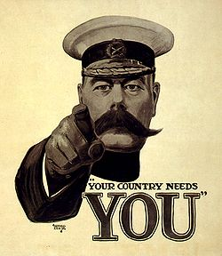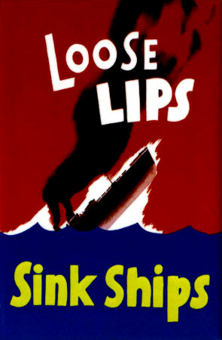

### Advertising posters

Many posters, particularly early posters, were used for advertising products. Posters continue to be used for this purpose, with posters advertising [films](http://en.wikipedia.org/wiki/Film), [music](http://en.wikipedia.org/wiki/Music) (both concerts and recorded albums), [comic books](http://en.wikipedia.org/wiki/Comic_book), and [travel](http://en.wikipedia.org/wiki/Tourism) destinations being particularly notable examples.

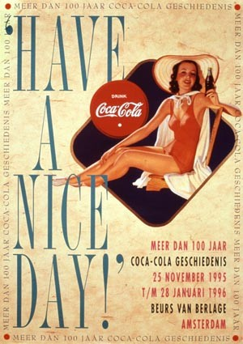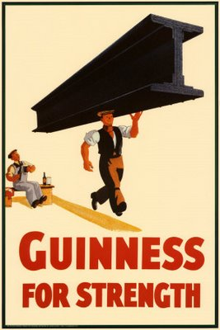

#### Film posters

The [film](http://en.wikipedia.org/wiki/Film) industry quickly discovered that vibrantly coloured posters were an easy way to sell their pictures. Today, posters are produced for most major films, and the collecting of movie posters has become a major hobby. The most valuable poster in the world, of which there is only 1 known copy, is the 1931 stone litho Frankenstein 6-sheet.

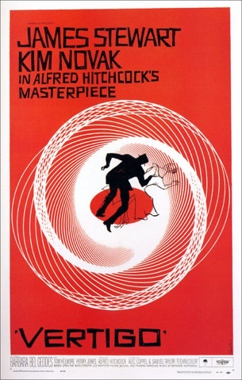

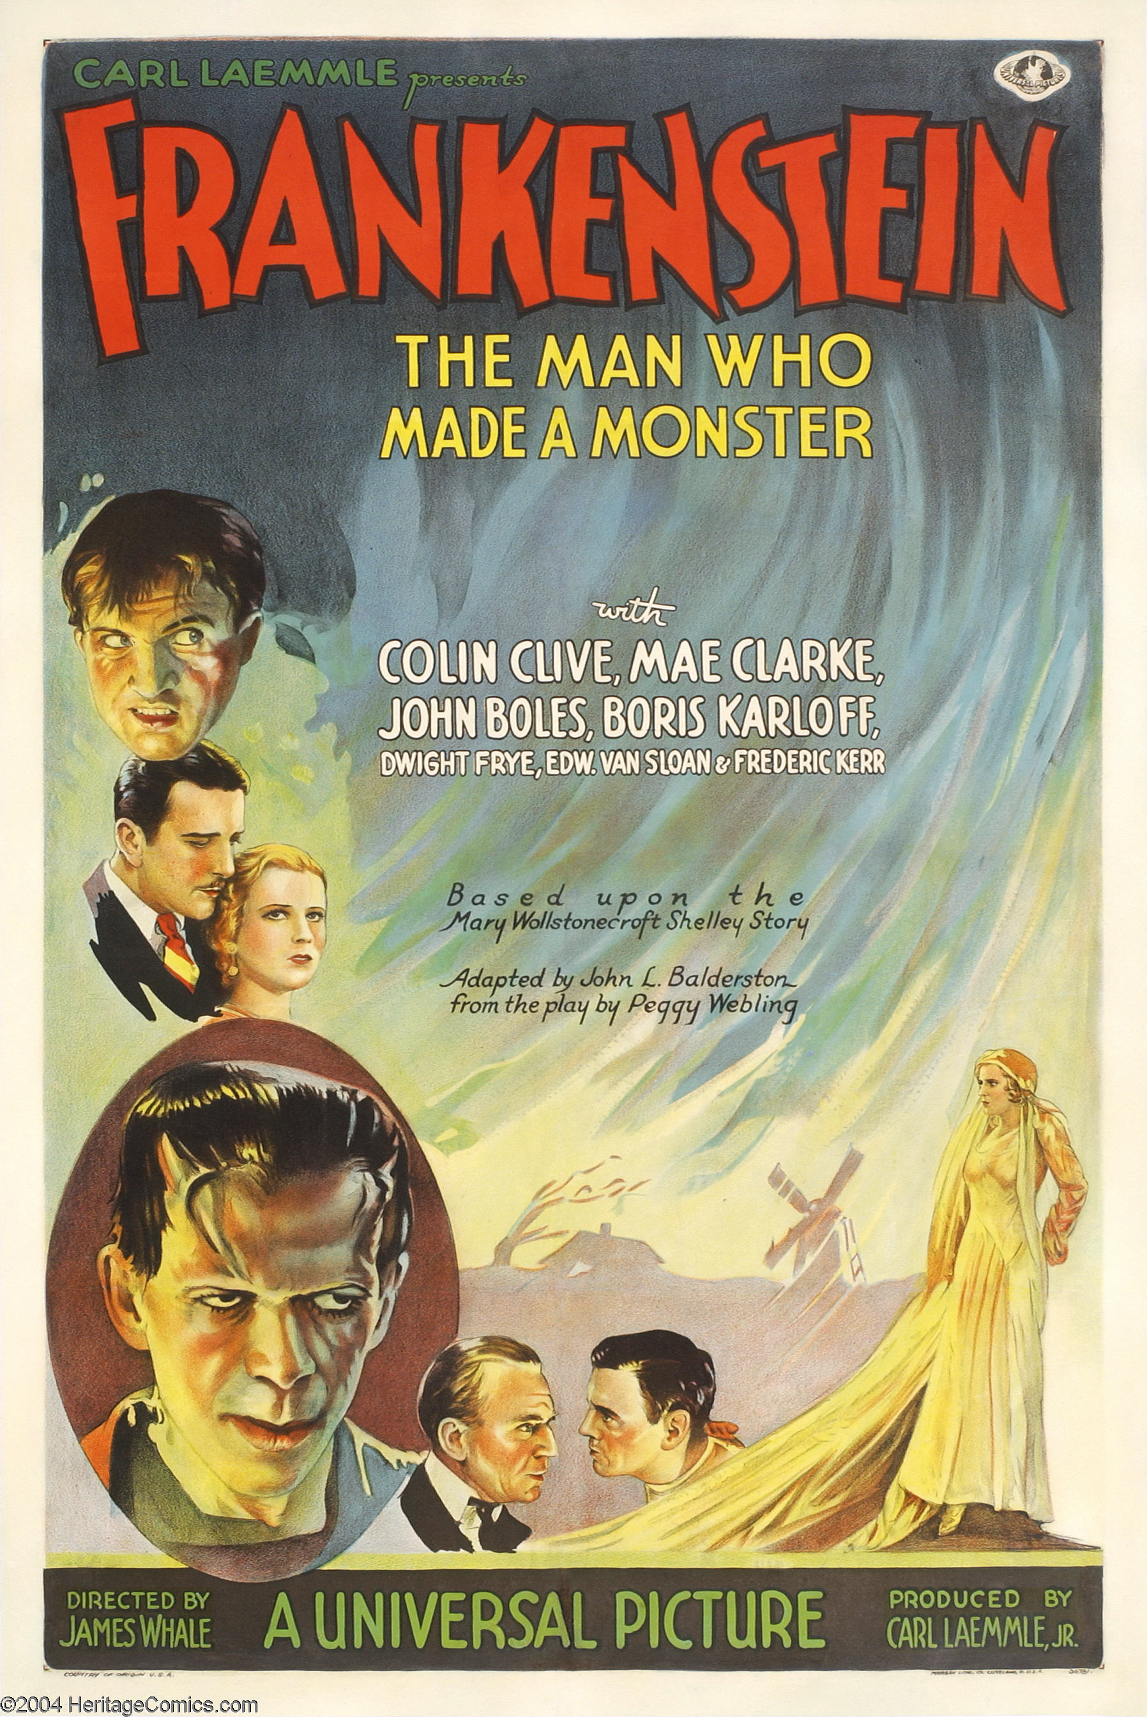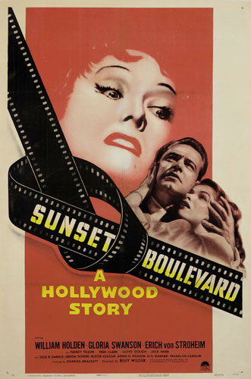

### Event posters

Posters advertising events have become common. Any sort of public event, from a rally to a play, may be advertised with posters; a few types of events have become notab le for their poster advertisements.

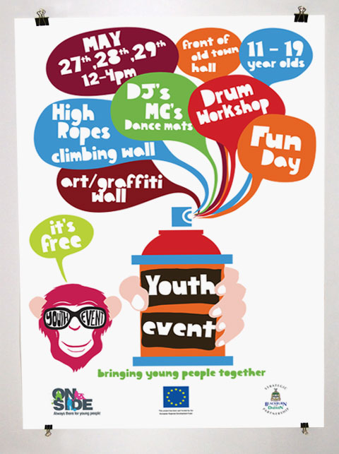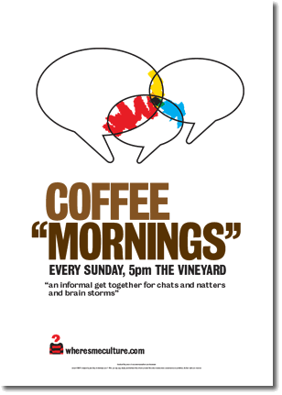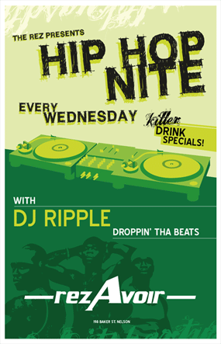

A Famous Poster Designer

Abram Games – was ‘The Official War Poster Artist’ and designed 100 posters. His clients included the United Nations, London Transport, British Airways, Shell, the Financial Times and Guinness. He designed stamps for Britain, Jersey and Israel, book jackets for Penguin Books and emblems for the Festival of Britain and the Queen’s Award for Industry. His influence even reached the infant television service in 1953 when he created the first moving BBC on-screen symbol.