Asthma Action Plan & School Medication Authorization

- Please order a VHC Spacer to use with any MDIs
Name: | DOB: | Date:
Important! Things that make your asthma worse (Triggers): X smoke □ pets □mold □dust-mites □pollen/trees □colds/viruses □exercise □seasons: other:
Severity Classification: □ Intermittent □ Mild Persistent □ Moderate Persistent □ Severe Persistent

GO – You’re Doing Well! Use these Medicines Everyday to prevent symptoms

CONTROLLER MEDICINE HOW MUCH HOW OFTEN/WHEN
1. |  |  | puffs | □ with Spacer |  | AM / PM
2. |  |  | Squirt(s), each nostril |  |  | AM / PM
3. |  |  |  |  |  | AM / PM
4. Albuterol / Xopenex (circle one) |  |  | puffs | □ with Spacer | □ Before Exercise  as needed

You have all of these:
- Breathing is good
- No cough or wheeze
- Sleep through
the night
- Can work
and play

CAUTION – Slow Down! Continue with Green Zone Medicine and ADD:

RESCUE MEDICINE (Circle one) HOW MUCH HOW OFTEN/WHEN
1. Albuterol / Xopenex (circle one) |  |  | Puffs/  1 vial | □ with Spacer |  | Every |  | Hours
□ May repeat in 20 minutes if needed
2.
- Call your Health Care Provider:
  - If getting worse and go to the RED ZONE or
  - Not improved in 2 days or any questions concerns about your asthma
You have any of these:
- First signs of a cold
- Exposure to known trigger
- Cough
- Mild wheeze
- Tight Chest
- Coughing at night
Your asthma is getting worse fast:
- Medicine is not helping
- Breathing is hard and fast
- Nose opens wide
- Ribs show
- Can’t talk well
You have any of these:
- First signs of a cold
- Exposure to known trigger
- Cough
- Wheeze
- Tight chest
- Coughing at night

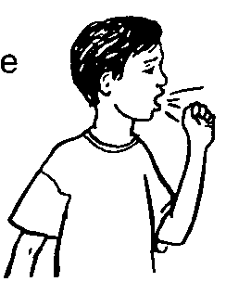

School Nurse: Call parent or provider if using PRN medication more than 2 times/week for asthma symptoms or for control concerns

DANGER – Get Help! Take these Medicines and Call your provider now

MEDICINE HOW MUCH HOW OFTEN/WHEN
Albuterol / Xopenex (circle one) |  |  | Puffs/  1 vial | □ with Spacer | NOW!
□ Repeat in 20 minutes if needed
- Call your Health Care Provider now, if they are not available, go directly to the emergency room or call 911 and bring this form with you.
  - DO NOT WAIT!

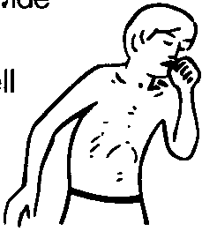
Your Asthma is getting worse fast:
- Medicine is not helping
- Breathing is hard and fast
- Nose opens wide
- Can’t talk well
- Getting nervous

Health care Provider School Medication Authorization required for Albuterol /Xopenex(Levalbuterol) as stated in above plan, and in accordance with CT State Law and Regulations 10-212a * Not to exceed 6 puffs within regular school hrs (6hrs), without notifying provider Office Stamp
Side effects:____________________________________ or Not expected |  |  | Medication Allergies:_______________________or NKDA
Self–Administration: This student is capable to safely and properly self-administer this medication OR
This student is not approved to self-administer this medication
Signature: |  | Date: |  |  | For School Year: | 2020-2021

Parent/Guardian Consent: REQUIRED
I authorize the student to possess and self-administer medication OR |  |  | I authorize this medication to be administered by school personnel
- I also authorize communication between the prescribing health care provider and school nurse necessary for asthma management and administration of this medication
Signature: |  | Date: |  | * Bring asthma meds and spacer to all visits
- Make an appointment with your health care provider within two days of an ED visit, hospitalization, or anytime for ANY problem or question with asthma

