Dear Parents,

As your child enters the Widefield School District 3 Preschool Program, we want to assure you that staff and administration are committed to ensuring the highest quality of education. We are committed to developing a home/school partnership and a nurturing environment for your child.

This handbook is for your information regarding the WSD3 Preschool Program. Please keep this on hand to answer any questions you may have about the program. We also encourage you to visit us or call us at any time should you have a question or concern about your child's education or any aspect of the preschool program. The number to the preschool office is (719) 391-3375.

Thank you for letting us partner with you in the education of your child. We are looking forward to working with your child and family!

Sincerely,

The WSD3 Preschool Staff

TABLE OF CONTENTS
Parking Lot Guidelines 5
WSD3 Preschool Program 6
Guiding Principles 7
Mission and Philosophy Statemen 8
Daily Activities 9
What you will see...............................................................................................................10
Child Find Information………………………………………………………………………………………………….11
Preschool Information/Transportation…………………………………………………………………….12

ADDITIONAL PROGRAM INFORMATION:
Access to Disciplinary Records 13
Accident/Injuries…………… 13
Additional Activities 13
Admission 13
Advertising 14
Age of Participants 14
Attendance 14
Authorized Person(s) 14
Behavior 15
Birthdays 15
Building Accountability and Advisory Committee………………………………………………….…15
Bus Rules/Safety .15
Car Seats .16
Change of Address/Telephone Number .16
Changes in Services............................................................................................................16
Check In/Out Procedure .16
Child Abuse and/or Neglect .16
Class Time .17
Classroom Newsletters .17
Closing the School at the End of Day .17
Clothing .17
Community Use of the Building .17
Complaints or Concerns .17
Conferences .18
Curriculum and Standards .18
Day Care Providers 18
Discipline 18
Dismissals During School Hours………………………………………………………………………………....19
Widefield School District 3 Mission Statement………………………………………….……......19
Drop Off & Pick-Up 19
Due Process 19
During School Hours…………………………………………………………………………………………………..….20
Electronic Equipment and Toys 20
Emergency School Closing and Two-Hour Late Starts 20
Equal Opportunity/Non Discrimination 21
Evacuation of Children with Disabilities…………………………………………………… 21
Evaluations and Assessment 21
Field Trips 21
Fire Drills 22
First Day Jitters………………………………………………………………………………………………………… 22
Grievances/Concerns………………………………………………………………………………………………… 22
Holidays 22
Inclement and Excessively Hot Weather………………………………………………………………….22
Illegal Substances/Items……………………………………………………………………………………….……23
Illness and Absence 23
Immunizations 23
Insurance 24
Intruder/Crisis Drill 24
Late Arrivals 24
Late Payment 24
Late Picking Up Child 24
Library………………………………………………………………………………………………………………………….……24
Lost Child 25
Lost and Found 25
Main Office Hours 25
Medicaid Release Information………………………………………………………………………………… 25
Medications 25
Mental Health………………………………………………………………………………………………………………….26
Parent Information Notices 26
Parent Teacher Conferences…………………………………………………………………………………… 26
Parent Visits...................................................................................................................... 26
Parking 26
Phone Numbers 26
Physical Exams ..27
Pictures ..27
Playground ..27
Positive Behavior Interventions and Supports…………………………………………………………..27
Restrooms ..28
Reunification of Family Following an Emergency……………………………………………………….28
Running and Opening Doors/Gates ..28
School Supplies ..28
Section 504………………………………………………………………………………………………………………..…..…29
Sex Offender Information for Parents……………………………………………………………………..29
Student Sexual Harassment……………………………………………..……………………………………..……29
Shoes ..29
Snacks ..30
Social/Health History/Student Information/Emergency Card Forms ..30
Student Records/Release of Student Information (FERPA)………….…………………..….30
Sun Protection… ..31
Teacher Absence…….…………………………………………………………………………………………………………31
Teddy Talk…… ..31
Tips to Parents.. ..31
Tobacco- and Drug-Free Policy…….………………………………………………………………………………..31
Toileting Needs ..31
Tornado Drills ..31
Toys and Miscellaneous Items ..31
Transportation ..32
Tuition Fees ..32
Videos/Movies…………………………………………………………………….……………………………………………..32
Violence Free Workplace…………………………………………………………………………………………….….32
Visitors……………. …………………………………………………………………………………………………………………32
Volunteers …33
Website….…………………………………………………………………………………………………………………………..33
Widefield School District 3 ..33
Widefield School District Calendar ..33
Withdrawn Participants…. ..33
How Sick Is Too Sick?........................................................................................................34
Standard Response Protocol………………………………………………………………………………………….38
Summary Student Conduct and Discipline Code from Colorado School Law and District Policy ………………………………………………………………………………………………………………………………..……………….34-36
Receipt of Handbook Signature Page……………………………………………………………………….…39

Parking Lot Procedures
For
Widefield School District 3 Preschool

Please practice the following parking lot/entrance guidelines to ensure everyone's safety.

1. Buckle up!!

2. At North, use the south parking lot (parallel to Hallam Ave.). The north parking lot/pull-through is for busses.
At Webster, park on the street by the gate entrance or in the circular drive.
At Grand Mountain, use the parking lot adjacent to the preschool wing of the building.

3. Slow down and use extreme caution.

4. Refrain from cell phone use upon entering and exiting the parking lot and when inside the school.

5. State law prohibits firearms, drugs and all tobacco use on school property. This includes smoking in or outside of your vehicle while on school property.

6. Look all directions before entering and leaving the parking lot and when backing from a parking space.

7. Never leave children unattended in your vehicle.

8. Hold children's hands at all times. No running!

9. Please close and lock gates when you pass through them.

10. If you enter the school, sign in at the front desk before proceeding to your child's classroom.

11. Working together we will have a safe and happy year!

Widefield School District 3
Preschool Program

The WSD3 Preschool Program is an integrated model designed to include tuition paying peers with children who have been identified as having special educational needs and Colorado Preschool Program (CPP) eligible students. The philosophy of this integration is to provide modeling and interaction, which ensures an enriching experience for all. Throughout the program, the children will learn through play exploration, participate in small and large group activities, enjoy art, music and science, and learn self-help skills for becoming more independent. A strong emphasis will be made on language development throughout the program. Children will receive Physical Therapy, Occupational Therapy, and Speech Language Therapy and Title I services based on identified needs. The preschool curriculum is based on the Colorado Department of Education’s P-12 Content Standards, Early Learning and Development Guidelines, and the Creative Curriculum to ensure the students’ readiness for kindergarten. Our program is licensed by the Colorado Department of Human Services Division of Child Care, and inspected by the Security Fire Protection District and Colorado Department of Public Health and Environment. Copies of the licensure inspections are available in the preschool office.

Tuition Paying Peers:
There are slots allocated in each class for a few tuition paying peers. These children are awarded slots and assigned to classes based on the order of the existing waiting list. Attendance is two days per week at a cost of $120 per quarter (4 quarters per school year).

Colorado Preschool Program:
Colorado Preschool Program (CPP) is a free educational program that provides comprehensive preschool services to qualified children and families. Integrated within the WSD3 Preschool Program, the four half day (CPP) preschool program services 4-year-old children who meet eligibility factors established by the state and district. Parents support the program through a services participation agreement. These free services are overseen by a district council. Parent education, regular meetings, and referrals for community services are part of the CPP program. For more information, call the main preschool office at 391-3375.

Children with Special Educational Needs:
Children with special educational needs are those who have had a comprehensive Child Find evaluation and have been determined eligible to receive special education services. Individual Education Plans (IEP’s) are developed based on student needs. Special education and related services are provided while children are in attendance, free of charge, at preschool. If you have developmental concerns for your child, please speak with your child’s classroom teacher who can advise you on the next steps in the process for seeking a Child Find evaluation.

GUIDING PRINCIPLES
WE BELIEVE:

- All children are special.
- All children are entitled to respect.
- All children can learn.
- Family support and involvement in the child's education is highly valued.
- Children learn best by doing.
- When children have choices, they take responsibility for their own learning.
- Children deserve to be surrounded by a rich environment that stimulates and encourages exploration, experimentation, and learning.
- Children learn through trial and error.
- After successes, children are ready to take on challenges and risk occasional failure.
- Children need a variety of experiences.
- Modeling provides a dynamic way in which children learn.
- Children’s play is their work.
- Parents are children’s primary teachers.

WE BELIEVE:

- All children are special.
- All children are entitled to respect.
- All children can learn.
- Family support and involvement in the child's education is highly valued.
- Children learn best by doing.
- When children have choices, they take responsibility for their own learning.
- Children deserve to be surrounded by a rich environment that stimulates and encourages exploration, experimentation, and learning.
- Children learn through trial and error.
- After successes, children are ready to take on challenges and risk occasional failure.
- Children need a variety of experiences.
- Modeling provides a dynamic way in which children learn.
- Children’s play is their work.
- Parents are children’s primary teachers.

WE BELIEVE:

- All children are special.
- All children are entitled to respect.
- All children can learn.
- Family support and involvement in the child's education is highly valued.
- Children learn best by doing.
- When children have choices, they take responsibility for their own learning.
- Children deserve to be surrounded by a rich environment that stimulates and encourages exploration, experimentation, and learning.
- Children learn through trial and error.
- After successes, children are ready to take on challenges and risk occasional failure.
- Children need a variety of experiences.
- Modeling provides a dynamic way in which children learn.
- Children’s play is their work.
- Parents are children’s primary teachers.

Preschool Mission and Philosophy

Our preschool mission is to provide children with a safe and nurturing learning environment that will provide opportunities that stimulate and encourage growth of the whole child. This includes their development in the areas of cognition, communication, social skills, motor, self-help and pre-academics.

Our philosophy is that children learn best through a balanced approach that includes play and direct instruction. We believe that play is the work of children and that we can facilitate learning through active exploration and interaction with other children, adults and materials. We also believe that by providing developmentally appropriate social and pre-academic instruction, we can foster a love of learning and build a strong foundation for their future educational experiences.

Daily activities and the skills they incorporate are: 1) Circle Time focuses on curriculum activities. Goals include:
Daily activities and the skills they incorporate are:

1) Circle Time focuses on curriculum activities. Goals include:
a. Increasing attention: auditory, visual, physical
b. Improving social skills: turn taking, interaction
c. Language development: eye contact, choice making, listening skills, understanding of concepts
d. Literacy development: listening for comprehension, letter recognition, letter sound connections, phonemic/phonological awareness
e. Math development: shape identification, counting, numeral recognition, understanding of math concepts
d. Motor Development: physical imitations-fingers/hands/body

2) Gross Motor Activities focus on body awareness. Goals include:
a. Improving balance and equilibrium
b. Improving motor planning: transitional moves
c. Improving primary skills: head control, sits, rolls
d. Improving fundamental skills: runs, jumps, catches, kicks, throws
e. Increasing body awareness in space

3) Fine Motor Activities focus on eye/hand coordination skills. Goals include:
a. Improving visual attention: using eyes and hands to complete a task
b. Improving use of hands: wrist rotation, finger isolation, crossing midline, reaching, two-handed tasks
c. Improving daily living skills: eating, drinking, toileting, dressing, undressing, nasal hygiene

4) Creative Play Activities are multi-purposed. Goals include:
a. Improving receptive and expressive language: eye contact,
turn taking, sound/word imitation, staying on topic, building vocabulary
b. Improving independence: choice making, imagination, problem solving
c. Increasing appropriate social skills: helping others, taking turns,
developing friendships, learning social behaviors

5) Snack Time refines all skill areas. Goals include:
a. Increasing oral motor skills: sensory awareness of tongue and mouth (chewing muscles and tongue control are needed for speech)
b. Increasing language skills: vocabulary, number concepts, sequencing,
turn taking
c. Learning responsibility: clean up
d. Improving social interaction: conversation, friendship
e. Increasing independence: pouring, unwrapping, requesting

1) Circle Time focuses on curriculum activities. Goals include:
a. Increasing attention: auditory, visual, physical
b. Improving social skills: turn taking, interaction
c. Language Development: eye contact, choice making, listening skills, understanding of concepts
d. Motor Development: physical imitations-fingers/hands/body

2) Gross Motor Activities focus on body awareness. Goals include:
a. Improving balance and equilibrium
b. Improving motor planning: transitional moves
c. Improving primary skills: head control, sits, rolls
d. Improving fundamental skills: runs, jumps, catches, kicks, throws

3) Fine Motor Activities focus on eye/hand coordination skills. Goals include:
a. Improving visual attention: using eyes and hands to complete a task
b. Improving use of hands: wrist rotation, finger isolation, crossing midline, reaching, two-handed tasks
c. Improving daily living skills: eating, drinking, toileting, dressing, undressing, nasal hygiene

4) Creative Play Activities are multi-purposed. Goals include:
a. Improving receptive and expressive language: eye contact,
turn taking, sound/word imitation, staying on topic, building vocabulary
b. Improving independence: choice making, imagination, problem solving
c. Increasing appropriate social skills: helping others, taking turns,
developing friendships, learning social behaviors

5) Touch Time focuses on tactile activities. Goals include:
a. Increasing tolerance to a variety of textures, touch, temperatures
b. Increasing body awareness in space
c. Increasing ability to use eyes and hands together
d. Increasing visual attention, tracking

6) Snack Time refines all skill areas. Goals include:
a. Increasing oral motor skills: sensory awareness of tongue and mouth (chewing muscles and tongue control are needed for speech)
b. Increasing language skills: vocabulary, number concepts, sequencing,
turn taking
c. Learning responsibility: clean up
d. Improving social interaction: conversation, friendship
e. Increasing independence: pouring, unwrapping, requesting

What you will see:

- Easy movement from one area to another
- Buckets/bins/baskets full of materials
- Materials clearly marked
- Large group area
- A process for children to choose centers
- The class has a sense of community
- Children talking to each other
- More children initiated activities - less teacher talk
- Teacher is a facilitator/co-facilitator/guide/encourager
- Teacher-led instruction
- A balance between activities
- Quiet/active activities
- Child-initiated/teacher-initiated tasks
- Tables set up in small groups in order to promote cooperative learning
- Large group/small group and individual activities
- Cooperative learning
- Peer teaching
- Interest groups
- Skill groups
- Children given choices

Child Find

Individuals with Disabilities Education Act (IDEA) and Exceptional Children Education ACT (ECEA) mandate that local school districts evaluate and identify children ages 0 to 21 suspected of having a disability, which would make them eligible for special education services. Widefield School District provides year-round Child Find services for children ages 0 to 5 and directly serves children ages 3 to 21.

To refer a child 0 to 5 years old for an evaluation, call the central intake number, 391-3375. The free evaluation will provide you with information about your child’s ability to talk, play, learn, move, see, hear, or interact with others. If your child is age 0 to 2 and is identified as having a delay in one of these areas, your child and family are eligible for service coordination. This includes an Individual Family Service Plan (IFSP), resources and support. If your child is age 3 to 4 and is identified as having a delay, your child is eligible for free preschool services, which will address your child’s needs in an educational setting. An Individual Educational Plan (IEP) will be developed for your child through a staffing process, which includes parents and staff. A child age 5 to 21 is eligible for an evaluation and services by requesting assistance through your neighborhood school counseling office. For more information, call our preschool office at 391-3375 or the District Child Find Coordinator, at 391-3378. We conform to the ADA standard practices.

PRESCHOOL INFORMATION

Age: Children who will be 3 or 4 years old in the current school year, on or before October 1st, including children who turn 5 after October 1st, are eligible for preschool during the current school year.

Class Location: Widefield School District 3 Preschool
Sites at: North, Webster and Grand Mountain
Phone: 391-3375 Fax: 391-9425

Class Time: A. M. Class 8:15 - 11:15 A.M.
P. M. Class 12:30 - 3:30 P.M.

Tuition: $120.00 per child every quarter. Tuition is waived for children with special needs per ECEA and CPP.

Tuition Payments are due on or before the first day of each quarter.

Transportation to and from preschool is available for children with special needs as a related service within WSD3 boundaries. Parents of tuition and CPP children must provide their own transportation.

Preschool Staff and Parent Policies and Procedures

Access to Disciplinary Records: Teachers or counselors may examine student disciplinary records maintained by the building administrator for students with whom they have direct contact. Parents and guardians may also examine student records as provided by board policy and applicable law. Access shall be granted to the teacher, counselor, or parent within a reasonable period of time following the request. Parents, guardians, and staff members shall be given written notice at the beginning of each school year regarding their opportunity to review student disciplinary records. Teachers and counselors shall not copy or take disciplinary records or information with them from the file and shall not disclose the information to any other person.

Accident, Illness or Injury at School: If a student is injured, it shall be his/her responsibility to inform a teacher or the office of the injury as soon as possible. In the event of a serious injury, all students should make it their responsibility to see that a teacher or the office is notified at once. A staff member will then take the proper steps to handle the particular situation. If the home/work fails to answer when phoned, the emergency contact, family physician or hospital will be contacted. In the event of serious accident/illness, 911 may be contacted and the child may be transported by ambulance for medical treatment. Please be sure the school has up-to-date information on home and work phone numbers.

Additional Activities: Throughout the school year, there will be opportunities for students to participate in program-wide activities that are not part of the regular daily schedule. These activities may include field trips, guest speakers, special activities and parties. Because the majority of students in each class attend four days per week, each additional activity will only be offered once. We recognize that this means some activities will be held on Mondays/Wednesdays and some will be held on Tuesdays/Thursdays. In order for there to be equity for students who attend only two days per week, these additional activities will be rotated accordingly. Furthermore, every effort will be made to ensure that educational activities and parties are also rotated so that each type of activity does not always fall on the same days of the week. When a program-wide additional activity is offered, students not regularly in attendance on that day may participate in the activity, only for the duration of the activity, if accompanied by a parent/guardian who will assume responsibility for them so as not to count against our CDHS licensing capacity and ratio.

Admission: When entering a school in the District for the first time, students are to present a birth certificate or other documentation to verify age. In accordance with Colorado Law, CRS 25-4-900, all students enrolled in public school are required to have a certificate showing required completion of immunizations. In addition, our school requires a physical statement from a licensed practitioner. If a challenge prevents you from meeting these criteria, please see an administrator.

Advertising: Widefield School District informs the Security/Widefield community of its program and availability. Children are admitted regardless of race, creed, color, sex, national origin or religion. Children with special needs are served in compliance with IDEA and ECEA rules.

Age of Participants: Children with special needs may be eligible for enrollment and services upon turning three years old. Tuition-paying children must be three by October 1st of the school year registered. Colorado Preschool Program slots are for 4 years olds who meet specific criteria and will be eligible for kindergarten the following school year. Entrance to kindergarten requires that a child be five years of age on or before October 1 following the opening of the school term. Entrance to first grade requires that a child be six years of age on or before October 1 following the opening of the school term.

Attendance: Teachers will keep their own records of attendance. If a child is going to be absent, please notify North’s office @ 391-3375. Please give the child's name, teacher and class. Also, if your child is bussed to school, you will need to contact Transportation @ 391-3544 to let them know your child will not be in attendance. THIS PROCEDURE IS FOR THE PROTECTION OF YOUR CHILD. IN ORDER TO MAKE IT MANAGEABLE, PARENTS SHOULD NOTIFY THE OFFICE OF ALL ABSENCES OR TARDIES. Attendance in preschool is not required by Colorado State Law, but consistent attendance is expected in order for the child to learn and to develop successful school behavior. If your child is funded by the Colorado Preschool Program to attend WSD3, your child may be dismissed from the free program if absences exceed 10 per semester.

Authorized Person(s): The parent/guardian will inform the school as to who is authorized to pick up and/or drop off a student. The authorized person(s) name, phone number and address must be on the Pupil Registration/Authorized Pick-Up Form. If someone other than an assigned person needs to check a student out of class, the teacher will need WRITTEN or VERBAL permission from the parent/guardian BEFOREHAND. Additionally, a photo ID will be requested of anyone with whom the staff is not familiar.
We CANNOT release a child to someone who is NOT LISTED ON THE PUPIL REGISTRATION/AUTHORIZED PICK-UP FORM. If there is someone who is ABSOLUTELY NOT to pick up the child, inform your child's teacher and provide necessary documentation for the file. Parents will be notified if an unauthorized person is attempting to pick-up a child. If necessary, WSD3 Security and/or law enforcement will be notified, as well.

Behavior - The WSD3 Preschool Program strives to help your child develop appropriate school behavior. This becomes very important as your child enters elementary school. You may help your child at home by discussing the preschool rules:
OUR SAFETY RULES
We keep ourselves safe.
We keep our friends safe.
We keep our things safe.
If behavior is a concern, you or the staff may call a conference to resolve the concern. The WSD3 Preschool administrators are available to provide direction per district policy and procedure.
Mental Health - Social/emotional, behavioral and mental health supports are available for students of WSD3 Preschool. A school psychologist and behavior teacher are on staff who can provide additional guidance and resources to staff and families when needed to assist with classroom behavior concerns and/or to develop behavior support plans. Additionally, we have a school nurse and social workers in the district that can be accessed to provide family support and community resources and referrals.

Birthdays: Parents/guardians who wish to provide food items for students’ birthdays or for any other celebrations must prearrange approval of the specific food item with the building (teacher, office, staff, etc.) at least 24 hours in advance. Food items must adhere to the policy requirements for zero trans fats, store bought items, not prepared in a private home and must include a visible nutritional label and ingredients list. We do encourage parents to send non-food options for birthday celebration such as stickers, pencils, etc. Please see District Policy ADF-R for more information. Other non-accepted items include but are not limited to soda water, water ices, chewing gum, jellied candy, hard candy, marshmallows, fondant, licorice, cotton candy, and candy-coated popcorn. Balloons will not be permitted as they are a choking hazard, distraction to instruction and allergen. There can be no gift exchange at school. HOME PARTY INVITATIONS MAY ONLY BE HANDED OUT IF ALL STUDENTS IN THE CLASS ARE INVITED.

Building Accountability and Advisory Committee: The Building Accountability and Advisory Committee (BAAC) provides parents, staff, students and interested citizens an opportunity to participate in the planning and accountability process. The committee is asked to act in an advisory role to the principal, serving primarily as a representative group for the community between and within the school, the school community, and the district. Persons interested in serving on the committee are asked to contact the principal.

Bus Rules/Safety: In view of the upcoming bus trips, the transportation department would like to pass along these tips to make our trips safer and more enjoyable. Please, discuss these rules with your child before the bus trips. The staff will also be reinforcing them in the classroom. Transportation may be reached at 391-3544.

STAFF AND ADULTS
1. Review bus conduct rules with the children before the trip.
2. The bus monitor(s) is primarily responsible for maintaining order on the bus. However, our driver will assist if necessary.
3. Please help the students understand that the bus is an extension of the classroom and behavior should be comparable. The driver must be able to hear emergency vehicles that may be outside the bus. Excessive noise must be controlled.
4. It is suggested that at least one adult sit in the rear of the bus to supervise.
5. Eating and drinking are not permitted unless prearranged with the transportation supervisor. We are looking forward to our bus trips. Thank you for helping us prepare the children.

Car Seats: Colorado State Car Seat Laws are in effect for all children who ride in privately owned vehicles. These youngsters MUST be in a car seat/booster. This information is a reminder when carpooling/transporting children.

Change of Address/Telephone Number: The current addresses and telephone numbers of all students are necessary for proper accounting procedures. If you change residence, mailing address, telephone number (home, work and emergency contact), or day care provider, please report the change promptly to North Preschool at 391-3375. This is very important in case of an emergency. IT IS IMPERATIVE THAT YOU LIST AN EMERGENCY CONTACT PERSON ON YOUR CHILD'S REGISTRATION FORM. WE MUST BE ABLE TO REACH YOU OR YOUR EMERGENCY CONTACT PERSON AT ALL TIMES.

Changes in Services: The WSD3 Preschool Program staff program will notify parents in writing of significant changes in services, policies or procedures so parents can decide whether the program continues to meet the needs of their child.

Check In/Out Procedure: Children enter/exit their classroom through the outside doors at the beginning and end of class. When you bring your child to school, the parent/guardian will bring the child to the classroom and SIGN the child IN. We ask for the signature, date and time on our daily CHECK IN/OUT FORM. At dismissal time, the door will open and parents may come in to SIGN the child OUT. If the parent is NOT there at the end of class, the child MUST wait in the classroom or main office. It is your responsibility to be on time.

Child Abuse and/or Neglect: A Colorado Statute (19-10-102 to 115) requires the reporting of these cases to the appropriate county department or local law enforcement agency. In the child abuse bill enacted in the 1976 session, the “school official or school employee” is listed as one of the persons required to report abuse or neglect. The bill goes further to state that any person who is listed to report, who willfully fails to report a case of child abuse or circumstances, or conditions which would reasonably result in child abuse “commits a class two petty offense and upon conviction thereof, shall be punished by a fine not to exceed $200.00 and shall be liable for damages proximately caused thereby.” No person who reports a case of suspected child abuse can be sued for making a good faith report. Members of the public may also report suspected child abuse or neglect using the Colorado Child Abuse and Neglect Hotline. 844-CO-4-Kids.

Class Time: Preschool classes are 3 hours in duration. We ask that the children come to class on time and be picked up on time. The teachers utilize every minute to prepare for the class before the starting time. If you find the door closed, your teacher may need those few minutes to finish preparing. All classes will be dismissed at the designated times and all parents/adults MUST be there to check out their children. Remember, your child realizes when you are late and he/she may become distressed.

Classroom Newsletters: A classroom newsletter will be sent home weekly. The newsletter will give the parent information of classroom activities and program news.

Closing the School at the End of the Day: Before the staff leaves at the end of their work schedules, they will look over the check-in/out form, and check the classroom, restroom areas, and hallways adjacent to the classroom. On their way off the grounds, each staff member will scan the area for any of our students.

Clothing: Your child's comfort and safety should be considered first. Items that restrict free movement or that are hard to remove for the purpose of toileting are discouraged. As you select your child's clothing, please keep in mind that we do go outside when possible and we will be involved in messy activities (art, water play, etc.). The child's name should be placed on all outdoor clothing and other belongings to help ensure the return of all the proper possessions and clothes.

Community Use of the Building: Any citizen, club, or organization within Widefield School District 3 boundaries may request use of the building/grounds, subject to the regulations for such use as approved by the Board of Education. Information on use of facilities may be obtained by contacting our office at 391-3375.

Complaints or Concerns: If a parent/guardian of a child registered in the program has a concern or complaint, they may call the Preschool Principal at 391-3375. You may also talk to your teacher at any time regarding any concerns you may have. A signed written complaint will also be accepted by the principal. To file a complaint about this facility contact:
The Colorado Department of Human Services
Division of Child Care
1575 Sherman Street
Denver, CO 80203-1714
(303) 866-5958 or 1-800-799-587

Conferences: You may have a parent conference at any time you desire. Your concerns are our concerns. If you have questions regarding your child's program or progress, please call and arrange a meeting. The best time to contact your child's teacher is between 8:00 and 8:15 a.m. or 11:15 and 12:00 p.m. The number to call is 391-3375. At other times, they are with the children in class, but will return your call at the first opportunity.

Curriculum and Standards: The WSD3 Preschool Program integrates the Colorado Department of Education Early Learning & Development Guidelines and P-12 Content Standards as our curriculum. We use the Creative Curriculum, Handwriting Without Tears, Zoo-Phonics and Dinosaur School as resources to address the standards. The instructional staff meets weekly to discuss lesson plans and/or activities so that the lessons are dynamic, align with curriculum guidelines, and meet the individual needs of students.

Day Care Providers: If your child is staying with a sitter during the day, inform them of the program's calendar and procedures. Please make sure your sitter's name, phone number, and address are on the student's registration card for the teacher to make a contact if needed.

Discipline: In preschool, we teach and guide young children as they learn appropriate school behavior. Staff is trained in Crisis Prevention Institute techniques for de-escalation, Dinosaur School Social Emotional Curriculum, Restorative Practices in early childhood environments, and Positive Behavior Intervention and Support. In the process of growing, young children need positive verbal guidance. We communicate with the children regarding inappropriate acts or behavior and reinforce positive actions and behaviors. For a child not cooperating in a group listening situation, the child is seated by a teacher and reminded of acceptable behavior. Removal from the group for a short period of time-out is the next approach used for a child who continually demonstrates unacceptable behavior. This time-out is not a punishment, but rather, a time when the child may calm down, remember what behavior the teacher is asking for, and decide for him or herself when he/she is ready to rejoin the group with the appropriate behavior. Children that need additional support in the area of social/emotional/behavioral development may be referred for individual interventions.

In lieu of suspension or expulsion, the principal or designee may consider the use of available interventions to address the child's misconduct and potentially develop a Behavior Intervention Plan for the child. The goal of the plan is to address the child's disruptive behavior and educational needs while keeping the child in school. To develop the plan, the principal or designee will contact the student's parent/guardian to schedule a meeting with the student's parent/guardian and any members of the staff whom the principal believes should attend.

Dismissals During School Hours:
- Please send a note with your child if it is necessary for him/her to be excused early.
- Students MUST be signed out by a parent or guardian in the office before leaving school.
- Under no circumstances are students to be excused directly from their classroom or playground during school hours.
- Emergency contacts are allowed to pick students up if they are listed on the student’s information sheet. However, parents must contact the office to arrange for others to pick up their child.

District 3 Mission Statement:
Work toward high standards of excellence
Instill pride and self-esteem
Develop responsible, productive citizens for tomorrow
Enhance each student's unique potential
Foster partnerships with parents and community
Increase academic and interpersonal skills
Encourage self-discipline
Learn to appreciate differences among people and cultures
Deliver high quality instructional programs

Drop Off & Pick-Up: Parents who transport their children need to park their cars on the street or in the parking area by the classrooms. You must follow the traffic pattern. This procedure is to ensure the safety of the children. Parents MUST HOLD THEIR CHILD'S HAND while escorting their child to the classroom, and must remain with their child until the teacher has opened the door for arrival. No children are to be left in the car or outside the classroom unattended.

Due Process: The determination of valid and rational rules and regulations for the operation of a school district rests primarily with the Board of Education. The guidelines, procedures, and policies for balancing individual interests when constitutional rights are involved are available to all persons in the public school community, regardless of status. Students and parents are encouraged to consult with their school principal if there are any questions regarding due process in:
1. Special Education; 2. Suspension, Expulsion, Denial of Admission; 3. Student Records; 4. Non-discrimination/Equal Educational Opportunity, or 5. Section 504.

During School Hours: A schedule is posted informing parents of where the students and staff are at all times. When the class leaves the classroom a notice is posted on/near the door as to the destination. The posted daily schedule indicates the timeframe for activities so that the time of return can be determined.

Electronic Equipment and Toys: Electronic equipment (cell phones, walkie-talkies, tablets, CD players, electronic organizers, pagers, radios, games, laser pointers, etc.) and toys (including trading cards) are not to be brought to school. If these items are brought to school, they may be confiscated and not given back until a parent comes in to retrieve them. The school will not be responsible for lost or stolen personal property. This policy extends to field trips, outdoor education (camp) and riding the bus to and from school. Please note, personal technology used for academic purposes may be allowed pending approval by administration and individual classroom teacher(s).

Emergency School Closing and Two-Hour Late Starts: The primary method to notify all district employees, parents and students of school closing is by radio and television. Listen to local stations for information.
Widefield School District 3 will…
- Make inclement weather decision(s) based on students’ safety
- Make the decision as to whether school will be closed and announce that decision no later than 6:00 a.m. on radio stations and TV stations
- Not penalize students if parents keep them home or pick them up from school on questionable days

In the event the decision made earlier is to open schools and the weather worsens unexpectedly, Widefield School District 3 will…
- Inform the same media, as stated above, that schools will dismiss students early
- Keep buildings open as long as necessary to evacuate all students safely

Parents are expected to…
- Be responsible for custody of children
- Decide whether or not to send children to school on threatening, stormy days
- Listen for an early dismissal announcement
- Know that students may be dismissed earlier than normal
- Not rely on telephones to make last minute arrangements for their children. (Lines tend to malfunction and be overloaded during storms and in the event of a power failure the telephones do not work)

Two-Hour Late Starts…
If an emergency closing is declared by the superintendent for part of the day only, a two-hour late start may be used. Whenever feasible, a two-hour late start will be announced by 5:30 a.m. through the same channels as a school closure. These channels include television, radios, and the district’s website.
When district officials announce a two-hour late start, all start times, bus pick-up times and other standard schedules will be moved back by two hours. Morning preschool will be cancelled for that day. Afternoon preschool classes will still be in session.

Equal Opportunity/Non Discrimination: Widefield School District 3 complies with all state and federal regulations prohibiting discrimination on the basis of race, color, national origin, creed, religion, age, sex, and disability. Widefield School District 3 is an equal opportunity employer. Inquiries concerning the application of Title IX, section 504, or Title VI may be referred to the Widefield School District 3 administrative office at 1820 Main Street, Colorado Springs, CO 80911; or to the Regional Director of Education, Office of Civil Rights, 1961 Stout Street, Denver CO 80294.

Evacuation of Children with Disabilities: In the event that the building must be evacuated in an emergency, any child that is unable to evacuate with the group due to a disability will have a specific adult assigned to assist. Each child for whom it is deemed necessary will have his/her own evacuation plan to ensure the child’s safety, as well as that of the whole group. The evacuation plans will be made available to pertinent staff and to emergency responders.

Evaluations and Assessments: Teachers and staff are concerned about your child's social, emotional, physical, and cognitive development. We may recommend that a child be evaluated/screened more extensively, following a discussion with the parents/guardians. Examples of additional evaluations: Child Find screenings, hearing/vision screenings, motor, speech, health, social/adaptive or cognitive evaluations. For a free multidisciplinary evaluation, contact the Child Find Coordinator at 391-3378, or the preschool office at 391-3375, or your child's teacher.

Field Trips: Transportation for field trips will be provided by a Widefield School District 3 school bus for children registered in our program. WSD3 Preschool Staff will be responsible for children and will maintain appropriate staff:child ratios at all times. Parents/guardians are occasionally asked to assist on trips and drive their privately owned vehicles. Advance notice will be given as to when a field trip will occur. All participants will need the FIELD TRIP PERMISSION SLIP FORM signed and given to the child's teacher to keep on file. Field trips are for children registered in our program, not for underage siblings. If your child is late on the day of the Field Trip activity, and the class is away from the preschool, the parent may take the child to the Field Trip site. Transportation back to the preschool will be provided with the class.

Fire Drills: There will be scheduled practice fire drills monthly throughout the school year. We will evacuate the building in an orderly fashion and have all students in their appropriate places as quickly as possible. The children will be under adult supervision at all times during the drills. Escape plans are located in the front and back of each classroom.

First Day Jitters: If your child is having second thoughts once he/she gets to the classroom, please leave even if there are a few tears. We have found in the long run that it is much easier if the parent leaves right away. The child will usually become interested in the other children and the situation will work itself out.

Grievances/Concerns: A grievance is defined as any event, condition, rule, or practice which the parent believes violates his or her civil rights, treats him or her unfairly, or causes him or her any degree of unpleasantness or unhappiness. Parents may share their concerns regarding any aspects of the WSD3 Preschool Program with the principal or a signed written complaint may also be accepted by the principal. If necessary, a meeting will be set up with you and the necessary staff. A grievance may also deal with an attitude, a statement, or an opinion held by a program staff member or volunteer. If a parent/guardian has a concern about the program and feels the need, he/she may contact the Human Services Licensing Department at (303) 866-5958. North License #41173. Webster License #1542575, Grand Mountain License #1732588.

Holidays: The preschool staff believes that holiday celebrations can be wonderful opportunities for children to learn about the traditions and values that are important parts of families’ lives. When celebrating holidays, our focus is on secular customs rather than on the religious components of the holidays. We may plan to celebrate Fall Festivities in October, Thanksgiving in November, Christmas in December, Valentine’s Day in February, Easter in the spring, and other holidays represented by members of each class. If your family celebrates other holidays that you believe would be significant and meaningful to celebrate in class, please discuss these with your child’s teacher. Also, if you prefer your child NOT participate in holiday activities, discuss that with your child’s teacher. You will be asked to sign a HOLIDAY PERMISSION FORM.

Inclement and Excessively Hot Weather: WSD3 Preschool Program follows the school district's decisions and guidance regarding inclement weather. If there is a heat or air quality advisory/warning, preschool students will remain indoors for gross motor activities while the advisories/warnings are active .

Illegal items/substances: No student shall have in his possession (possession shall mean having on the student's person, or retaining in the student's desk or backpack) while on school district property or while attending school district activities substances or items such as the following:
1. Alcoholic beverages
2. Any controlled substance as defined in Colorado Revised statues 12-22-309.
3. Any substance which is accepted or represented to be a narcotic drug or which is a simulated narcotic drug.
4. Material which is illegal to possess under any local, state or federal law or ordinance.
5. Property which is stolen or improperly retained.
6. Any material or thing which might reasonably present a threat to the health, safety, or welfare of the school, staff or students. This listing shall be considered illustrative and not exclusive.
(District Policies: JICH & JICI)

Illness and Absence: Preschool-aged children frequently become mildly ill. Deciding whether to keep your child home from preschool can be a difficult decision. Our office staff, along with the school nurse, follow specific state rules and regulations regarding illness and exclusion from preschool. If you are unsure whether or not to send your child, please call and we can discuss whether your child needs to be excluded from school. Please contact the preschool office at 391-3375 for further clarification or to report an absence. If your child rides a bus, please notify transportation of their absence at 391-3544. These guidelines also apply to children already at school. If your child meets the exclusion guidelines, parent/guardians will be contacted and the student must be picked up from school.

The school nurse follows the current guidelines set by the Colorado Department of Public Health & Environment for reporting any required communicable diseases.

Immunizations: Children may not attend until the school has received a copy of the most recent immunization record. Colorado law requires all students attending Colorado schools and licensed child care programs to be vaccinated against certain diseases unless they have a medical or non-medical exemption on file (Colorado Board of Health rule 6 CCR 1009-2). Please see https://www.colorado.gov/pacific/cdphe/vaccine-exemptions for more information about vaccine exemptions and how to turn one in. We will accept children who have not had immunizations, if they have the immunization waiver. However, in the event of an outbreak of disease against which immunization is required, no exemption or exception from immunization shall be recognized and exempted persons may be subject to exclusion from preschool.

Insurance: The School District will not assume responsibility for payment of doctor, hospital, or ambulance costs resulting from injuries incurred on school property or at school functions during school hours. Each year the Board of Education authorizes an insurance company to sell life, accident, and dental insurance to provide for student coverage at very low rates. The information concerning this insurance is sent home with students sometime during the first week of school. The purchase of insurance under this program is at the option of parents/guardians and becomes effective upon completing the application and payment of the premium. Participation in this program is strongly encouraged. Widefield School District 3 encourages parents to provide some type of insurance coverage for their children.

Intruder/Crisis Drills: WSD3 and its preschool program have a crisis plan for emergency situations such as an unwelcome intruder, act of violence, or unexpected crisis. This is practiced, minimally, 4 times during the year.

Late Arrivals: If your child arrives late to the classroom, check-in at the front office. If you have arrived more than 5 minutes late, following safety protocol, the classroom staff will not open the outside doors to accept students. If the group is not in the classroom 1.) check the classroom for posted field trip info (field trips are not to leave the facility until 15 minutes after the designated starting class time), and 2.) check the calendar for daily activities (i.e. playground, motor time, etc.). In case the group has left the facility on a field trip, the late child will need to go home with the parent/guardian. Please leave a note for the teacher on the Check In/Out board. No child should be dropped off at the school by themselves. Child Care Licensing Rules and Regulations require that the parent/adult accompany their child in and out of the building.

Late Payment: If we do not receive tuition payment on time, someone from the office will make a call or send a letter to the child's parent. You may discuss with the principal other arrangements if needed. Failure to make payment will result in your child’s dismissal from the WSD3 Preschool Program.

Late Picking Up Child: All classes are dismissed at the posted times and all parents/authorized adults MUST be there to check out their children. If you fail to pick up your child on time, your emergency contact will be notified and asked to assume care for your child. If we cannot reach or contact anyone listed on the child's registration form within 90 minutes of dismissal, the next step is to contact the local police department to arrange for your child’s return home.

Library: All classes will be scheduled a time to visit the school library on a regular basis. The librarian will teach the children how to check out books and the proper care of all library books and materials. Some classes may have lending library books sent home on a rotating basis. If the children lose or damage a book, they are asked to pay for it. The amount to be paid depends on the age and condition of the book. Please impress upon the children the importance of returning books on time and of treating books with respect and care.

Lost Child: The procedure for a lost student while at school: staff will
1.) thoroughly check all areas where the child was last seen, 2.) notify the office and principal or designee 3.) with help, search the immediate grounds, 4.) notify the child's parents, 5.) make sure the child did not go with friends or family, 6.) when all else has been completed, contact local police with complete information.

Lost and Found: Please label all items (i.e., jackets, coats, mittens, back packs, gloves, etc.) you send to school with your child's name. Often times children have the same shoes or jackets and it can be very confusing if they are not labeled. A black permanent marker works well. If your child loses a personal item, please notify the school or teacher and we will assist in locating the article(s). Unclaimed items will be given to charity.

Main Office Hours: North Preschool Office hours are 7:30 A. M. to 4:00 P. M., Monday through Friday, 391-3375.

Medicaid Release Information: As a Medicaid provider, Widefield School District 3 will access Medicaid eligibility information for students enrolled in Widefield School District 3 from Health Care Policy and Financing (HCPF). HCPF is the designated Medicaid agency in the state. Directory information of name and date of birth will be released to HCPF to verify Medicaid Eligibility of students in the District. The description of health and
health-related services delivered to Medicaid eligible students will be released to
Medicaid and/or the District claiming agent for proper administration of the program.

Medications: Preschool personnel will not administer prescription or nonprescription medications to students unless administration cannot be reasonably accomplished outside of school hours. Medications may be administered to students by the school nurse or other school staff designee only when the following requirements are met:
- Medication shall be in the original, properly labeled container. If it is a prescription medication, the pharmacy label must clearly state: student’s name, name of the medication, dosage, route, how often it is to be administered, and the name of the prescribing health practitioner. The label must be on the original container.
- The school shall have received written permission from the student’s parent/guardian to administer the medication to the student.
- The school shall have received written permission to administer the medication from the student’s health care practitioner with prescriptive authority under Colorado law. This permission is only valid for one school year during which it was signed.
- The parent/guardian shall be responsible for providing all medication to be administered to the student. Medication provided must be in the dosage in which it was prescribed.
- Medications that are accepted at school will be kept in a safe location, out of the reach of any students. Pertinent staff will be advised in advance as to where to locate and how to give children’s emergency medications (ex. Epi-pens, inhalers etc.) so as not to delay treating the condition.
(District policy JLCD.)

Mental Health - Social/emotional, behavioral and mental health supports are available for students of WSD3 Preschool. A school psychologist and behavior teacher are on staff who can provide additional guidance and resources to staff and families when needed to assist with classroom behavior concerns and/or to help develop behavior support plans. Additionally, we have a school nurse and social workers in the district that can be accessed to provide family support and community resources and referrals.

Parent Information Notices: There may be information regarding your child's class outside of the classroom or sometimes next to the CHECK IN/OUT form. Please read this information.

Parent-Teacher Conferences: Parent-teacher conferences will be held twice a year, once at the beginning of the school year and once at the end. You may request an individual conference at any time.

Parent Visits: We encourage parents to visit our school at any time after the first few weeks of school. Please stop by the office and pick up a visitor pass before going to the classroom. Parents who wish to volunteer more than a few times per year will be asked to submit to a background check. If you would like to come on a specific day, or at a special time, or help with a certain project/event, please talk with the teacher.

Parking: Please park your vehicle in the designated parking lots or on the street. Be very careful when arriving and leaving the school grounds as there are children being dropped off and picked up throughout the day. Please refrain from cell phone use while driving in the preschool parking lot. Remember to always hold your child's hand for safety reasons. Students are not allowed past the sidewalks without adult supervision. Children should never be left alone in vehicles. Those that are will be reported to the preschool principal.

Phone Numbers:
WSD3 Preschool Office 391-3375
Dept. of Human Services (Child Abuse) 844-CO-4-Kids
Dept. of Human Services (Licensing) (303) 866-5958
School Nurse 391-3382
Transportation 391-3540
Child Find Coordinator 391-3378
Webster Preschool Classrooms 391-3454
Grand Mountain Classrooms 391-3685

It is extremely important that we can always contact you. Please keep your current phone number (both home and work) on file at the school office. If there is any change in your number(s) or emergency contact information, please inform us immediately.

Physical Exams: Current physical exams are required to be on file for preschool students within 30 days of starting school. The physical must be signed and dated within the last 12 months. An updated physical will be required within 30 days of the expiration of the last physical the preschool has on file. Forms are included in the registration packet or one may be picked up in our office, 209 Leta Drive, Colorado Springs, CO 80911. Note: 3-5 year olds must have a physical annually when participating in the WSD3 Preschool Program (required by Department of Social Services). Physicals must state when the next physical exam is required by the health care provider.

Pictures: Individual preschool pictures will be taken by a professional photographer at the beginning of the school year and photo packages may be purchased. Notices and reminders will be given prior to picture day. Group class pictures will be taken in the spring and may also be purchased. Any problems or concerns with the quality of the photos should be addressed to the photographer.

Playground: When the weather is nice, we go outside to play on the playground or grass area. All playground equipment is to be used in a safe and proper manner.
PARENTS PLEASE REVIEW THESE PLAYGROUND PROCEDURES WITH YOUR CHILD!!
*Follow grown-ups directions.
*Use toys and equipment appropriately.
*Hands to own body.
*Share and take turns.
*Fill in the holes you have dug.
*Put toys away.

Positive Behavioral Interventions and Supports: PBIS is an approach to teaching and supporting positive behaviors and meeting the needs of ALL students. This school-wide approach to discipline focuses on building a safe and positive environment in which all students can learn. Throughout the school year, students will be taught how to behave according to the safety rules. Teachers will help students learn what the expectations “look” and “sound” like in every setting during the school day. These lessons will be re-taught and reinforced throughout the school year. Acknowledging and reinforcing positive behavior is one of the best ways to encourage appropriate behavior. When students make good choices at school they will get a Warm Fuzzy pompom in a classroom jar. When the jar is full, the class will choose a celebration. In addition, students will get a Warm Fuzzy sticker to take home so parents can acknowledge their accomplishments as well.

Restrooms: The WSD3 Preschool Program uses the restrooms in the facility. The staff assists the children to the restroom as a group at North and Webster. Grand Mountain has restrooms in the preschool classrooms. If a child needs to use the restroom, he/she may ask the classroom staff and the child will be taken as needed with appropriate adult supervision.

Reunification of Family Following an Emergency – In the event of an emergency that would cause us to have to evacuate the preschool site, we have identified appropriate locations within the school district, some of which are within walking distance of the preschools. Transportation to distant sites would be provided by WSD3 Transportation. Off-site evacuation locations for North Preschool are Widefield High School (615 Widefield Drive), Webster Elementary School (445 Jersey Lane) or King Elementary School (6910 Defoe Ave). Off-site evacuation locations for Webster Preschool are Mesa Ridge High School (6070 Mesa Ridge Parkway), Janitell Junior High School (7635 Fountain Mesa Road) or Widefield High School (615 Widefield Blvd). Off-site evacuation locations for Grand Mountain are The MILL (4450 Foreign Trade Zone Blvd) and Mesa Ridge High School (6070 Mesa Ridge Parkway). There are no feasible, off-site evacuation locations within walking distance for Grand Mountain. In the event of an emergency evacuation, parents/guardians will be notified based on the means of communication available and functioning at the time such as media, email, telephone, etc. All adults picking up a child from school or the evacuation site will need to have a picture ID and be on the Authorized Pick-up List. Children will be signed-out, one at a time, only to authorized adults so that an accurate record can be kept regarding the safety and release of every child.
Running and Opening Doors/Gates: We ask the parents’ help in this matter. The children should NOT RUN inside the building or outside on the sidewalks. Additionally, we teach the children that ONLY ADULTS OPEN DOORS and GATES in and around the building. We are thinking of the children's safety.

School Supplies: All classroom and curriculum materials will be provided. On occasion, a teacher may ask that your child bring in a box of tissue or other supplies needed for use in the class. We suggest a backpack or bag for carrying notes to and from school, as well as for class work your child does. Please check your child's backpack EVERY DAY. Also, make sure your child’s name is on it.

Section 504: Section 504 is an act that prohibits discrimination against persons with disabilities in any program receiving federal financial assistance. The act defines a person with a disability as anyone whom:
- Has a mental or physical impairment which substantially limits one or more major life activities (major life activities include activities such as caring for one’s self, performing manual tasks, walking, seeing, hearing, speaking, breathing, learning, or working;
- Has a record of such impairment; or
- Is regarded as having such an impairment.

In order to fulfill obligations under Section 504, Widefield District 3 has the responsibility to avoid discrimination in policies and practices regarding its personnel and students. No discrimination against any person with a disability should knowingly be permitted in any of the programs and practices of the school system. The school district has responsibilities under Section 504, which include the obligation to identify, evaluate, and if the student is determined to be eligible under Section 504, to afford access to appropriate educational services. If the parent/guardian disagrees with the determination made by the professional staff of the school district, he/she has a right to a hearing with an impartial hearing officer.

Sex Offender Information for Parents: Parents may obtain information collected by law enforcement agencies related to registered sex offenders by contacting the El Paso County Sheriff’s Office at 520-7333.
Legal Ref.: CRS 22-1-124

Student Sexual Harassment: Students have a right to a school environment free of sexual harassment. Widefield District 3 policy (District Policy JBB) states, “Sexual harassment is recognized as a form of sex discrimination and thus a violation of the laws that prohibit sex discrimination. It shall be a violation of policy for any student to harass other students or staff through conduct or communications of a sexual nature. Behaviors considered sexual harassment include (but are not limited to) the following:
- unwelcome sexual advances and/or requests for sexual acts or favors
- verbal or nonverbal behavior, including “kidding,” which is demeaning or abusive
- the use of vulgarity by anyone when addressing another either verbally or in writing
- hazing of any form
- other verbal or physical contact of a harassing nature
Any student who has a complaint of sexual harassment at school shall report the incident immediately to his/her principal.

Shoes: Rubber-soled shoes are the safest. Boots and leather-soled shoes, sandals and jellies are unsafe.

Snacks: Colorado Health Department rules are strictly enforced according to regulations governing the sanitation of food service establishments in the state of Colorado. Food will be in sound condition and obtained from an approved source, and shall contain zero grams trans fat per serving. Staff is required to take sanitary precautions before serving food to participants. Snack menus will be provided to families in advance.

Social/Health History/Student Information/Emergency Card Forms: It is imperative that you fill out the Social/Health History/Student Information/Emergency Card form and return it to your child's teacher before the scheduled first day of class. Each day we will have snacks during class time, so please inform your child's teacher if your child has any food allergies. We need all of the information on the forms for our school files.

Student Records/Release of Information on Students (District Policy JRA): The Family Educational Rights & Privacy Act (FERPA) and Colorado law afford parents/guardians (parents) and students over 18 years of age (eligible students) certain rights with respect to the student’s educational record as follows: 1) the right to inspect and review the student’s records; 2) the right to request to amend the student’s educational records; and 3) the right to consent to disclosure of personally identifiable information contained in the student’s educational records, except as authorized without consent; 4) the right to file a complaint with the U.S. Department of Education; 5) the right to refuse to permit the designation of any or all of the categories of directory information; 6) the right to request that information not be provided to military recruiters.

The district is permitted by law to disclose information regarding students. Directory information may include the student’s name, date and place of birth, major/minor fields of study, participation in officially recognized activities and sports, weight and height of members of athletic teams, dates of attendance, honors and awards received, the most recent and previous schools or institutions attended, and other similar information. The parent or eligible student, however, has the right to refuse to permit the disclosure of any or all directory information and may submit an objection in writing to the superintendent or designee within twenty (20) calendar days of publication of this notice.

Disclosure of personally identifiable information can be made without consent to the following: 1) school officials working in the school at which the student is enrolled who have a specific and legitimate educational interest in the information for use in furthering a student’s academic achievement or maintaining a safe and orderly learning environment; 2) officials of another school, school system or post secondary institution in which the student seeks to enroll; 3) authorities named in FERPA including comptroller general of the United States, secretary of education, and state educational authorities; 4) institutions connected with a student’s application for or receipt of financial aid; 5) a criminal justice agency investigating a criminal matter concerning a student enrolled or who will enroll in the school district; 6) educational testing and research organizations; 7) accrediting agencies for the purpose of accreditation only; 8) parents of students over 18 years of age who are dependent for financial income tax purposes; 9) emergency situations; 10) anyone if required by a court order or subpoena; and 11) parties to litigation or if the district initiates legal action against a parent or student.

Sun Protection: We must obtain the parent's written authorization and instructions for applying sunscreen to their child's exposed skin prior to outside play. A doctor's permission is NOT NEEDED. The parent may provide the sunscreen and label the container with child's first/last name. Otherwise, the WSD3 Preschool Program will use a sunscreen with an SPF of 30.

Teacher Absence: If your child's teacher is unable to make it to class, there will be a substitute teacher to take her place. We want the children to feel comfortable with a substitute, so you may want to explain the situation to your child when the time arises. All substitute teachers are licensed through the Colorado Department of Education.

Teddy Talk: The Teddy Talk Newsletter is a creative, informative newsletter written by staff for parents to keep them informed of WSD3 Preschool Program news and important information related to child development and parenting. Be sure to read it.

Tips to Parents:
1. Show an interest in your child's work and praise his/her constructive accomplishments.
2. Help develop self-reliance by giving your child responsibilities suitable to his/her age.
3. See that your child gets plenty of sleep every night.
4. Your child is ready to learn when he/she comes to school each day in a happy frame of mind.
5. You can't beat a good leisurely breakfast/lunch for a calm and happy school day.

Tobacco- and Drug-Free Policy: Tobacco, alcohol, and illegal drug products of any kind are banned from use by staff, students and members of the general public in all buildings/grounds and district vehicles in Widefield School District 3 (Colorado School Law 25-14-101). Cigarette smoking is prohibited in the parking lot.

Toileting Needs: Please keep a complete set of clothes in your child's backpack at all times. If your child is in the process of being toilet trained, please send extra diapers or pull ups.

Tornado Drills: Tornado drills will occur monthly from March through October while children are in attendance according to the school calendar. All children and staff shall gather in the hallway away from glass. When the "Tornado Warning" is given, everyone will be "crouched" down and their heads covered. Everyone will stay in the hall until all danger has passed.

Toys and Miscellaneous Items: We ask that children not bring in any toys, money, or things from home unless a teacher requests. A lot of times a child is disappointed when his/her belongings are lost or broken.

Transportation: Parents/Guardians of tuition paying students and CPP must provide transportation to and from the school. Children with special needs may be bussed by the school district. Seating and safety on any WSD3 school bus will be guided by WSD3 transportation procedures and expectations. Children will be supervised at all times and participate in emergency drills. If you have any questions about transportation call 391-3541. If your child is ill or will not be attending school, please inform Transportation at 391-3544 as early as possible. Also call the preschool office at 391-3375.

Tuition Fees: Tuition is $120.00 per quarter or $480.00 per year. The first payment must be paid prior to the start of school. There are four (4) quarters in a school year and reminder notices will be mailed prior to each quarter. There will be NO reduction for scheduled holidays, snow days, or other building emergencies. Children will not be allowed to participate if fees are not paid for the current session. Once the child has attended a class in the program, the tuition is NON-REFUNDABLE unless by doctor's orders. A one-week notice is required for all withdrawals. Please notify the office or your child's teacher.

Videos/Movies/Internet: All videos shown and websites used during school hours relate to the curriculum. WSD3 Preschool Program staff preview all videos and websites and adhere to district policy for their use and screen time limits set forth by CDHS. No fees are charged for the children to watch videos or participate in educational activities that access the worldwide web. You will be asked to sign a MULTI-MEDIA VIEWING PERMISSION FORM for preschool. If you do not want your child to participate in activities that access the internet, you may sign the opt-out form per district policy.

Violence-free Workplace: It is the goal of Widefield School District 3 to maintain a work environment free from acts or threats of physical violence, including intimidation, harassment, and/or coercion, which involve or affect the district or which occur on district property. (District Policy GBEE)

Visitors: Parents/guardians are encouraged to visit the preschool. All visitors are required to sign in at the front office. To ensure the safety of the children, any adult who enters the building must first report to the school secretary and show one form of picture ID which will be scanned through the RAPTOR system which flags sexual offenders. (If an adult entering the building is flagged, the school administrator will be immediately notified and school/District protocol will be followed based on individual circumstances.) Visitors must receive a pass before entering any classroom. This means all adults who wish to visit, pick up a child early, or drop off a child late must first sign in and secure a pass. Visitation policy signs are posted at each entrance to the building.

Volunteers: We are fortunate to have volunteers who assist in the classroom and with the children. Volunteers may include former Widefield School District staff members, junior high and high school students, interns, practicum students, parents, grandparents or grand friends. The Widefield High School and Mesa Ridge High School Special Services work-study program also sends students to volunteer in the classroom. The high school students are accompanied by a job coach who supervises and guides them with their duties. From time to time, the teachers will ask for parents to help with events in the classroom or to assist with preparation on craft projects. Adults who wish to volunteer will be required by the District to have a background check completed. Volunteers will not to be alone with any children, other than their own, or be included in the adult:child ratio requirements set forth by CDHS preschool licensing. PARENTS ARE ASKED TO LEAVE SIBLINGS AT HOME WHEN VOLUNTEERING IN THE PRESCHOOL.

Website: Visit us online at www.wsd3.org and look for us under the Schools/Sites tab.

Widefield School District 3: The WSD3 Preschool Program is a part of Widefield School District 3. The school board is the governing body for all programming. The administration building is located at:
Widefield School District 3
Administration Building
1820 Main Street
Colorado Springs, CO 80911
(719) 391-3000

Widefield School District Calendar: Our program aligns with the school district calendar. State funded preschoolers must attend 180 hours per school year. Tuitioned students are scheduled for approximately 90 hours per school year. Therefore, preschoolers will not necessarily attend all days that are indicated on the district calendar. A copy of the preschool calendar will be provided upon registration. Please note the exceptions.

Withdrawn Participants: If for some reason your child will not be continuing in the preschool program, please inform the staff or office as soon as possible. Refund policy: no refunds after the child has started in the program unless through doctor's orders or the program is canceled.
SUMMARY
STUDENT CONDUCT AND DISCIPLINE CODE
FROM COLORADO SCHOOL LAW AND DISTRICT POLICY

I. Philosophy
In accordance with state law, the General Assembly finds and declares that every student in a public school in this state has the right to learn in an environment which is safe, conducive to the learning process, and free from unnecessary disruption...and that every student is expected to follow accepted rules of conduct and to show respect for and to obey the persons in authority in the school...and that certain behavior, especially behavior that disrupts the classroom, is unacceptable from a student and may result in disciplinary action being taken against the student. (Colorado Revised Statutes, C.R.S., 22-32-109.1)

II. Student Conduct and Discipline Code
While in school buildings, on school grounds, in school vehicles, during a school-sponsored activity, or whenever there is a direct or indirect effect on school programs or school personnel, and in certain cases when the behavior occurs off school property, the principal or designee may initiate disciplinary action, including but not limited to suspension or expulsion, against a student who improperly engages in one or more of the following activities:

A. causing or attempting to cause damage to school/private property or stealing or attempting to steal school/private property;
B. causing or attempting to cause physical injury to another person;
C. violation of district or building policies or procedures;
D. throwing objects that can cause bodily injury or damage property;
E. directing profanity, vulgar language or obscene gestures toward other students, school personnel or visitors to the school;
F. engaging in verbal abuse, i.e., name calling, ethnic or racial slurs or derogatory statements addressed publicly to others that may precipitate disruption of the school program or incite violence;
G. committing extortion, coercion or blackmail, i.e., obtaining money or other objects of value from an unwilling person or forcing an individual to act through the use of force or threat of force;
H. lying or giving false information either verbally or in writing to a school employee;
I. scholastic dishonesty which includes, but is not limited to, cheating on a test, plagiarism or unauthorized collaboration with another person in preparing written work;
J. continued willful disobedience or open and persistent defiance of proper authority including deliberate refusal to obey a member of the school staff;
K. behavior on or off school property which is detrimental to the welfare, safety or morals of other students or school personnel;
L. repeated interference with the school’s ability to provide educational opportunities to other students;
M. violation of the district’s policy on gang activity;
N. violation of the district’s tobacco-free schools policy;
O. violation of the district’s policy on alcohol/drug abuse by students;
P. violation of the district’s policy on dangerous weapons in the schools;
Q. violation of the district’s policy on student sexual harassment;
R. violation of criminal law which has an immediate effect on the school or on the general safety or welfare of students
or staff;
S. engaging in "hazing" activities, i.e., forcing prolonged physical activity, forcing excessive consumption of any substance, forcing prolonged deprivation of sleep, food, or drink, or any other behavior which recklessly endangers
the health or safety of an individual for purposes of initiation into any student group;
T. violation of the district's dress code policy;
U. violation of the district’s policy on bullying behavior;
V. violation of the district's policy on student expression. (Colorado Revised Statutes and Board Policy JICDA)

W. other factors may be considered in determining appropriate discipline when a student is harmed or injured. These factors may include, but shall not be limited to, the following: 1) victim less able to protect himself/herself; 2) victim less able to understand what was happening to him/her; 3) number of students involved with the victim; 4) victim less able to seek assistance because of surprise or location; or 5) other similar factors. All of the factors in this paragraph shall be grounds for a more severe disciplinary action. The code shall be enforced uniformly, fairly and consistently for all students.

III. Student Discipline Procedures

A. Disciplinary Action
Disciplinary action may result in but may not be limited to the following: 1) warning; 2) loss of privilege; 3) in-house suspension/detention; 4) detention; 5) suspension; 6) transfer to another school in district; 7) transfer to another class; 8) home instruction; 9) assistance from outside agency; 10) expulsion; 11) Remedial Discipline Plan; or 12) Alternative Education Program. The choice among the above disciplinary, preventive, and/or corrective measures in each case is discretionary with the school district and will be made by the appropriate school official based on the circumstances of a given situation. (Board Procedure JK-R)
B. Remedial Discipline Plan
The principal may develop a plan for any student who causes a material and substantial disruption in the classroom, on school grounds, in school vehicles or at school activities or events. To develop the plan, the principal will arrange for a meeting with the student, the student's parent/guardian and any members of the staff whom the principal believes should attend. A written plan will be prepared which addresses the student's disruptive behavior, educational needs and what steps are necessary to keep the child in school. The plan may include incentives and consequences, and may be written in the form of a contract which the student and the parent/guardian will sign and date. (Board Procedure JK-R)
C. Habitually Disruptive Students
A student will be declared "habitually disruptive" if suspended three times during the course of the school year for causing a material and substantial disruption in the classroom, on school grounds or at school activities or events. After appropriate notification of the student and the parent/guardian, district procedures for expulsion will be initiated when the student is suspended for the third time. (Board Procedure JK-R)
D. Disciplinary Removal from the Classroom
It is the policy of the Board to maintain classrooms in which student behavior does not interfere with the ability of the teacher to teach effectively or the ability of other students to participate in classroom learning activities. Students shall be expected to abide by the code of conduct and any other classroom rules of behavior established by the building principal and/or classroom teacher for the purpose of maintaining order and a favorable academic atmosphere. Any student who violates the code of conduct or other classroom rules may be subject to removal from class and/or other disciplinary action. (Board Policy JKBA)
E. Student Dress Code
District-wide standards on student attire are intended to help students concentrate on schoolwork, reduce discipline problems, and improve school order and safety. Any student deemed in violation of the dress code shall be required to change into appropriate clothing and may also be subject to other disciplinary action as outlined in the school discipline code. Building principals may develop and adopt school-specific dress codes that are consistent with this policy. (Board Policy JICA)

IV. Specific Policies on Gangs, Weapons, Alcohol, Drugs, and Tobacco

A. Gang Activity Policy
It is the intention of the Board of Education to maintain a safe and productive school atmosphere that is free from the harmful influence of gang or gang-related activity. The Board specifically finds that any gang or gang-related activity, or the presence of any gang, in the schools disrupts and interferes with school programs and obstructs the lawful missions, processes, procedures or functions of the schools.
A gang is defined as any group of two or more persons which advocates or regularly engages in drug use, violence, illegal acts, disruptive behavior, or other similar acts and behaviors. Students will not engage in any actions that are intended to encourage or facilitate, or that have the effect of encouraging or facilitating, gang or gang-related activities or purposes.
Students or non-students may not: 1) recruit or aid in the recruitment of gang members; 2) wear or display any clothing, accessories, symbols or signs which indicate membership in or affiliation with any gang; 3) threaten or intimidate students, school personnel, or others lawfully on school premises or attending school functions, or engage in behavior intended to threaten or intimidate those individuals; or 4) engage in any actions that aid or further gang or gang-related activities or purposes. (Board Policy JICF)
B. Dangerous Weapons
The Board determines that possession and/or use of a dangerous weapon as defined in this policy is detrimental to the welfare and safety of students and school personnel. Carrying, bringing, using, or possessing any dangerous weapon in any school building, on school grounds, in any school vehicle or at any school-sponsored activity is prohibited unless permission has been granted by the school administration. The student will be suspended from school and may be recommended for expulsion. (Board Policy JICI)
C. Alcohol/Drug Abuse
The Board is concerned about the problem of substance abuse and further recognizes that inappropriate possession and/or use of alcohol, narcotic drugs, depressants or other controlled substances constitutes a hazard to the positive development of students. Therefore, students are prohibited from using, possessing or distributing alcohol, substances which are represented to be illegal drugs, or illegal drugs on school property or in connection with any school activity. The student will be suspended from school and may be recommended for expulsion. Expulsion is mandatory for the sale of drugs or other controlled substances. (Board Policy JICH)
D. Tobacco-Free Policy
In order to promote general health, welfare, and well-being of staff and students, smoking, chewing, or other use of tobacco products by staff, students, and members of the public shall be banned from all buildings, grounds and district vehicles. Students who violate this policy shall be subject to disciplinary action. (Board Policy JICG)

V. Student Search and Seizure
The district has a duty to maintain an orderly educational environment free of all acts, things, or substances which are dangerous to student welfare. Therefore, school district personnel shall have the authority to conduct lawful searches of students and their possessions, and to seize any materials not legally or rightfully possessed by the student, when school officials have a reasonable suspicion that a search is necessary.
The district will make lockers available to secondary students. However, the district shall have access to and may conduct a search and inspection of any student locker at any time. A student may not store any substances, thing, or material in his/her locker which is unsanitary or otherwise harmful to the health and welfare of others. (Board Policies JIH and JIH-R)

VI. Use of Physical Intervention and Staff Immunity

A. Use of Physical Intervention
In dealing with disruptive students, any person employed by the school district may, within the scope of his/her employment, use reasonable and appropriate physical intervention or force as necessary for the following purposes: 1) to prevent a student from an act of wrong-doing; 2) to quell a disturbance threatening physical injury to others; 3) to obtain possession of weapons or other dangerous objects upon a student or within the control of a student; 4) for the purpose of self-defense; 5) for the protection of persons or property; and 6) to maintain discipline. Any such acts are not in conflict with the legal definition of child abuse and shall not be construed to constitute corporal punishment within the meaning and intention of this policy. Corporal punishment shall not be administered to students by anyone in any district school. (Board Policy JKA)
B. Immunity for Enforcement of Discipline Code
An act of a teacher or other employee of the district shall not be considered child abuse if the act was performed in good faith and in compliance with Board policy and procedures. Such person shall be immune from civil liability unless the person acted willfully or wantonly.

NOTE: Complete policies are available on the wsd3.org website.

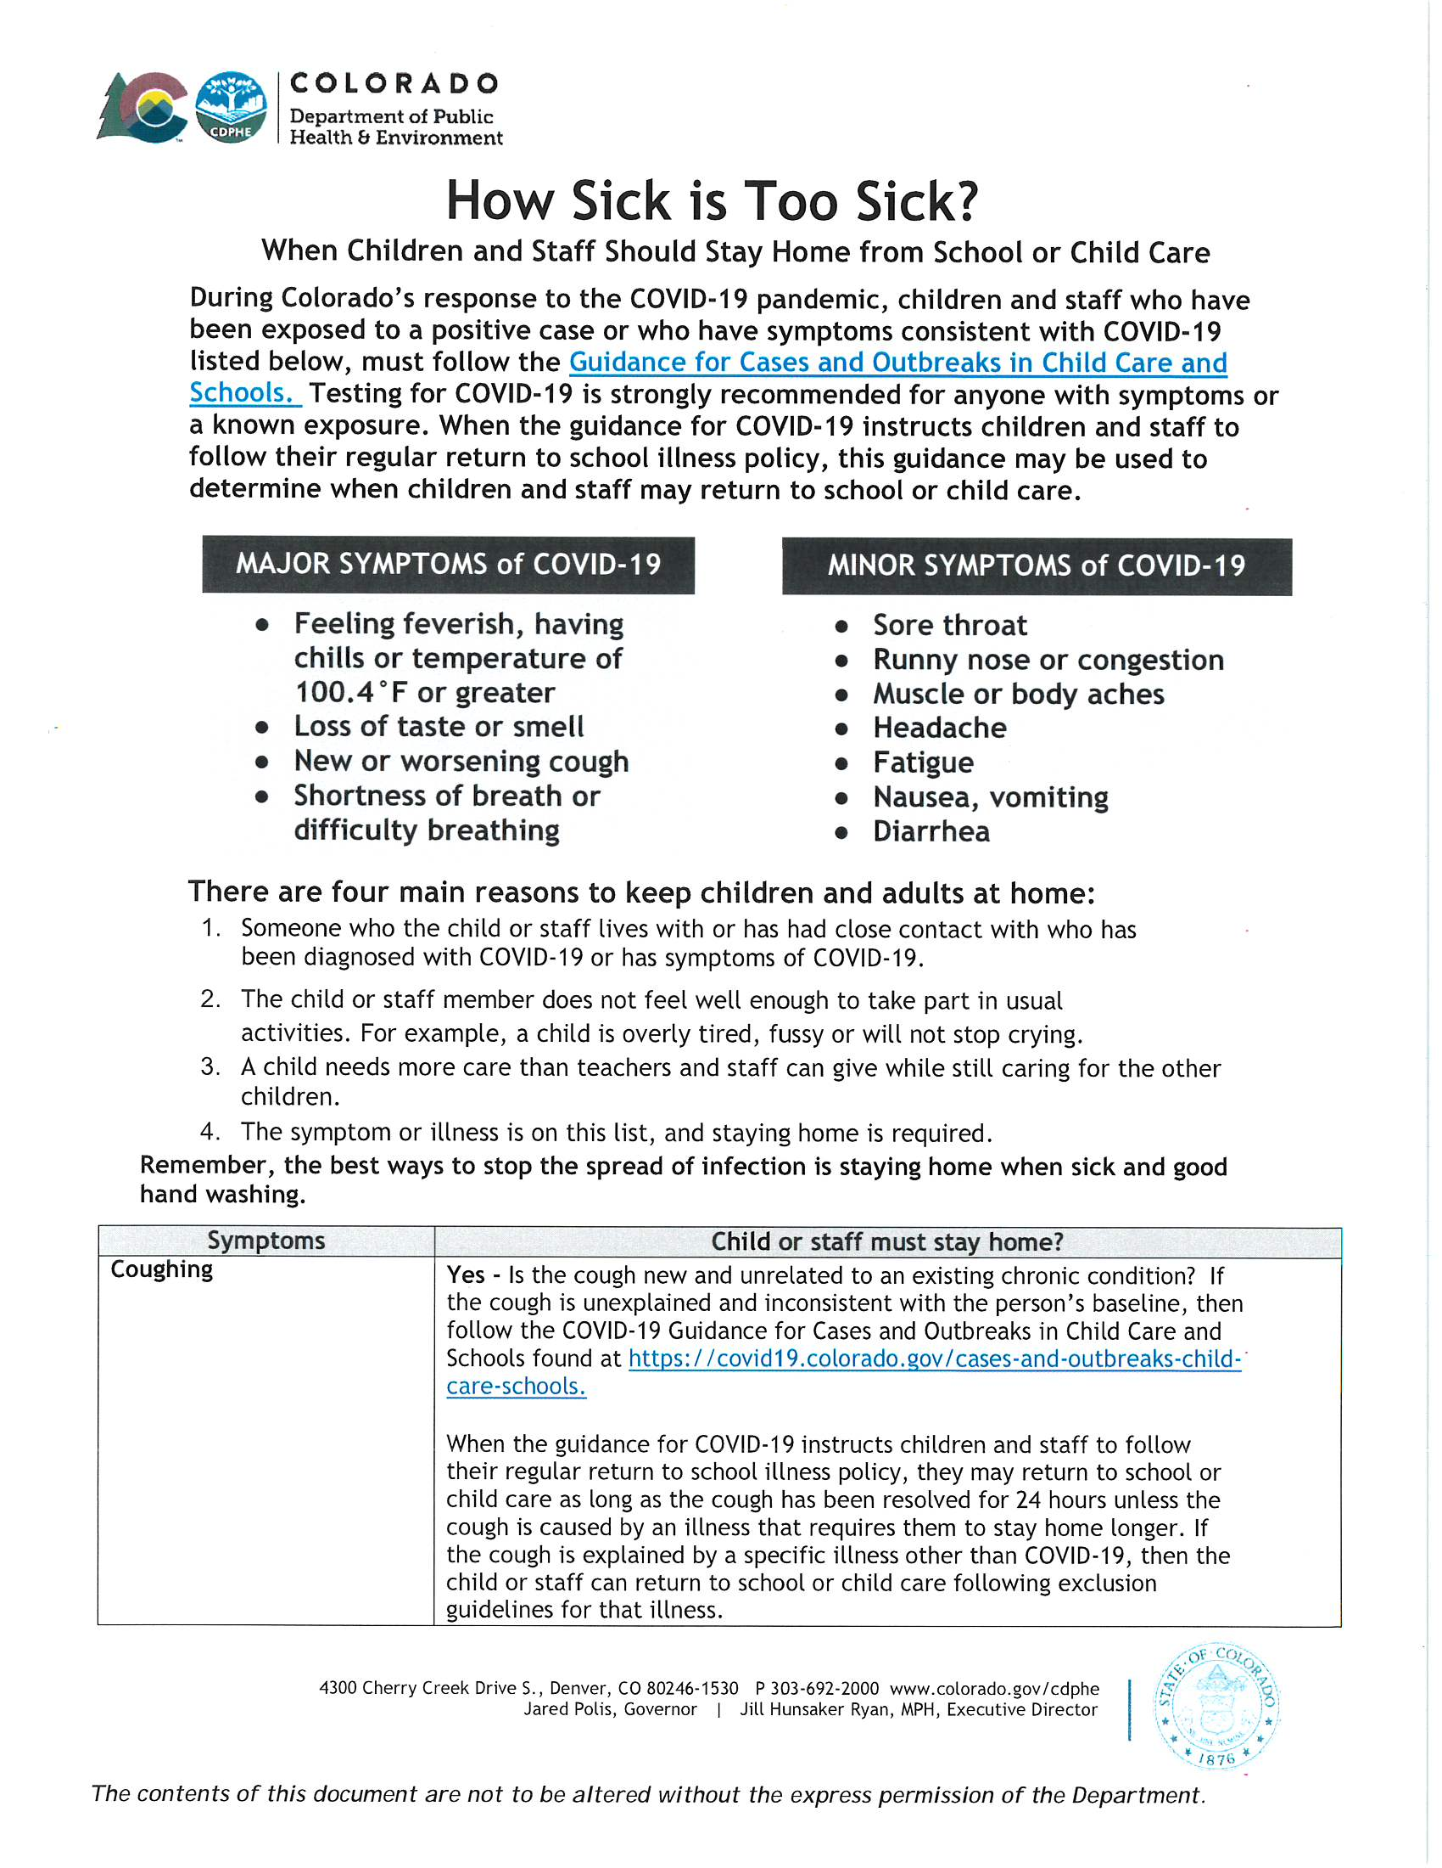
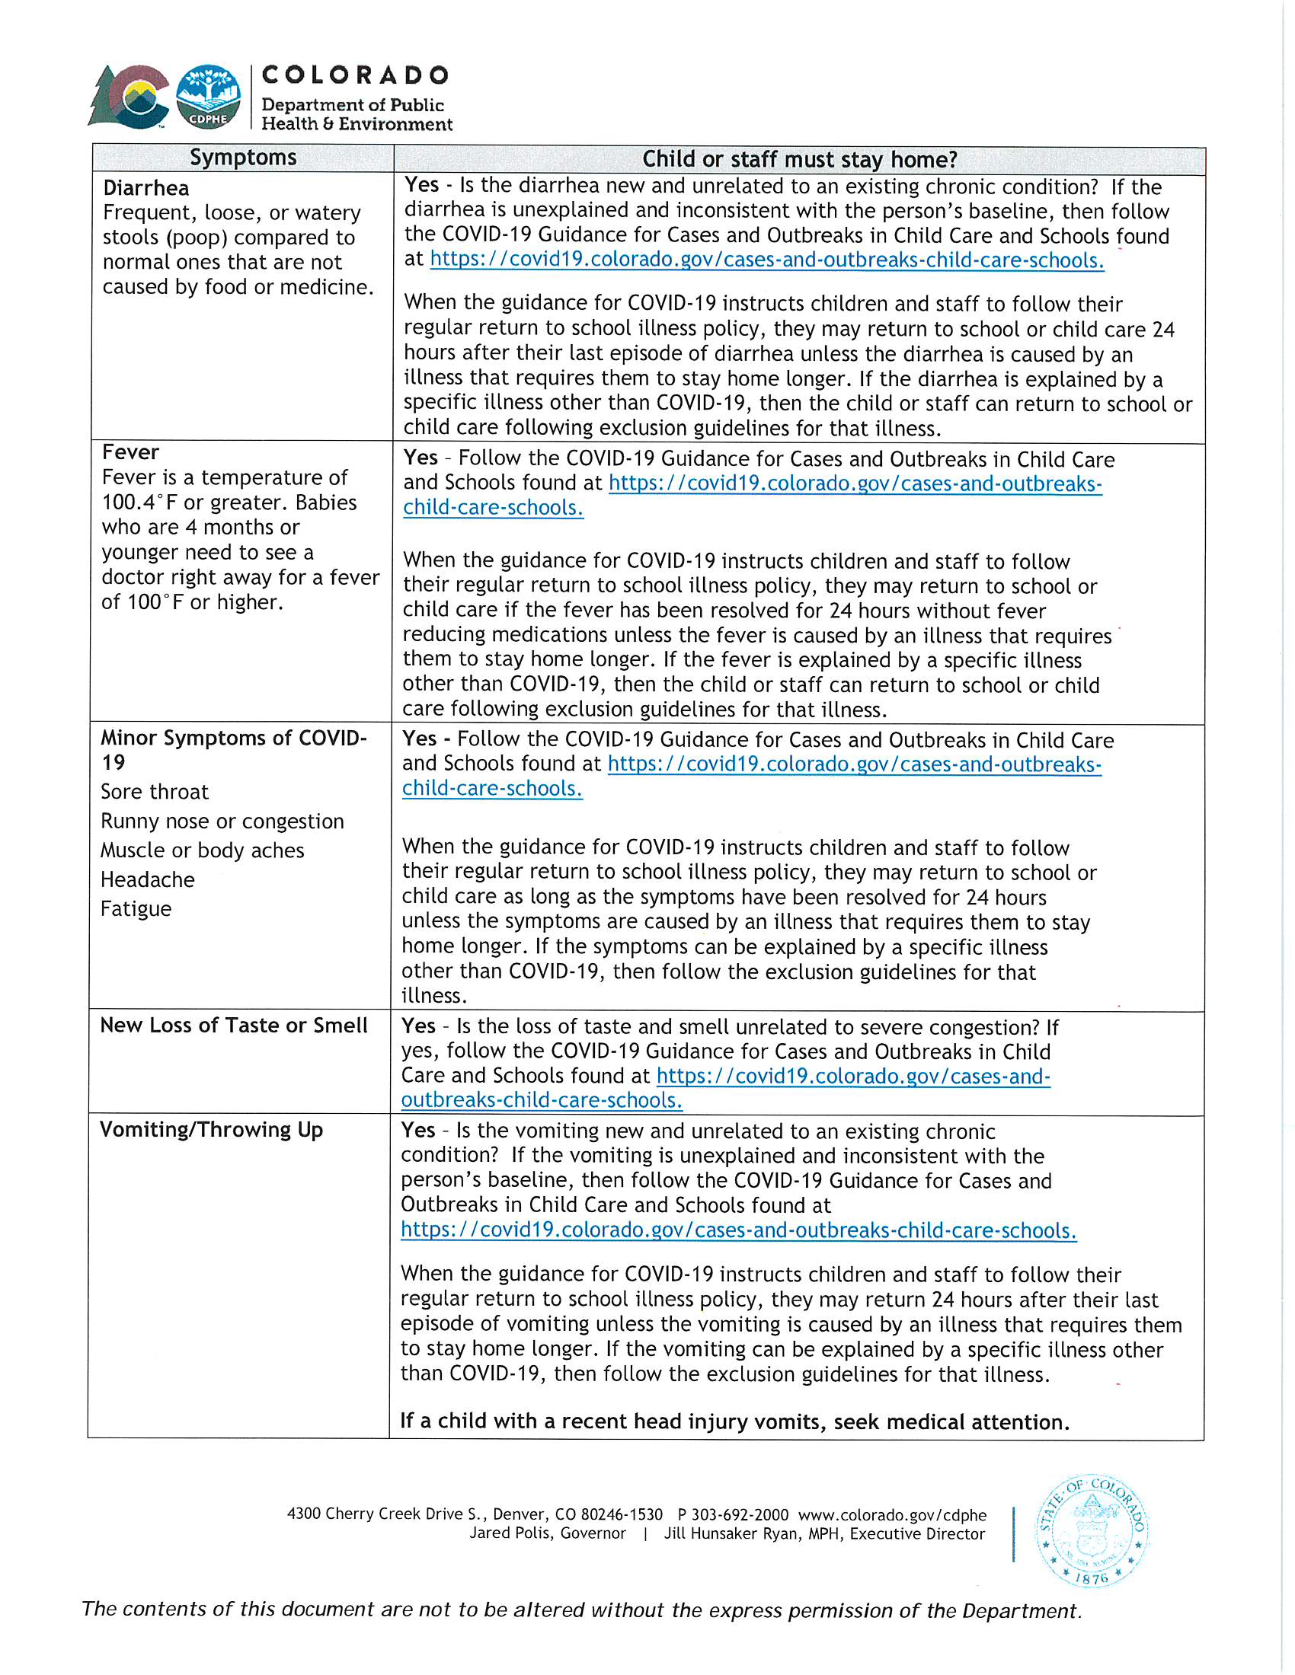
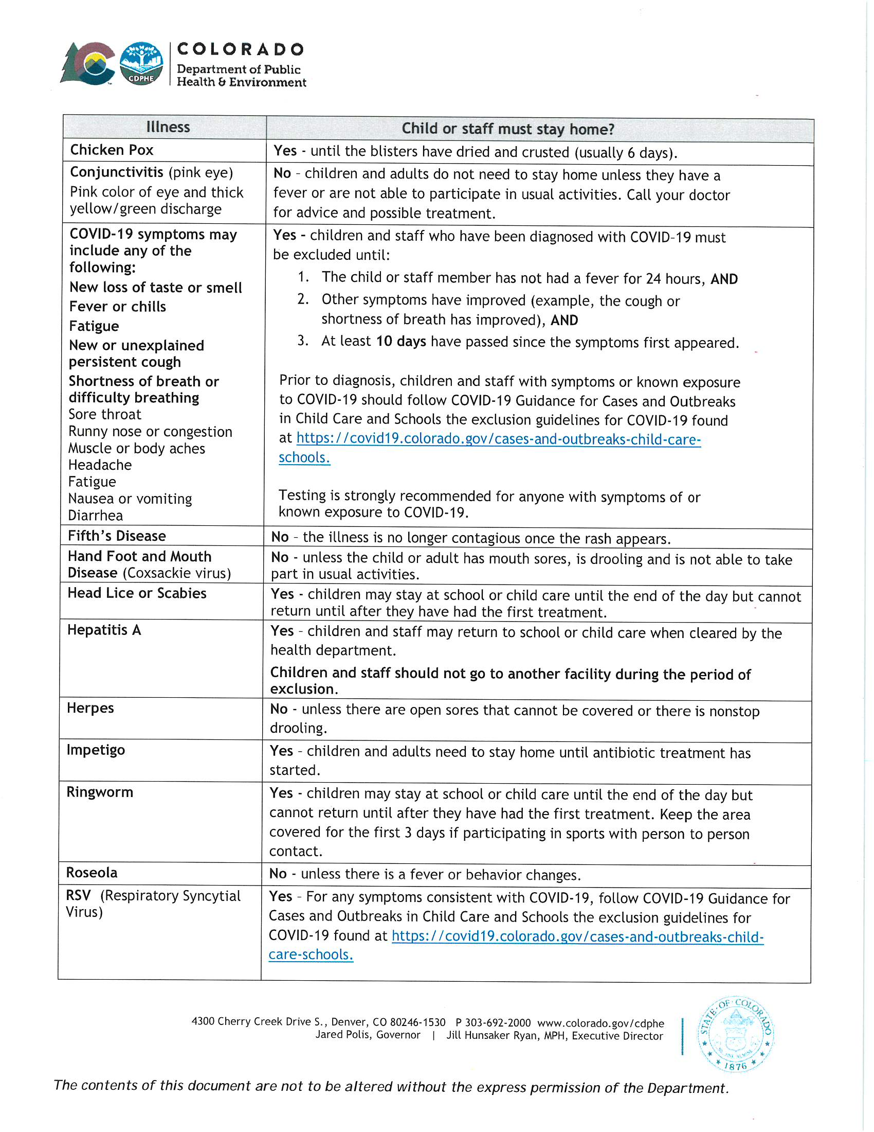
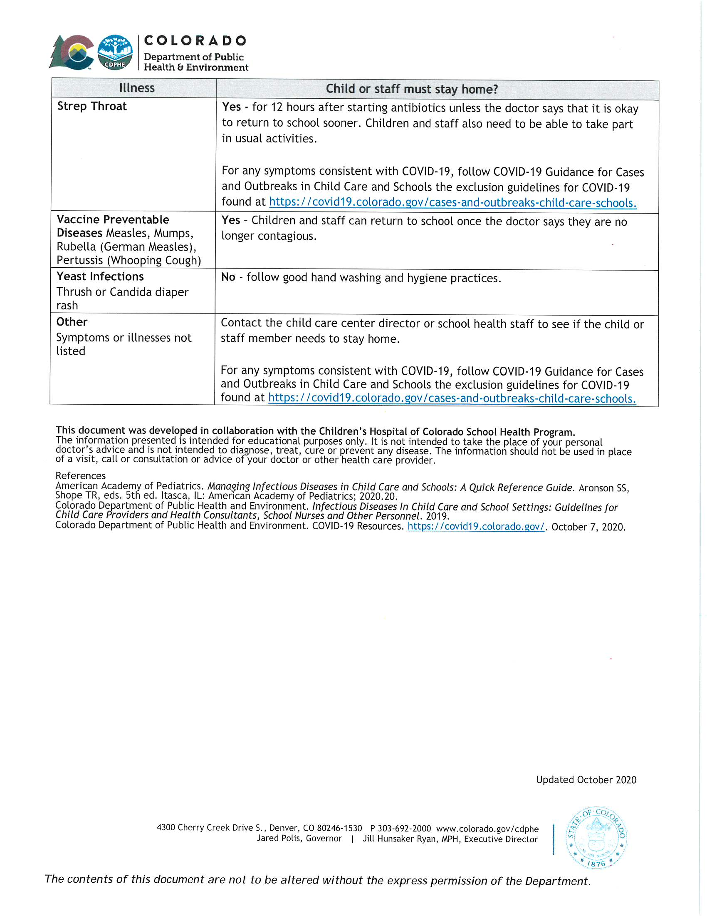
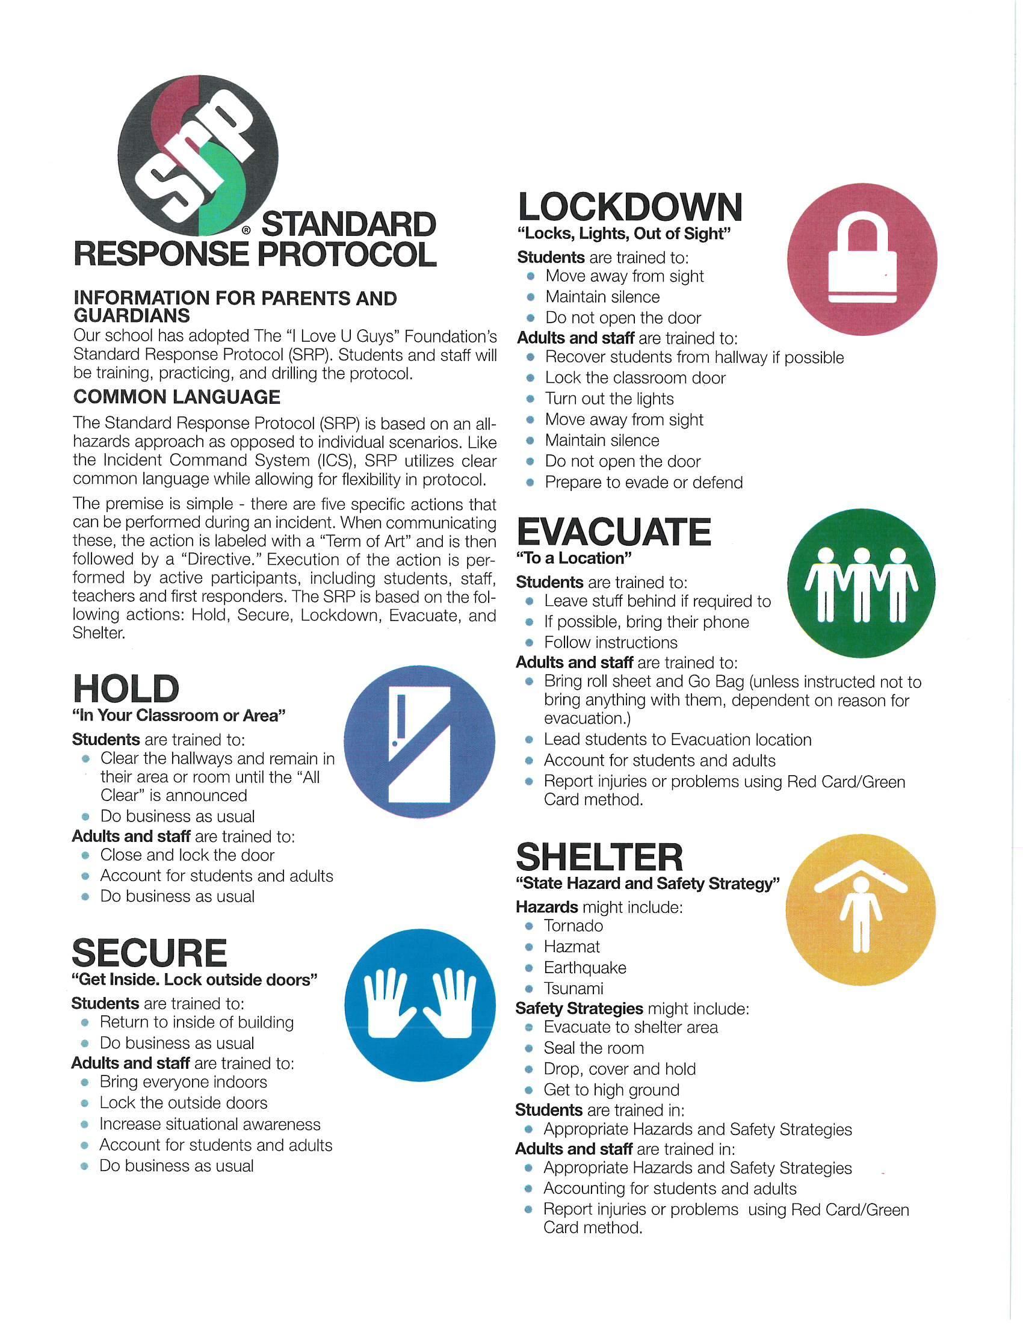

Widefield School District 3
Preschool Program

STATEMENT OF ACKNOWLEDGMENT

I ______,

acknowledge that I have received and been given the opportunity to review the
WSD3 Preschool Program Parent Handbook which describes the program’s
procedures and policies. By signing below, I agree to follow, accept the conditions of, and give authorization and approval for the activities described in the WSD3 Preschool Program Parent Handbook.

Child’s name:____________________________________________________

Parent/guardian signature: _________________________________________

Date:__________________________________________________________

