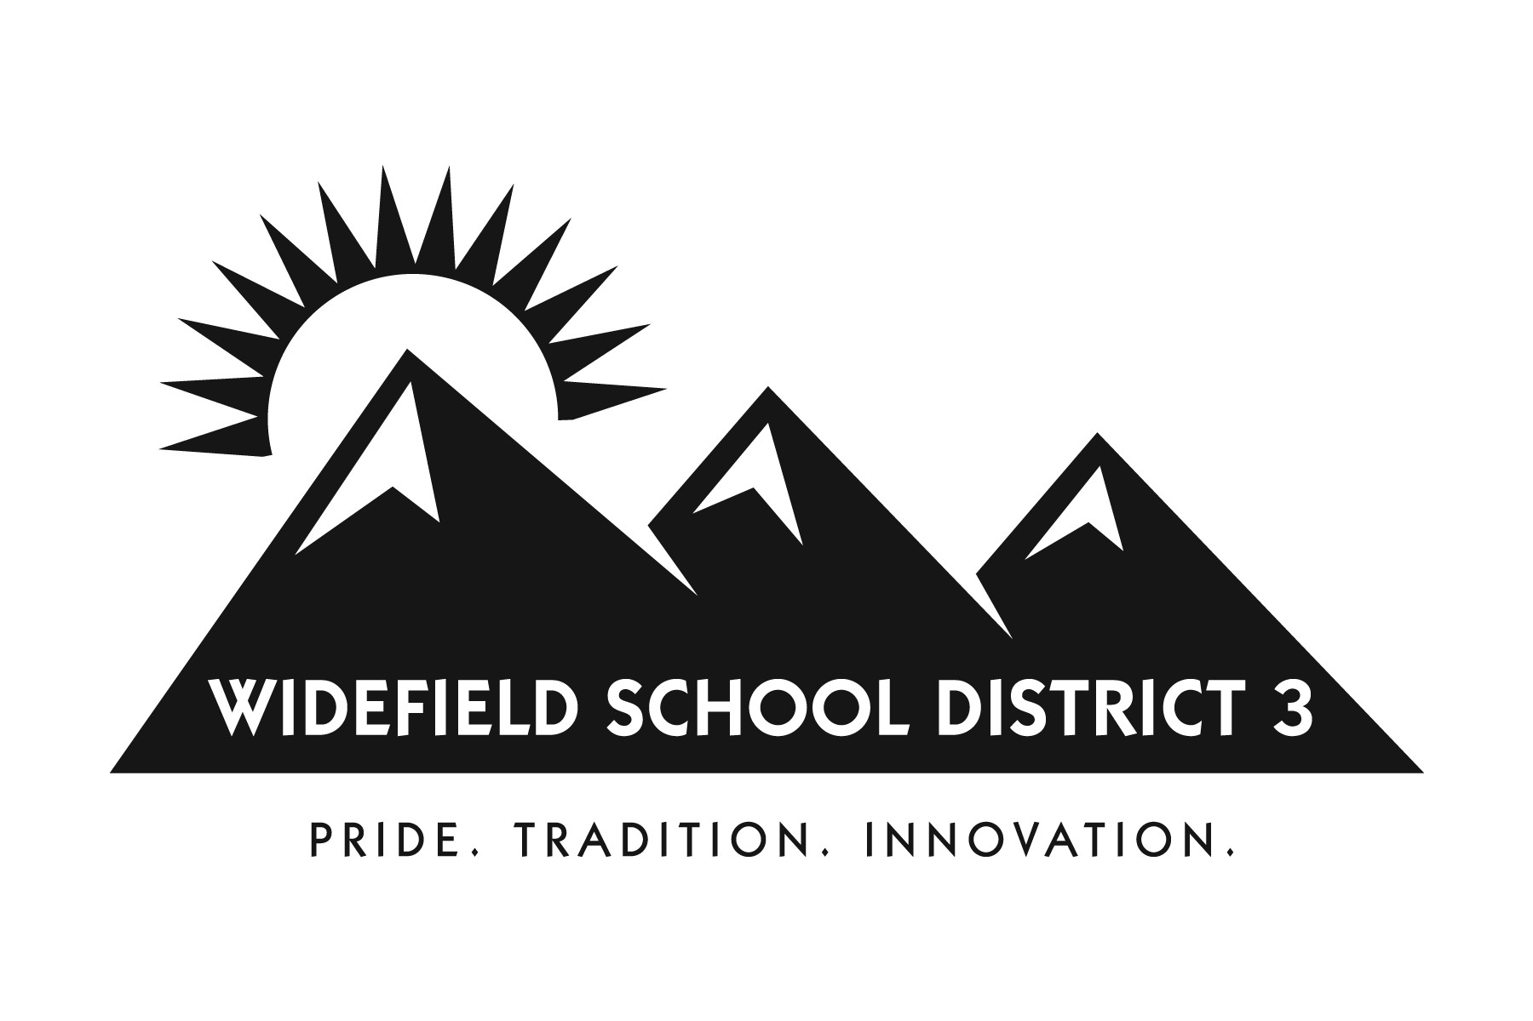

11060 FONTAINE BOULEVARD

COLORADO SPRINGS, CO 80925

Welcome to Grand Mountain School for the 2020-2021 School Year!

We are very excited that your child will be a Grand Mountain Maverick in the fall. The human growth and character development of students, along with their academic achievement, will always be our focus. We also recognize the importance of providing students with experiences to develop other interests outside of the core subjects they will be required to take. Each student will get computer science/coding instruction as it is the focus of the innovation status of our new school. In addition to our core program and computer science offerings, we will also have electives and extracurricular activities.

All middle school students will have seven classes per day, four core, two elective, a computer science course, and a 30-minute lunch. In the case that your child’s spring data shows a reading or math deficit, they may have to take an additional reading or math class in place of one elective. All students will have the opportunity to participate in a number of extracurricular activities and competitions.

Please feel free to check out our website-https://www.wsd3.org/k8

Sincerely,

Brian Pohl, Principal

This booklet was developed to assist you in planning for a successful middle school experience. It also contains brief descriptions of the courses offered and information regarding student expectations at Grand Mountain Middle School. Read the requirements and course descriptions carefully with your parents before selecting courses. Your choice of courses should be based upon post-high school plans, teacher recommendations, interests and abilities, and your achievements.

Please note that some of the courses listed in this guide may not be offered, depending on availability of the course, if the number of students requesting the courses is insufficient, or if the class has reached full capacity before the student applies. **Also note: applicable students will be placed based on individual needs in reading and writing interventions, in place of an elective(s) based on data.
REGISTRATION PROCEDURE

Each student will have access to a course description book online for family consideration.
Each student will have access to a Google Survey to enter their scheduling requests.

The school will develop a master schedule based upon the pre-registration requests by students. Students must adhere to the procedure and dates for all scheduling procedures. Students may choose from a broad range of course offerings designed by Grand Mountain Middle School to meet the individual needs of our students.

Students are also required to return the following WSD3 Board forms prior to the start of the 2019-2020 school year: Health History, Records/Release of Information, Attendance, and AYPYN. These will be handed out at GMS open house prior to the start of the school year. Please note, if you wish to opt your student out of having their image published, to include print and social media, website, yearbook, and student news, please fill out a Media Opt Out form from Grand Mountain’s front office. Also, if you would like to opt your student out of having access to the internet at school, please obtain an Internet and Electronic Communications form from Grand Mountain’s front office.

GMS Course Description
Year Long Electives
Computer Science/Coding (Required Elective) Grade: 6, 7, 8
All students will focus on computer science/coding. The course content includes Code.org Discoveries Curriculum and multiple software and hardware applications. This course is designed to give students a solid background in technology skills so they can comfortably integrate technology into their coursework.

Beginning Band Grade: 6, 7, 8
This class is for all beginning band students. Beginning band is for students who want to learn a band instrument for the first time, as well as those who have already played a band instrument in elementary school. The focus is on basic musicianship skills such as note reading, tone, embouchure, dynamics and specific instrument technique. This is a yearlong course that is performance-based. Students are expected to participate in scheduled evening concerts as part of the requirements for the course. Please specify on your schedule request if you are interested in brass/percussion or wood winds.

Beginning Choir Grade: 6, 7, 8
Students will be exposed to varied choral literature geared toward the ability levels of the students. Emphasis will be placed on basic musicianship and reading skills. A variety of styles of music will be used during sixth grade choir. This course is performance-based and students are expected to participate in scheduled evening concerts as part of the requirements for the course.

Beginning Orchestra Grade: 6, 7, 8
This class is for all beginning orchestra students. Beginning Orchestra is for students who want to learn violin, viola, cello, or string bass for the first time, as well as those who have already played one of these string instruments in elementary school. The focus of beginning string orchestra is on musicianship skills such as note reading, tone, position, dynamics and specific instrument technique. This is a year-long course that is performance-based. Students are expected to participate in scheduled evening concerts as part of the requirements for the course. Please specify if you are interested in low strings or upper strings on your schedule request form.

Intermediate Band Grade: 7, 8
Students work on intermediate skills that build upon what they learned in beginning band and/or sixth grade band. This is a yearlong course that is performance-based. Students are expected to participate in scheduled evening concerts as part of the requirements for seventh grade band.

Intermediate Choir Grade: 7, 8
Intermediate choir offers the opportunity for students to concentrate on vocal skills learned in previous years’ choirs and music classes, but to a higher degree. A variety of styles will be used at a level of difficulty designed to challenge the students. This course is performance based. Students are expected to participate in scheduled evening concerts as part of the requirements for the course.

Intermediate Orchestra Grade: 7, 8
The intermediate string orchestra is for students who would like to expand their skills on the violin, viola, cello, or bass. Students will learn more challenging music and techniques than in sixth grade. Practice time is expected to be completed. This course is performance-based and students are expected to participate in scheduled evening concerts as part of the requirements for the course.

Advanced Band Grade: 7, 8
(pre-requisite: successful completion of Beginning/Intermediate Band, or approval from band teacher)
Students work on advanced skills as an extension of what they learned in previous years of band class. This is a year-long course that is performance-based. Students are expected to participate in scheduled evening concerts as part of the requirements for eighth grade band. Participation as a 7th grader requires teacher recommendation.

Advanced Choir Grade: 7, 8
(pre-requisite: successful completion of Beginning/Intermediate Choir, or approval from choir teacher)
Advanced choir offers the opportunity for students to concentrate on vocal skills learned in previous years’ choirs and music classes, but to a higher degree. A variety of styles will be used at a level of difficulty designed to challenge the students. This course is performance based. Students are expected to participate in scheduled evening concerts as part of the requirements for the course. Participation as a 7th grader requires teacher recommendation. Participation as a 7th grader requires teacher recommendation.

Advanced String Orchestra Grade: 7, 8
(pre-requisite: successful completion of Beginning/Intermediate Orchestra, or approval from orchestra teacher)
The advanced string orchestra is for students who would like to play much more advanced music. Musicianship skills learned in previous years of orchestra class will be built upon and expanded to a much higher level. Practice time is a must. This course is performance-based and students are expected to participate in scheduled evening concerts as part of the requirements for the course. Participation as a 7th grader requires teacher recommendation.

Jazz Band Grade: 6, 7, 8
In Jazz Band students will be exposed to the jazz styles of rock, swing and Latin. Improvisation and combo technique will also be taught. This course is performance-based and students are expected to participate in scheduled evening concerts as part of the requirements for the course.

Men’s Choir Grade: 6, 7, 8
Men’s Choir is an elective course of study in vocal music. There are no auditions! This course is an exciting, energetic class that seeks to develop good vocal technique and musicianship skills and to provide assistance to the changing and developing voice. Part-singing and sight-reading skills are a part of rehearsals, as well as introduction to academic musical concepts including theory and history. Repertoire for Men’s Choir ranges from serious choral literature to contemporary pop arrangements.
Instructional Methods and Assessments: Regular class activities include daily full choir rehearsals as well as occasional small-group sectionals. A large part of the academic grade is based on students’ active participation in these rehearsals, as well as the required concerts

Beginning Spanish Grade: 7, 8
Students will learn the four basic skills of Spanish; reading, writing, speaking and listening, as well as the cultural aspects of the Spanish speaking world.

8th Grade/Spanish I Grade 8
(pre-requisite: successful completion of Beginning Spanish, or approval from Spanish teacher)
Students who have successfully completed an entire year of Beginning Spanish are eligible to take Spanish I. The four basic skills of Spanish; reading, writing, speaking and listening, as well as the cultural aspects of the Spanish speaking world will be built upon and expanded. Students who successfully complete Spanish I are eligible to take Spanish II when they enter high school.

Skills In Leadership Grade: 7, 8
This course is by application only. Please send the application to Mrs. Hershberger.
Students will learn leadership skills through community service projects, running the student concessions, and leading Grand Mountain events. Skills such as public speaking, counting money, advertising, and planning are all a part of this program. Students will increase their self-confidence and become role models for their peers. Integrity, initiative, and a strong work ethic is a must for this class.

Publication and Design Grade: 6, 7, 8
This course is by application only. Please send the application to Ms. Selke.
Students work to complete the GMS yearbook which includes: interviewing students, investigating, reporting, and capturing images,. We learn online software through InterState Studio and also market and advertise it's sale. We track sales and talk about the "business" of selling the yearbook.
We also learn how to properly layout pages, spacing, creating headlines and sticking with a theme. The yearbook is a student produced, 80 page book that brings memories back to all Grand Mountain students in future years.

KGMS-Maverick Minutes Grade: 7, 8
This course is by application only. Please send the application to Ms. Knoop.
This year-long course will produce the news for Grand Mountain School. Among other things, students will learn skills in interviewing, scriptwriting, public speaking, photography, design and layout, video editing, post news production technology, digital citizenship, and student press and copyright laws. This course may require students to work on projects outside of the regular class period. Average typing skills, fundamental computer knowledge, and basic photography and design skills are desired. Because the news will be broadcast publicly, students will need to apply and have permission to be published online.

GMS Course Description
Semester Long Electives
Sound Production Grade 6, 7, 8
(Prerequisite is concurrent enrollment in band, choir, or orchestra)
What does technology have to do with music? In our current society, music and technology are quickly blending together. The goal of this course is to provide the tools young musicians need to record, produce, and promote themselves as they continue through their education. Students will learn the different types of musical ensembles, how to mix music and sounds, how to use a soundboard and sound equipment, and how to put all of their skills together in the field.

Guitar Grade 6, 7, 8
In Guitar Class, students will receive introductory classroom instruction in the art of classic guitar playing. Classic guitar is a solo style, which combines melody, bass, and chords together. Students will start at the beginning and study basic music reading, technique and tuning. At the end of this course, students will have knowledge of basic guitar chords and finger plucking techniques.

6th Grade Art Grade: 6
Students will be given a basic foundation in which to gain exposure to a variety of art media including drawing, painting and sculpture. This class lays the ground work for subsequent classes, evoking creativity and self-expression. Sixth Grade Art provides a strong foundation for more in depth studies and skill development for years to come. Get ready to unlock your creativity!

7th Grade Art Grade: 7
Students will be introduced to an assortment of 2-dimensional art techniques, such as shading, mixing colors and making their artwork look 3-dimensional using grid and perspective drawing. Students will acquire and hone their drawing and painting skills through working with a variety of media including graphite, charcoal, oil and chalk pastels, tempera and acrylic paint in order to create realistic and abstract pictures. From beginners to advanced artists, all that is needed is a desire to learn. No previous experience is necessary!

8th Grade Art Grade: 8
Students of all skill levels will be exposed to fine art in the 3-dimensional form. They will experiment with a variety of art media including paper, clay, paper mache, and wire. Students will be introduced to an assortment of art techniques, such as additive and subtractive sculpture, pinch pots, coil, slab, and hand building. No previous experience is required!

Exploring Spanish Grade: 6, 7
Through the foundations of the Spanish language, students will begin to learn basic communication skills. In addition, this course will teach students to understand and appreciate the traditions of Spanish speaking cultures.

Spanish Cultures Grade: 6, 7, 8
Explore Spanish-speaking countries around this world as we investigate food, travel, and culture. In this class we will “travel” around the world to a variety of countries and continents and learn about how other people live.

Physical Education (P.E.) Grade: 6, 8
This course offers a variety of team and individual sports throughout the school year. Students are expected to dress out daily and participate to the best of their ability. P.E. classes are co-ed.

Health, Physiology, and PE Grade 7
Students will study the physical, mental, emotional, and social health of the human body. In addition, physiological interactions such as anatomy, body systems, and nutritional elements will be explored. This course explores a variety of team and individual sports throughout the PE section of the semester (This will count as the required health credit).

Team Sports (6th) Grade: 6
This course offers a variety of team sports throughout the school semester. Students are expected to dress out daily and participate to the best of their ability. P.E. classes are co-ed.

Team Sports (7th-8th) Grade: 7, 8
This course offers a variety of team sports throughout the school semester. Students are expected to dress out daily and participate to the best of their ability. P.E. classes are co-ed.

Tech Tools Grade: 6, 7, 8
Students will gain a working knowledge of computer operations and word processing, spreadsheet, presentation, audio/video editing and Web 2.0 tools. Keyboarding skills will also be strengthened. A focus on information literacy, internet safety, and responsible use of technology and information will help prepare students for 21st century learning. Students who successfully complete this course will have a solid background in technology skills that will allow them to comfortably integrate technology into their coursework.

