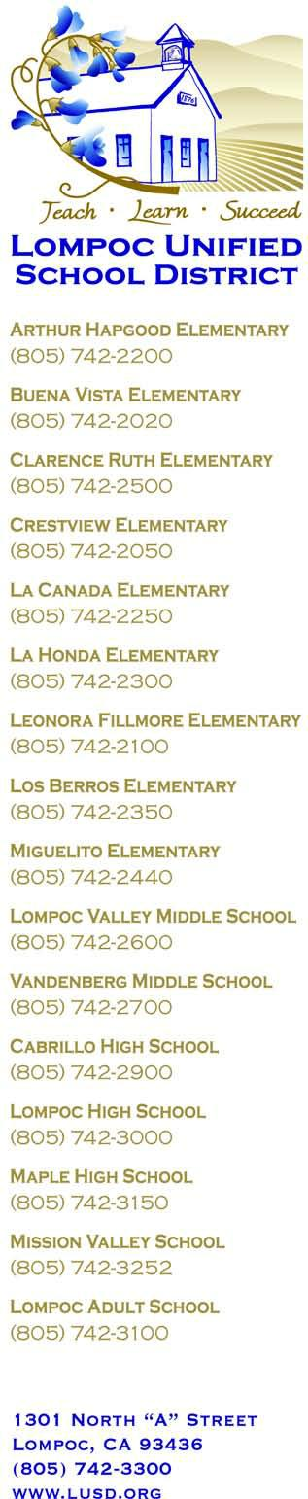
Irma Manzo, Interim Assistant Superintendent
Business Services

December 12, 2016

Dear Community Members and Lompoc Unified School District Facility Renters,

Lompoc Unified School District is pleased to announce a new online facility request and rental system designed to provide a positive user experience for all. With the new system, reservation requests can be submitted easily and will be handled more efficiently. Renters will be able to access photos and descriptions, see real-time availability, get estimated quotes and pay online.

In partnering with Facilitron, we are launching web-based facility web sites for each school with facility availability – allowing facility use requests to be submitted at any time. You can view all district facilities at: https://facilitron.com/lusd93436

You can also view each school facilities directly at their dedicated facility rental sites:
- Lompoc High School: https://facilitron.com/lhs93436
- Cabrillo High School: https://facilitron.com/chs93436
- Maple High School: https://facilitron.com/mhs93436
- Lompoc Valley Middle School: https://facilitron.com/lvms93436
- Vandenberg Middle School: https://facilitron.com/vms93427
- Buena Vista Elementary School: https://facilitron.com/bves93426
- Clarence Ruth Elementary School: https://facilitron.com/cres93436
- Crestview Elementary School: https://facilitron.com/ces93437
- Fillmore Elementary School: https://facilitron.com/fes93436
- Hapgood Elementary School: https://facilitron.com/hes93436
- La Cañada Elementary School: https://facilitron.com/lces93436
- La Honda Elementary School: https://facilitron.com/lhes93436
- Los Berros Elementary School: https://facilitron.com/lbes93436
- Miguelito Elementary School: https://facilitron.com/mes93436
- El Camino Community Center / Adult Education: https://facilitron.com/eccc93436

Facilitron will assist with the set-up of organizational accounts and the verification of their non-profit status (if applicable). Facility use payments include PayPal, major credit cards, and checks. Proof of insurance can be conveniently uploaded into the platform, and/or it can be obtained directly through Facilitron.

Our new Facilitron system was beta launched on November 10, 2016, and is now live for all sites. The best way to secure a site is to create a Facilitron account and place your request. If you need any assistance setting up an account and/or in placing a facility use request, you can contact Facilitron directly at:
support@facilitron.com, or by calling them at: 800-272-2962. You may also contact Business Services at: 805-742-3200.

As a District we look forward to continuing our partnerships with our community members and the Lompoc Unified School District family. We have included a Quick Start Guide instructions for your convenience.

Sincerely,

Irma Manzo
Interim Assistant Superintendent
Business Services

