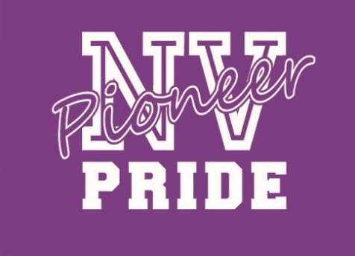
Nooksack Valley Adopt A Senior 2020
Class of Support our Nooksack Valley 2020 Seniors by showering them with love, kind words and care during this transition by "adopting them." This can be sending cards, gift cards, snacks, gift baskets, college gear, words of wisdom, etc. Go to the Facebook page to "adopt" a senior. Have them complete this simple survey in order get to know them better and get some fun gifting ideas!

