STEAM plans
Hi everyone,
I hope you are staying safe and healthy. These are definitely some crazy times and I am sure you miss me. I miss you. If you have access to the internet, make sure you go to my webpage and log into coding, typing, and other things. www.pcesadams.weebly.com. If you create a project in coding, don’t forget to share it and put it in the studio. Since we would normally only have class for 2 more weeks because of the rotation, I didn’t want to give you too much work.
Engineering
Play some of the engineering games on my webpage. Keep a log of what games you played and for how long. Or create a marble run using materials you have around the house. Try to include many turns and switchbacks. If you do not have a marble, create one using another material. Here is an example:
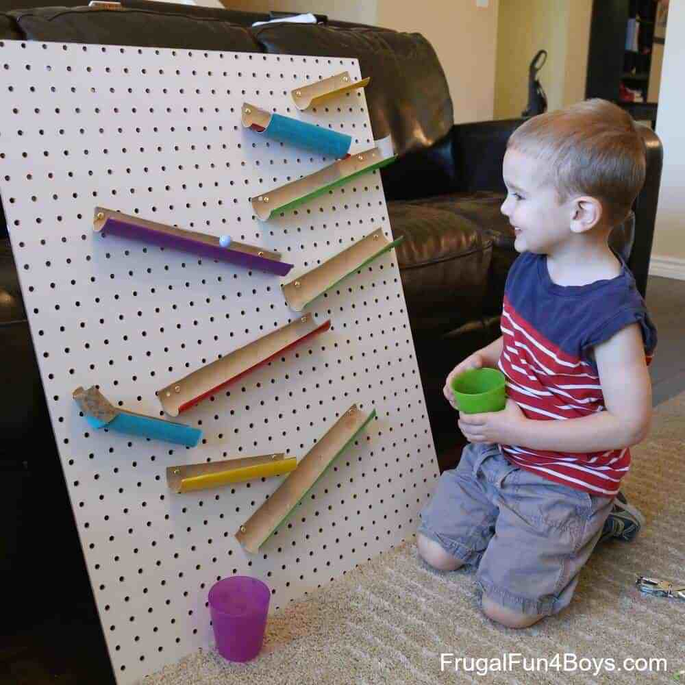
If you feel like a challenge, try making a marble run that is really big, using things like big boxes or a garden hose. Take a picture or video of your project and send it to Mr. Adams
Typing
Practice typing using the program you used in class. Do this at least 3 days per week for 15 minutes each. Keep a log of the days and time you worked.
If you do not have access to a computer keyboard, practice using the attached paper keyboard. Fill in the full sized keyboard and practice on it.
Everyone see how many of the keys you can fill in by memory on the blank keyboard. Try multiple times.
Art
Create a picture using Paint or Paint 3d. (It should be installed on your computer)
If you do not have the program, create a picture on paper. Make sure to use some color.
Take a picture of it and email it to me or return it to school.

Hope to see you soon,
Mr. Adams

