Name ______________________________
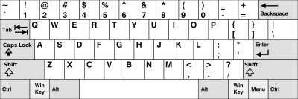

Copy the keys onto the blank keyboard below
