Mrs. Evans & Mrs. Golden 1st Grade Class
MONDAY – APRIL 20th – FRIDAY APRIL 24TH
Note: Your teacher will send you all logins for digital learning
Digital Lesson Plan | Hardcopy Lesson Plan
https://classroommagazines.scholastic.com/support/learnathome/grades-1-2.html  - Complete Week 1 - Day 1 through Day 5 online reading and activities  - You will turn in the daily draw and write activity to teacher. The daily draw and write activity is the same as for the hardcopy lessons and is also on line on the Scholastic site above. | Day 1: Read Wolf Spider  Invent a Spider. Some spiders are named for how they look—like the wolf spider or the pumpkin spider. Pretend you discovered a new kind of spider. Draw it. Describe it in words. Name it!  Day 2: Read Wild Weather  Raining Bats and Frogs! You might have heard the saying, “It’s raining cats and dogs.” If you could make it rain any two things you wanted, what would you choose? Write about your special rainstorm. What would be falling from the clouds and why? Draw a picture of it.  Day 3: Read Hearing  Listening Ears. Take a seat, close your eyes, and listen. What sounds do you hear around you? Listen. Draw four boxes on a sheet of paper. In each box, write what you hear. Then draw a picture of what’s making each sound.  Day 4: Read Day at the Pumpkin Patch  Create Your Own Community. If you could create your own community, what would it look like? Decide if your community is rural, urban, or suburban. Draw a picture of your community. Name it!  Day 5: Bare Bones  Whose Bones Are Those? Look at the skeletons on the next page. Unscramble the letters to name each animal. Write them on a piece of paper.  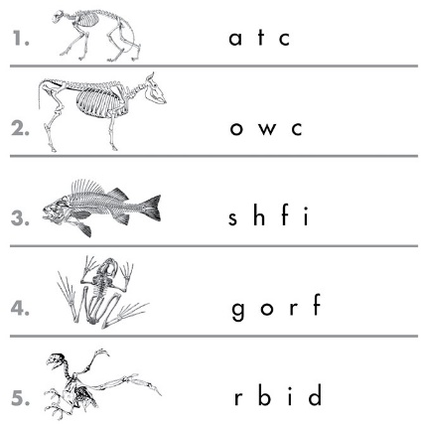
https://www.spellingcity.com/users/levanstusd  This Week: Unit 5.1  - Write our Spelling and Sight words for the week. Circle the vowels with blue crayon. Then play at least one game each day with the words  - Friday - complete online test and print, or have parent write how many you got correct to turn in. | Homework packet – ignore dates, and just work on these items from the packet Unit 5.1  - Complete spelling word work portion of the homework packet only.  - On Friday, have parent give you a test on spelling words.  - Do not do the Book Club page.
https://h100003728.education.scholastic.com  iRead for 15 min. each day | Read the three stories in the homework packet. Read for 15 min. each day
https://www.khanacademy.org/  Math Khan Academy Lessons on Nonstandard Length  - Ordering by Length video  - Order by Length Exercise  - Indirect Measurement Exercise  - Measuring Length: golden statue video  - Measure lengths 1 exercise | Complete the math pages on length.  Unit 8 Lesson 1 pgs 563-568 Compare Length  Unit 8 Lesson 2 pgs 569-574 Compare & Order Length  Unit 8 Lesson 3 pgs 575-580 Nonstandard Units of Measure
DUE BACK TO TEACHER:  Classwork that must be turned in can be 1) scanned and emailed 2) Take pictures of the work and email, OR 3) bringing hard copies to the school office to turn in. These are the items that are due:  - 5 days of writing and drawing activities  - Parent acknowledgement that did Spelling City activities  - Spelling Test  - Khan Math activities completed; teacher can check assignment online no need for hardcopies | DUE BACK TO TEACHER:  Classwork that must be turned in can be 1) scanned and emailed 2) Take pictures of the work and email, OR 3) bringing hard copies to the school office to turn in. These are the items that are due:  - 5 Days of reading & writing activities  - Spelling / Word work only from homework packet must be turned in at end of the assignment period  - Spelling Test  - Math pages on length and nonstandard measurement pgs 563-580

