Math
First graders have been working on comparing numbers and finding the difference between two numbers. For example, 8 is less than 10, and the difference between 8 and 10 is 2. This can be shown as 10-8=2 or 8+2=10.

The math task this week is to find real life amounts to compare, then find the difference between the two numbers.

*You will need a pencil and paper to record your findings.

- Cups Vs. Mugs
Count the number of cups in your home. Write this number down. Next, count the number of mugs in your home.

Which has the greater amount?

What is the difference between cups and mugs? Write and equation or draw a picture to find the difference between the number of cups and mugs.

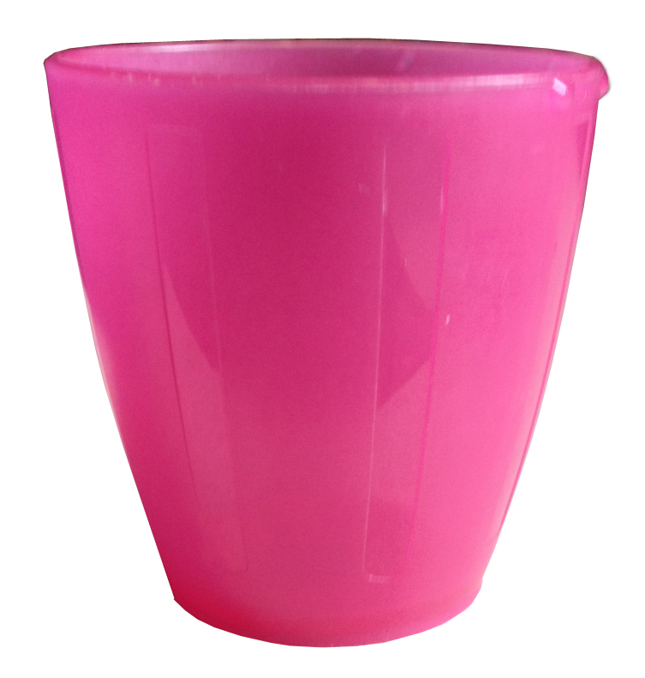
This Photo by Unknown Author is licensed under CC BY-NC-ND
This Photo by Unknown Author is licensed under CC BY-SA
Cup – used for cold drinks Mug- used for hot drinks

- Kid shoes vs. adult shoes
Count the number of adult shoes at your house. Write this number down. Count the number of children’s shoes at your house. Write this number down.

Who has the lesser amount of shoes?

What is the difference between adult and children’s shoes? Write an equation or draw a picture to find the difference between adult and children’s shoes.

- Take it outside- window doors vs. solid doors
Ask your grown-up to take a walk around the neighborhood with you. Count the number of homes that have a door with a window, and the number of homes that do not have windows on their doors.

Which type of door has the greater amount?

Write an equation or draw a picture to find the difference between the two numbers.

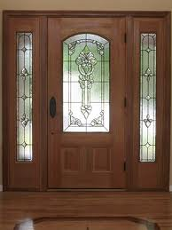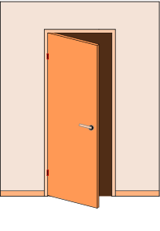
This Photo by Unknown Author is licensed under CC BY-SA
This Photo by Unknown Author is licensed under CC BY-SA
Door with window Door without windows

- ** Challenge**
Compare 3 amounts!
Take another walk around the neighborhood. Collect data on the number of homes with:
- no fence
- a wood fence
- a metal (or chain link) fence

Which type of fence did you see the most?

Which type did of fence did you see the least?

Write equations or draw pictures to show the difference between the homes with no fence vs. the homes with wood fences, the homes with wood fences vs. the homes with metal fences, and the homes with metal fences vs. the homes with no fences.

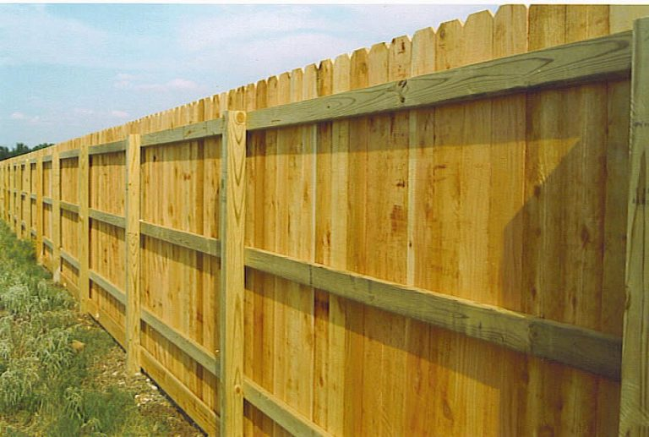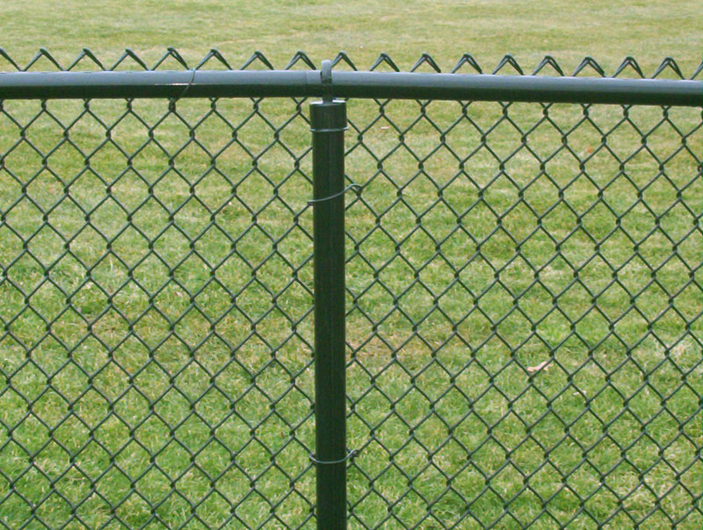
This Photo by Unknown Author is licensed under CC BY-SA
This Photo by Unknown Author is licensed under CC BY-NC-ND
Wood Fence Chain link fence

5. Are there other things that you can find to compare?

