# Home

**Words to use:**

Living room: TV, chair, couch, lamp Kitchen: sink, refrigerator, table, stove Bathroom: toilet, bathtub, shower, towels Bedroom: bed, closet, pillow, blanket

1. **Watch videos.** [**https://www.youtube.com/watch?v=jUNTMKpoLAI**](https://www.youtube.com/watch?v=jUNTMKpoLAI) [**https://www.youtube.com/watch?v=R9intHqlzhc**](https://www.youtube.com/watch?v=R9intHqlzhc)
2. **Look at picture flash cards.**
3. **Look at the picture of the house.**
4. **Look at the blank house. Draw in a picture of your home and label it.**

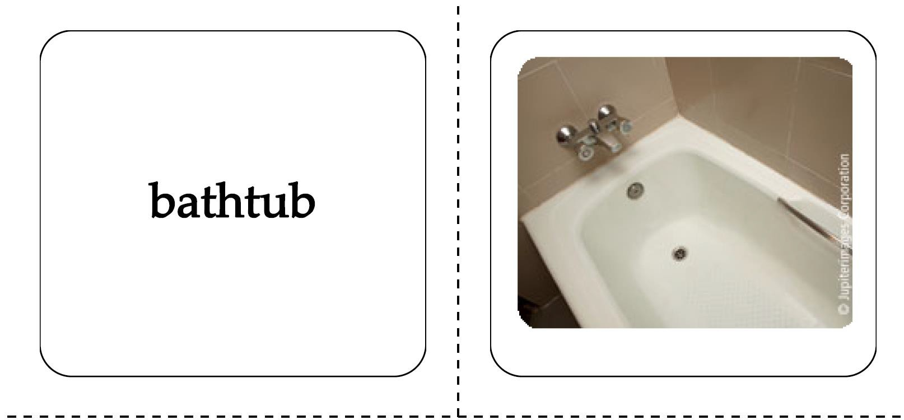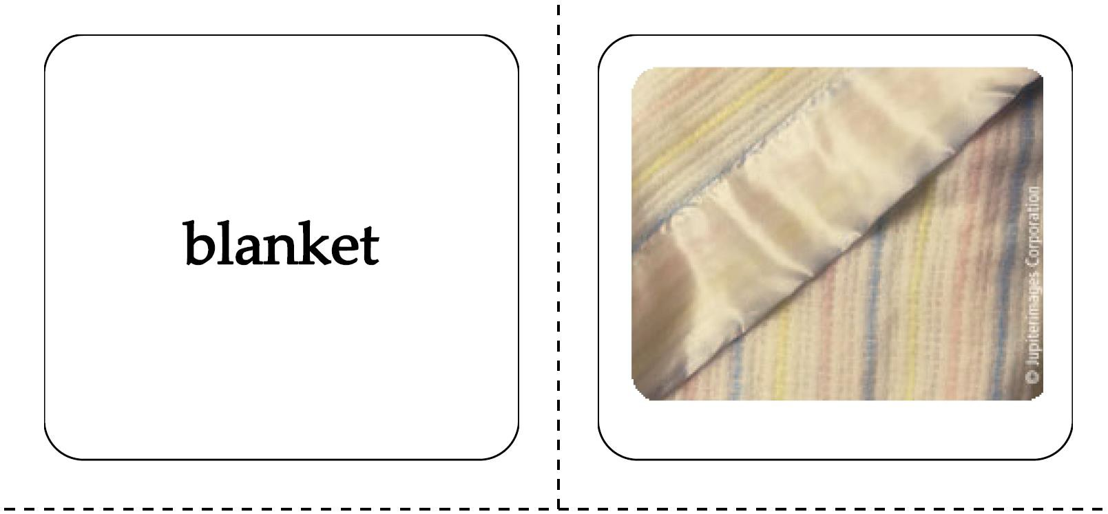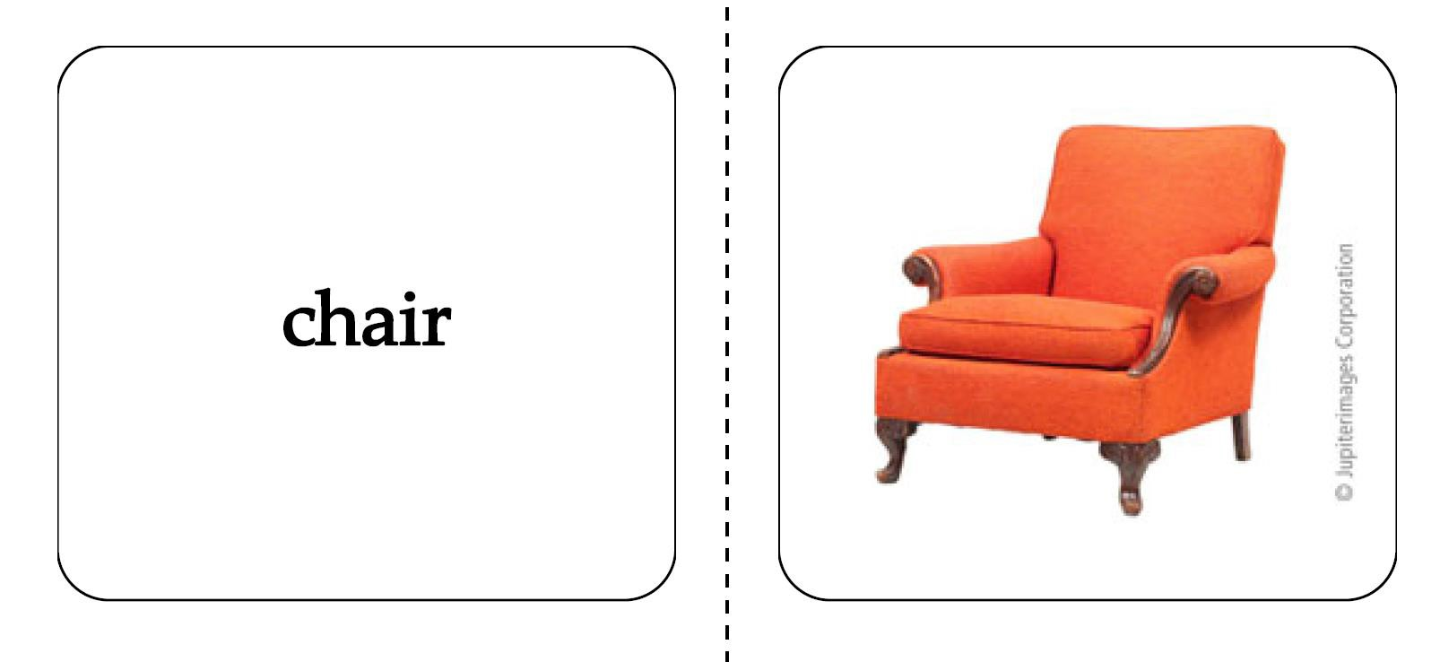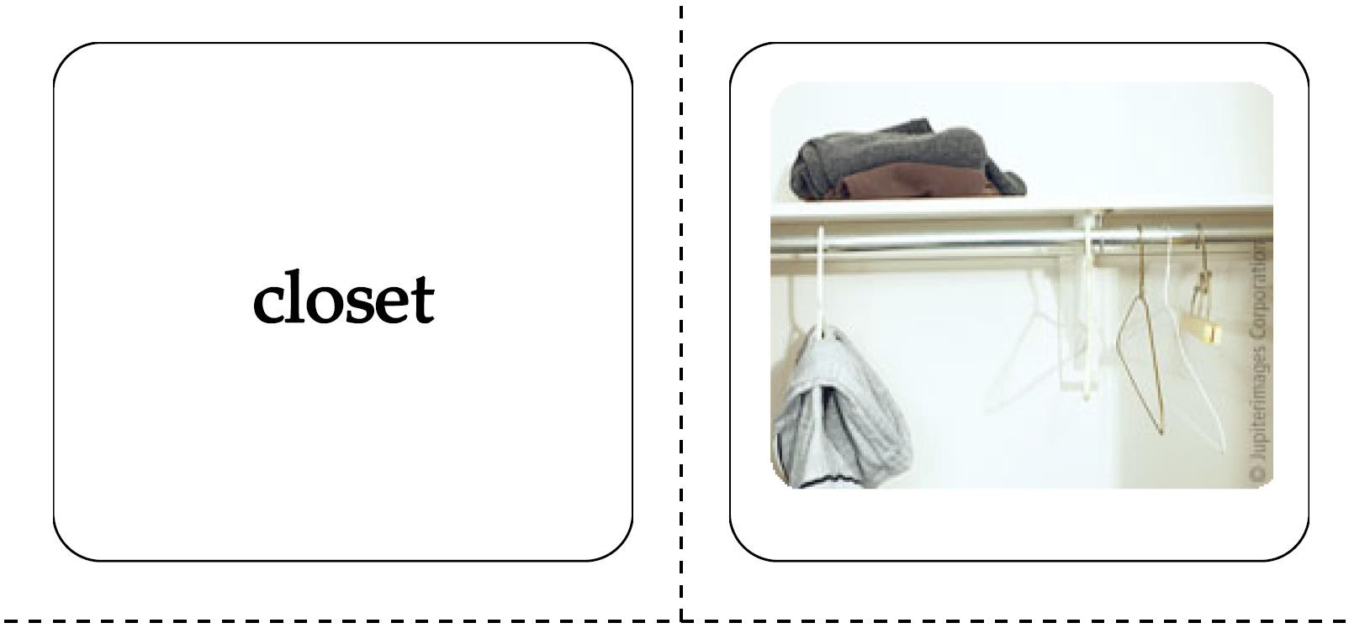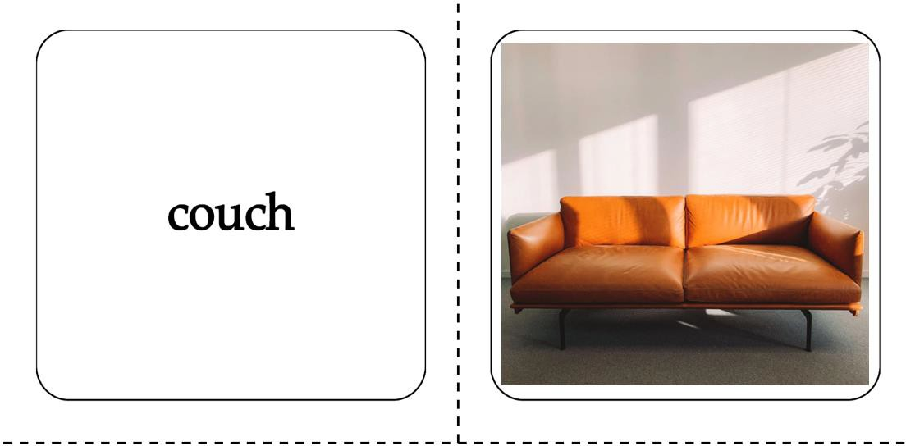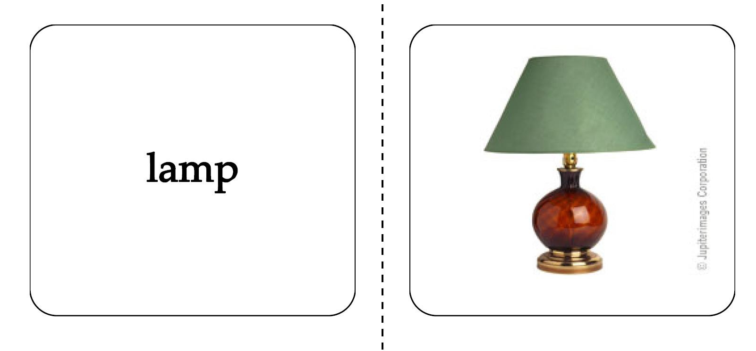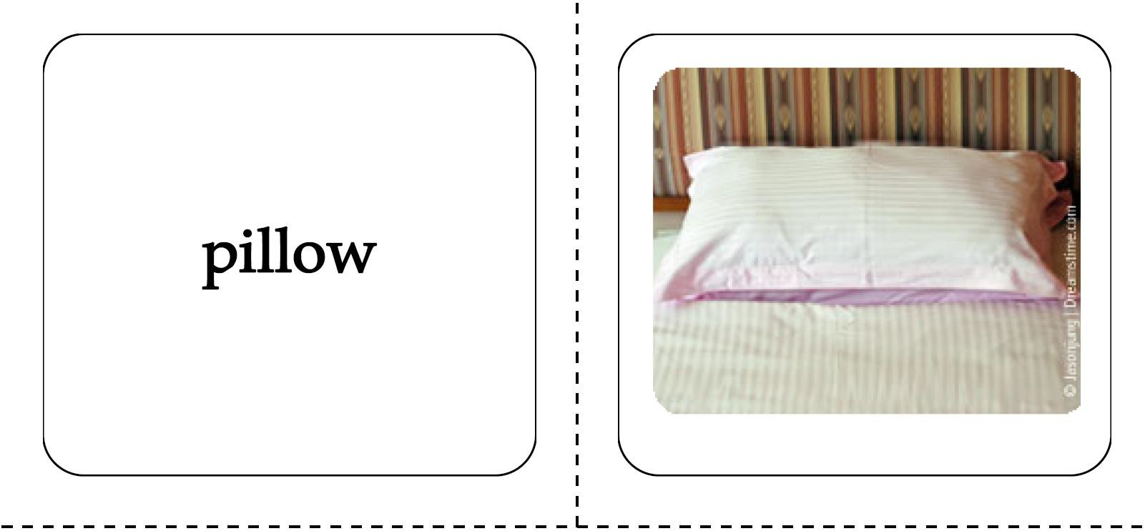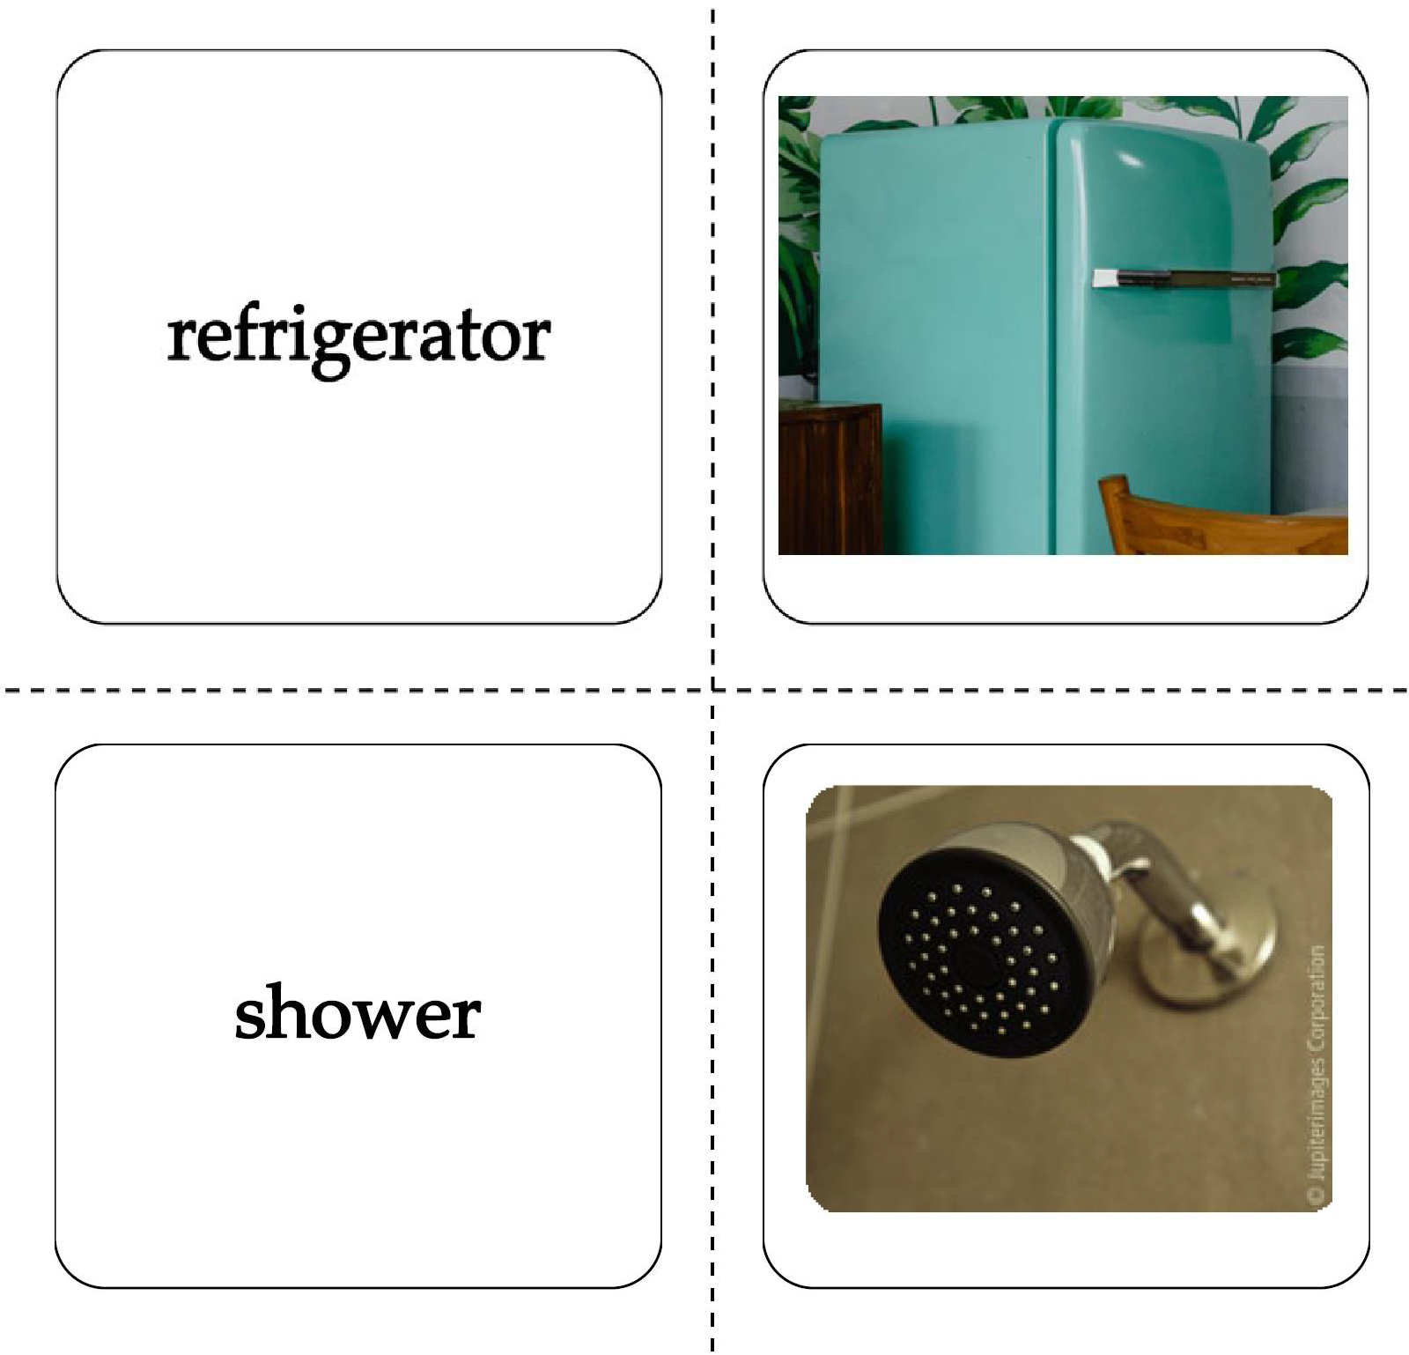

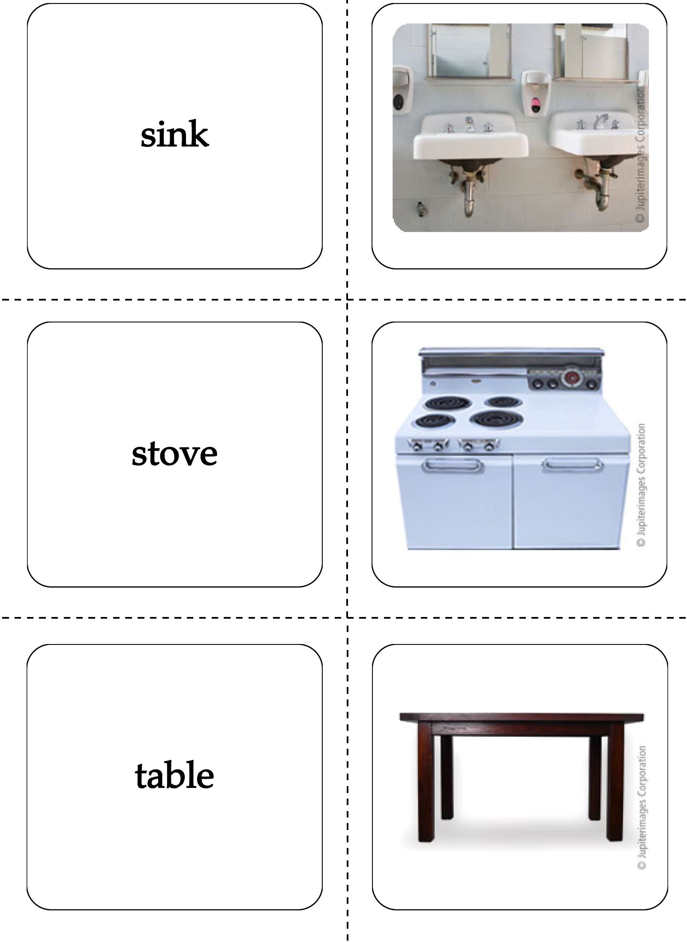

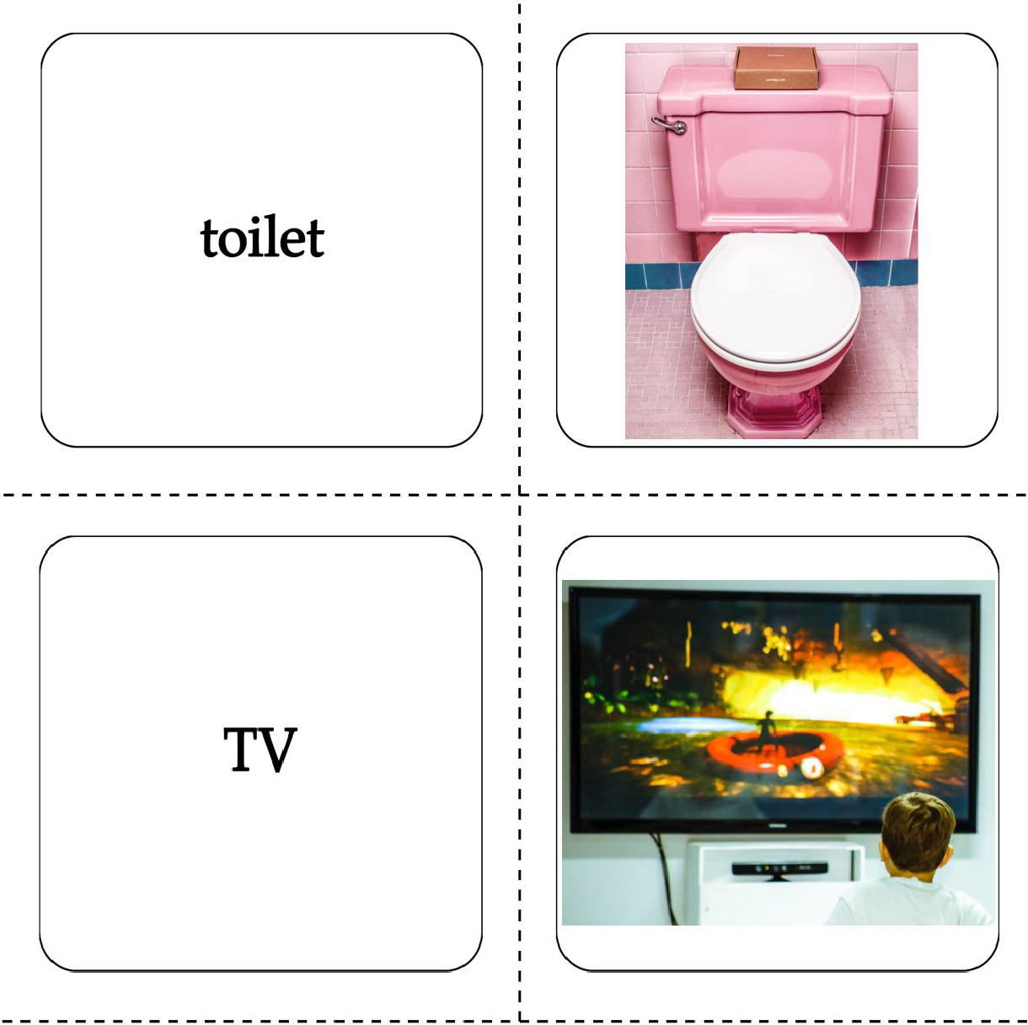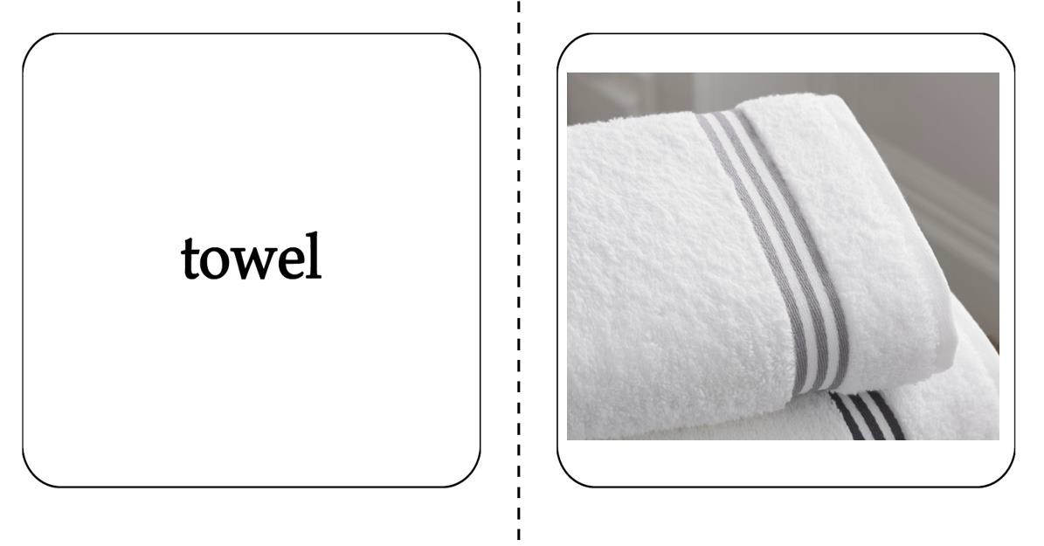

**House**

