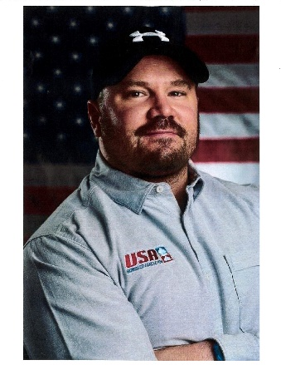
Steven Holcomb Memorial
Scholarship Application

Born in Salt Lake City, Utah in 1980, Steven Holcomb became the face of American bobsledding. Steven ended a 62-year gold medal drought for the USA Bobsled program by winning 4-man bobsled gold in the 2010 Winter Olympics in Vancouver. Steven is one of the most decorated bobsled pilots in the world. In addition to his 2010 gold medal, Steven won 2 silver medals in the 2014 Sochi Olympics, 60 World Cup medals, and 5 World Championship titles. A skier, Steven was a graduate of The Park City Winter School, an alternative high school for winter athletes. He was an Eagle Scout, a member of the Army World Class Athlete Program, and the Utah National Guard. A self-described computer geek, he was a Certified Microsoft Technician and studied computer forensics at DeVry University. At the age of 18 he became the youngest member of the U.S. Bobsled team, pursuing a love of speed and his childhood dream of winning an Olympic medal. Keratoconus, a degenerative eye condition leading to blindness, threatened his career as his vision deteriorated to 20/500. The medical procedure, experimental at the time, that arrested the condition has been named the Holcomb C3-R. At his passing in 2017, Steven was known for his driving expertise, leadership, perseverance, sense of humor, kindness, and his attention to teammates and fans. Furthermore, Steven never let anything get in the way of his passion to pursue his goals and dreams.

Eligibility:
All Discovery High School graduating seniors who have applied or been accepted to a post-secondary institution and who have a desire to pursue their dreams as Steven Holcomb exemplified.
Application Requirements:
- Complete the applicant information section referenced below.
- Write a 1-2 page essay describing how this scholarship will help you achieve your dreams and/or future career goals. Please include the post-secondary institution you will attend during the 2020-21 school year.
Awards:
The student awarded the Steven Holcomb Scholarship will have $500 sent to the school of acceptance. The school of acceptance will also be sent an additional $500 to support the student during their second semester as long as adequate progress is being made toward graduation or completion requirements.
Application Information:
Name (First & Last): ___________________________________________________________
Address: ____________________________________________________________________
Phone Number/Email:__________________________________________________________
Please check to make sure you have met all of the criteria referenced below.
____ I am currently on track to graduate during the 2018-19 school year.
____ I have applied and been accepted to a post-secondary institution.
____ I have attached a copy of my 1-2 page essay.

