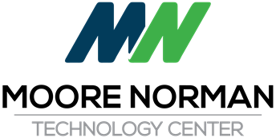

Special Board Meeting
February 27, 2020 11:30 AM
Artesian Hotel 1001 W. 1st Street
Sulphur, OK 73086
3rd Floor Conference Room
1. Pledge of Allegiance
2. Call to Order and the Recording of Members Present and Absent
3. Miscellaneous Public Comment
4. Discussion and interaction between Board and Administration regarding the MNTC Strategic Plan
5. Consider and Vote to table the MNTC Strategic Plan discussion until we reconvene at 8:30 am on Friday, February 28, 2020, 3rd Floor Conference Room, Artesian Hotel
6. Adjourn

