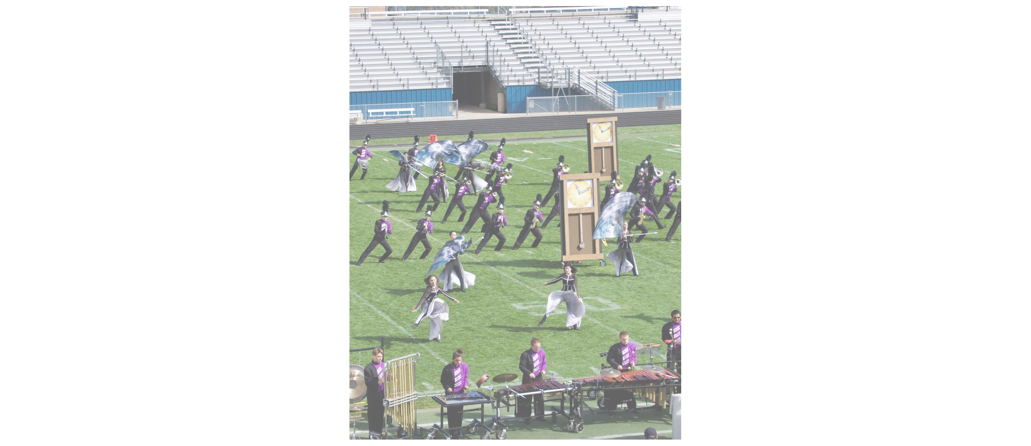
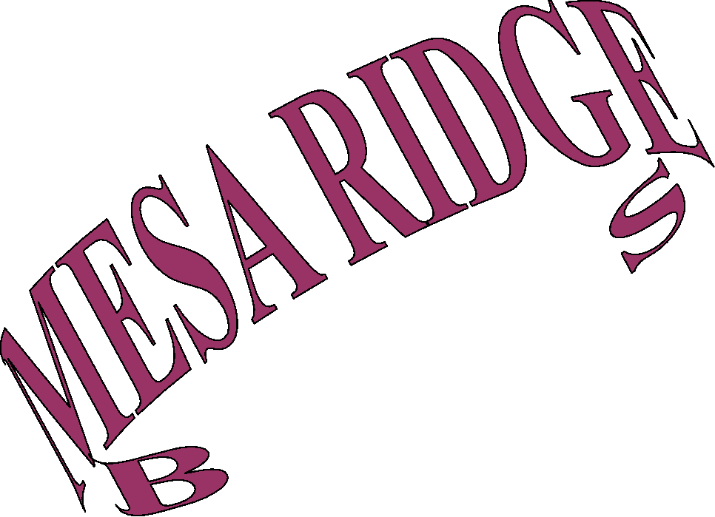
• Music teaches discipline, hard work, long term skill and mental development.

• Opportunities to Compete and Perform on a STATE and NATIONAL level!

• Involvement in a TEAM activity that focuses on success and cooperative learning!

• Studies show Music students perform better on achievement tests and SAT exams in reading and math .
• The arts are one of the six subject areas in which the College Board recognizes as essential in order to thrive in college!

Long term scheduling flexibility — YOU CAN BE in our pro-grams! Let us help you create a successful 4 year plan!

Contact the Mesa Ridge Performing Arts Department

at olivasp@wsd3.org for assistance in geting into one of the best music programs in Colorado!

