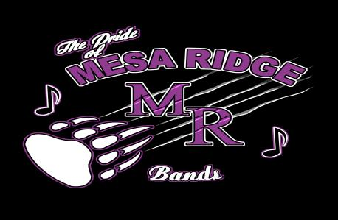
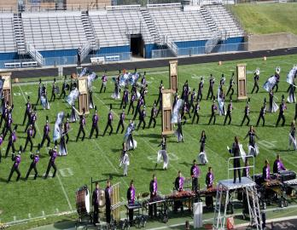
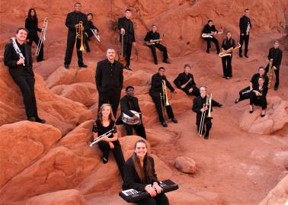
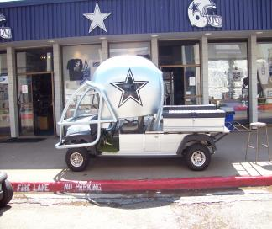
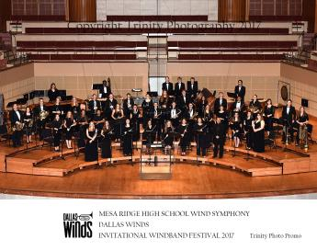
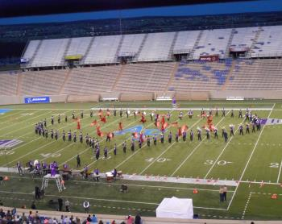
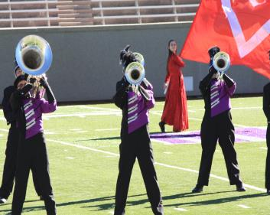
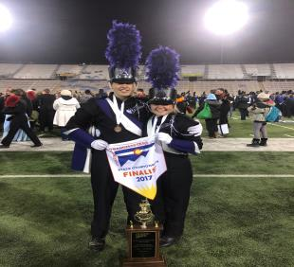
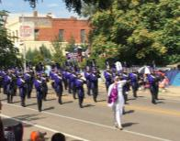

Director Phil Olivas is in his 26th year of teaching and has been at Mesa Ridge since it opened in 1997. Mr. Olivas has been teaching in the Widefield School district for 25 years. Under his direction the bands at Mesa Ridge have received consistent #1 ratings at State Music Festivals in both Concert and Jazz Band Competition.
Mr. Della Penna has been in the district for 5 years and holds positions at Janitell and Mesa Ridge. Both Mr. Olivas and Mr. Della Penna received degrees from the University of Colorado, Boulder.

In the last few years the Mesa Ridge Bands have performed in the famed Meyerson Symphony Center in Dallas, TX. , The Reno Jazz Festival, and Disneyland!

Mr. Olivas and Mr. Della Penna credit the students’ hard work and the parents’ support for the continued success of the Mesa Ridge Band Program.

The Pride of Mesa Ridge Marching Band continues to strive for success. The group has earned countless awards and podium finishes at every major Colorado competition. “The Pride” are the 2008, 2010, 2012, 2014, 2016 and 2018 Grand Champions of the Colorado State Fair Parade Competition.
The Pride of Mesa Ridge has ranked as one of the top 8 “Finalist Bands” at State Marching Championships competition for the past 15 years!

In 2019 the Marching Band returned to STATE CHAMPIONSHIPS earning 6th Place in Colorado!! WE ARE VERY PROUD OF YOU!

The Bands at Mesa Ridge under the direction of Mr. Olivas and Mr. Della Penna continually strive for success at the individual and ensemble level. Our students are consistently selected to Honor Bands around the state and receive consistent Superior and Excellent ratings.
Individual achievement, team effort, consistent improvement, group success, and musical enjoyment are the cornerstones of what has become one of the premier music programs in the state.

Mesa Ridge Bands Registration Sheet 2020-2021
Dear Student,

As the band director at Mesa Ridge I am looking forward to the coming year. As always we strive to build the strongest bands possible. I am proud to say that our bands consistently compete with kids from larger schools with great success.
This past year has been terrific and next year looks to be even better. Traveling opportunities with marching and concert bands, honor bands, several concerts, possible induction into Tri M National Music Society, and the opportunity to meet and hang out with the hardest working, strangest, “funnest”, coolest people at Mesa Ridge are all available to you.
We are inviting you to join the bands here at Mesa Ridge! You are a fine musician and we, the staff at Mesa Ridge want to make sure we don’t miss you while scheduling. High School is filled with opportunity and we don’t want you to miss out. Craig Kirkoff of the University of Minnesota stated recently, “95 percent of students who don’t play their freshman year will never touch their instrument again.” I hope to encourage you before that happens!

Instructions
The Band program at Mesa Ridge High School consists of 3 Concert Bands, a Jazz Band, and Marching Band. Our goal is to offer a rewarding and challenging musical experience to our students. We achieve this goal by having high musical and performance expectations.
I encourage all instrumental students to join a musical group that interests and challenges them. My goal as director is to place students in such a band. I, with the help of the Junior High teachers, will evaluate students in the coming month and place them in a particular group.
My further hope is to continue to build a SUCCESSFUL and FUN program that will enrich our lives.

On the Class Selection Sheet students should put a #1 next to “BAND” for the first elective slot.
(SEE EXAMPLE) Doing this will secure a position in a concert group for the following year. You will be placed in specific groups at a later date.
** If you are interested in taking 2 music classes, Band and Jazz Band or BAND and foreign language, or BAND and ….. etc. you may elect not to take PE as a ninth grader, however you will have to take it at some point over your 4 years at MRHS. Let your counselor know you want this option!

**Marching Band meets as an after school class. Students DO receive credit and a grade for being in marching band. This class meets after school to avoid conflicts with other performing groups. Marching Band students can also receive a PE credit for multiple season participation. Marching Band DOES NOT take up one of your elective choices because it meets after school. Students are required to be in a concert group to participate in Marching Band. This is to ensure we are getting quality musicians in all groups. To register students should “X” MARCHING BAND in the section at the bottom of the class selection sheet or write “marching band” near the elective selection area.

***YOU MUST CLICK ON THE BAND BOX WHEN ENTERING YOUR SELECTIONS IN THE COMPUTER!!!***
The program here continues to grow and is full of opportunity to learn and have fun. We will do everything we can to get you signed up. I look forward to teaching you and getting to know you better during the 2020 school year and beyond. Please share this information with your parents and I hope to see you soon!!! For additional information please e mail me. I am happy to help!
Directors,
Phil Olivas, Joseph DellaPenna

*Example from the Class Selection Sheet:

All of the classes in this section are Year Long classes so they will take TWO of your 8 choices. **This means each class lasts 2 semesters and counts as 2 of the 8 lines you should mark.**

FOREIGN LANGUAGE
____19005 French I ____19010 French II ____19030 German I
PERFORMING ARTS __1_22055 BAND __2__22010 CHOIR _____22025 ORCHESTRA
*Marching Band

