VENDOR PACKET

Name of Vendor: __________________________________________

TABLE OF CONTENTS

Items below are components which comprise this bid/proposal package. Respondents are asked to review the proposal document and attachments package to be sure that all applicable parts are included. If any portion of the package is missing, please notify SMSD immediately.

This attachment package must be completed, executed, and dated by the authorized proposer and must be included with your proposal at the time of submission.

Attachments:

- Conflict of Interest Questionnaire (Mandatory)
- IRS Form W-9 (Mandatory)
- Proposer Certifications (Mandatory)
- Felony Conviction Notice Form (Mandatory)
- Antitrust Certification Statement (Mandatory)

Add this item if it deals with student contact
- SB9 Contractor Certification Form: Contractor Employees (Varies)
- SB9 Contractor Certification Form: Subcontractor (Varies)

Add this Form, for items going to the board
- Certificate of Interested Parties – Form 1295 (for Board Items only)

SMSD CONFLICT OF INTEREST DISCLOSURE STATEMENT
Stafford Municipal School District (SMSD) is required to comply with Texas Local Government Code Chapter 176, Disclosure of Certain Relationships with Local Government Officers. House Bill 23 significantly changed Chapter 176 as well as the required disclosures and the corresponding forms. As of September 1, 2015, any vendor who does business with SMSD or who seeks to do business with SMSD must fill out the new Conflict of Interest Questionnaire (CIQ) whether or not a conflict of interest exists. A conflict of interest exists in the following situations:
- If the vendor has an employment or other business relationship with a local government officer of SMSD or a family member of the officer, as described by section 176.003(a)(2)(A) of the Texas Local Government Code; or
- If the vendor has given a local government officer of SMSD, or a family member of the officer, one or more gifts with the aggregate value of $100, excluding any gift accepted by the officer or a family member of the officer if the gift is: (a) a political contribution as defined by Title 15 of the Election Code; or (b) a gift of food accepted as a guest; or
- If the vendor has a family relationship with a local government officer of SMSD.

“Vendor” means a person who enters or seeks to enter into a contract with a local governmental entity. The term includes an agent of a vendor. The term includes an officer or employee of a state agency when that individual is acting in a private capacity to enter into a contract. The term does not include a state agency except for Texas Correctional Industries. Texas Local Government Code 176.001(7).

“Business relationship” means a connection between two or more parties based on commercial activity of one of the parties. The term does not include a connection based on: (A) a transaction that is subject to rate or fee regulation by a federal, state, or local governmental entity or an agency of a federal, state, or local governmental entity; (B) a transaction conducted at a price and subject to terms available to the public; or (C) a purchase or lease of goods or services from a person that is chartered by a state or federal agency and that is subject to regular examination by, and reporting to, that agency. Texas Local Government Code 176.001(3).

“Family relationship” means a relationship between a person and another person within the third degree by consanguinity or the second degree by affinity, as those terms are defined by Subchapter B, Chapter 573, Government Code. Texas Local Government Code 176.001(2-a).

“Local government officer” means: (A) a member of the governing body of a local governmental entity; (B) a director, superintendent, administrator, president, or other person designated as the executive officer of a local governmental entity; or (C) an agent of a local governmental entity who exercises discretion in the planning, recommending, selecting, or contracting of a vendor. Texas Local Government Code 176.001(4).

- SMSD Board of Trustees and Superintendent include:
Mr. Christopher Caldwell Ms. Alicia Lacy-Castille
Mr. Xavier Herrera Mr. Greg Holsapple
Mr. Ash Hamirani Mr. Manuel Hinojosa
Ms. Jacqueline Jean-Baptiste Dr. Robert Bostic, Superintendent

- Current local government officers include, but are not limited to:
Marva Rasberry, Chief Innovations Officer
Dr. Kadir Almus, Chief Academic Officer
Dr. Dawn Dubose, Chief of Schools
Dr. Jesus J. Amezcua, Acting CFO
If no conflict of interest exists, you must fill out Box 1 and type N/A on Box 3 of the CIQ form, sign and date it. In the event of changed circumstances, an updated CIQ must be filed within seven (7) business days after the vendor becomes aware that a conflict of interest exists.

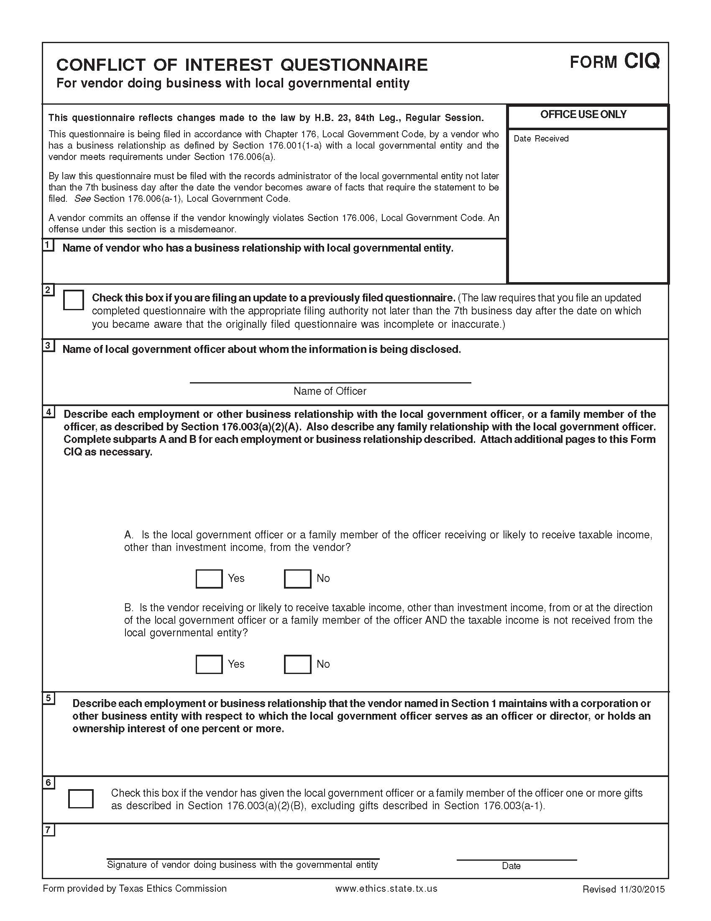
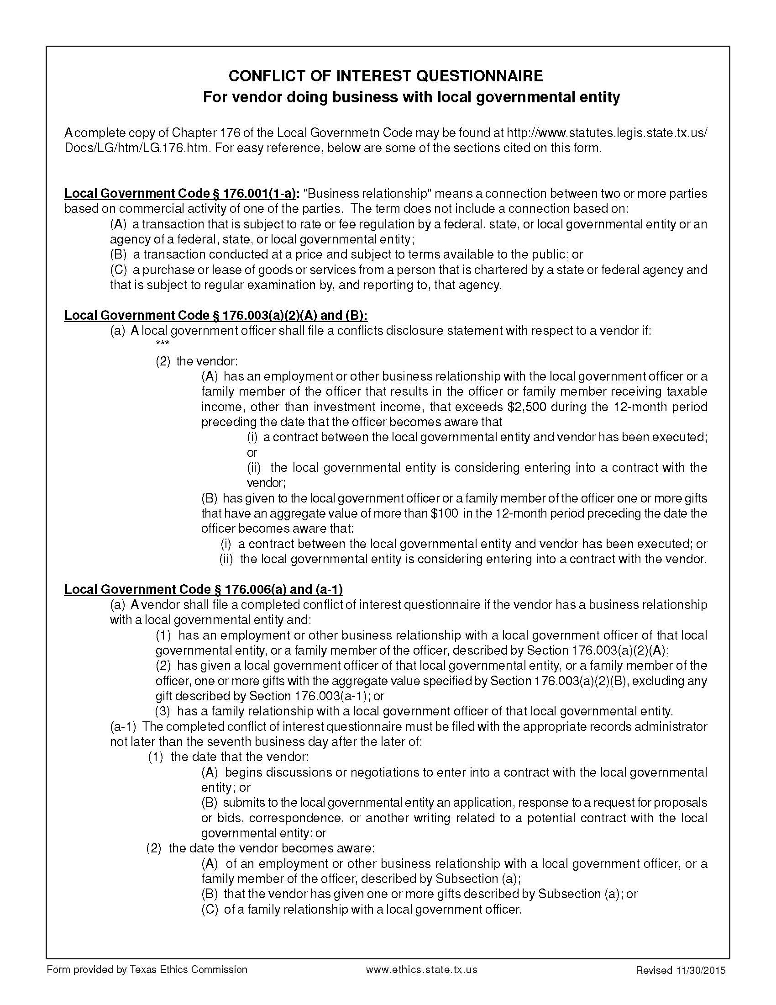

SMSD CERTIFICATE OF INTERESTED PARTIES – FORM 1295

SMSD is required to comply with House Bill 1295, which amended the Texas Government Code by adding Section 2252.908, Disclosure of Interested Parties. Section 2252.908 prohibits SMSD from entering into a contract resulting from this RFP with a business entity unless the business entity submits a Disclosure of Interested Parties (Form 1295) to SMSD at the time business entity submits the signed contract. Effective January 1, 2018, the Form 1295 requirement does not apply to: (1) a contract with a publicly traded business entity or wholly owned subsidiary of the same; (2) an electric utility; or (3) a gas utility. The Texas Ethics Commission has adopted rules requiring the business entity to file Form 1295 electronically with the Texas Ethics Commission. The following definitions apply:

- “Business Entity” means an entity recognized by law through which business is conducted, including a sole proprietorship, partnership, or corporation. Tex. Gov’t Code § 2252.908(1).

- “Interested Party” means a person:
- who has a controlling interest in a business entity with whom SMSD contracts; or
- who actively participates in facilitating the contract or negotiating the terms of the contract, including a broker, intermediary, adviser, or attorney for the business entity. Tex. Gov’t Code § 2252.908(3).

- “Controlling interest” means:
- an ownership interest or participating interest in a business entity by virtue of units, percentage, shares, stock, or otherwise that exceeds 10 percent;
- membership on the board of directors or other governing body of a business entity of which the board or other governing body is composed of not more than 10 members; or
- service as an officer of a business entity that has four or fewer officers, or service as one of the four officers most highly compensated by a business entity that has more than four officers. Subsection (c) does not apply to an officer of a publicly held business entity or its wholly owned subsidiaries. Tex. Ethics Comm. Rule 46.3(c).

- “Intermediary” means a person who actively participates in the facilitation of the contract or negotiating the contract, including a broker, adviser, attorney, or representative of or agent for the business entity who:
- receives compensation from the business entity for the person’s participation;
- communicates directly with the governmental entity or state agency on behalf of the business entity regarding the contract; and
- is not an employee of the business entity. Tex. Ethics Comm. Rule 46.3(e).

As a “business entity,” all vendors must:
- complete Form 1295 electronically with the Texas Ethics Commission using the online filing application, which can be found at https://www.ethics.state.tx.us/whatsnew/elf_info_form1295.htm
- All vendors must complete Form 1295, even if no interested parties exist
- In Section 2, insert “Stafford Municipal School District”
- In Section 3, insert the SMSD RFQ/RFP # for this proposal
- print a copy of the completed form (make sure that it has a computer-generated certification number in the “Office Use Only” box)
- have an authorized agent of the business entity sign the form
- submit the completed Form 1295 by attaching the form to your statement of qualifications/proposal.
SMSD must acknowledge the receipt of the filed Form 1295 by notifying the Texas Ethics Commission of the receipt of the filed Form 1295 no later than the 30th day after receipt by SMSD. After SMSD acknowledges the Form 1295, the Texas Ethics Commission will post the completed Form 1295 to its website with seven business days after receiving notice from SMSD.

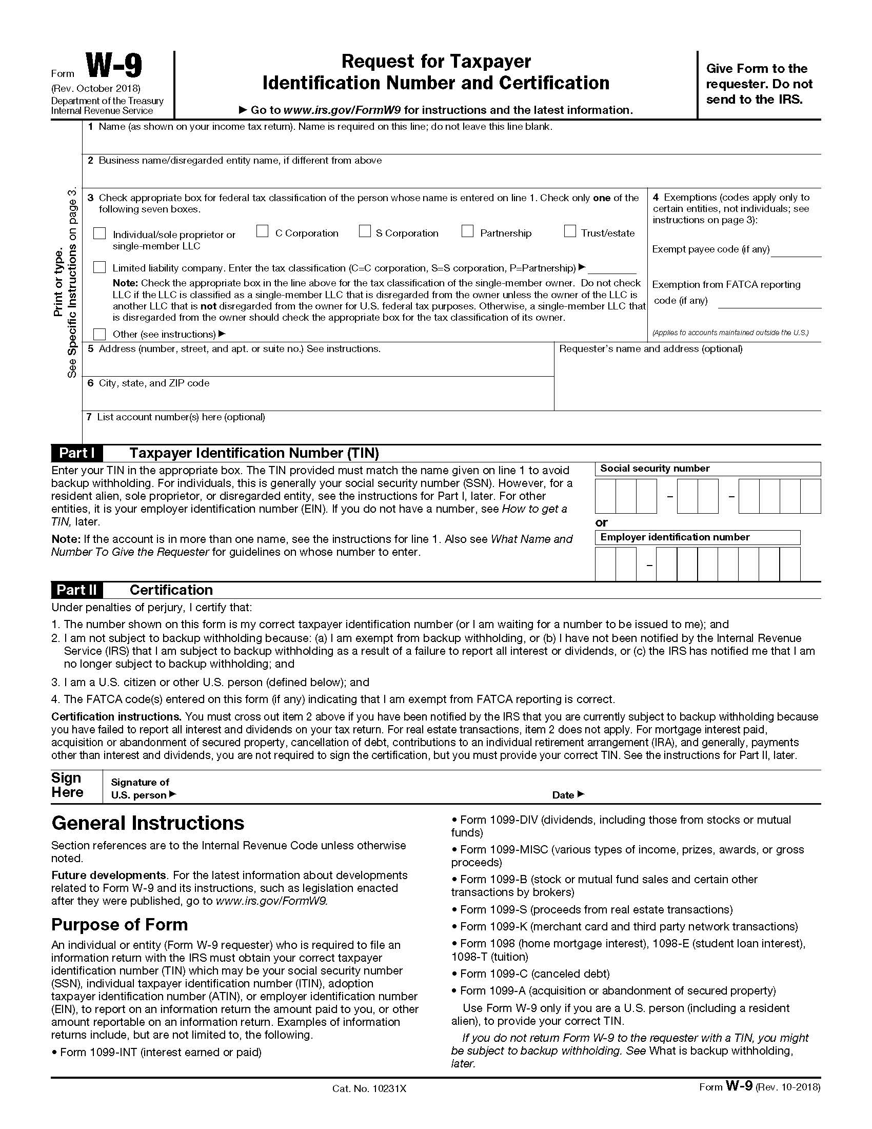
STAFFORD MUNICIPAL SCHOOL DISTRICT
PROPOSER/VENDOR CERTIFICATION FORMS

CERTIFICATION OF RESIDENCY
The State of Texas has a law concerning non-resident vendors. This law can be found in Texas Education Code under Chapter 2252, Subchapter A. This law makes it necessary for SMSD to determine the residency of its Vendors. In part, this law reads as follows:
Section: 2252.001: "Non-resident bidder” refers to a person who is not a resident. “Resident bidder” refers to a person whose principal place of business is in this state, including a vendor whose ultimate parent company or majority owner has its principal place of business in this state.
Section: 2252.002: "A governmental entity may not award a governmental contract to a non-resident bidder unless the nonresident underbids the lowest bid submitted by a resident bidder by an amount that is not less than the amount by which a resident bidder would be required to underbid the nonresident bidder to obtain a comparable contract in the state in which the nonresident’s principal place of business is located.”
Company submitting bid is a resident bidder: ◻ Yes ◻ No
City and state of vendor's principal place of business:

SMSD SUPPLER DIVERSITY PROGRAM – REQUIRED FORM
SMSD’s supplier diversity program ensures that the District shall use its best efforts to inform small, women-owned, and minority-owned businesses of current and future purchasing activities. Pursuant to SMSD Board Policy CH (Local), the District shall encourage the participation of these businesses in purchasing of all goods and services. All solicitations issued by the District shall include this supplier diversity program form that is to be completed and submitted with the bid response.
If possible, the District shall attain 25 percent of its professional goods and services from small, women-owned, and minority- owned businesses.
In addition, the District shall make every effort to purchase goods and services from Stafford-owned businesses.
The following definitions shall apply:
- A “small business” shall be defined as a business entity that is in- dependently owned and operated and is not dominant in its field of operation. The business shall employ fewer than 50 employees and/or shall have less than $3 million in annual business volume from this local operation.
- A “minority business” shall be a business entity that is at least 51 percent owned by one or more minority individuals or, in the case of any publicly owned business, at least 51 percent of the stock is owned by one or more minority individuals and whose management and daily business operations are controlled by one or more of the minority individuals who own the entity. Minority individuals shall mean residents of the United States who are members of the following groups: African Americans, Hispanics, American Indians, Asian Americans, Alaska natives, or Pacific Islanders.
- A “woman business enterprise” shall mean a business entity that follows the same guidelines as a minority business but that is at least 51 percent owned by one or more women, or in the case of a publicly owned business, at least 51 percent of the stock is owned by one or more women and whose management and daily business operations are controlled by one or more women who own the entity.

Vendor certifies that it has the following supplier diversity classification(s):
Vendor certifies that it is a small business as defined above: | - Yes | - No
Vendor certifies that it is a minority business as defined above: | - Yes | - No
Vendor certifies that it is a woman business enterprise as defined above: | - Yes | - No
If Vendor is MWBE and/or HUB certified, please include a copy of the certification letter and the percentage of your business with MWBE and/or HUB suppliers, if applicable, in your proposal response.

I, the authorized representative for the company named below, certify that the information concerning residency certification, and MWBE and HUB certifications have been reviewed by me and the information furnished is true to the best of my knowledge.

Contractor’s Name/Company Name: ________________________________________________________
Address, City, State, and Zip Code: Phone Number: Fax Number:
Printed Name and Title of Authorized Representative: Email Address:
Signature of Authorized Representative: Date:

CERTIFICATION REGARDING TERRORIST ORGANIZATIONS

Vendor hereby certifies that it is not a company identified on the Texas Comptroller’s list of companies known to have contracts with, or provide supplies or services to, a foreign organization designated as a Foreign Terrorist Organization by the U.S. Secretary of State.

______ Initials of Authorized Representative of Vendor

CERTIFICATION REGARDING BOYCOTTING OF ISRAEL

If (a) Vendor is not a sole proprietorship; (b) Vendor has ten (10) or more full-time employees; and (c) this Agreement has a value of $100,000 or more, the following certification shall apply; otherwise, this certification is not required. Pursuant to Chapter 2270 of the Texas Government Code, the Vendor hereby certifies and verifies that neither the Vendor, nor any affiliate, subsidiary, or parent company of the Vendor, if any (the “Vendor Companies”), boycotts Israel, and the Vendor agrees that the Vendor and Vendor Companies will not boycott Israel during the term of this Agreement. For purposes of this Agreement, the term “boycott” shall mean and include refusing to deal with, terminating business activities with, or otherwise taking any action that is intended to penalize, inflict economic harm on, or limit commercial relations with Israel, or with a person or entity doing business in Israel or in an Israeli-controlled territory, but does not include an action made for ordinary business purposes.

______ Initials of Authorized Representative of Vendor, if applicable

Required Contract Provisions for Non-Federal Entity Contracts
Under Federal Awards – Appendix II to 2 CFR Part 200

The following provisions are required and apply when federal funds are expended by SMSD for any contract resulting from this procurement process.

- Contracts for more than the simplified acquisition threshold currently set at $250,000, which is the inflation adjusted amount determined by the Civilian Agency Acquisition Council and the Defense Acquisition Regulations Council (Councils) as authorized by 41 U.S.C. 1908, must address administrative, contractual, or legal remedies in instances where contractors violate or breach contract terms, and provide for such sanctions and penalties as appropriate.

Pursuant to Federal Rule (A) above, when federal funds are expended by SMSD, SMSD reserves all rights and privileges under the applicable laws and regulations with respect to this procurement in the event of breach of contract by either party.

Does vendor agree? YES ________ Initials of Authorized Representative of vendor

- Termination for cause and for convenience by the grantee or subgrantee including the manner by which it will be effected and the basis for settlement. (All contracts in excess of $10,000)

Pursuant to Federal Rule (B) above, when federal funds are expended by SMSD, SMSD reserves the right to immediately terminate any agreement in excess of $10,000 resulting from this procurement process in the event of a breach or default of the agreement by Vendor, in the event vendor fails to: (1) meet schedules, deadlines, and/or delivery dates within the time specified in the procurement solicitation, contract, and/or a purchase order; (2) make any payments owed; or (3) otherwise perform in accordance with the contract and/or the procurement solicitation. SMSD also reserve the right to terminate the contract immediately, with written notice to vendor, for convenience, if SMSD believes, in its sole discretion that it is in the best interest of SMSD to do so. The vendor will be compensated for work performed and accepted and goods accepted by SMSD as of the termination date if the contract is terminated for convenience of SMSD. Any award under this procurement process is not exclusive and SMSD reserves the right to purchase goods and services from other vendors when it is in the best interest of SMSD.

Does vendor agree? YES ________ Initials of Authorized Representative of vendor

- Equal Employment Opportunity. Except as otherwise provided under 41 CFR Part 60, all contracts that meet the definition of “federally assisted construction contract” in 41 CFR Part 60-1.3 must include the equal opportunity clause provided under 41 CFR 60-1.4(b), in accordance with Executive Order 11246, “Equal Employment Opportunity” (30 FR 12319, 12935, 3 CFR Part, 1964-1965 Comp., p. 339), as amended by Executive Order 11375, “Amending Executive Order 11246 Relating to Equal Employment Opportunity,” and implementing regulations at 41 CFR part 60, “Office of Federal Contract Compliance Programs, Equal Employment Opportunity, Department of Labor.”

Pursuant to Federal Rule (C) above, when federal funds are expended by SMSD on any federally assisted construction contract, the equal opportunity clause is incorporated by reference herein.

Does vendor agree to abide by the above?

YES ________ Initials of Authorized Representative of vendor

- Davis-Bacon Act, as amended (40 U.S.C. 3141-3148). When required by Federal program legislation, all prime construction contracts in excess of $2,000 awarded by non-Federal entities must include a provision for compliance with the Davis-Bacon Act (40 U.S.C. 3141-3144, and 3146-3148) as supplemented by Department of Labor regulations (29 CFR Part 5, “Labor Standards Provisions Applicable to Contracts Covering Federally Financed and Assisted Construction”). In accordance with the statute, contractors must be required to pay wages to laborers and mechanics at a rate not less than the prevailing wages specified in a wage determination made by the Secretary of Labor. In addition, contractors must be required to pay wages not less than once a week. The non-Federal entity must place a copy of the current prevailing wage determination issued by the Department of Labor in each solicitation. The decision to award a contract or subcontract must be conditioned upon the acceptance of the wage determination. The non-Federal entity must report all suspected or reported violations to the Federal awarding agency. The contracts must also include a provision for compliance with the Copeland “Anti-Kickback” Act (40 U.S.C. 3145), as supplemented by Department of Labor regulations (29 CFR Part 3, “Contractors and Subcontractors on Public Building or Public Work Financed in Whole or in Part by Loans or Grants from the United States”). The Act provides that each contractor or subrecipient must be prohibited from inducing, by any means, any person employed in the construction, completion, or repair of public work, to give up any part of the compensation to which he or she is otherwise entitled. The non-Federal entity must report all suspected or reported violations to the Federal awarding agency.

Pursuant to Federal Rule (D) above, when federal funds are expended by SMSD, during the term of an award for all contracts and subgrants for construction or repair, the vendor will be in compliance with all applicable Davis-Bacon Act provisions.

Does vendor agree? YES ________ Initials of Authorized Representative of vendor

- Contract Work Hours and Safety Standards Act (40 U.S.C. 3701-3708). Where applicable, all contracts awarded by the non-Federal entity in excess of $100,000 that involve the employment of mechanics or laborers must include a provision for compliance with 40 U.S.C. 3702 and 3704, as supplemented by Department of Labor regulations (29 CFR Part 5). Under 40 U.S.C. 3702 of the Act, each contractor must be required to compute the wages of every mechanic and laborer on the basis of a standard work week of 40 hours. Work in excess of the standard work week is permissible provided that the worker is compensated at a rate of not less than one and a half times the basic rate of pay for all hours worked in excess of 40 hours in the work week. The requirements of 40 U.S.C. 3704 are applicable to construction work and provide that no laborer or mechanic must be required to work in surroundings or under working conditions which are unsanitary, hazardous or dangerous. These requirements do not apply to the purchases of supplies or materials or articles ordinarily available on the open market, or contracts for transportation or transmission of intelligence.

Pursuant to Federal Rule (E) above, when federal funds are expended by SMSD, the vendor certifies that during the term of an award for all contracts by SMSD resulting from this procurement process, the vendor will be in compliance with all applicable provisions of the Contract Work Hours and Safety Standards Act.

Does vendor agree? YES ________ Initials of Authorized Representative of vendor

- Rights to Inventions Made Under a Contract or Agreement. If the Federal award meets the definition of “funding agreement” under 37 CFR §401.2 (a) and the recipient or subrecipient wishes to enter into a contract with a small business firm or nonprofit organization regarding the substitution of parties, assignment or performance of experimental, developmental, or research work under that “funding agreement,” the recipient or subrecipient must comply with the requirements of 37 CFR Part 401, “Rights to Inventions Made by Nonprofit Organizations and Small Business Firms Under Government Grants, Contracts and Cooperative Agreements,” and any implementing regulations issued by the awarding agency.

Pursuant to Federal Rule (F) above, when federal funds are expended by SMSD, the vendor certifies that during the term of an award for all contracts by SMSD resulting from this procurement process, the vendor agrees to comply with all applicable requirements as referenced in Federal Rule (F) above.

Does vendor agree? YES ________ Initials of Authorized Representative of vendor

- Clean Air Act (42 U.S.C. 7401-7671q.) and the Federal Water Pollution Control Act (33 U.S.C. 1251-1387), as amended—Contracts and subgrants of amounts in excess of $150,000 must contain a provision that requires the non-Federal award to agree to comply with all applicable standards, orders or regulations issued pursuant to the Clean Air Act (42 U.S.C. 7401-7671q) and the Federal Water Pollution Control Act as amended (33 U.S.C. 1251- 1387). Violations must be reported to the Federal awarding agency and the Regional Office of the Environmental Protection Agency (EPA).

Pursuant to Federal Rule (G) above, when federal funds are expended by SMSD, the vendor certifies that during the term of an award for all contracts by SMSD resulting from this procurement process, the vendor agrees to comply with all applicable requirements as referenced in Federal Rule (G) above.

Does vendor agree? YES ________ Initials of Authorized Representative of vendor

- Debarment and Suspension (Executive Orders 12549 and 12689)—A contract award (see 2 CFR 180.220) must not be made to parties listed on the government wide exclusions in the System for Award Management (SAM), in accordance with the OMB guidelines at 2 CFR 180 that implement Executive Orders 12549 (3 CFR part 1986 Comp., p. 189) and 12689 (3 CFR part 1989 Comp., p. 235), “Debarment and Suspension.” SAM Exclusions contains the names of parties debarred, suspended, or otherwise excluded by agencies, as well as parties declared ineligible under statutory or regulatory authority other than Executive Order 12549.

Pursuant to Federal Rule (H) above, when federal funds are expended by SMSD, the vendor certifies that during the term of an award for all contracts by SMSD resulting from this procurement process, the vendor certifies that neither it nor its principals is presently debarred, suspended, proposed for debarment, declared ineligible, or voluntarily excluded from participation by any federal department or agency or by the State of Texas. Vendor shall immediately provide written notice to SMSD if at any time the vendor learns that this certification was erroneous when submitted or has become erroneous by reason of changed circumstances. SMSD may rely upon a certification of a vendor that the vendor is not debarred, suspended, ineligible, or voluntarily excluded from the covered contract, unless SMSD knows the certification is erroneous.

Does vendor agree? YES ________ Initials of Authorized Representative of vendor

- Byrd Anti-Lobbying Amendment (31 U.S.C. 1352)—Contractors that apply or bid for an award exceeding $100,000 must file the required certification. Each tier certifies to the tier above that it will not and has not used Federal appropriated funds to pay any person or organization for influencing or attempting to influence an officer or employee of any agency, a member of Congress, officer or employee of Congress, or an employee of a member of Congress in connection with obtaining any Federal contract, grant or any other award covered by 31 U.S.C. 1352. Each tier must also disclose any lobbying with non-Federal funds that takes place in connection with obtaining any Federal award. Such disclosures are forwarded from tier to tier up to the non-Federal award.

Pursuant to Federal Rule (I) above, when federal funds are expended by SMSD, the vendor certifies that during the term and after the awarded term of an award for all contracts by SMSD resulting from this procurement process, the vendor certifies that it is in compliance with all applicable provisions of the Byrd Anti-Lobbying Amendment (31 U.S.C. 1352). The undersigned further certifies that:
- No Federal appropriated funds have been paid or will be paid by or on behalf of the undersigned, to any person for influencing or attempting to influence an officer or employee of any agency, a Member of Congress, an officer or employee of Congress, or an employee of a Member of Congress in connection with the awarding of a Federal contract, the making of a Federal grant, the making of a Federal loan, the entering into a cooperative agreement, and the extension, continuation, renewal, amendment, or modification of a Federal contract, grant, loan, or cooperative agreement.
- If any funds other than Federal appropriated funds have been paid or will be paid to any person for influencing or attempting to influence an officer or employee of any agency, a Member of Congress, an officer or employee of Congress, or an employee of a Member of Congress in connection with this Federal contract, grant, loan, or cooperative agreement, the undersigned shall complete and submit Standard Form-LLL, “Disclosure Form to Report Lobbying”, in accordance with its instructions.
- The undersigned shall require that the language of this certification be included in the award documents for all subawards at all tiers (including subcontracts, subgrants, and contracts under grants, loans, and cooperative agreements) and that all subrecipients shall certify and disclose accordingly.
This certification is a material representation of fact upon which reliance was placed when this transaction was made or entered into. Submission of this certificate is a prerequisite for making or entering into this transaction imposed by Section 1352, title 31, U.S. Code. Any person who fails to file the required certification shall be subject to a civil penalty of not less than $10,000 and not more than $100,000 for each such failure.

Does vendor agree? YES ________ Initials of Authorized Representative of vendor

- Procurement of Recovered Materials – When federal funds are expended by SMSD, SMSD and its contractors must comply with section 6002 of the Solid Waste Disposal Act, as amended by the Resource Conservation and Recovery Act. The requirements of Section 6002 include: (1) procuring only items designated in guidelines of the Environmental Protection Agency (EPA) at 40 CFR part 247 that contain the highest percentage of recovered materials practicable, consistent with maintaining a satisfactory level of competition, where the purchase price of the item exceeds $10,000 or the value of the quantity acquired during the preceding fiscal year exceeded $10,000; (2) procuring solid waste management services in a manner that maximizes energy and resource recovery; and (3) establishing an affirmative procurement program for procurement of recovered materials identified in the EPA guidelines.

Pursuant to Federal Rule (J) above, when federal funds are expended SMSD, as required by the Resource Conservation and Recovery Act of 1976 (42 U.S.C. § 6962(c)(3)(A)(i)), the vendor certifies, by signing this document, that the percentage of recovered materials content for EPA-designated items to be delivered or used in the performance of the contract will be at least the amount required by the applicable contract specifications or other contractual requirements.

Does vendor agree? YES ________ Initials of Authorized Representative of vendor

Required Affirmative Steps for Small, Minority, And Women-Owned Firms for
Contracts Paid for with Federal Funds – 2 CFR § 200.321

When federal funds are expended by SMSD, Vendor is required to take all affirmative steps set forth in 2 CFR 200.321 to solicit and reach out to small, minority and women owned firms for any subcontracting opportunities on the project, including:

Placing qualified small and minority businesses and women's business enterprises on solicitation lists;

Assuring that small and minority businesses, and women's business enterprises are solicited whenever they are potential sources;

Dividing total requirements, when economically feasible, into smaller tasks or quantities to permit maximum participation by small and minority businesses, and women's business enterprises;

Establishing delivery schedules, where the requirement permits, which encourage participation by small and minority businesses, and women's business enterprises; and

Using the services and assistance, as appropriate, of such organizations as the Small Business Administration and the Minority Business Development Agency of the Department of Commerce.

Does vendor agree? YES ________ Initials of Authorized Representative of vendor

Record Retention Requirements for Contracts Paid for with Federal Funds –
2 CFR § 200.333

When federal funds are expended by SMSD for any contract resulting from this procurement process, the vendor certifies that it will comply with the record retention requirements detailed in 2 CFR § 200.333. The vendor further certifies that vendor will retain all records as required by 2 CFR § 200.333 for a period of three years after grantees or subgrantees submit final expenditure reports or quarterly or annual financial reports, as applicable, and all other pending matters are closed.

Does vendor agree? YES ________ Initials of Authorized Representative of vendor

Certification of Compliance with EPA Regulations
Applicable to Grants, Subgrants, Cooperative Agreements, and Contracts
in excess of $100,000 of Federal Funds

When federal funds are expended by SMSD for any contract resulting from this procurement process in excess of $100,000, the vendor certifies that the vendor is in compliance with all applicable standards, orders, regulations, and/or requirements issued pursuant to the Clean Air Act of 1970, as amended (42 U.S.C. 1857(h)), Section 508 of the Clean Water Act, as amended (33 U.S.C. 1368), Executive Order 117389 and Environmental Protection Agency Regulation, 40 CFR Part 15.

Does vendor agree? YES ________ Initials of Authorized Representative of vendor

Certification of Compliance with the Energy Policy and Conservation Act

When federal funds are expended by SMSD for any contract resulting from this procurement process, the vendor certifies that the vendor will be in compliance with mandatory standards and policies relating to energy efficiency which are contained in the state energy conservation plan issued in compliance with the Energy Policy and Conservation Act (Pub. L. 94-163, 89 Stat. 871).

Does vendor agree? YES ________ Initials of Authorized Representative of vendor

Certification of Compliance with Buy America Provisions

Vendor certifies that vendor is in compliance with all applicable provisions of the Buy America Act. Purchases made in accordance with the Buy America Act must still follow the applicable procurement rules calling for free and open competition.

Does vendor agree? YES ________ Initials of Authorized Representative of vendor

CERTIFICATION OF NON-COLLUSION STATEMENT

Vendor certifies under penalty of perjury that its response to this procurement solicitation is in all respects bona fide, fair, and made without collusion or fraud with any person, joint venture, partnership, corporation or other business or legal entity.

Does vendor agree? YES ________ Initials of Authorized Representative of vendor

Vendor agrees to comply with all federal, state, and local laws, rules, regulations and ordinances, as applicable. It is further acknowledged that vendor certifies compliance with all provisions, laws, acts, regulations, etc. as specifically noted above.

Vendor’s Name/Company Name: Address, City, State, and Zip Code:
Phone Number: Fax Number:
Printed Name and Title of Authorized Representative: Email Address: Signature of Authorized Representative: Date: Federal Tax ID #

STAFFORD MUNICIPAL SCHOOL DISTRICT

FELONY CONVICTION NOTICE FORM

FELONY CONVICTION NOTIFICATION

State of Texas Legislative Senate Bill No. 1 Section 44.034, Notification of Criminal History, Subsection (a), states “a person or business entity that enters into an agreement with a school district must give advance notice to the district if the person or an owner or operator of the business entity has been convicted of a felony. The notice must include a general description of the conduct resulting in the conviction of a felony”.
Subsection (b) states “a school district may terminate the agreement with a person or business entity if the district determines that the person or business entity failed to give notice as required by Subsection (a), or misrepresented the conduct resulting in the conviction. The district must compensate the person or business entity for services performed before the termination of the contract”.
Subsection (c) states “this section does not apply to a publicly held corporation”.

I, the undersigned agent for the firm named below, certify that the information concerning notification of felony convictions has been reviewed by me and the information furnished is true to the best of my knowledge.

Contractor’s Name/Company Name:
Authorized Official’s Name (Printed or Typed):

You must select one and sign below:
Firm is a publicly held corporation; therefore the above reporting requirement does not apply per Section 44.034, Texas Education Code, Subsection (c).
Contractor/Firm is not owned nor operated by anyone who has been convicted of a felony.
Contractor/Firm is operated or owned by the following individual(s) who has/have been convicted of a felony:
Name of Individual(s): Detail of Conviction(s): (Attach additional pages if necessary.)

Signature of Company Official: Date:

STAFFORD MUNICIPAL SCHOOL DISTRICT
ANTITRUST CERTIFICATION STATEMENT
(Tex. Government Code § 2155.005)

I affirm under penalty of perjury of the laws of the State of Texas that:
- I am duly authorized to execute this contract on my own behalf or on behalf of the company, corporation, firm, partnership or individual (Company) listed below;
- In connection with this bid, neither I nor any representatives of the Company have violated any provision of the Texas Antitrust laws codified in Tex. Bus. & Comm. Code Chapter 15;
- In connection with this bid, neither I nor any representative of the Company have violated any federal antitrust law; and
- Neither I nor any representatives of the Company have directly or indirectly communicated any of the contents of this bid to a competitor of the Company or any other company, corporation, firm, partnership or individual engaged in the same line of business as the Company.

Contractor’s Name/Company Name:

Address, City, State, and Zip Code:

Signature:

Printed Name:

Title: Date Signed:

SB 9 Contractor Certification: Contractor Employees
(As applicable)

Background: Texas Education Code Chapter 22 requires entities that contract with school districts to obtain criminal history records on covered employees. Covered employees with disqualifying criminal histories are prohibited from serving at a school district. Contractors must certify to SMSD that they have complied and must obtain similar certifications from their subcontractors. See SB 9 Contractor Certification: Subcontractor attachment. The law requires each contractor to obtain the criminal histories of its covered employees. For more information or to set up an account, a contractor should contact the Texas Department of Public Safety’s Crime Records Service at 512.424.2474.

Definitions:
Covered employees: Employees of a contractor who have or will have continuing duties related to the service to be performed at a school district and have or will have direct contact with students. SMSD will be the final arbiter of what constitutes continuing duties and direct contact with students.

Public Works Exception to Covered Employees: Covered employees do not include employees of a contracting or subcontracting entity that is providing engineering, architectural, or construction services on a project to design, construct, alter, or repair a public work if: (1) the public work does not involve the construction, alteration, or repair of an instructional facility as defined by Texas Education Code Section 46.001; (2) the employee’s duties will be completed more than seven (7) days before a new instructional facility will be used for instruction; or (3) for an existing instructional facility, the work area contains sanitary facilities separated from all areas used by students by a fence at least six (6) feet high, and the Contractor adopts, informs employees of, and enforces a policy prohibiting employees and any subcontractor’s employees from interacting with students or entering areas used by students.

Disqualifying criminal history: (1) a conviction or other criminal history information designated by SMSD; (2) a felony or misdemeanor offense that would prevent a person from being employed under Texas Education Code § 22.085(a), that is: if at the time of the offense, the victim was under 18 or was enrolled in a public school: (a) a felony offense under Title 5, Texas Penal Code; (b) an offense on conviction for which a defendant is required to register as a sex offender under Chapter 62, Texas Code of Criminal Procedure; or (c) an offense under federal law or the laws of another state that is equivalent to (a) or (b).

Types of Criminal History Record Information:
- For employees hired by Contractor before January 1, 2008—Any law enforcement or criminal justice agency;
- For employees hired by Contractor on or after January 1, 2008—National criminal history information from the Texas Department of Public Safety criminal history clearinghouse.

On behalf of __________________________________(“Contractor”), I, the undersigned authorized signatory for Contractor, certify to Stafford Municipal School District (“SMSD”) that [check one]:

[ ] None of Contractor’s employees are covered employees, as defined above. If this box is checked, I further certify that Contractor has taken precautions or imposed conditions to ensure that its employees will not become covered employees. Contractor will maintain these precautions or conditions throughout the time the contracted services are provided.
Or
[ ] Some or all of Contractor’s employees are covered employees. If this box is checked, I further certify that:
  - Contractor has obtained all required criminal history record information regarding its covered employees. None of the covered employees has a disqualifying criminal history.
  - If Contractor receives information that a covered employee subsequently has a reported criminal history, Contractor will immediately remove the covered employee from contract duties and notify SMSD in writing within 3 business days.
  - Upon request, Contractor will provide SMSD with the name and any other requested information of covered employees so that SMSD may obtain criminal history record information on the covered employees.

If SMSD objects to the assignment of a covered employee on the basis of the covered employee’s criminal history record information, Contractor agrees to discontinue using that covered employee to provide services at SMSD locations.

I also certify to SMSD on behalf of Contractor that Contractor has obtained certifications from its subcontractors of compliance with Texas Education Code, Chapter 22. Noncompliance or misrepresentation regarding this certification may be grounds for contract termination.

Signature Title Date

SB 9 Contractor Certification: Subcontractor
(As applicable)

Background: Texas Education Code Chapter 22 requires entities that contract with school district contractors to obtain criminal history records regarding covered employees. Covered employees with disqualifying criminal histories are prohibited from serving at a school district. Subcontractors must certify to SMSD and to the contractor that they have complied. The law requires each subcontractor to obtain the criminal histories of its covered employees. For more information or to set up an account, a contractor should contact the Texas Department of Public Safety’s Crime Records Service at 512.424.2474.
Definitions:
Covered employees: Employees of a subcontractor who have or will have continuing duties related to the service to be performed at a school district and have or will have direct contact with students. SMSD will be the final arbiter of what constitutes continuing duties and direct contact with students.

Public Works Exception to Covered Employees: Covered employees do not include employees of a contracting or subcontracting entity that is providing engineering, architectural, or construction services on a project to design, construct, alter, or repair a public work if: (1) the public work does not involve the construction, alteration, or repair of an instructional facility as defined by Texas Education Code Section 46.001; (2) the employee’s duties will be completed more than seven (7) days before a new instructional facility will be used for instruction; or (3) for an existing instructional facility, the work area contains sanitary facilities separated from all areas used by students by a fence at least six (6) feet high, and the Contractor adopts, informs employees of, and enforces a policy prohibiting employees and any subcontractor’s employees from interacting with students or entering areas used by students.
Disqualifying criminal history: (1) a conviction or other criminal history information designated by SMSD; (2) a felony or misdemeanor offense that would prevent a person from being employed under Texas Education Code § 22.085(a), that is: if at the time of the offense, the victim was under 18 or was enrolled in a public school: (a) a felony offense under Title 5, Texas Penal Code; (b) an offense on conviction for which a defendant is required to register as a sex offender under Chapter 62, Texas Code of Criminal Procedure; or (c) an offense under federal law or the laws of another state that is equivalent to (a) or (b).
Subcontractor has entered into a contract with___________________________________ (“Contractor”), to provide services in connection with the contract between Stafford Municipal School District (“SMSD”) and Contractor. I, the authorized signatory for Subcontractor, certify to SMSD and Contractor that [check one]
[ ] None of Subcontractor’s employees are covered employees, as defined above. If this box is checked, I further certify that Subcontractor has taken precautions or imposed conditions to ensure that its employees will not become covered employees. Subcontractor will maintain these precautions or conditions throughout the time the contracted services are provided.
Or
[ ] Some or all of Subcontractor’s employees are covered employees. If this box is checked, I further certify that:
- Subcontractor has obtained all required criminal history record information regarding its covered employees. None of the covered employees has a disqualifying criminal history.
- If Subcontractor receives information that a covered employee subsequently has a reported criminal history, Subcontractor will immediately remove the covered employee from contract duties and notify SMSD in writing within 3 business days.
- Upon request, Subcontractor will provide SMSD with the name and any other requested information of covered employees so that SMSD may obtain criminal history record information on the covered employees.

If SMSD objects to the assignment of a covered employee on the basis of the covered employee’s criminal history record information, Subcontractor agrees to discontinue using that covered employee to provide services at SMSD locations.

I also certify to SMSD and Contractor on behalf of Subcontractor that Subcontractor has obtained certifications from its subcontractors of compliance with Texas Education Code, Chapter 22. Noncompliance or misrepresentation regarding this certification may be grounds for contract termination.

Signature Title Date

