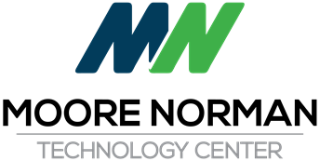

Regular Board Meeting
January 14, 2020 5:30 PM
IT Building - Seminar Center
4701 12th Avenue NW
Norman, OK 73069

1. Pledge of Allegiance
2. Call to Order and the Recording of Members Present and Absent
3. Miscellaneous Public Comment
4. Superintendent's Update:
5. Recognition, Reports and Presentations
5.A. Participation in Cleveland County Natural Hazard Mitigation Plan - Jerry McConnell
5.B. Teacher Prep Program Update - Cheryl Pantalone
6. Consent Agenda:
6.A. Minutes of 12-19-19 Regular Board Meeting
6.B. Monthly Financial Reports (Treasurer/Activity Fund)
6.C. General Fund Encumbrance numbers 2002321-2002452 and Fundraisers
6.D. Approve Participation in Cleveland County Natural Hazard Mitigation Plan
6.E. Declare Items as Surplus Property and Authorize Sale of Said Items

Regular Board Meeting
January 14, 2020 5:30 PM
IT Building - Seminar Center
4701 12th Avenue NW
Page 2
7. Consider and Vote to Approve Superintendent's Personnel Recommendations:
7.A. Acknowledge Letter of Resignation - Karen Petrak, RN - Nursing
7.B. Employment of Part Time Employees
8. Consider and Vote to Approve General Business Items:
8.A. Consider and vote to Renew Annual Contract with Norman Economic Development Coalition, Inc in the amount of $125,000.00.
9. New Business
10. Consider and Vote to Move to Executive Session to Discuss:
10.A. Current Personnel Issue
10.B. Programs
11. Statement by Presiding Officer concerning Minutes of Executive Session
12. Adjourn

