Desmos - Online Graphing Calculator
https://www.desmos.com/

KHANACADEMY
https://www.khanacademy.org/

MATH APPS FOR MIDDLE SCHOOL
https://edshelf.com/profile/cbeyerle/math-apps-for-middle-school

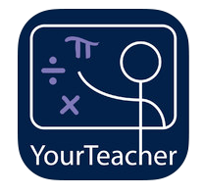
REFERENCE APPS:
https://itunes.apple.com/us/app/math./id469234810?mt=8
https://itunes.apple.com/us/app/math-formulas-reference-guide/id423545644?mt=8

MIDDLE SCHOOL MATH:
https://itunes.apple.com/us/app/ixl-math-practice/id693689912?mt=8

https://itunes.apple.com/app/buzzmath-middle-school/id593186620

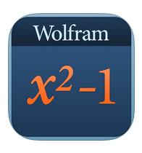
WOLFRAM SERIES:
Algebra:
https://itunes.apple.com/us/app/wolfram-algebra-course-assistant/id410592976?mt=8

KHAN ACADEMY APPS:
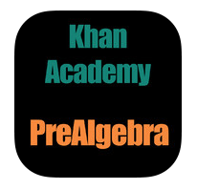
Pre-Algebra:
https://itunes.apple.com/us/app/khan-academy- prealgebra/id358511707?mt=8

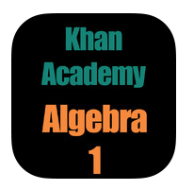
Algebra 1:
https://itunes.apple.com/us/app/khan-academy-algebra- 1/id358519986?mt=8

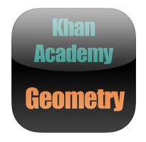
Geometry:
https://itunes.apple.com/us/app/khan-academy-geometry/id358508794?mt=8

- The vision of the mathematics standards is focused on achieving one central goal: to enable ALL of New Jersey’s children to acquire the mathematical skills, understanding, and attitudes they need to be successful in their careers and daily lives.

- Students at WWMS are required to successfully complete a mathematics course in grades 6, 7, and 8. Student placement is based upon aptitude, district criteria, and classroom performance.

- All courses are aligned with the Common Core Content Standards for Mathematics.

- Mathematics teachers at AMS are a greatest resource. Besides upholding an excellent and thorough knowledge of the subject, each teacher utilizes differentiated instructional strategies that enhance student success. In-service programs and workshops are conducted throughout the year to assure professional growth for all of our teachers.

- The WWMS Mathematics Department focuses not only on the content of the curriculum but the application to real-life situations reinforcing 21st Century Skills. Our students will be prepared for the challenges they will face during their high school and college experience. Calculators, computers, manipulatives, technology and the internet are used as tools to enhance learning and assist in problem solving.

- In this ever changing world, students who have a solid understanding and foundation of mathematics, will have multiple opportunities throughout their lives. The WWMS Mathematics Department is committed to providing all students with the opportunity and support necessary to learn, explore, and apply mathematics.

